Devonshire
December 2021
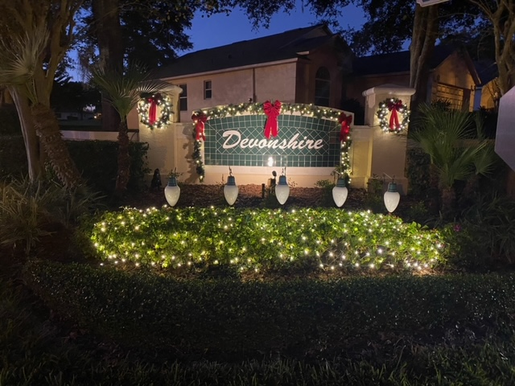

As the holidays rapidly approach, things are happening in Devonshire,
Pictured above is our entrance monument decked out for the season. This beautiful rendition was put together by Brack Leaberry with assistance from Terry Schander and Tim Jewell. Thanks to all for your efforts.
Don’t forget our informal gathering on Tuesday, the 14th on the side lawn of 3636 Kingswood Court. Thanks to Jo Ann Wickham for use of her property. A flyer was inserted in everyone’s flyer box below your mail box.
If you are anxious to do some caroling, Penny Lempa and Gail Domenico are looking for some volunteers. Give Gail a call at 352 241 9033.
As we previously reported. Leland Management will be our new property manager beginning in January. Our January monthly assessment will be processed by Leland, You should have received a notice from Sentry regarding 2022 payments. Please ignore that letter. You will be receiving payment information and coupon payment books from Leland in the coming days.
On behalf of your Board of Directors, we wish you happiness and good health during this special time and throughout the coming year!

Paul Hannon
President

