**VenYou201**

201 Redwood Ave, Niceville, FL 32578

***Niceville’s event and meeting place.***

**Booking Fees:** Half Day Full Day 2 Hr

Friday/Saturday/Sunday $250 $500 $125

Monday – Thursday $150 $300 $75

**Other Fees:**

Damage deposit: $100 or ½ rental fee whichever is greater

Projector deposit: $100

Tablecloth rental: $40 (includes all 12 round/4 rectangle, black or white)

Cleaning fee: $125 (can self-clean if 2 Hrs or less)

Returned check fee: $30

**EVENT HOURS:** 7 am – 9 pm Sun-Thurs

7 am – 11 pm Fri & Sat

**VENYOU201 FEATURES:**

Capacity maximum of 100 with 80 matching chairs

12 round and 4 rectangle tables (rental tablecloths available)

Free Wifi, Bluetooth capable sound system and microphones

Caterer’s prep/serving area

Portable podium

Projector (additional deposit) and electric screen available

Handicap accessible entrance, bathroom, and parking

**Key Details:**

- Damage deposit can be paid by cash or check separate from the other fees. If damage occurs, manager will determine cost for repairs or excessive cleaning to be withheld from the deposit.

- One-half the total booking fee, deposits and cleaning fee are due at time of booking. The balance is due one month prior to the event. If not received, the reservation will be relinquished.

- We realize that cancellations are sometimes necessary. Therefore, we are happy to refund your money with a written notice at least 10 days prior to your event. Without a 10-day notice, one-half of your reservation fee will be forfeited.

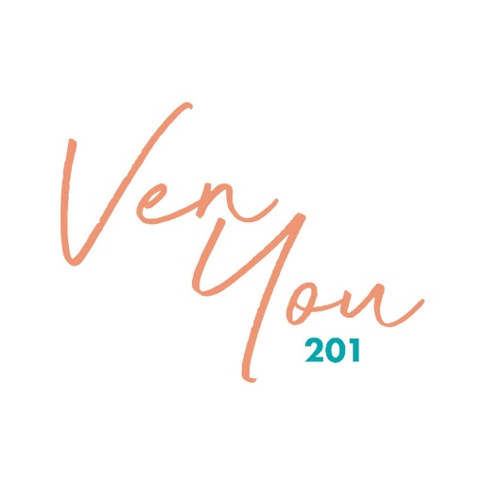

|  |  |
| --- | --- |
| **CONTACT** PHONE:  850-280-4420  WEBSITE:  Venyou201.com  EMAIL:  [venyou201@gmail.com](mailto:venyou201@gmail.com)  All revenues support  CALM House  Organization  a non-profit 501(c)3 |  |