Repairs for 5633 Yeary Rd house
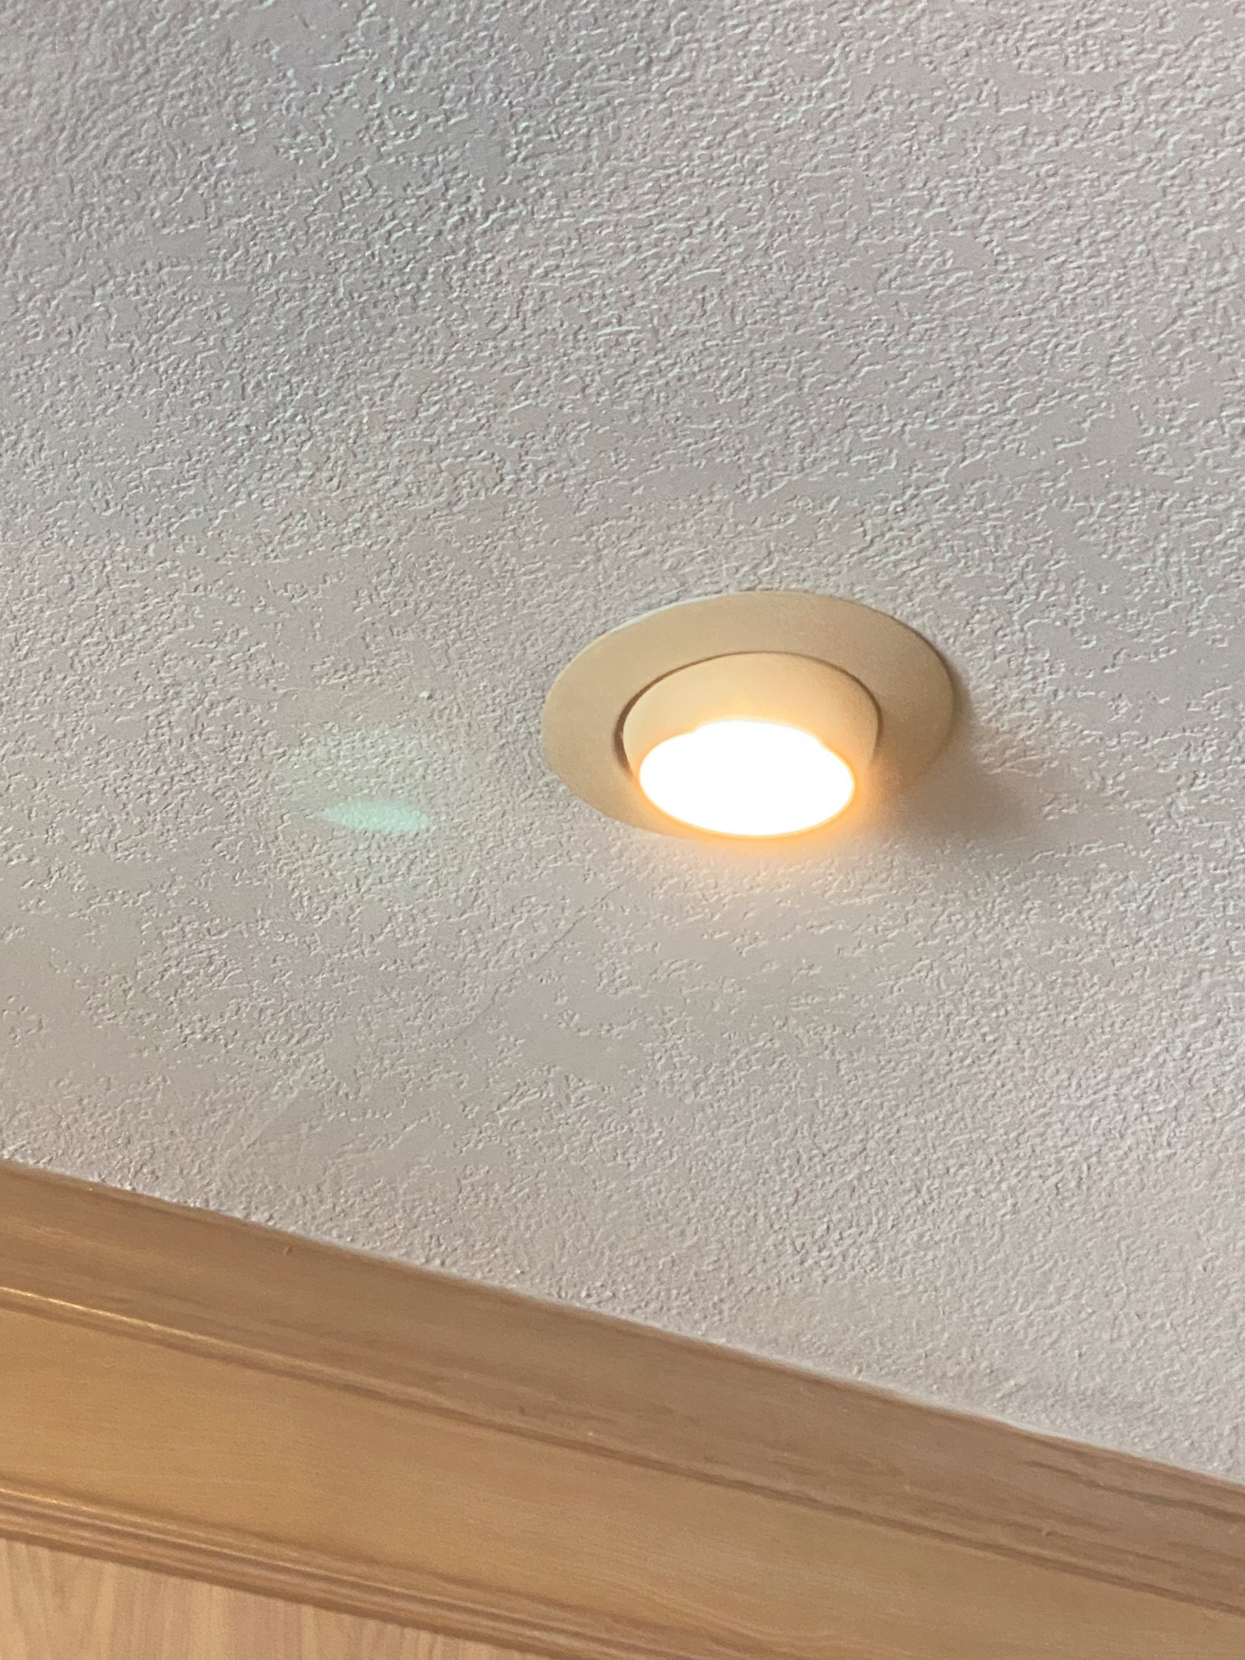
Family Room light bulb replacement
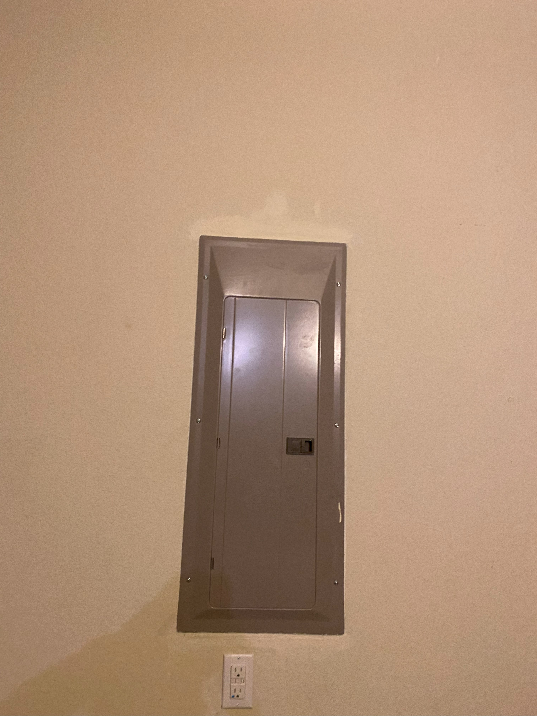
Repair drywall in garage above electrical panel
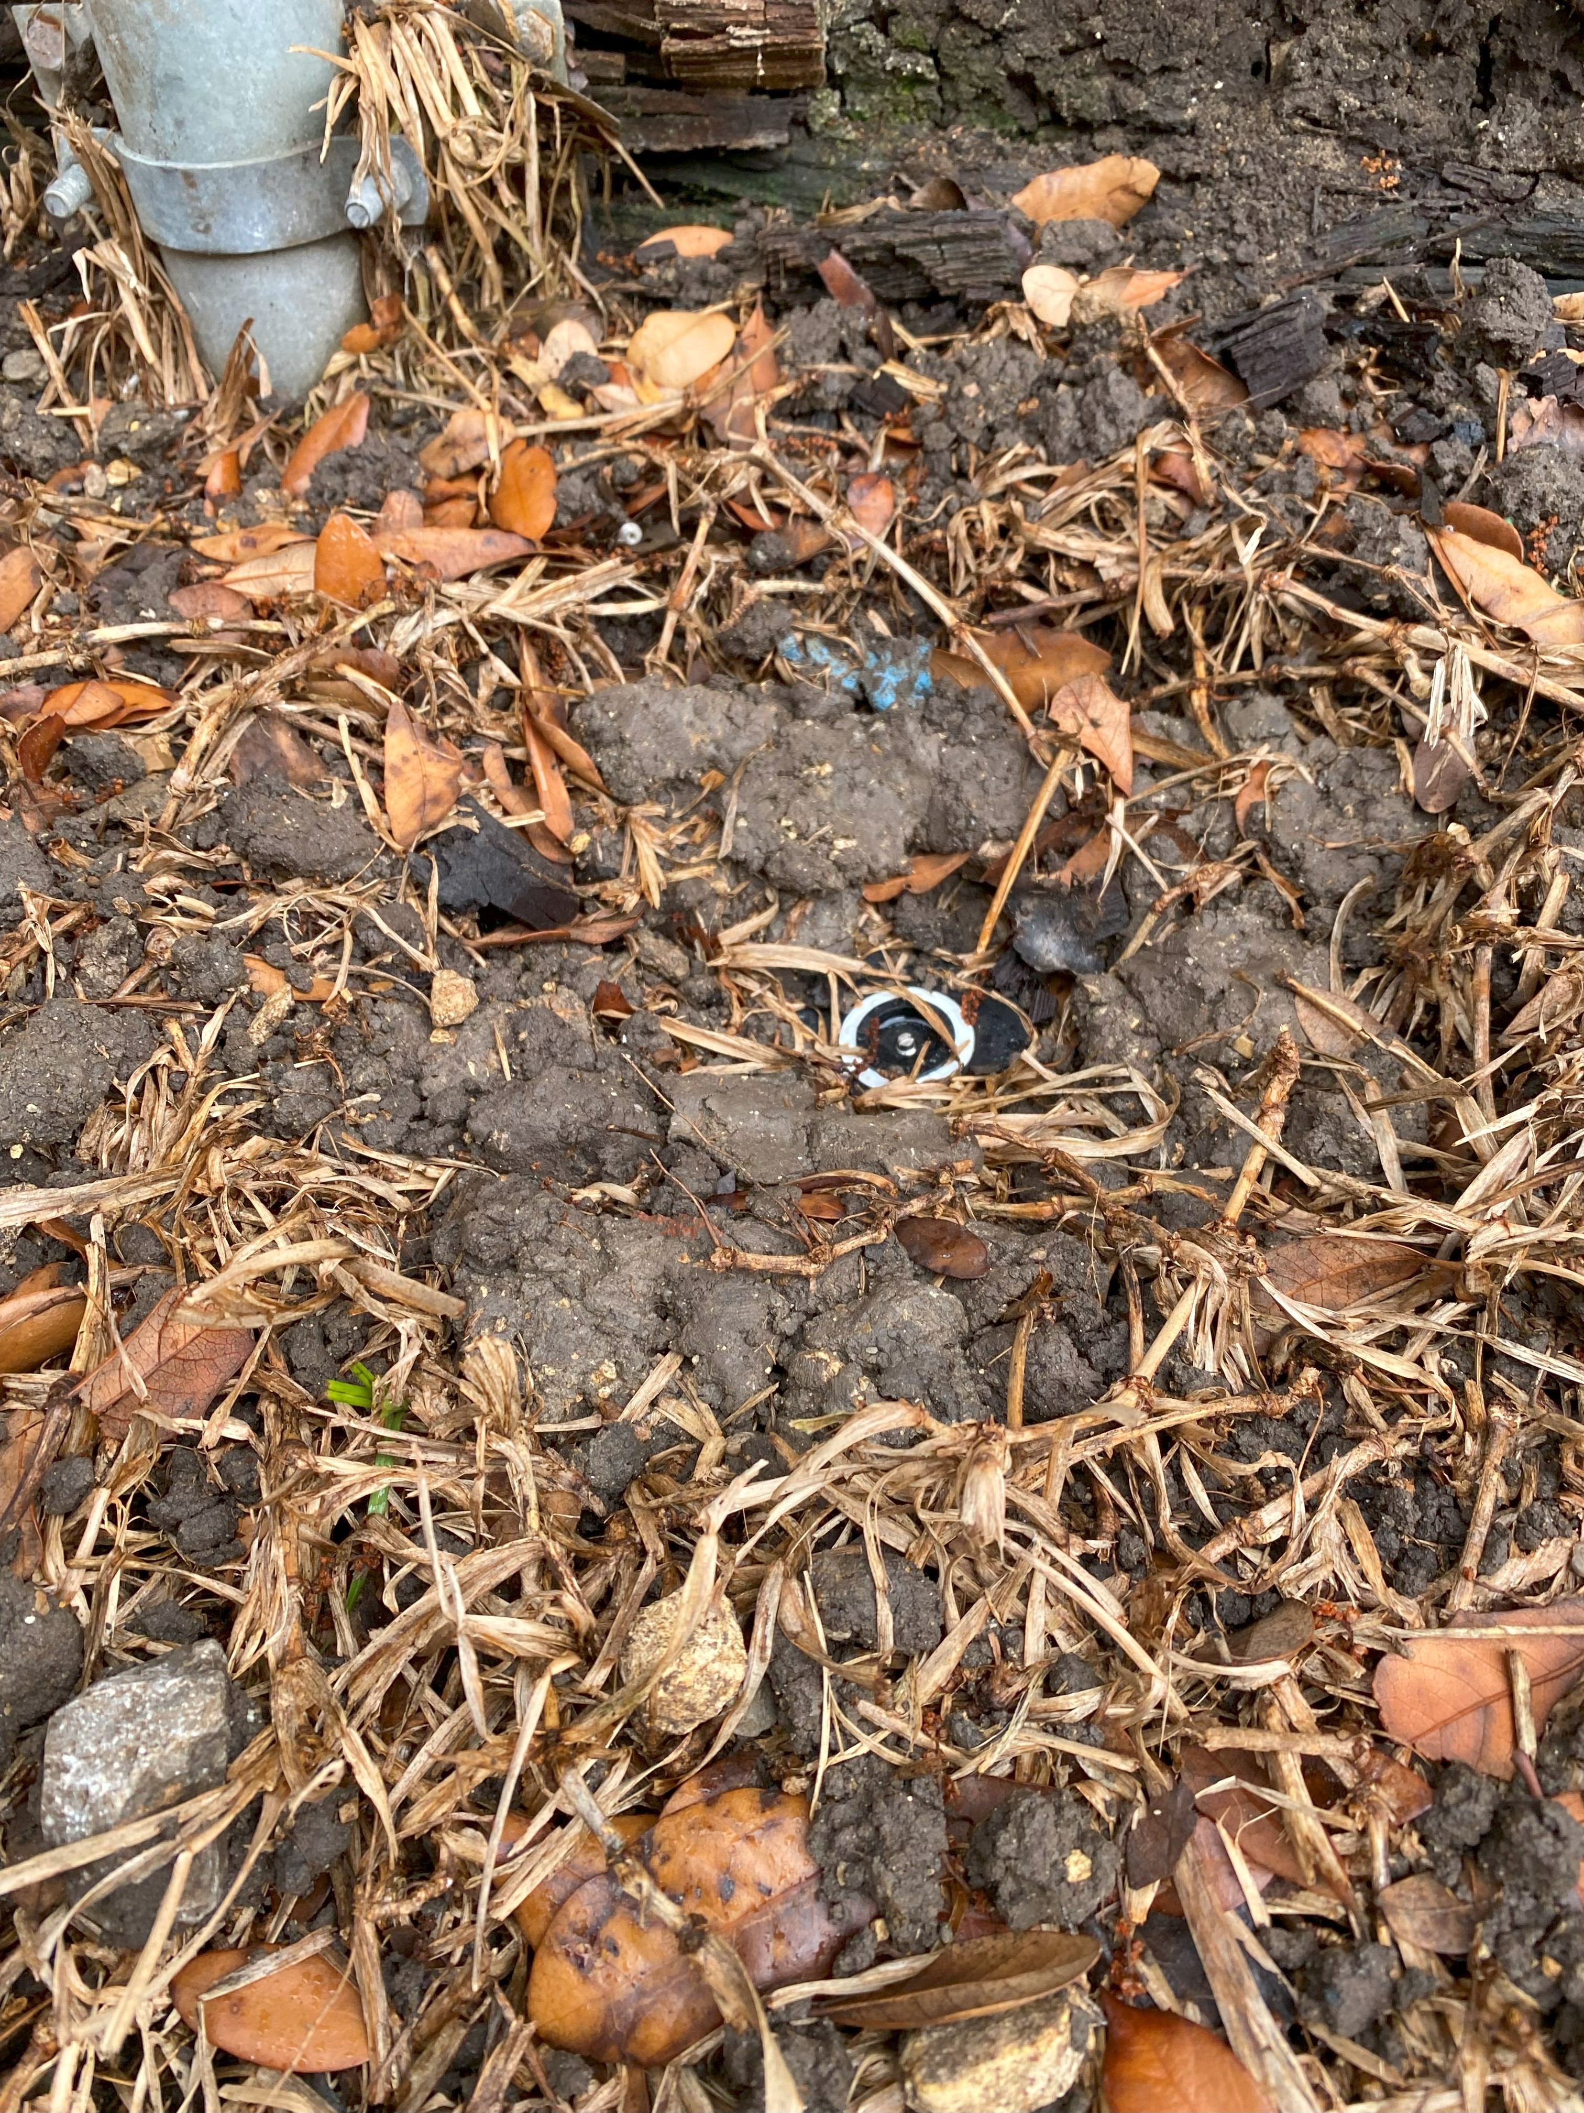
Sprinkler head fix
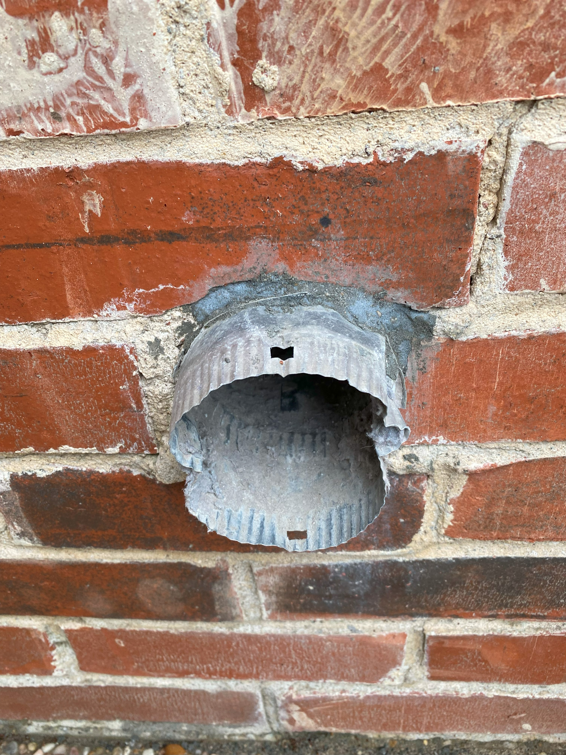
Dryer exhaust vent cleaned and sealed.
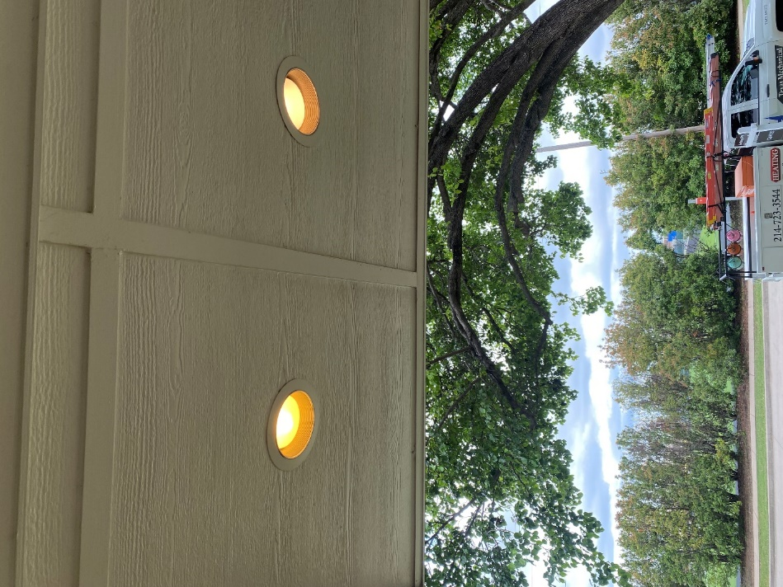
Front porch lights.

