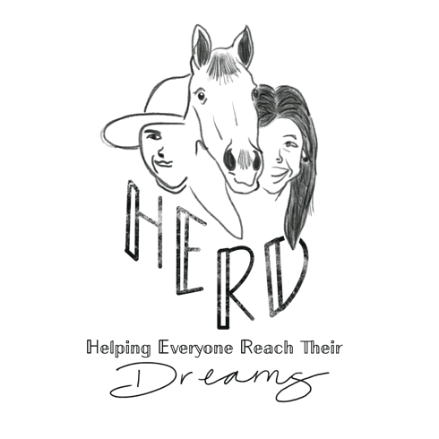
LIABILTY and RELEASE

I ___________________________, understand participating in said equine activities
(Print name of Participant)
comes with an inherent risk of injury or even death. By signing this I agree that my participation is of my own volition, and I will not hold Shayla Anderson responsible for any unforeseen circumstances or potential injury.

WARNING: Under South Carolina law, an equine activity sponsor or equine professional is not liable for an injury to or the death of a participant in an equine activity resulting from an inherent risk of equine activity, pursuant to Article 7, Chapter 9 of Title 47, Code of Laws of South Carolina, 1976.

HERD IS an equine assisted service program designed to assist individuals with identified differing abilities and special needs reach their aspirations and potential through engagement with horses. HERD is a skill based and building program that aims to do the following:
- Foster independence
- Facilitate teamwork
- Increase daily functioning
- Stimulate socialization

HERD IS NOT a program that offers hippotherapy, physical therapy, psychotherapy.

(Signature of Participant OR Parent/Legal Guardian) (Date)

Printed Name: _________________________________________________________________________________

Address: _____________________________________________________________________________________
____________________________________________________________________________________________

Phone Number: ________________________________________________________________________________

Email: _______________________________________________________________________________________

