Introduction
About Halo by Genivity
HALO is health analysis and longevity optimizer that helps users to Plan for active and healthy years in retirement, determine how many years of additional daily care person may need and what the estimated costs could be, and estimate out of pocket care costs throughout lifespan.

What is the problem?
The Halo assessment tool needs to grab the attention of new customers, specially the younger generation and that by improving it user friendliness.
Genivity is looking into documenting any issues with the tool and a strategy to improve the experience for advisors and their clients.

Main concerns:
Is the assessment easy to follow and easy to understand?
Is the results page is displaying enough information to assessment taker before scheduling and appointment with financial advisor for full report.
How to display the results and empathies with people with shorter longevity results.

Methodology

Usability Testing:
Usability testing is to understand how real users interact with the tool and make changes based on the insights gathered based on the usability test results.
The insights will help in understanding how the users thinking while interacting with the app and if it meets their expectations.
The usability testing was moderated and conducted remotely, which will allow to see how successful users are with performing the task and will help in discovering any flaws with the assessment.

The test was designed to take about 15-20 minutes to perform, with only one task to complete the assessment, followed with post interview questions.
Total number of participants is 5, consists of individuals between the ages of 25 and 40 that have no familiarity with the Halo assessment.
post-test questions were to gather feedback on the website, likes, dislikes and frustrations from users.

Heuristic Evaluation:
The heuristic evaluation is an evaluation conducted by usability experts to review the system interface and compare it against accepted usability principles helps to identify the usability problems in a user interface design.

Detailed results from testing:

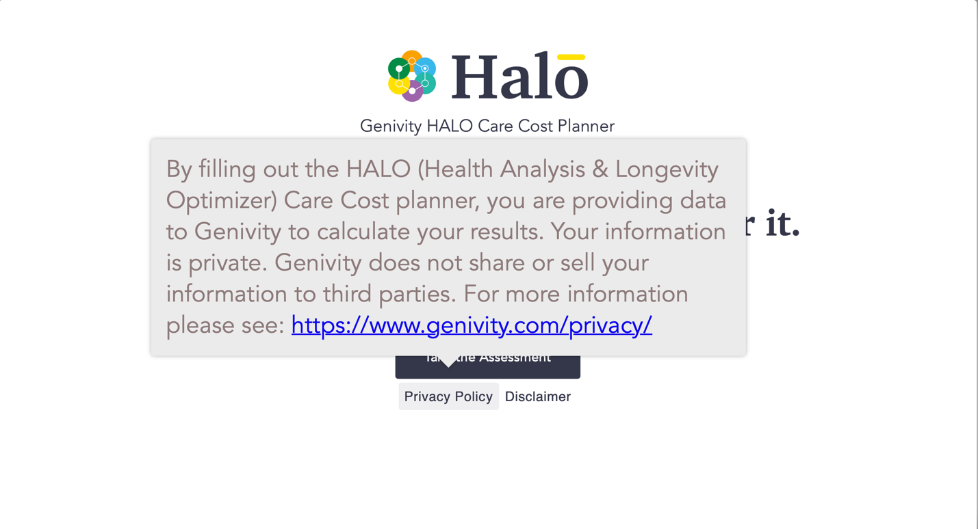
From heuristic evaluation:
When click on privacy policy or Disclaimer, will not be able to close it, which will hide the take assessment button

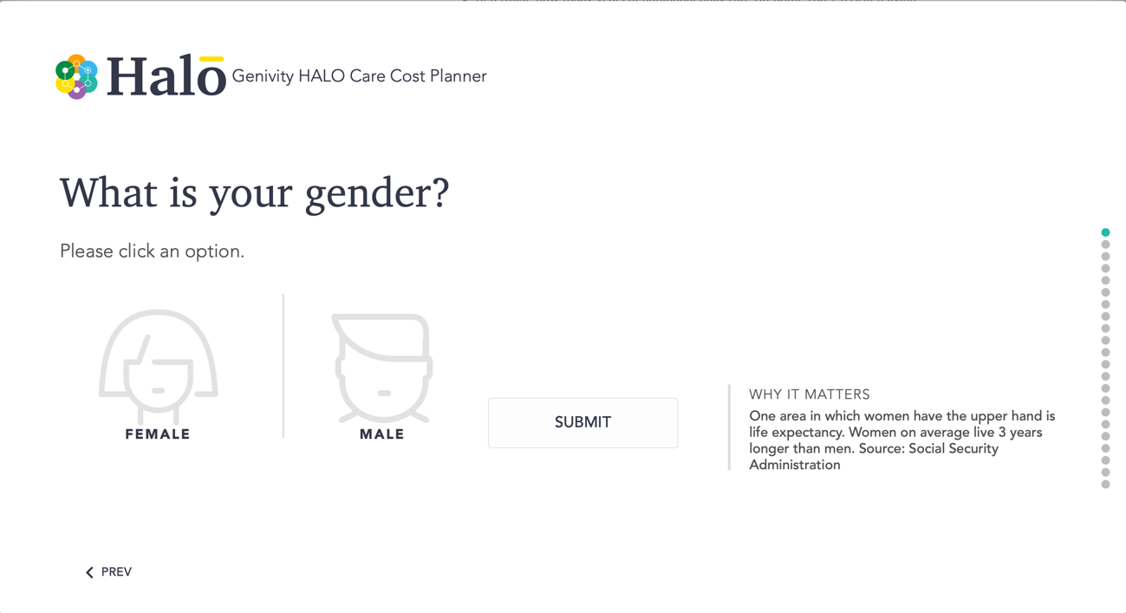
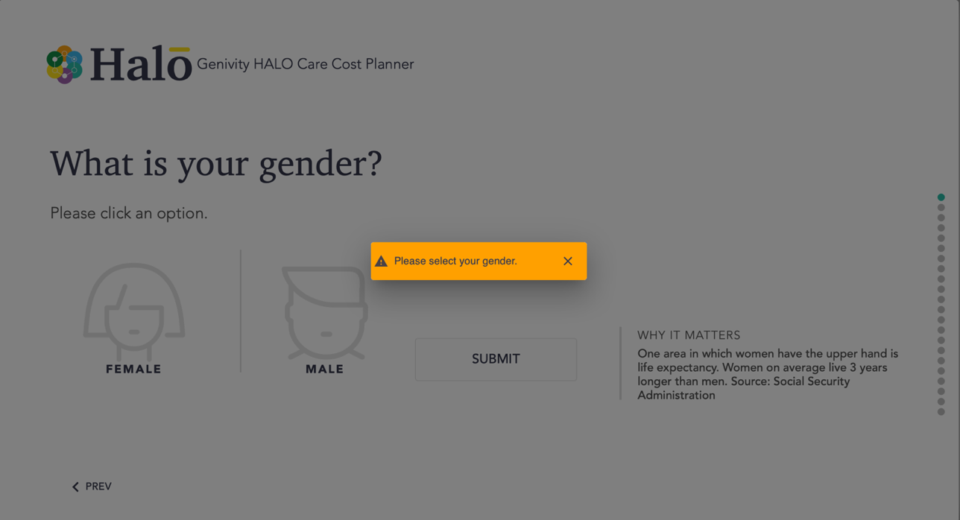
From Usability testing:
Submit button: user was confused with the submit button.
Why it matters: user didn’t notice the text

From heuristic evaluation:
The progress bar made it seems as a long assessment (many steps)
Submit button: position not consistent with the PREV button
If user didn’t select an option a pop-up validation message will appear, giving the user extra step to close the pop-up

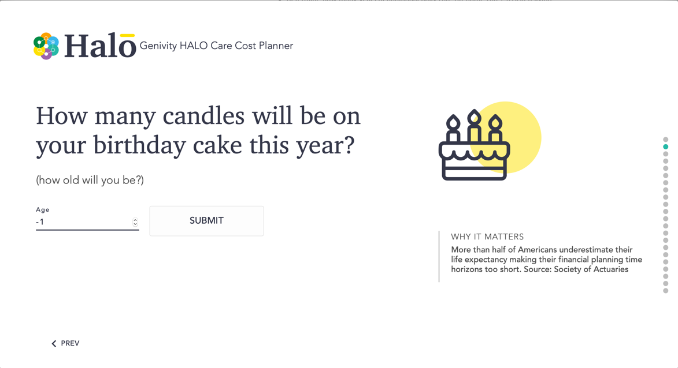
From Usability testing:
The question: confusing. What does it mean how many candles will be this year what if the user birthday already past this year?

From heuristic evaluation:
Age text field: arrows allow user to move below zero, however, it will not allow the user to submit any number less than 18.

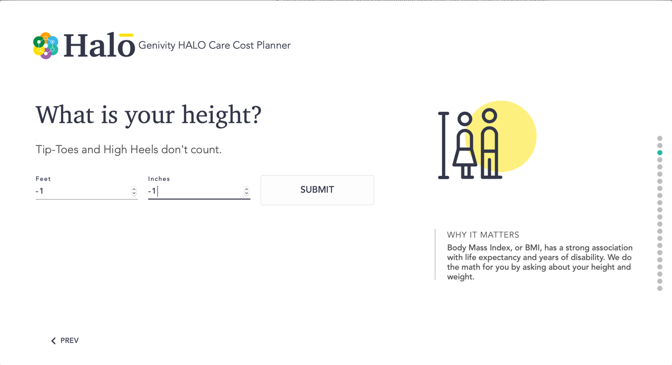
From heuristic evaluation:
No metric unit options
Feet and inches text fields: arrows allow user to insert zero or less numbers and allow user to submit.

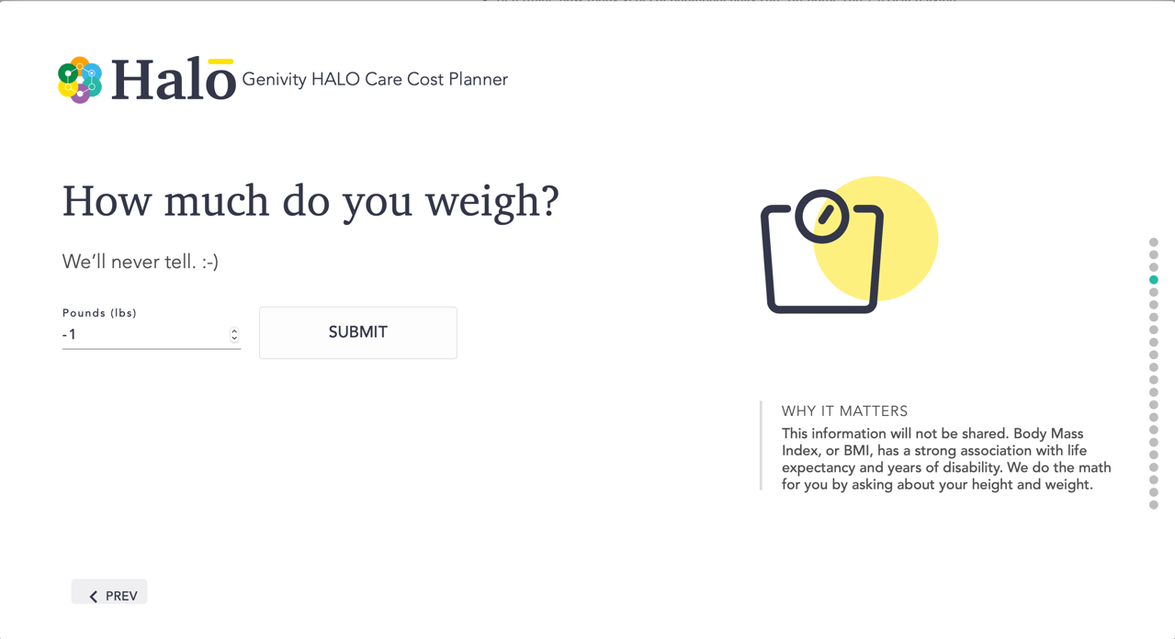

From heuristic evaluation:
No metric unit options
Pounds text field: arrows allow user to insert zero or less numbers and allow user to submit.

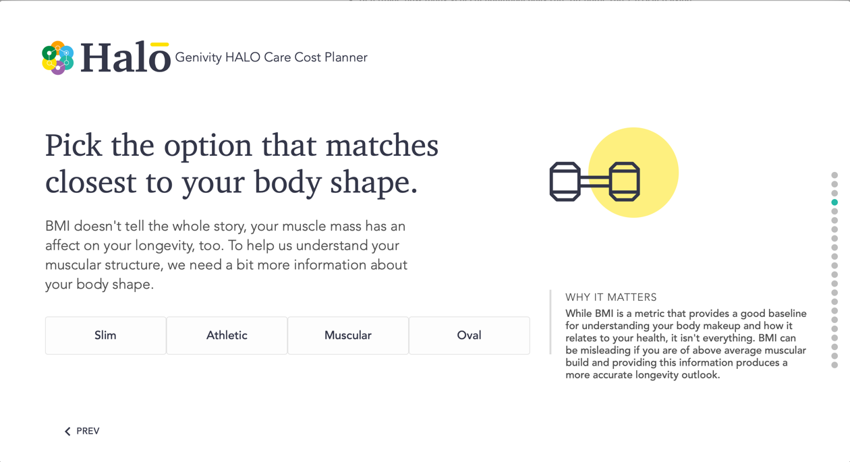
From heuristic evaluation:
All previous pages has submit button. In this page no submit/net button

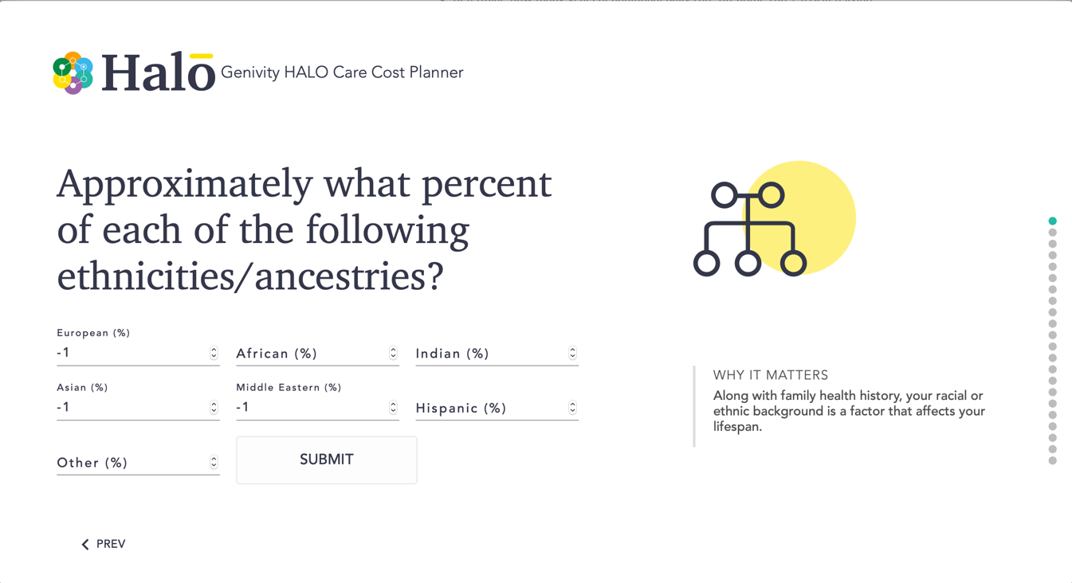
From heuristic evaluation:
Text fields: arrows allow user to insert zero or less numbers and allow user to submit as long as the total is 100
Submit button: its position
Progress bar: jumped back to step one

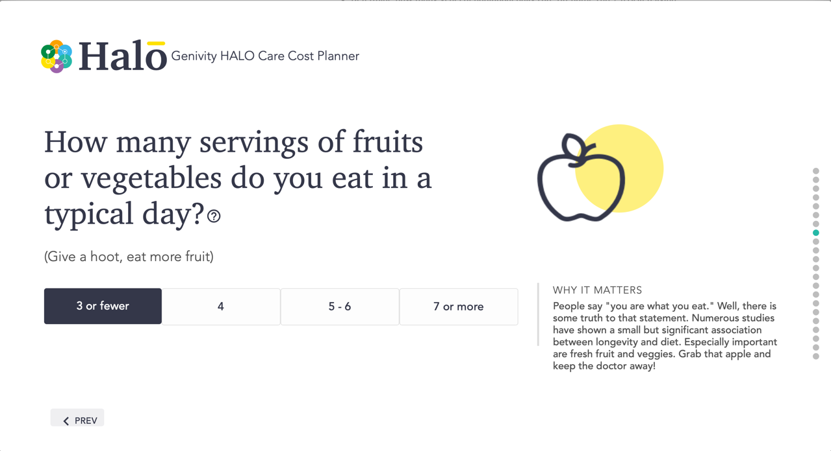
From Usability testing:
That’s a hard question. There is a big discrepancy (0 and 3 are considered equal)

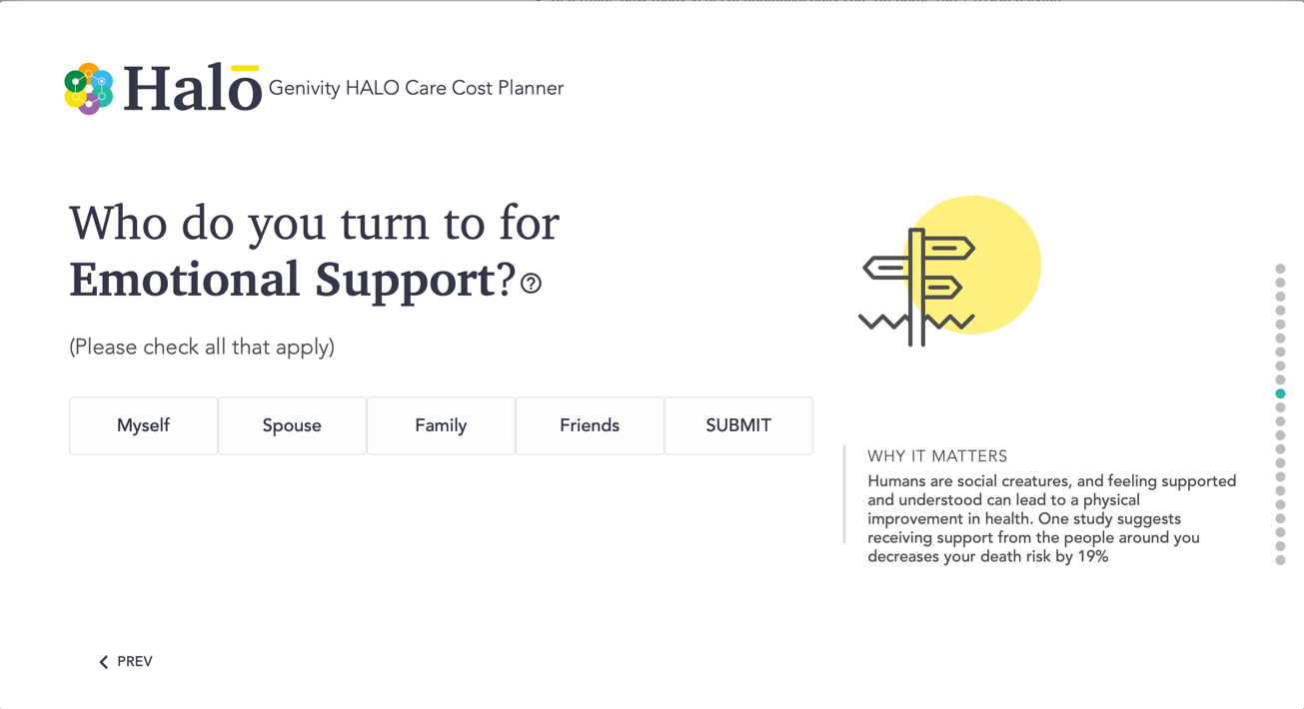
From Usability testing:
That’s a broad question. “I don’t know what it meant by myself? I clicked it because I hope I would be there for myself”
It is not obvious if user can click on multiple options. “Does it allow me to click multiple?”

From heuristic evaluation:
Submit button: its position next and similar to other buttons.

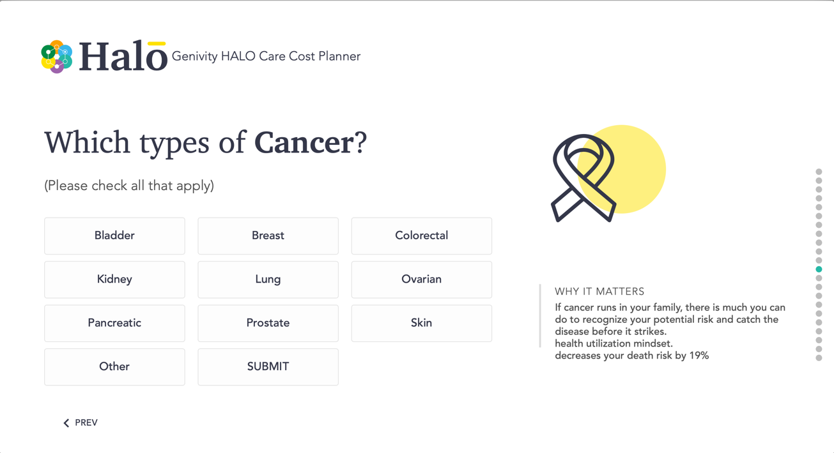
From heuristic evaluation:
Submit button: its position next and similar to other buttons.

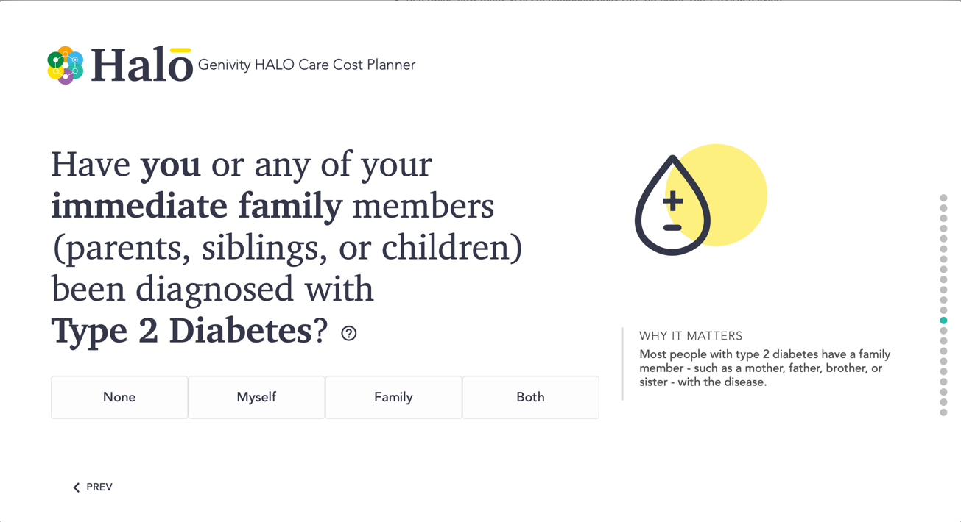
From Usability testing:
After user clicked on an answer, it moved to the next question. The user was a bit. Frustrated by that. “I wanted to read the Why It Matters note” “and what if I miss select?”

From heuristic evaluation:
This screen will appear and will keep loading when I entered minus numbers for weight and

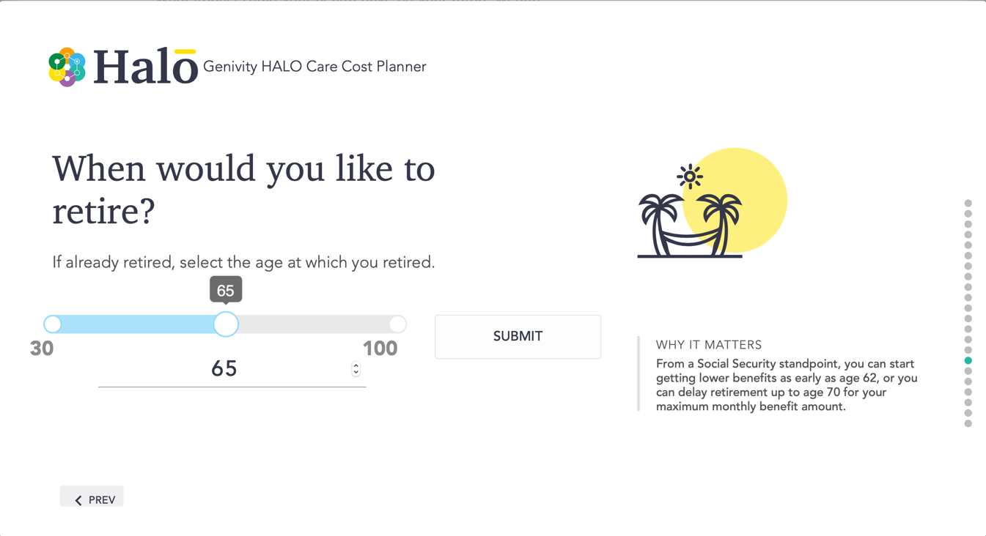
From Usability testing:
User was not sure when to retire? “I never thought about it. I’m not sure what the average age to retire?”
User decided to select 72, then user noticed the Why it Matters and changed the answer to 65.
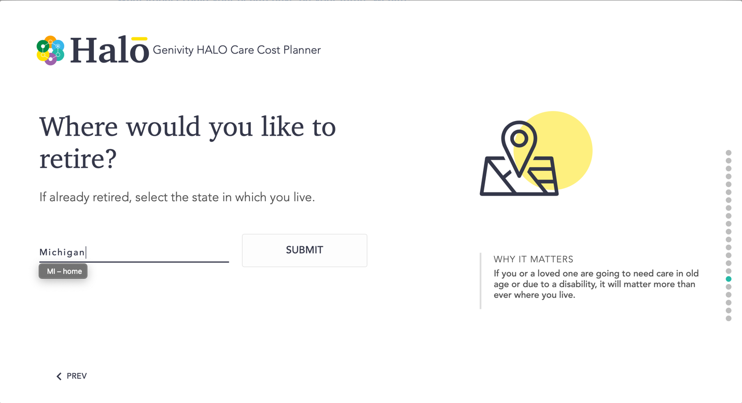
From Usability testing:
What if I don’t want to retire in the US?

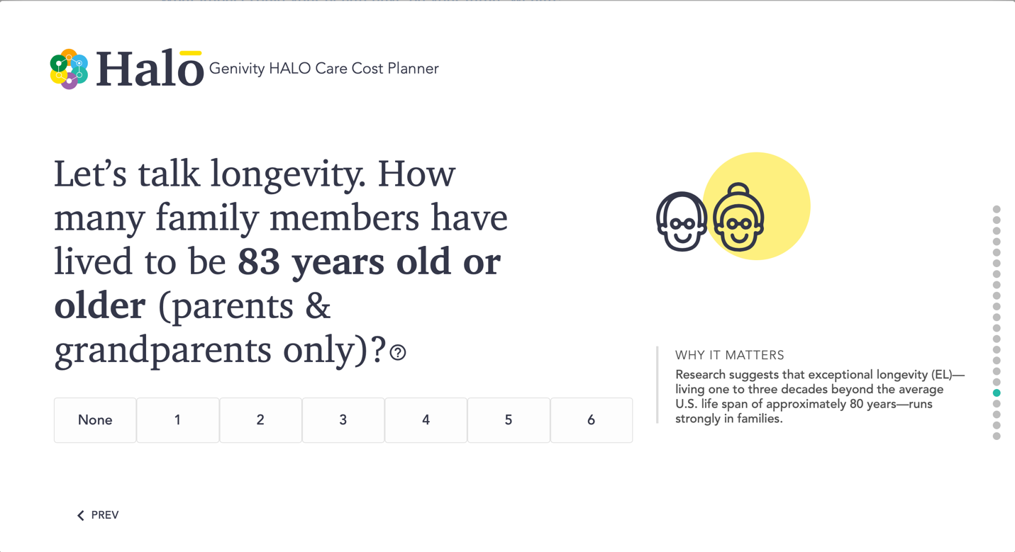
From Usability testing:
The question is a bit confusing. “Three of my grandparents still alive and they didn’t reach 83 yet but they might live till 83. So I’m not sure how to answer it”
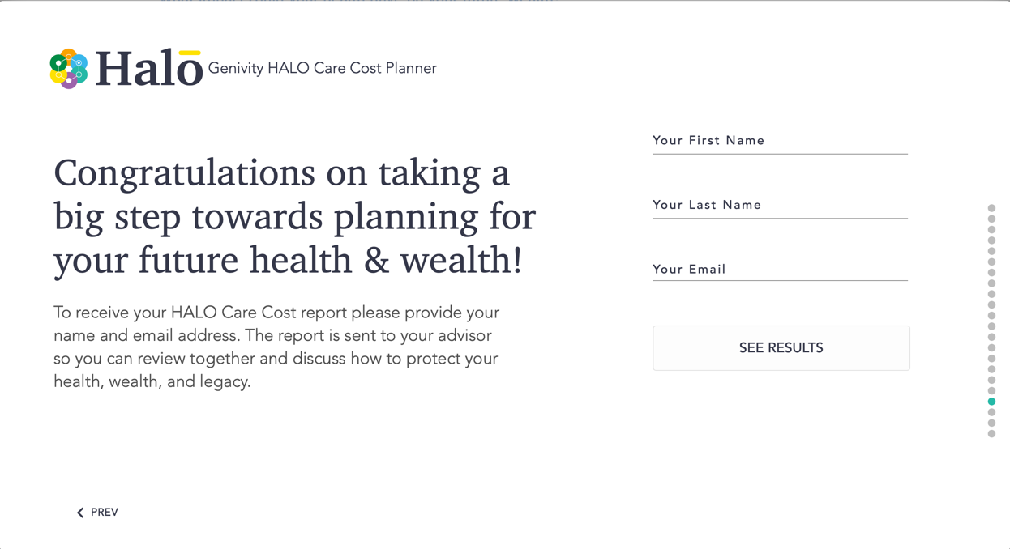
From Usability testing:
Do I have to fill up my information?

From heuristic evaluation:
The location of the form make it seems not important

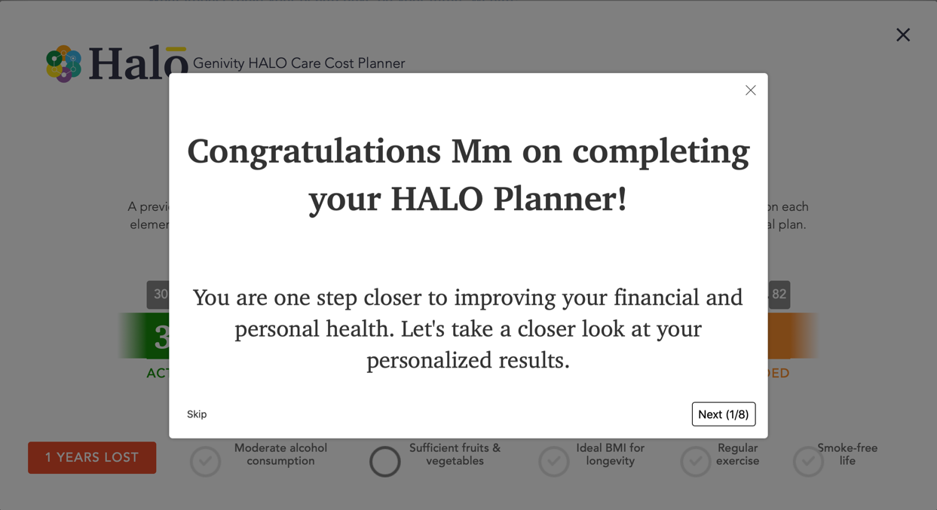
From Usability testing:
“Oh there is still 8 more steps?”
“I’m scared I don’t know what to do now? I thought I’m done.”

From heuristic evaluation:
there is exit, skip and next button. It is a little bit confusing
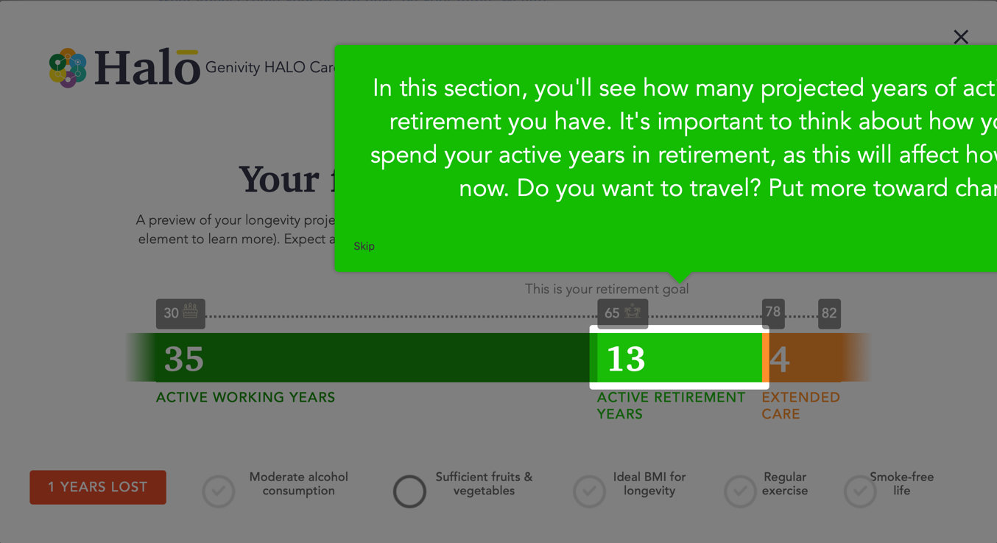
From Usability testing:

From heuristic evaluation:
The text is cut off. Outside the tool screen dimensions

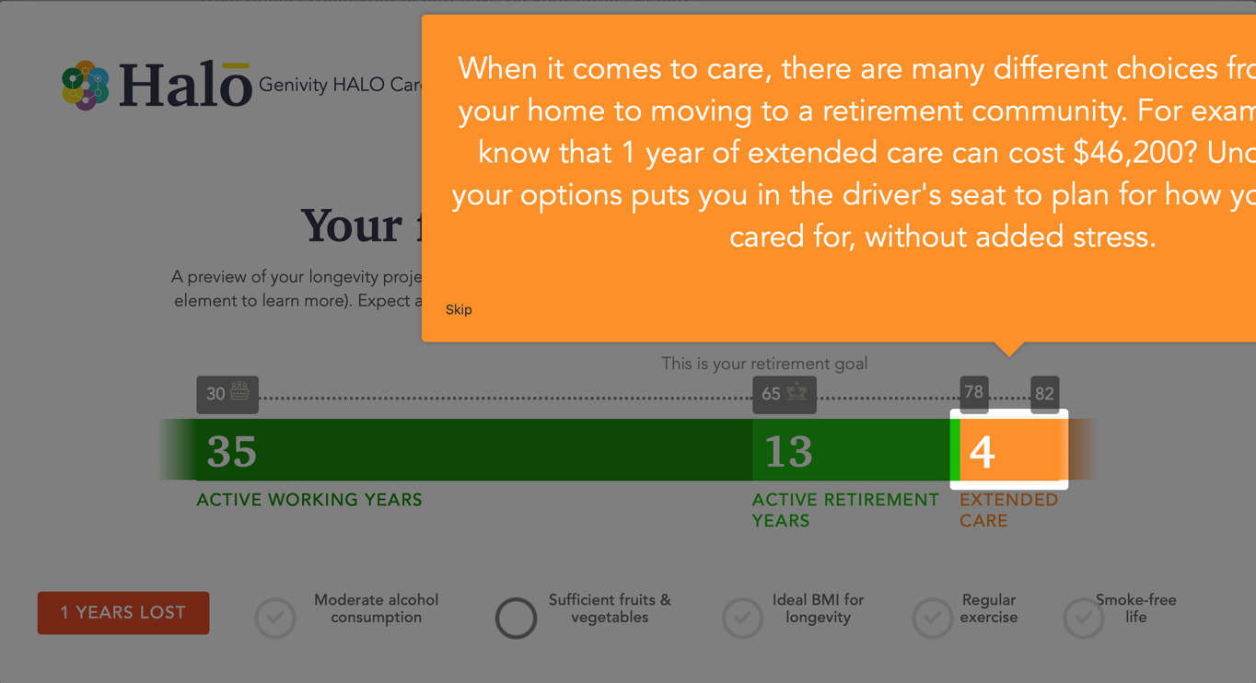
From Usability testing:

From heuristic evaluation:
The text is cut off. Outside the tool screen dimensions
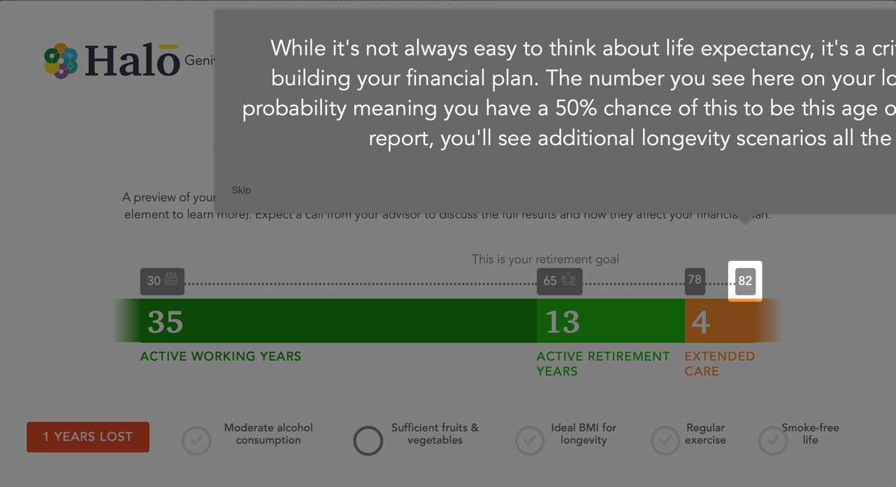
From Usability testing:
Where is next button?

From heuristic evaluation:
The text is cut off. Outside the tool screen dimensions. Can’t see the next button

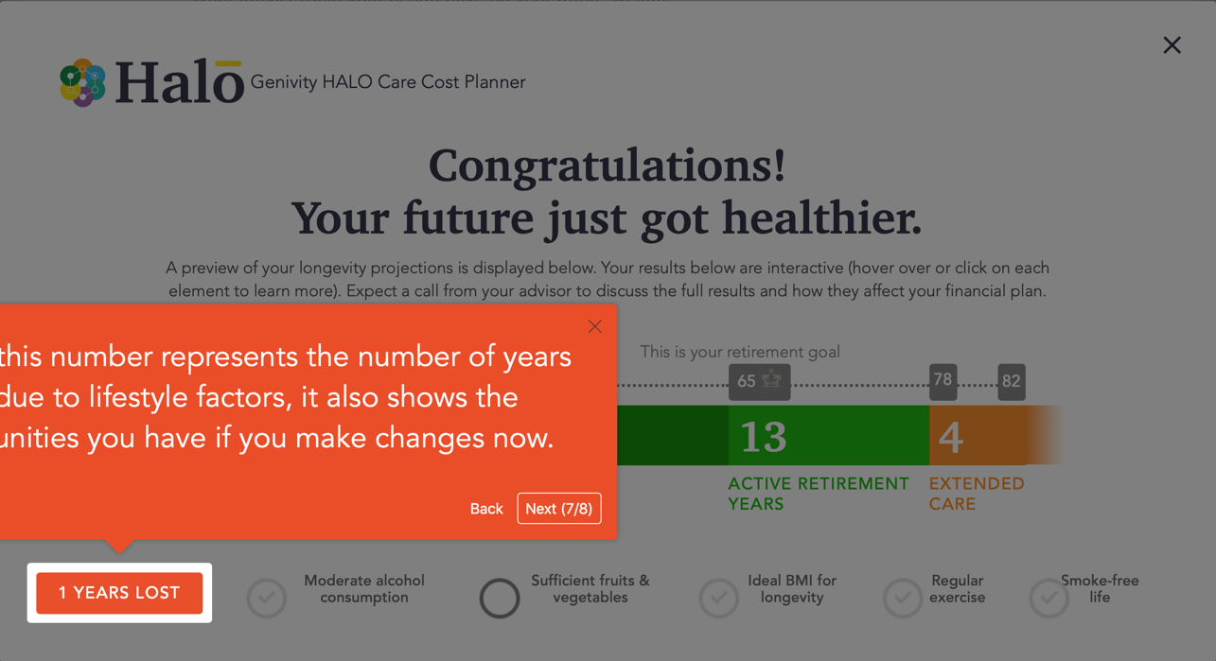
From Usability testing:
“what does it mean by I lost 1 year?”

From heuristic evaluation:
The text is cut off. Outside the tool screen dimensions
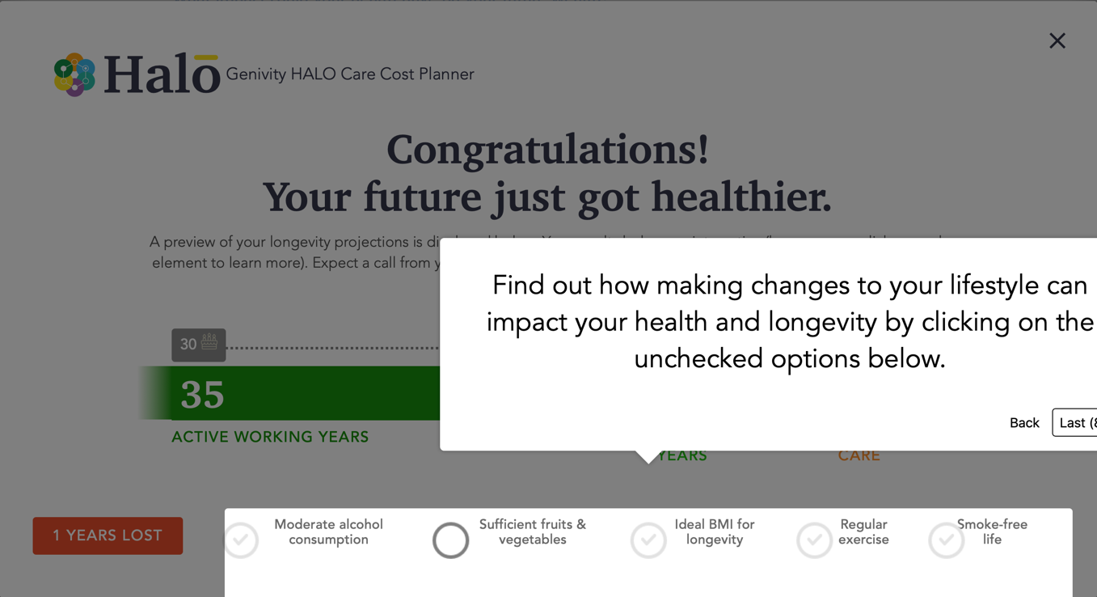
From heuristic evaluation:
The text is cut off. Outside the tool screen dimensions

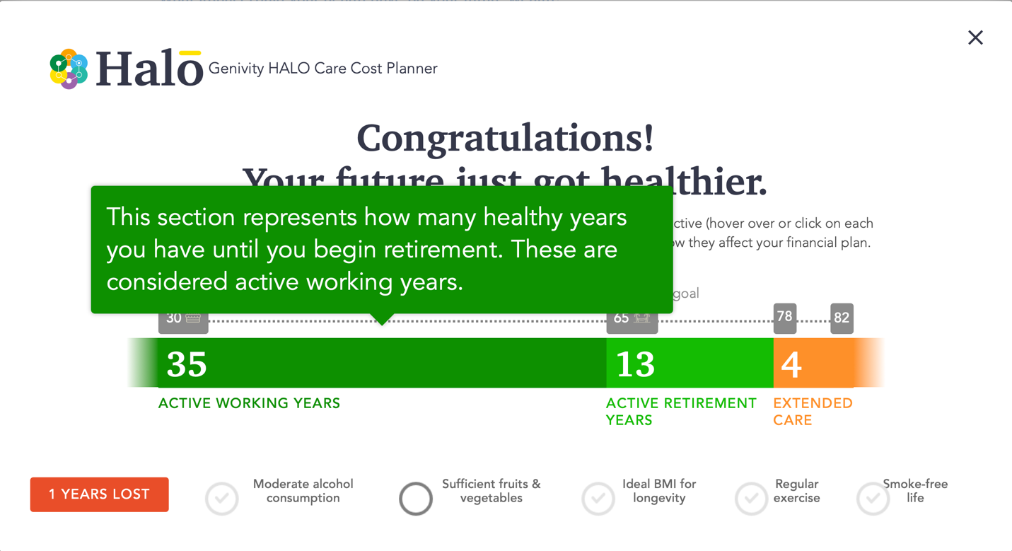
From Usability testing:
User was not sure if they can check off things in the chart. “Can I check off these?”

From heuristic evaluation:
When hover some text is cut off. Outside the tool screen dimensions
Findings:
- Submit/next button: some questions has no submit/next button. Once user select an answer it will move to next question. Some users missed to read the Why It Matters as they usually read it after they select an answer. Also, there was a frustration when a user selects a wrong answer and wasn’t sure how to go back.
Also no consistency for the submit button location.
- Progress Bar: Some users didn’t notice the progress bar. Some users assumed that it will allow to click on the dots to move between screens
when looking at the progress bar it seems like it is a long assessment (lots of questions to answer)
Number of slides/questions: too many slides it seems like it is a long assessment.
- Why It Matters: Users liked it, and feel it’s very helpful, but some users didn’t notice it or read it after they answer the question.
- The question How old will you be: confusing. Some users paused a bit at this question. The question confusing. What does it mean how many candles will be this year what if the user birthday already past this year?

- Some questions are broad or confusing: example:
- Emotional support question: “I don’t know what it meant by myself? I clicked it because I hope I would be there for myself”
- How many family members lived to certain age: “Three of my grandparents still alive and they didn’t reach 83 yet but they might live till 83. So I’m not sure how to answer it”
- Fruits and vegetables serving: That’s a hard question. There is a big discrepancy (0 and 3 fall under same category)
- Where to retire: “what if I want to retire out of USA?”

- Minus variables: some text field allow the user to insert minus values
- Last page (where user can put their name and email): the position of the form implied that is not important so users might not be encouraged to provide their info.
- Congratulation page: there is exit, skip and next button. It is a little bit confusing.
Next (1/8): user will think there is still 8 more steps to go through.

- Result pages: in many slides the text expand to the edge of the screen Outside the tool screen dimensions. Some text not visible
- Number of years lost: some users didn’t know what that means

Post-interview questions:
- How did you feel about taking the assessment?
Users thought it is quick and easy to understand and for most questions they don’t have to think a lot about it. Only paused for 2 questions: where and when to retire.
“ is a little chocking to see my life expectancy”
“It feels confusing that at the beginning it talks about financials, but result didn’t display anything about financials.”
- What do like or dislike about the assessment?
“Never noticed a back button. Or maybe I missed it”
“Why It Matters it is really helpful”
“I like the big text”
- How do you feel talking about retirement?
Most users never thought about it, and felt it is early to think about retirement at this point.
- After taking the assessment, do you feel motivated to think and plan about retirement?
“For sure that motivates me. I like the concise chart at the end and I like how you can check and uncheck things“
“It is a good reminder that I should start some financial planning”

Recommendations:
- Submit button: replace it with next and position it to the bottom right
the position needs to be consistent in all pages
- Why it matters: Make more visible so user can notice it
Either add some color to it or position it under the question, hide the text and user can view on hover.

- Reduce the number of slides/pages by considering combing some question in the same page.
Example: Gender, Age, height and weight
disease questions all in one page (click all apply)
- Progress bar: move it to the bottom of the page. Make it possible to click on the dots to move to specific question. User can hover over the dot to know the question.
- Form Validations: when user must provide an answer replace the message pop-up with a message to appear next to the question or grey out the next button til the user answer all questions.
- The question How old will you be: replace it with how old you are or better if person asked to put their birthday.
- Minus variables: force the user to input positive numbers.
- Last page (where user can put their name and email): move the form to the left side
- Congratulation page: remove skip button and just include exit and see results button.
- Result pages: fix it so text will not expand to the edge
- Result pages: reduce number of slides. Remove some steps and just keep the last slide where it gives the complete results and user can hover over the numbers to get more details.
- For question where to retire add other countries as some users mentioned they are planning to retire out of USA.
- Need to conduct more usability testing with people of age 40 and older.

