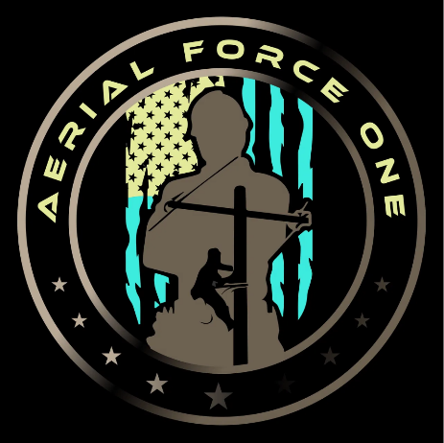
Aerial Force One Workplace Safety Subjects:

Drug and Alcohol Policy

1. Purpose
The purpose of this policy is to ensure a safe and productive work environment for all employees by addressing the use of drugs and alcohol. This policy outlines the guidelines and procedures for drug and alcohol testing, as well as the consequences for violations.

2. Prohibited Substance Use
The use, possession, sale, distribution, or being under the influence of illegal drugs or alcohol during work hours, while operating company vehicles or machinery, or while representing the company is strictly prohibited.

3. Pre-Employment Testing
All job applicants will be required to undergo drug and alcohol testing as a condition of employment. Offers of employment will be contingent upon the successful completion of the testing process.

4. Reasonable Cause Testing
If there is reasonable cause to suspect an employee is under the influence of drugs or alcohol while on the job, the company reserves the right to conduct reasonable cause testing. Reasonable cause may include, but is not limited to, observed impairment, erratic behavior, unexplained absences, or accidents.

5. Post-Incident Testing
In the event of a workplace accident or injury, the involved employees may be required to undergo post-incident drug and alcohol testing. This testing is aimed at determining whether substance use may have contributed to the incident.

6. Random Testing
To maintain a drug and alcohol-free workplace, the company may conduct random drug and alcohol testing on employees. Random selection will be conducted in a fair and non-discriminatory manner, and the selection process will be confidential.

7. Testing Procedures
Drug and alcohol testing will be conducted by Owners, Office Staff, and Supervisors, either by mouth swab or urine sample. Only approved methods will be applied when an employee or other member of the company is found to be in violation of safety standards, poor workmanship, poor attitude or a change in behavior, nodding out on the site, or causing damage to tools, equipment, or another worker.

8. Consequences for Violations
Any employee found to be in violation of this policy, including testing positive for drugs or alcohol, may face disciplinary action, up to and including termination of employment. The company may also provide resources and support for employees who voluntarily seek assistance for substance abuse issues.

9. Confidentiality
All drug and alcohol testing results will be treated as confidential information. Access to test results will be limited to those individuals with a legitimate need to know, and information will be handled in accordance with applicable privacy laws.

10. Education and Awareness
The company is committed to promoting education and awareness regarding the dangers of drug and alcohol abuse. We will provide training programs and resources to employees to help them understand the policy, recognize the signs of substance abuse, and seek assistance when needed.

By signing below, employees acknowledge that they have read, understood, and agree to comply with the company's Drug and Alcohol Policy.

Signature of Employee ____________________________________ Date:____/____/_______

Signature of Office Staff Member_____________________________ Date:____/____/_______

Signature of Safety Manager__________________________________Date:____/____/_______

