**CELOSIA CRISTATA: A POTENTIALBIOCOLOURANT**

**Monika Thakur*, Rukhsaar Sayeed and Nida Naaz**

***Amity Institute of Food Technology, Amity University, Sector-125, Noida, Uttar Pradesh-201303, India***

**Corresponding author*:** [**mthakur1@amity.edu**](mailto:mthakur1@amity.edu)**;** [**monika.harsh05@gmail.com**](mailto:monika.harsh05@gmail.com)

**Abstract**

Color is the main feature of any food item as it enhances the appeal and acceptability of food. Currently, there is increasing awareness among people towards natural dyes and dye yielding plants due to severe health problems. Because of the deficiencies of existing natural food colorants, the demand for natural pigments is repeatedly raised by the food industry. *Celosia crista* is a member of the genus *Celosia*, and is commonly known as cockscomb. It is called Mawal in Kashmiri language. *Celosia cristata* can offer a more natural and healthy way of coloring food and can be used as a new source of natural pigment i.e., Betalains. Till now, most research has been focused on carotenoids and anthocyanins but betalains have not yet received much attention. So far there is only one single betalainic source that has been extensively used in food industries worldwide and that is the red beet. To meet the high demands of food industries, there is a need for developing natural food colours from sources other than red beets.

*C. cristata* is used mainly as a food color in traditional Kashmiri Wazwan. It imparts a fiery hot colour to gravies, without affecting the taste and aroma of the dish, unlike beetroot pigments that impart an earthy flavor to the dishes due to “**geosmin**”. So, thebetalain pigment extracted from from*C. cristata* could prove to be a better alternative to beet red colour developed from beetroot.

**Key words: Celosia, natural dyes, betalains, beetroot, natural food colours**

**INTRODUCTION**

Every food designer knows that consumers judge a product not only on its flavor, but on its appearance as well. One important class of ingredients exists solely to enhance the appearance of what we eat: food colors.Throughout human history, food color has been a key trait of sensory quality evaluation.With the advent of processed food, food coloring has gained even more importance. Food colorants may be classified into synthetic, Natural- identical, inorganic and natural colorants.The coloring of foods isbelieved to have emerged around 1500 BC. Ancient Egyptian writings describethe coloring of drugs, and the coloring of wine was described by the Romans in 400 BC.Color is added to food for one or more of the following reasons[1]:

(1)To replace color lost during processing,

(2)To enhance color already present,

(3)To minimize batch to batch variations and

(4) To color otherwise uncolored food.

Colorants are characterized by their ability to absorb visible part of the electromagnetic spectrum (380 —780 nm). It must have properties enabling it to keep with colored material and stability.Considering the significant impact of organoleptic characteristics on food selection and acceptance, color attributes may be conceived as one of the most important quality indicators, from which subsequently consumers accept or reject a particular foodstuff. But it is also really important to emphasize that coloring foodstuffs were unfortunately used for many years to mask the poor quality of numerous food products, being this problem currently considered under control. Regulatory practices and certification authorities have progressively implemented highly specific and reliable procedures, toward to avert this and many other inconvenient.

**Synthetic and Natural Food Colors:**

Artificial food coloring makes your foods more appealing and desirable. While the safety of these dyes has been called into question, the U.S. Food and Drug Administration maintains that the artificial food coloring currently permitted for use meet strict safety requirements. Consumer advocacy groups and recent scientific research, however, have linked these food dyes to a number of potential health problems, most notably certain types of cancer in animals and attention-deficitdisorder and hyperactivity in children. In fact, there are several synthetic food additives, among them food colorants, which are no longer authorized, due to their potential toxicity and side effects occurrence, at short, middle and long terms. Azo dyes, such as tartrazine (E1029), azorubine (E122), allura red (E129), ponceau 4R (E124), brown HT (E155), and brilliant black (E151) constitute good examples, and the main constraint to their use is the potential carcinogenicity after azo-reduction by intestinal microbiota, with the subsequent formation of carcinogenic metabolites.

In recent years, product designers have been asked to formulate using so-called natural colors with increasing frequency. This presents a set of challenges that is totally different to those presented when using certified colors. Natural colorants for food are made from renewable sources. Most often the colorants are extracted from plant material, but other sources such as insects, algae, cyanobacteria and fungi are used as well. Natural colorants are usually extracted and concentrated using either water or lower alcohols for water - soluble pigments and organic solvents for lipophilic pigments. Legislation restricts which colorants are allowed, what sources may be used for that particular colorant, what solvents may be used to extract it and the purity of the pigment. colorants are formulated to make them more suitable for a variety of foods and drinks and to increase their stability. Replacing synthetic dyes with natural colorants poses a challenge due to the higher stability of synthetic colorants with respect to light, temperature, and pH, among other factors [2].

Historically the use of colors centered on synthetic one. However, as technology has evolved, a revolution in the availability of natural colors has taken place. Natural colors have always been part of the diet. They have been isolated and added back to foods for the same reasons as the synthetic/ certified colors. Chlorophyllis, carotenoids and anthocyanins are consumed in the foods through our diet.

**Market Scenario for Natural Food Colors**

The demand for food color in global market in 2000 was 2400 MT which increased to 3000 MT by the year 2005 and further to increase to 8000 MT by the year 2010 and is expected to increase to 15000 MT by the year 2015.The investment in natural food color market across the globe has touched to US $ 1 billion and is continuously growing as there is demand for natural food colors against synthetic food colors. Because of consumer’s choice for ‘natural’ food processing industry and have contributed to the increase in natural color market significantly [3], [4]. Recently, interest in the use of natural dyes has been growing rapidly due to the result of stringent environmental standards imposed by many countries in response to toxic and allergic reactions associated with synthetic dyes [5]. Research has shown that synthetic dyes are suspected to release harmful chemicals that are allergic, carcinogenic and detrimental to human health.On the other hand, a wide spectrum of bioactive properties and applications have been attributed to natural food colorants, being also considered as health-promoters, when properly included in daily diets [6],[7], [8], [9].

**Sources of Natural Food Colors** Biocolorants are prepared from renewable sources and majority is of plant origin. The main food biocolorants are carotenoids, flavanoids, anthocyanidins, chlorophyll, betalin and crocin, which are extracted from mostly from horticultural plants [10].

The most important dyes extracted from animal sources are natural; **sepia** (from the ink sac of the cuttlefish), **crimson** (from the kermes louse) and **Tyrian** purple (Imperial purple of the ancient world, from the murex shellfish). Very many dyes have been extracted traditionally from roots, berries, flower heads, barks and leaves. Red dyes include **madder** (from 'dyer's root', the madder plant), **brazil wood**, **beet root**, **cranberry**, **safflower** ('dyer's thistle'), and **orchil** ('dyer's moss'). Orange dye is obtained from stigmas of the saffron flower, yellows from chamomile and milkwort flowers, plus weld ('dyer's herb'). Greens are obtainable from ripe buckthorn berries and ragweed; and blue from the woad plant (also called 'dyer's weed') and indigo. As a rule, vegetable dyes are extracted by pounding or cutting up the colouring material. This is immersed in water, heated to just below boiling point and simmered until the colour has been transferred from the dye solution. Other common natural colorings include **annatto**, **paprika**, **grapes skin**, **caramel**,**cochineal** and **turmeric**.

**ADVANTAGES OF NATURAL FOOD COLORS**

The vast benefits of using natural additives to color food cannot be undermined. They provide a healthier alternative to their artificial counterparts. Time and again, the advantages of utilizing nature’s best ingredients and additives to enhance the appeal and acceptability of food and related products have been brought into focus. Some of these are:

* They are obtained from renewable sources.
* They are safe to use and free from hazardous and life- threatening components.
* They contain bio- active compounds which benefit the health of consumers in the long run.
* They are not associated with any allergic reactions.
* They don’t pose any threat to the environment as the processes involved in their preparation are eco- friendly and there are no issues concerned with their disposal.
* They are unsophisticated and harmonized with nature.

**Betalain- a natural source of red food color:**

Betalains constitute an optimum example, displaying not only prominent coloring attributes but also a wide variety of biological properties, namely antioxidant and antiradical, conferring protection against oxidative damages[11],[12],[13], antimicrobial[11], anti-proliferative and cytotoxic[11],[14],[15], radio protective[16], neuroprotective, and also have the ability to ameliorate cognitive deficits [12]. However, it is important to emphasize that the concentrations used to achieve functional benefits are markedly different (normally higher) from those used to colorant purposes. There are several sources of betalains, but the most common and widely known are those belonging to the *Amaranthaceae*(namely *Beta vulgaris* L. and *Amaranthus* spp)and *Cataceae* families (namely *Opuntia* xoconostle. and *Hylocereus*spp.) [17].

Red beet has been established in the market as the oldest and most abundant red food colorant, called betanin, that is known as E-162 in the European and as 73.40 in the chapter 21 of the Code of Federal Regulations (CFR) section of the Food and Drug Administration (FDA) in the USA. Practically it has been used to color foods such as yoghurt, confectionery, ice creams, syrups, sausages and processed meats. However, the typical earthy flavor caused by geosmin and high nitrate concentrations associated with the formation of nitrosamines may affect its commercial use [18]. Furthermore, the risk to carry-over earth-bound microorganisms from the raw material in red beet is a crucial point. Thereby, there is a high demand for other alternative compounds that can be substitute for red beet [19].

***Celosia cristata*- an alternative to beet red:**

*Celosia cristata*, a deeply hued, magnificient flower, can prove to be an alternative and promising source of betalains pigments. The flower is used mainly as a food color in traditional Kashmiri Wazwan. It is commonly recognized as wool flower, common cockscomb, velvet flower, brain celosia, fire-flame bush, foxtail amaranth and wood fordia, belongs to the family *Amaranthaceae*. Owing to its marvelous appearance and flame like flowers, it derives its name from the Greek word ‘*kelos*’ meaning ‘burned’.The flowers have a crested appearance resembling a rooster’s comb, hence the name “*Cockscomb*” or “*Lalmurga*”. The scentless flowers are deeply hued and wrinkled (Figure 1). Although mostly red in colour, different shades of pink, orange, purple and yellow are also found. The flower bears a large number of black, lustrous seeds up to 1500 per gram or 43000 per ounce and about 1mm in diameter. Known for its brilliantly colored inflorescences, it is mainly grown as an ornamental plant. In some parts of the World like Africa, Indonesia, India, and other parts of Asia, its leaves and young flowers are eaten as vegetables. The flowers, leaves, and seeds of *C. cristata* are reportedly used in Ayurvedic, Unani and Chinese medicine and is known for activities like in the treatment of hematemesis, abnormal uterine bleeding, hematochezia, hemorrhoidal bleeding, leukorrhea, chronic dysentery with persistent diarrhoea, redness of the eye and dizziness due to excessive heat or fire in the liver; nebula with blurred vision. Ideal way to use the plant for therapy as per the conventional method is the decoction of whole herb. For the research purpose extracts by organic solvents of either flowers or leaves are used to determine the biological activity. Several activities like Antioxidant, Antiviral, Anthelmintic actions are found to be investigated.

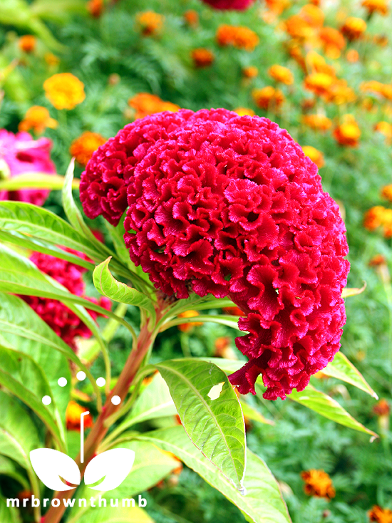

**Figure 1:  *Celosia cristata*, commonly known as Cock’s comb flower.**

**TRADITIONAL METHOD OF COLOR EXTRACTION FROM *CELOSIA CRISTATA***

*C. cristata*is used as a key ingredient in culinary delicacies. The Kashmiri cockscomb flower is bright red in color. Kashmiris have found a unique way of using the flower*,* and that is its use as a natural food colorant in local dishes. This invention dates back to the 14th century when *wazwan* as a cuisine was introduced in Kashmir under Mongolian. It imparts a fiery hot color to gravies, without affecting the taste and aroma of the dish. The decoction is prepared by grinding the dried flowers, extracting the color with warm water and straining to remove any residues. The resulting extract is added directly to the dishes (Figure 2a and 2b).

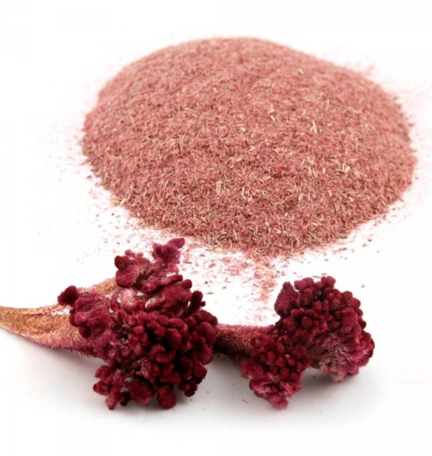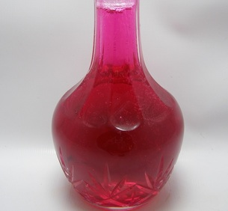

Figure 2 a: Dried flower ground into powder Figure 2 b: Extracted color from Cock's comb flower.

**IV. APPLICATION OF EXTRACTED COLOR FROM *CELOSIA CRISTATA***

The extracted color finds its use in food for enhancing the appearance and the appeal of homemade food and if this traditional knowledge is utilized properly the pigment from cockscomb flower can replace the artificial colors used in processed food preparations. It's not only food coloring bottles that we need to throw away, but also to start to look at the ingredients lists and eliminate artificial additives as much as realistically possible. The color extracted from *C. cristata* can be used in burgers, bakery items, desserts, cake frostings, colored rice, puddings, ice cream, jams, jellies, soups, sauces, sweets, drinks, dairy products and yogurts [20]. Traditionally, the extract is used to color meat gravies (Figure 3).

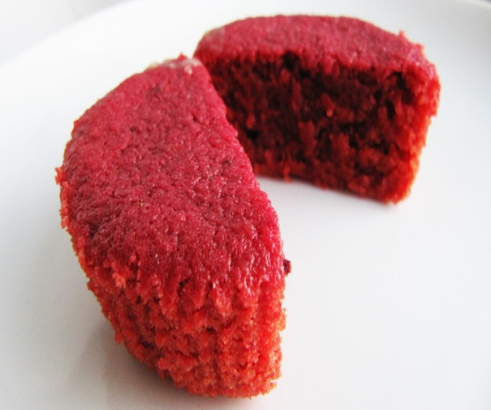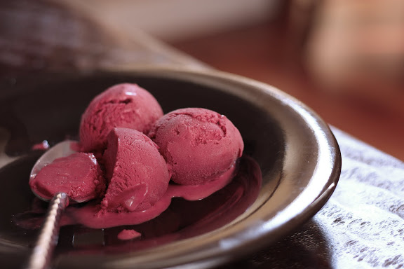

**A red- velvet cake prepared fromice- cream colored with *Celosia cristata* extractthe pigment extracted from**

***Celosia cristata*.**

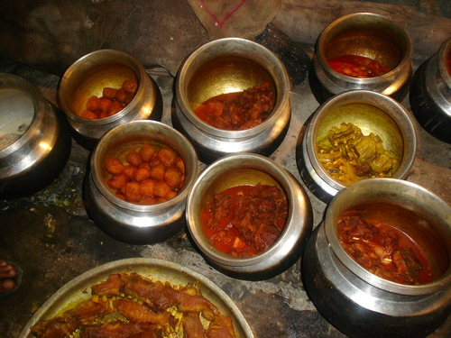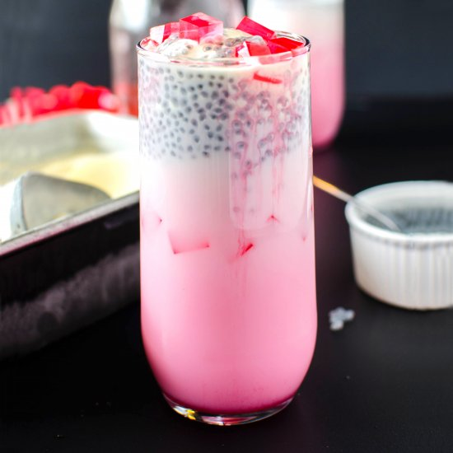

**Use of color extracted from *C. crsitata* in traditional Kashmiri dishes and beverages.**

**Figure 3: Applications of *Celosia cristata* extract in different food products.**

**V. CONCLUSION**

Food colorants constitute a widespread requirement and industrial key to ensureconsumers satisfaction and foodstuffs appealing. Currently, the consumers’ satisfaction is not only reached through optimum organoleptic characteristic of food, but also by its ability to act as longevity promoter and health-improving effects. Linked with this, the interest by consumers for healthy foodstuffs, bioactive ingredients, functional foods, and even “super foods” has been largely observed, up to a point that natural ingredients gained the market leadership, Food industry is increasingly focused on the discovery of effective and safer alternatives to many food additives from synthetic origin, once several side effects, and even the occurrence of short-middle or long terms toxicity has been reported. Overall, betalain pigments and corresponding sources have a promissory potential of application, not only in the food industry, but also for cosmetic, pharmaceutical and nutraceutical purposes.So far there is only one single betalainic source that has been extensively used in food industries worldwide and that is the red beet. To meet the high demands of food industries, there is a need for developing natural food colors from sources other than red beets. *Celosia crisata*, which has relatively high betalain content, has a high potential as a natural food colorant and an alternative beet red color. The unexploited potential can be further explored and the flower can be used to extract the natural colorants at a commercial scale.

**REFERENCES:**

1. Ali A., 2011. Department of fisheries, Behbahan High Educational Complex, Behbahan, Iran.
2. Anna Bakowska-Barczak., 2005. Department of fruit, vegetable and cereal technology, Agricultural University, Wroclaw.
3. Ree E, 2006. Opinion of the Scientific Panel on Food Additives, Flavourings, Processing Aids and Materials in Contact with Food on a request from the Commission related to Lutein for use in foods for particular nutritional uses, The EFSA Journal.
4. Magoulas C., 2009. How color affect food choices?. University of Nevada.
5. Kamel M.M, El-Shishtawy R.M, Yussef B.M and Mashaly H, 2005. Ultrasonic assisted dyeing: III. Dyeing of wool with lac as a natural dye, Dyes Pigments. 65: 103-110.
6. Alavizadeh S. H. and Hosseinzadeh H., 2014. Food Chem. Toxicol.64: 65–80.
7. Rodriguez-Amaya D. B., 2016. Curr. Opin. Food Sci.7: 20–26.
8. Shahid M., Shahid-ul-Islam and Mohammad F., 2013. J. Clean. Prod.53, 310–331
9. Shahid-ul-Islam, Rather L. J. and Mohammad F., 2015. J. Adv. Res.
10. Rymbai H., Sharma R.R., Srivastav M., 2011. International Journal of Pharm tech Research. 3: 2228-2244.Vulić J. J., Cebović T. N., Canadanović V. M., Cetković G. S., Djilas S. M.,.Canadanović-Brunet J. M, Velićanski A. S., Cvetković D. D. and Tumbas V. T., 2013. Food Funct.4: 713–721.
11. Vulić J. J., Cebović T. N., Canadanović V. M., Cetković G. S., Djilas S. M.,.Canadanović-Brunet J. M, Velićanski A. S., Cvetković D. D. and Tumbas V. T., 2013. Food Funct.4: 713–721.
12. Wang C.-Q. and Yang G.-Q., 2010. Phytomedicine. 17, 527–532.
13. Zhang J., Hou X., Ahmad H., Zhang H., Zhang L. and Wang T., 2014. Food Chem., 145: 57–65.
14. Serra A. T., Poejo J., Matias A. A., Bronze M. R. and Duarte C. M. M., 2013. FoodRes. Int. 54: 892–901.
15. Sreekanth D., Arunasree M. K., Roy K. R., Chandramohan Reddy T., Reddy G. V. and Reddanna P., 2007. Phytomedicine. 14: 739–746.
16. Lu X., Wang Y. and Zhang Z., 2009. Eur. J. Pharmacol. 615: 223–227.
17. Azeredo H. M. C., 2009. Int. J. Food Sci. Technol. 44: 2365–2376.
18. Clydesdale, F.M., 1993.Color asafactor infood choice.CriticalRev.FoodSci.Nutr.33:83-101.
19. Rukhsaar Sayeed, and Monika Thakur. 2019. Comparative studies on extraction methods of betalain content and anti-oxidant activity of biocolorant obtained from *Celosia cristata* L. flowers. Medicinal Plants. 11(4): 367-371.
20. Sayeed R, Thakur M and Gani A. 2020. Effect of *Celosia cristata* extract on the quality of flavoured milk during storage. Indian Journal of Agricultural Sciences 90 (3): 569–72, March 2020.