Nutritional Assessment of College Students of NCR Region

Archana Gupta, Prity Pant, Neetu Chaudhary and R. C. Mishra
Department of Agricultural Science, Swami Vivekanand University, Sagar, MP

ABSTRACT
Food is any matter which on consumption gives nutrition to an organism. It gives energy to do work, maintain our body structure and maintain immunity. Various nutrients we get are carbohydrate, protein, fat, vitamins, minerals and water. Nutrition is the study of nutrients in food, how the body uses them, and the correlation between diet, health, and disease. Nutrients give nourishment to the body. There is a relationship between healthy diet and good health especially of college students.
Key words: Food, Nutrients, Diet, Healthy Diet, College Students

INTRODUCTION
Food is a wholesome substance that is eaten, drunk, or else taken into the body to maintain life, give energy, promote growth, etc.
Food is the major source of nutrients for the animal body. We get proteins to maintain our muscular structure; vitamins, to catalyze the physiological processes; and carbohydrates and fats for getting energy. Various researches have revealed that students of every age group are able to learn better if they get good nourishment and eat healthy diet. They have higher grades, improved memory and attentiveness. So, in this research we studied the relationship between healthy diet and good health especially of college students of NCR region.

OBJECTIVES:
- Nutritional assessment of college students through Google form
- Awareness program for the health benefits in their adulthood

REVIEW OF LITERATURE
According to Rae Galloway et al. (2002)1 although malnutrition’s effects on this group have been recognized for decades, there has been little measurable progress in addressing the specific nutritional problems of women and adolescent girls. Ignorance about the symptoms of malnutrition, such as the lethargy and depression caused by iron deficiency, may be dismissed as “normal” or unimportant, further exacerbating the problem.

Malnutrition declines girl’s ability to carry on childbirth, makes them more prone to infections, and leaves them with lesser reserves to improve from illness.

According to Lindsay (2000)2 Anemia affects about 43 percent of women of reproductive age in less developed countries. Women are especially susceptible to iron deficiency and anemia during pregnancy, and about half of all pregnant women in less developed countries are anemic, although rates vary significantly among regions. Fernando E. Viteri (1994)3 explained that iron deficiency and anemia cause fatigue, reduce work capacity, and make people more susceptible to infection. Severe anemia places women at higher risk of death during delivery and the period following childbirth. Majid Ezzati et al. (2002)4 told that recent research suggests that even mild anemia puts women at greater risk of death.

Leslie and Elizabeth (2003)5 wrote that illness associated with nutrient deficiencies have significantly reduced the productivity of women in less developed countries. A recent report from Asia shows that malnutrition reduces human productivity by 10 percent to 15 percent and gross domestic product by 5 percent to 10 percent. By improving the nutrition of adolescent girls and women, nations can reduce health care costs, increase intellectual capacity, and improve adult productivity.

MATERIALS AND METHODS
A research study was conducted on college going students between the ages of 17-24 years. This was an anonymous survey. Contact information or name was not be collected of the participants of survey. Different questions were asked. The responses of the participants were strictly confidential, and these were used only for statistical analysis. There was be no loss of benefits on withdrawal but surely would help in improving the health of the participants. Participation was completely voluntary. Survey was done with the following Google Form.

Swami Vivekananda University, Sagar, MP is conducting a research study on college going student between the ages of17-24 years.
- This is an anonymous survey - we are not collecting your contact information or name.
- In this survey, you will be asked different questions. Your responses will be strictly confidential, and it will be used only for statistical analysis.
- There is no loss of benefits on withdrawal but surely it will help in improving your health.
- Participation is completely voluntary.

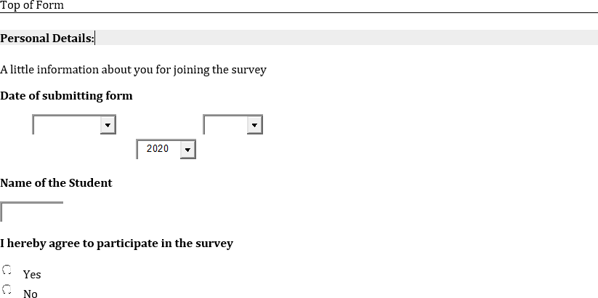
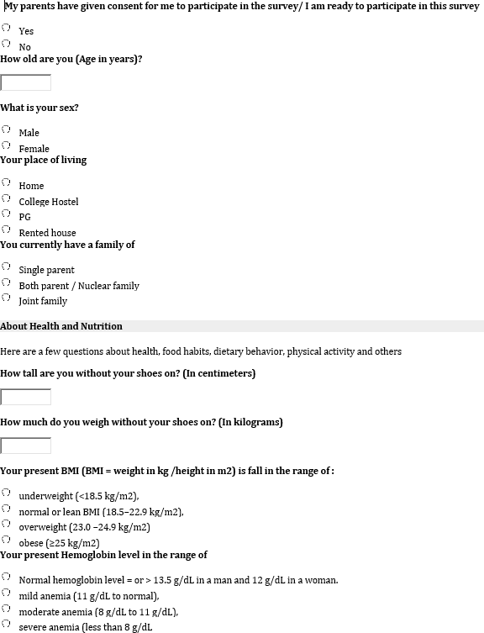

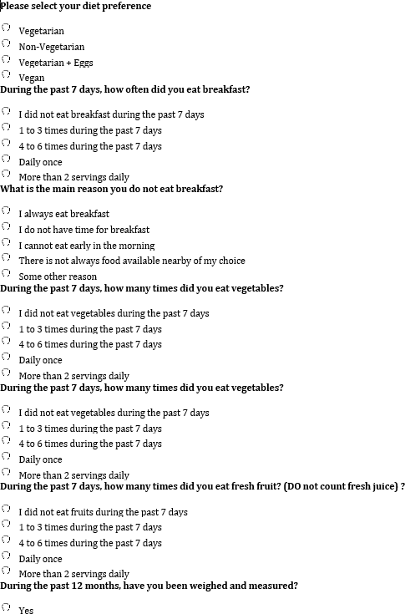

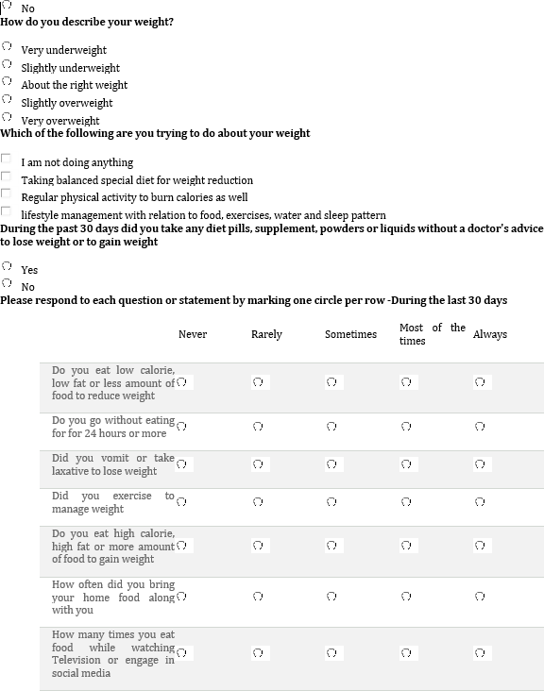

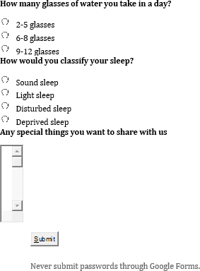

RESULT AND DISCUSSION

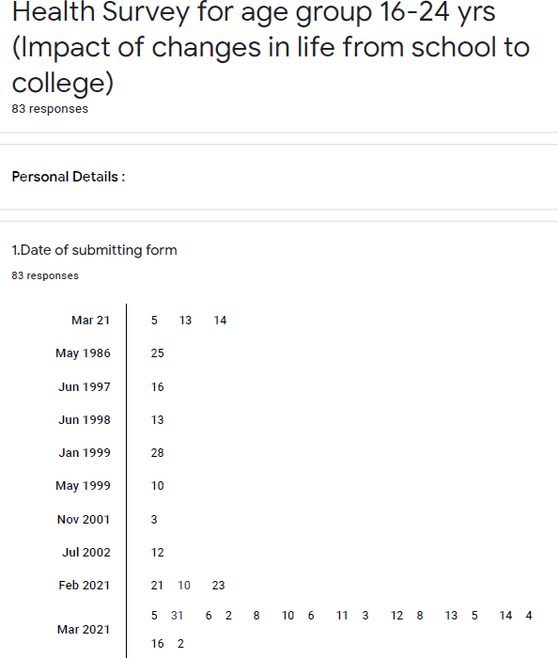

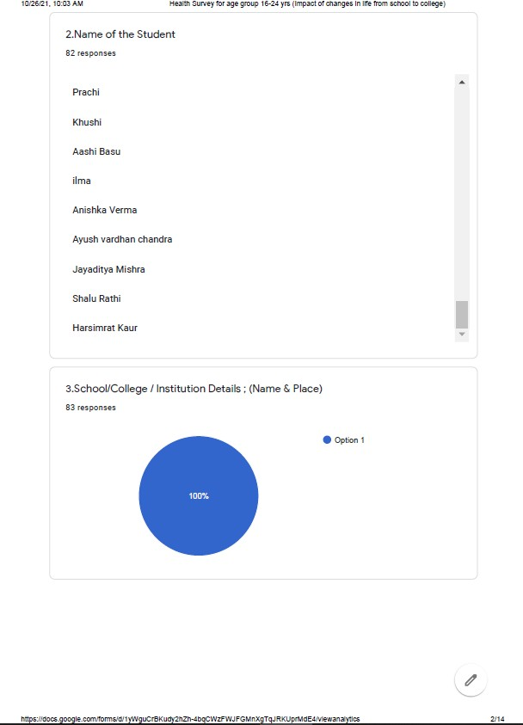

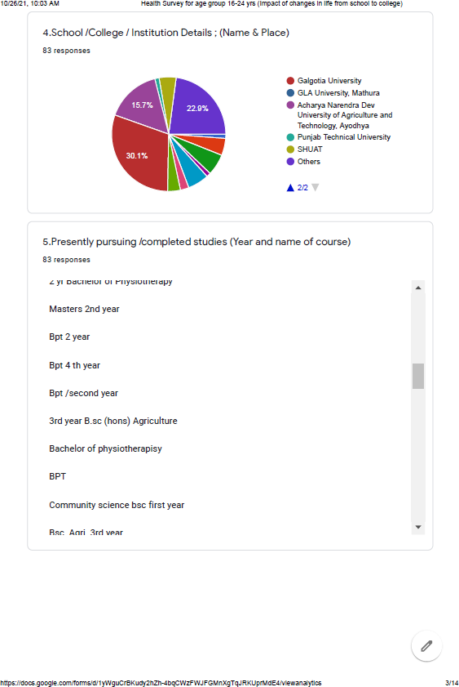

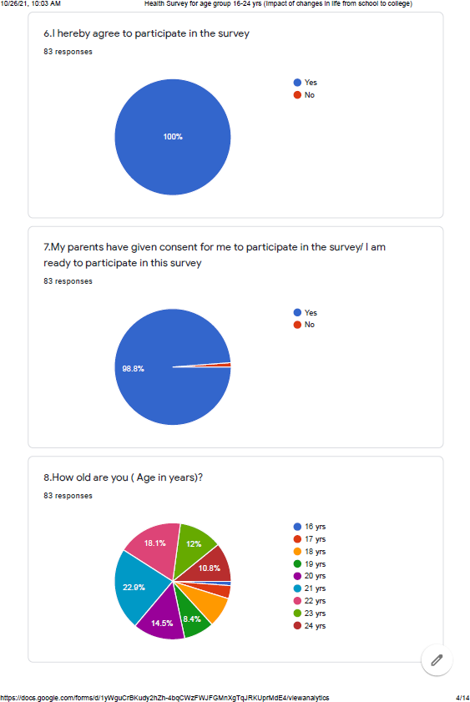

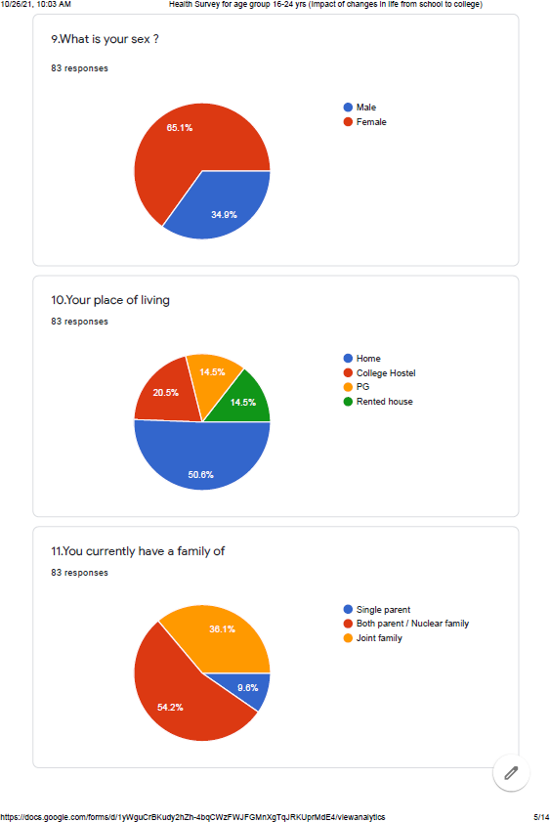

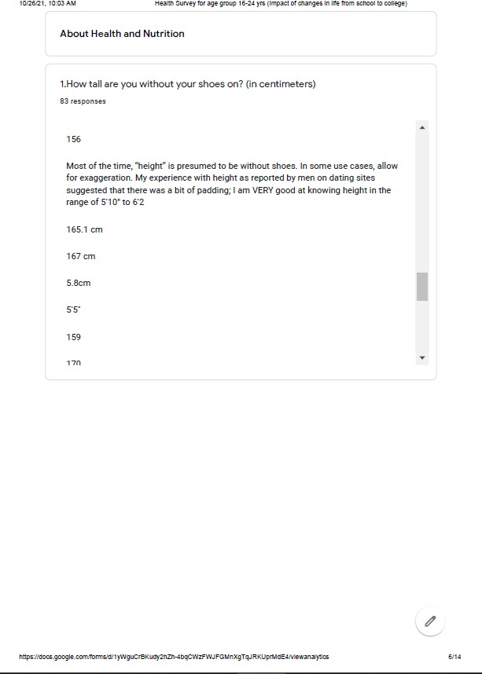

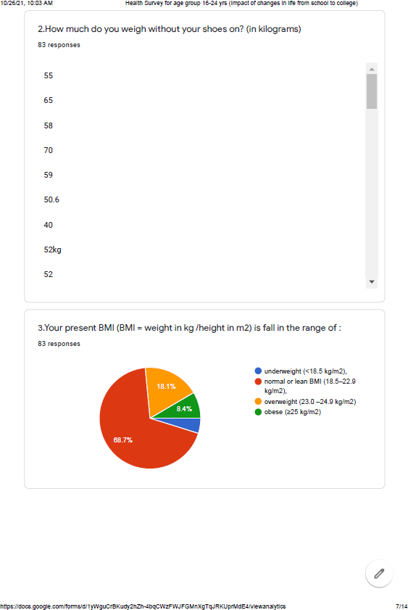

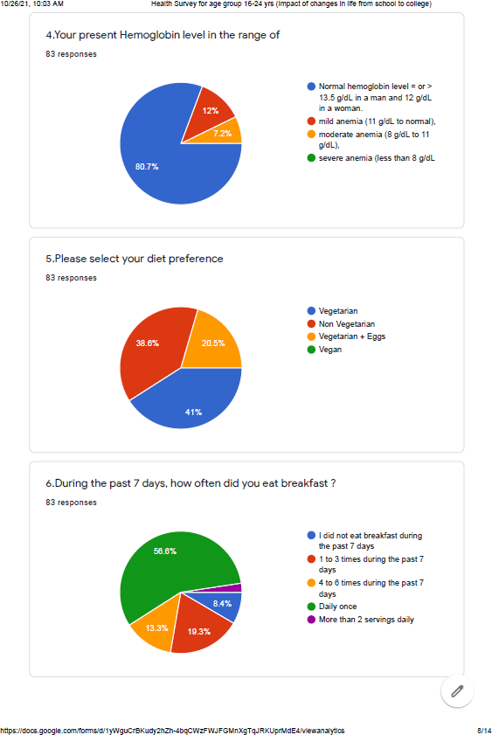

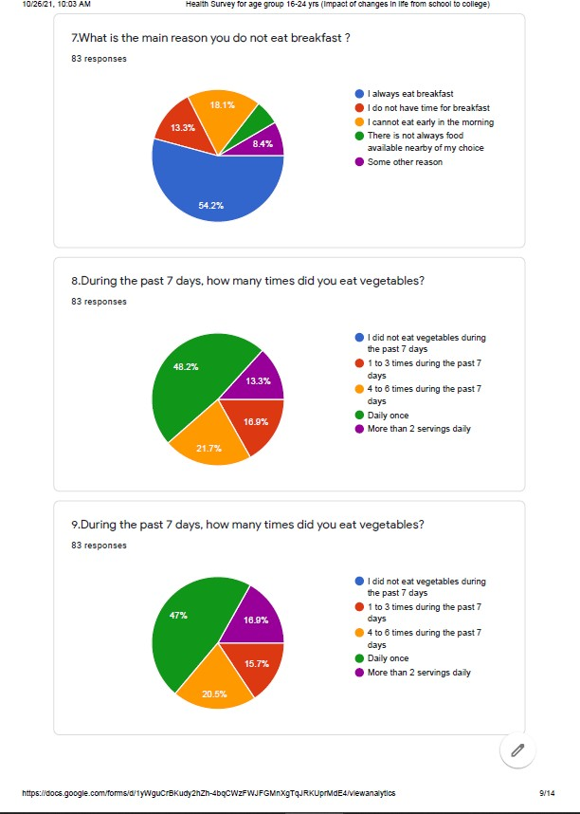

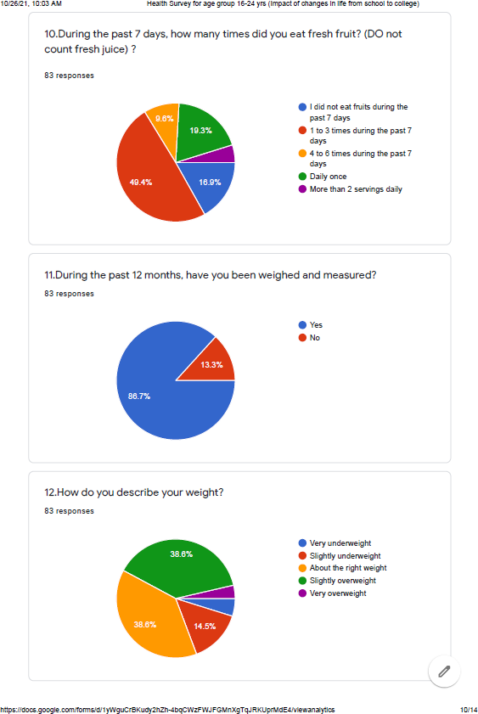

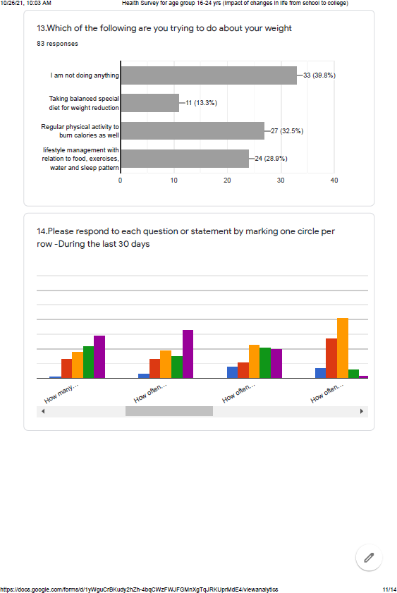

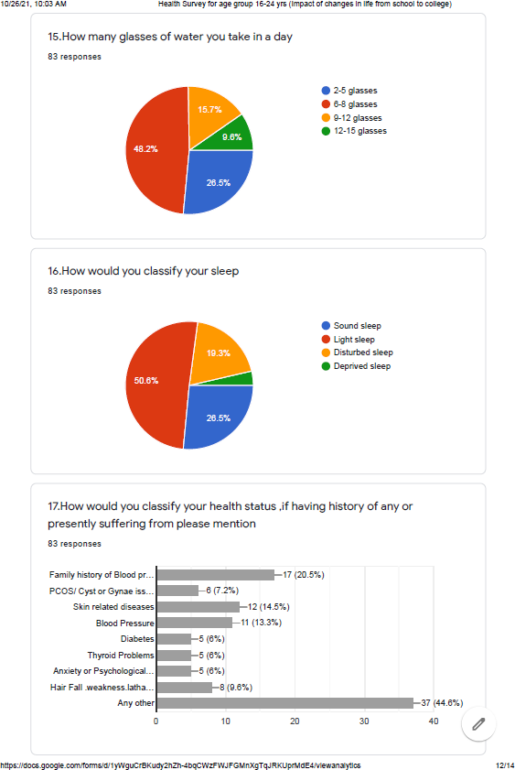

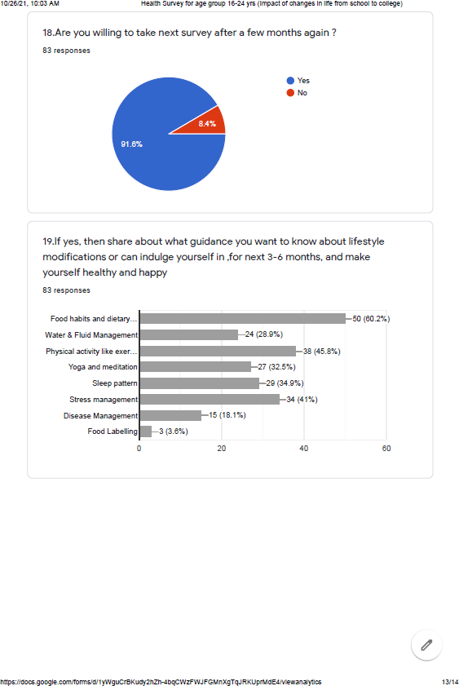

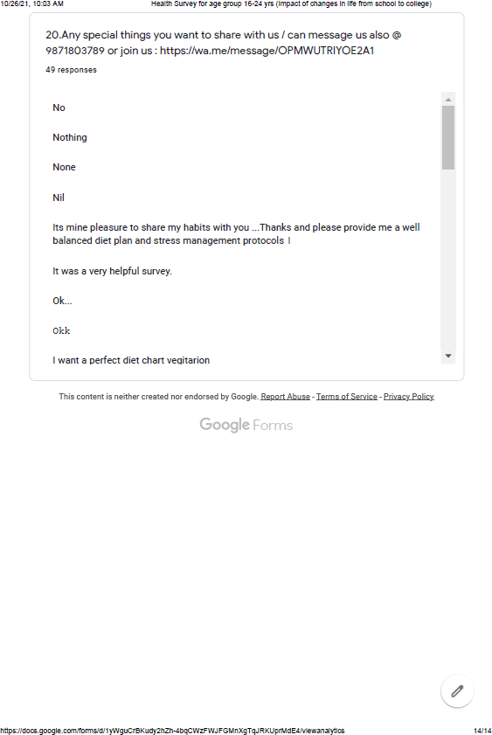

Following is a summary of the conclusions from the conducted survey:

- 65.1% females participated in the surveillance. 50.8% participants are living in home and rest of the students are living outside home in hostel, rented house etc. effecting the effecting the lifestyle and health. A few students around 9.6% are from single parenting and 54.2% of them from nuclear family and rest are from joint family.
- It’s really a great thing that college students are concerned about their weight and 68.7% fall into the range of normal BMI, rest are under malnutrition range ,weather underweight, overweight or obese.
- 12% amongst students are mild anaemic having range of 11-13.5 g/dl and 7.2 % fall into the range of 8- 11 g/dl moderately anaemic.
- Only 41% students have vegetarian food choices in comparison of 38.6% non-vegetarian and 20.5% taking eggs.
- 8.4% students are starting their days without having breakfast and even 19.3% are taking only once or thrice in a week, while only 56.6% are having their breakfast on daily basis definitely going to affect their health in future.
- Around 46% are not having their breakfast because of many reasons like, lack of time, availability of food and early morning busy schedule.
- Only 13.3% students are having two serving of vegetables daily , rest of the students are taking only ones even 16.9% are taking vegetables in their diet only 1-3 days in a week.
- 16.9% students are not taking fruits a very important food group in their diet and 49.4% only taking sparingly in their routine, only 19.3% are taking fruits on daily basis in their diet.
- 86.7% students have checked their weight during last one year of their life means they are concern of their health and weight.
- 39.8% students are not doing anything to maintain their weight and health while 32.5% are physically active ,28.8% are trying to manage their lifestyle with relation to food, water, physical activity and sleep, only 13.3% are focusing on balancing caloric intake to manage their weight.
- 18% of the students never eat low fat diet to reduce weight, only 7% takes low calorie, low fat food to reduce their weight and 31% sometimes takes these types of diet for weight reduction.
- A positive note that only a few students around 10% miss their meals in 24 hours though it’s a not good
sign for their future health.
- Only 8% students take high fat high calorie food to gain weight and 22 % sometimes take high fat diet,
though rest of them don’t take high fat food for weight gain purpose.
- If we talk about the hygiene practice of washing hands before taking food only 28% always wash their hands with soap, 22% most of the time wash. Rest of them are washing sometimes or missed these hygiene practice.
- Only 33% students take their breakfast on regular basis and 15% most of the times, and rest of them are missing their breakfast and 3% even never have their breakfast a very important meal of the day.
- 41% students bring home made healthy lunch along with themselves for proper nourishment, 23% students sometimes carry their lunch and around 19% never had homemade lunch even missing their lunch as well.
- Around 8-20% take processed or packed lunch from their canteen or outside eateries.
- Only a 2-4% take food supplement to compensate their lack of nourishment for maintaining health.
- 7% students always indulge in watching Television or mobile, 16% most of the times while 31% sometimes watching media and not doing mindful eating. 11% of the students never enjoy physical activity to burn calories and 17% are rarely active ,24% are sometimes active as per their choice to make themselves healthy and active.
- Only 21% students are involved in yoga, meditation or any other relaxing activities to release their stress.
- 12% of students having soft drinks on regular basis, 27% sometimes and rest of them takes rarely. 46% students never take hard drinks and 20% have it rarely, only 9% takes them on regular basis. 26.5% drink only 2-5 glasses of water in a day, while 48.2% drinks 6-8 glasses only ,rest of them have sufficient water intake from 9-15 glasses as per their demand.
- Only 26.5% students take sound sleep, rest of them having light sleep or disturbed sleep and even deprived sleep.
- In this study we have found that 20.5% students are from family history of lifestyle diseases like blood pressure and diabetes.7.2% girls are suffering from PCOS/PCOD or gynaecological issues. 14.5% having skin related issues that may be because of hormones, food habits, water intake or stress. 13.3% students are suffering from Blood pressure at this younger stage of their life,6% are having diabetes, thyroid issues an psychological disorders and 44% are having many others health related issues going to add on burden on our growth of the nation.
- 91.8% students are willing to fill the survey again after sessions and experiencing the benefits of lifestyle management preventive measures taken by them with the guidance of their nutritionist or health consultant.
- Amongst all these students 60.2% interested in lifestyle modification through food habits and dietary modification guidance, 28.9% also want to know about the importance of water and fluid management in body. 45.8% are interested in lifestyle modification through physical activity involvement by exercises, dance or outdoor activities while 32.5% are interested in yoga and meditation. 34.9% are interested in improving their sleep pattern and 42% in stress management while 18.1% are interested in disease management as well.
After this surveillance study we get to know about the lifestyle pattern of these college students in NCR region and planned to implement preventive measures into their life of young generation for healthy living nation.

REFERENCES
- Rae Galloway et al., “Women’s Perceptions of Iron Deficiency and Anemia Prevention and Control in Eight Developing Countries,” Social Science & Medicine 55, no. 4 (2002): 529-44.
- Lindsay H. Allen, “Anemia and Iron Deficiency: Effects on Pregnancy Outcomes,” American Journal of Clinical Nutrition 71, no. 5 suppl. (2000): 1280S-84S.
- Fernando E. Viteri, “The Consequences of Iron Deficiency and Anemia in Pregnancy,” in Nutrient Regulation During Pregnancy, Lactation, and Infant Growth, ed. Lindsay Allen et al. (New York: Plenum Press, 1994): 127-40.
- Majid Ezzati et al., “Selected Major Risk Factors and Global and Regional Disease,” The Lancet 360, no. 9343 (2002): 1347-60.
- Elder and Elizabeth Ransom (2003); Nutrition of Women and Adolescent Girls: Why It Matters. https://www.prb.org/nutritionofwomenandadolescentgirlswhyitmatters/

