ASSESSMENT OF NUTRITIONAL STATUS OF ADOLESCENT GIRLS RESIDING IN ODANADI ORPHANAGE
Nandini. S*, Anitha C**, Rajeshwari J***
*Student and **Assistant Professor,
Department of Studies in Food Sceince and Nutrition,
Karnataka State Open University, Mysuru, Karnataka, India
Email: anithaksou@gmail.com
***Associate Professor and HOD,
Department of Home Science (Food Science & Nutrition),
Maharani’s science college for Women (Autonomous), Mysuru. Karnataka, India.
Email: rajeshwarimscwm@gmail.com

ABSTRACT
Adolescents experience dramatic physical growth and development during puberty, which in turn appreciably increases their requirements for energy, protein, and many vitamins and minerals. The increased need for nutrients among adolescents, combined with increasing need for autonomy when making food choices, place adolescents at nutritional risk. Good dietary habits during adolescence is important as body needs more nutrients to meet the requirement of growth spurt. Better nutritional knowledge will help them to make better choices favouring to meet the requirement of all essential nutrients. Since, malnutrition increases health care costs and reduces productivity it is essential that everyone is aware of importance of balanced nutrition. Hence the present study was taken up to understand the nutrition and health status of adolescent girls.
Objective: The objective of the investigation was to assess the nutritional status of adolescent girls residing in Odanadi orphanage in Mysore.
Methodology: The investigation was conducted on a total of 60 adolescent girls who were in the age group of 12-16 years, from Odanadi orphanage in Mysore. Data were collected on somatic status, dietary intake and hemoglobin status by standard techniques. BMI was computed from weight and height data. Academic scores were obtained from the schools.
Results: the results obtained showed that 87% of the study population were in mild grades of malnutrition. Majority of the subjects (80.8%) were found to have low hemoglobin status, mild to moderate anemic. Nutrition education was not satisfactory and their academic performance was below average.
Conclusion: The present study reflected the low nutritional status of adolescent girls had a impact on their academic performance. It was found that higher proportions of adolescent girls were undernourished. This indicates that adolescents in urban slums need health awareness and importance of nutrition to maintain nutritional status.
Keywords: Adolescent girls, orphanage, nutritional status, anemia, academic performance.

INTRODUCTION

Adolescence is derived from Latin word adolescere which means ‘to grow up'. World Health Organization (WHO) defines adolescence as the section of people between the ages of 10-19 years. Adolescence is a transitional period between childhood and adulthood, which begins from the earliest signs of secondary sexual characteristics development and ends when a person has achieved adult status (WHO, 1995). According to Marriam and Webster, it is an important stage of development where physical and physiological development occurs. Adolescent's health and well-being are crucial because they are tomorrow's adult population. During infancy, childhood and adolescence nutrition play a critical role in influencing growth and development. But the nutrient needs are highest during the period of adolescence (Lifshitz et al, 1993). Over many years less importance was given to the research of adolescents as they were considered less prone to life-threatening diseases when compared to children and elderly So, then it is considered a period where they are less prone to diseases and have good health (Senderowitz 1995). Both developed and developing countries show similar Mortality and morbidity trends among adolescents (Blum 1991; Maddaleno and Silber, 1993). After infancy, adolescence is the stage where the vigorous physical growth takes place, which is due to the hormonal changes in the body resulting in cognitive, and emotional changes that make adolescence an especially vulnerable period of life. Hence Nutrition plays an important role during these stages, nutritional deficiencies can have a permanent impact on an adolescent's cognitive development, resulting in decreased learning ability, poor concentration, and impaired academic performance. Well-nourished adolescents can make maximum utilization of their skills, talents, and energies. Healthy adolescents can be healthy adults’ tomorrow. One of the third most common chronic illnesses among females is the eating disorder which varies from 1.5% to 5%. over the past three decades’ occurrence of eating disorders is increasing. Though eating disorders occur among both the genders occurrence is diagnosed more in females than males. Inadequate nutrition in adolescence can potentially retard growth and sexual maturation, and can put them at high risk of chronic diseases particularly if combined with another adverse lifestyle behaviors. The problem of malnutrition received recognition from planners and policymakers right from the inception of five-year planning; a large number of national nutritional programs were implemented to combat the menace of malnutrition. However, malnutrition persists (J. P.Singh et al. 2014).
Adolescents have received low priority because adolescents are comparatively healthy compared with other life cycle groups. Adolescence is a stage that brings specific challenges for treating diseases and promoting health. According to the World Health Organization (WHO), the South East Asian Region has a large number of adolescents, constituting 20% of the population in these countries. They mostly suffer from malnutrition and anaemia, which adversely impacts their health and development, and an anthropometry is a good tool for measuring nutritional status and health risks among this group. Since adolescent nutrition in India is receiving minimal attention at this moment, there is a need for nutritional interventions for improving adolescent nutrition These findings have future inferences (NFHS-5) so that vital statistics of the nutritional status of adolescents and nutrition transition among the population is neither concealed in the adult data nor does it influence adult means
inappropriately (Madhavi Bhargava et al 2020). It was found that there were macro and micronutrient deficiencies (Mrigrn Deka, et al 2015). According to them, a high prevalence of malnutrition occurs among Adolescence who are more vulnerable, it is essential to give priority to national health programs (Mohammad Atif, et al 2016). Anaemia is highly prevalent among adolescent girls and there is a need to intensify efforts at all levels to reduce the prevalence of anaemia (Poyyamozhi JS, et al 2018). Hence this study was under taken as need based.
OBJECTIVES.
- To assess the nutritional status of adolescent girls
- To determine the haemoglobin status of adolescent girls.
- To detect any clinical signs and symptoms for nutritional deficiency.
MATERIAL SELECTION
The locale for the study was Mysore District, Karnataka. The data was collected from Odandi Orphanage from Mysore city. A study population of 60 orphan adolescent girls between the age group of 12-16 years residing in Odandi Orphanage were selected for the present study.
Study techniques:
Anthropometric measurements were recorded according to the standard techniques. Body weight, height, MUAC, Waist and hip ration were the major measurements considered for the study. Hemoglobin concentration was estimated with the help of pathology laboratory. Information related to the nutrition knowledge of subjects was also determined using a separate questionnaire. In designing questionnaire simple local language was used. A total score of 25 was allotted for assessing the knowledge. The description of the score is as follows; 1-5; poor, 6-10; satisfactory. 11- 15; good, 16-20; very good. 21-25; excellent.
Statistical analysis: The obtained data was compiled and was utilized for computing mean and SD. Further the data was also subjected to t-test to know the significant differences using excel stat software version 14.

CONCEPTUAL FRAME WORK

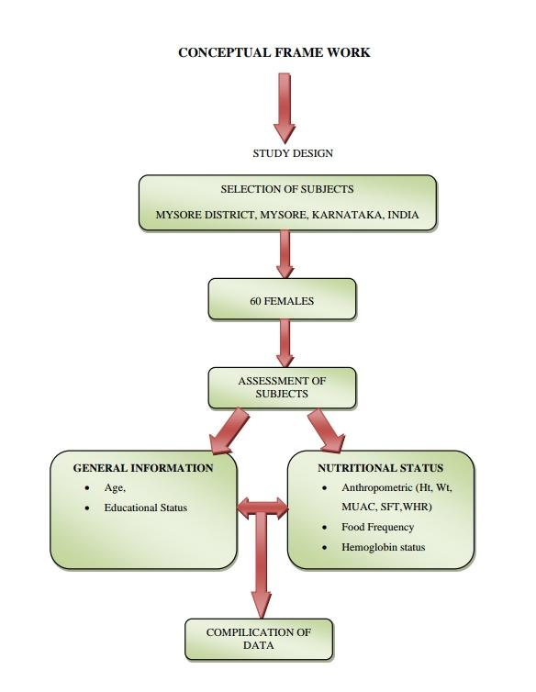

RESULTS AND DISCUSSION
Fig.1: DISTRIBUTION OF STUDY POPULATION WITH RESPECTIVE TO THEIR AGE
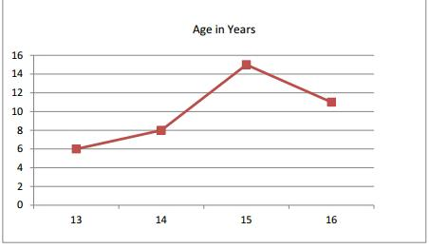

Fig. 1 details about the study population according to age as 15%, 20%, 37.5% and 27.5% in the age of13, 14, 15 and 16 years respectively.

Table 1: SUBJECTIVE CHARACTERISTICS
CHARACTERISTICS |  | Percentage  ( %)
Religion | Hindu | 62.5
 | Muslim | 22.5
 | Christian | 15.0
Education Level | 8th | 27.5
 | 9th | 32.5
 | 10th | 40.0

According to table1 62.5 % of the study group were Hindus, followed by 22.5% Muslims and 15% Christans. The girls were studying in high school 40% of them were in 10th standard, 32.5 % doing their 9th standard, while 27.5% of the girls were learning in 8th standard.

Table 2: ANTHROPOMETRIC MEASUREMENTS
Age | Height cm | Weight kg | BMI kg /mt²
13 | 133.7±6.4 | 26.7±1.6 | 14.9±1.2
14 | 147.8±8.4 | 37.6±4.9 | 17.1±1.2
15 | 155.7±7.0 | 47.1±4.1 | 19.6±1.5
16 | 158.2±9.7 | 49.5±4.5 | 19.8±2.7

From the table 2 it is very much evident that 87% of the girls between the age group of 13 to 14 years were malnourished with Body mass index less than 18.5, while girls of age 15 and 16 years were in the lower level of normal body mass index.

Fig.2: GRAPH SHOWING FACTOR LOADING FOR THE INDICES OF BODY MASS AMONG THE STUDY POPULATION
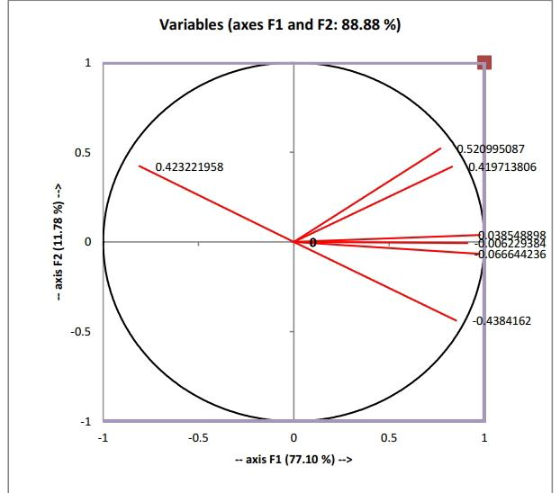

At the level of significance Alpha=0.050, the Pearson correlation between variables (age, height. Weight, and BMI) is significant i.e P= 0.001.
Figure 2 gives a clear fact about the significance correlation between age, height. Weight, and BMI of the study population (p value=0.001). This shows that the study population were malnourished and suffering from mild to moderate grades of malnourishment. Similar results were obtained by others studies.

Table 3: HEMOGLOBIN ESTIMATION OF THE STUDY POPULATION
AGE IN YEARS | HEMOGLOBIN gm/DL  Mean ±SD
13 | 10.1 ± 1.8
14 | 10.9 ± 1.6
15 | 9.7 ± 1.6
16 | 9.9 ± 1.6

As per table 3 hemoglobin status among the study group was blow the normal level recommended by WHO. It is evident that the girls suffered from mild to moderate anaemia. Similar results were recorded from studies emphasizing that there is a serious need for counseling the adolescent girls and for nutrition intervention. These results obtained were supported by the clinical signs and symptoms of the study population as 72.5% of them showed pale face, 38.3% with dry hair indicating micro nutrient deficiency, 68% with pale eye and nails showing iron deficiency anaemia.

Table 4: NUTRITIONAL KNOWLEDGE AMONG STUDY POPULATION
Nutritional knowledge | Know | Don't Know | P value
Over all nutrition knowledge | 36 | 64 | P = 0.050  Significant
knowledge about iron rich foods | 26 | 14
Understanding Importance of iron rich foods | 3 | 37
Understanding Effect of iron rich foods | 2 | 38

It was noteworthy observation indicated in table 4 about the nutrition knowledge by the study population. It was observed that only 36% of them had a fair knowledge about nutrition and its consequence and 64% of them did not have any knowledge about any nutrient. This again was a supportive factor for their nutritional status.

TABLE 5: ACADEMIC PERFORMANCE OF THE SUBJECTS

Age in years | very poor | poor | average | excellent | Chi square  Value
 | less than 34 | more than 35 | more than 51 | more than 71 | = 5.83  Df = 9  P = 0.757
13 | 0 | 3 | 5 | 0
14 | 1 | 2 | 6 | 2
15 | 1 | 2 | 8 | 2
16 | 0 | 3 | 5 | 0

Attempt was made to further understand if there was an impact of the study population nutritional status with that of their academic performance. It was again noteworthy that there was a significant correlation between the nutritional status and their academic performance (p value <0.001). Academic performance of 92% of them were between very poor to average. Thus emphasizing that the nutrition has signiﬁcant impact on the academic performance of students.
Conclusion: Adolescent's health and well-being are crucial because they are tomorrow's adult population. During infancy, childhood and adolescence nutrition play a critical role in influencing growth and development. But the nutrient needs are highest during the period of adolescence. It was found that higher proportions of adolescent girls were undernourished. This indicates that adolescents in urban slums need health awareness and importance of nutrition to maintain nutritional status. Effective implementation of government programs program will be a paradigm shift from the existing clinic-based services to promotion and prevention and reaching adolescents in their environment, such as in schools and communities. Skills-based nutrition education and routine health assessment of school-going girls should be done.

REFERENCES
- Madhavi Bhargava ,Anurag Bhargava,Sudeep D. Ghate,R. Shyama Prasad Rao,
Nutritional status of Indian adolescents (15-19 years) from National Family Health
Surveys 3 and 4: Revised estimates using WHO 2007 Growth reference, Published:
June 22, 2020.
- Dasgupta, A., Butt, A., Saha, T.K., Basu, G., Chattopadhyay, A and Mukherjee A. Assessment of malnutrition among adolescents: Can BMI be replaced by MUAC. Indian Journal of Medicine, 2010, 35, (2), 276-279.
- Sharja Phulijhele, Shashikant Dewangan, Anu, Assessment of the nutritional status of adolescent girls aged between 15 to 18 years studying in government high school in Raipur, Chhattisgarh, India, Inenational Journal of Pediartrics Research, vol. 8. No 2 , 2021, DOI: https://doi.org/10.17511/ijpr.2021.i02.06
- Pauline Sharmila , R. Sree Raja Kumar, Correlation between Prevalence of Anemia and Body Mass Index among Adolescent Girls, International Journal of Science and Research (IJSR), 2015, Paper ID: 4111703
- Divya Rani, Jitendra Kumar Singh, Mona Srivastava, Pragya Verma, Deepali Srivastava, S. P. Singh, Assessment of Nutritional Status of Teenage Adolescent Girls in Urban Slum of Varanasi, International Journal of Current Research and Review Research Article, | Vol 10 • Issue 20 • October 2018 , DOI: http://dx.doi.org/10.31782/IJCRR.2018.10202
- Sulakshana S Baliga, Vijaya A Naik, Mallapur M D, Assessment of nutritional status of adolescent girls residing in rural area of Belagavi, International Journal of Medical Science and Public Health | 2017 | Vol 6 | Issue 2 3.
- Darakhshan Saiyadain, Seema Jain, Sunil Kumar Garg, Harivansh Chopra, Impact of Nutritional Status On Academic Performance Among School-Going Adolescents of Rural Meerut, May 2020, International Journal of Scientific Research 9(5):1-3
- Pratibha Singh, Shalu, Shikha and Rita Singh Raghuvanshi, Effect of nutrition education programme on adolescents girls in Uttarakhand state, International, Journal of Home Science 2019; 5(1): 34-36.

