Integrating Aadhar Biometrics with IoT for the Purpose of Search and Investigation

Rohit Goyal¹, Prof. Rakesh Ranjan², Dr. Manish Pandey³

¹Research Scholar, Himgiri Zee University, Dehradun, India
²Vice Chancellor, Himgiri Zee University, Dehradun, India
³Professor and Dean, Himaliyaya University, Dehradun, India

Abstract
In this era of ever updating technologies in this digital world searching and investigations are big issues for forensic and criminal investigation. Out of many Eye biometrics, Aadhar Card in India depends upon the Iris Scanner for the purpose of Unique Identification in addition with other factors such as fingerprints and face scan. Iris Scanner uses infrared light for the purpose of identity detection. We propose a system in which Infrared cameras are integrated with Internet of Things (IoT) sensors and AI tools for the purpose of searching lost people all around the nation and also which would help greatly in the investigation of criminal cases. Aadhar database would be intertwined with this integrated server system and purpose required may be achieved. Further experimental approach to test the hypothesis will be validation of proposed model. When validated it would be a foolproof and improved technology of identification and search.
Keywords – Aadhar, Iris scanner, IoT sensors, AI, Identification

Introduction

Human beings are blessed with several features one of them is uniqueness. They used this feature only to recognize each other from starting. Biometrics is the similar methodology; it is basically the identification of human beings through their biological features which are totally unique to them. Biometric is basically a pattern recognition which is attained from bodily features of the person. This system basically operates in two modes: Verification Mode and Identification Mode. In former mode the system validates a person’s identity by comparing captured biometrics data of the person itself. However in latter mode a person’s identity is checked from the universal database itself.[1-5]
Following physiological features qualify to become suitable for Biometrics:

- Uniqueness
- Distinctiveness
- Permanence
- Performance
- Acceptability
- Collectability
- Circumvention

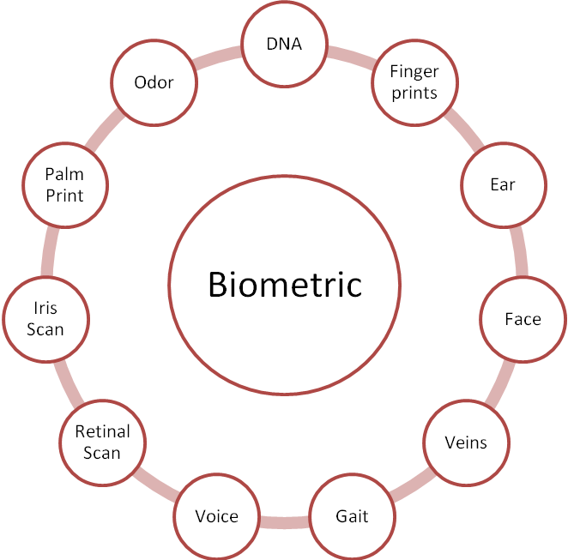

Figure 1: Kinds of Biometrics

  - IRIS SCAN: Iris is the annular region of an eye which is bounded by the sclera i.e. the white part of the eye and the Pupil. The texture of the IRIS is formed during the fetal development and takes a stable form during first two years of life. For the purpose of personal recognition or identification the texture of an Iris carries very distinctive information, which can be used also due to its complexity and uniqueness. Iris based recognition system are now widely been used due to its speed and accuracy. Iris based recognition system points to the feasibility of large scale system of Identification, also it also proven to be promising mode of Biometric Identification. Same as fingerprints, Iris Texture is also unique for an individual; even twins do not have the same texture of Iris. It is almost impossible to tamper the Iris Texture surgically. Newer systems of iris based identification/recognition system are now much cheaper as compared to earlier days.[6-9]
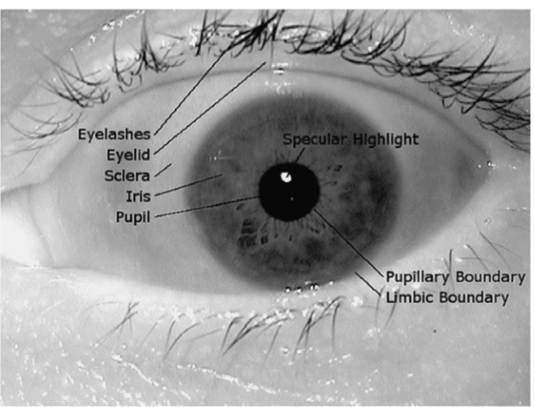

Figure 2 : Example of Iris Scan

Adhaar and Internet of things:

The main objective of Aadhaar program was to provide Universal identification to every Indian resident. This program also aimed to reduce the corruption because each individual carries his own unique number. Soon after the launch of Aadhar card government made it clear that everyone must get it issued. It is also mandatory document when various government schemes are considered. There are various benefits of Aadhar such as direct benefit transfer of LPG subsidy, Jana Dhan Yojana, passport in 10 days, digital locker, monthly pension, common booking up to 12 tickets in IRCTC website in a month by Linking Aadhaar.
There are various fields researches have tapped as the benefit of Aadhar Card program. However there are several more areas on which researches have not yet focused upon. Aadhar Card being the universal identification system for being used in various other ways such as finding lost people, investigation of a crime scene, capturing the criminals. However on June 22nd 2018 UIDAI specified that use of Aadhaar biometric data for investigating crime is not allowed under the law. This is section 29 of the Aadhaar act 2016. UIDAI so specified that under section 33 of Aadhaar act permitted to use or have access to Aadhaar biometric data in the cases involving national security only after pre-authorization by an oversight committee headed by Cabinet Secretary.

However we must get assured that this may not be allowed for investigating the crime, but can be used for finding the lost person or any other criminal. [10- 17]

Statement of Problem

In this research paper we have lighted upon the issue of people who are lost. We have observed occasionally that there are several advertisements about people who are lost and got separated from their family and their circle. There may have several causes such as getting kidnapped, being dead, getting into some difficult situations and getting disconnected. Family members and circle members try their best to find their lost ones but seldom get the results. Aadhar hereby gives us an opportunity in prviding great releive to these people. Aadhar being universally connected and being a widespread network can be of great help in the purpose of finding these lost people.

Proposed Solution

We propose a system which is the combination of internet of things, artificial intelligence, Aadhar biometric system and infrared scanner system of Iris biometric. We have imagined a system in which there would be infrared beam spread all over the country whose purpose basically would be the Iris Recognition of a person. These infrared beams would be connected to the internet of things and its process would be managed through Artificial Intelligence and machine networks. This hardware and software combination would be connected to the Aadhaar database.
Let us consider a situation in which family member comes to the authorities with the plea to find his lost one in Uttar Pradesh. Authorities after considering and analyzing the situation proceeds a request to this system. The system being spread throughout the country would help the authorities to find out the lost one quickly and more efficiently. Let us suppose that lost person was found in Tamil Nadu railway station. The infrared beams to detect the Iris of people sends the signal through Network of Artificial Intelligence and internet of things to the database of Aadhar gets verified and message to Uttar Pradesh authorities that required person is located.
Overall system communication is been depicted pictorially in figure 3
Further in figure 4 we have depicted the combined system of Artificial Intelligence + Internet of Things + Infrared Beam (Iris Recognition) + Aadhar Database for the purpose of recognition of lost person and locating the one.

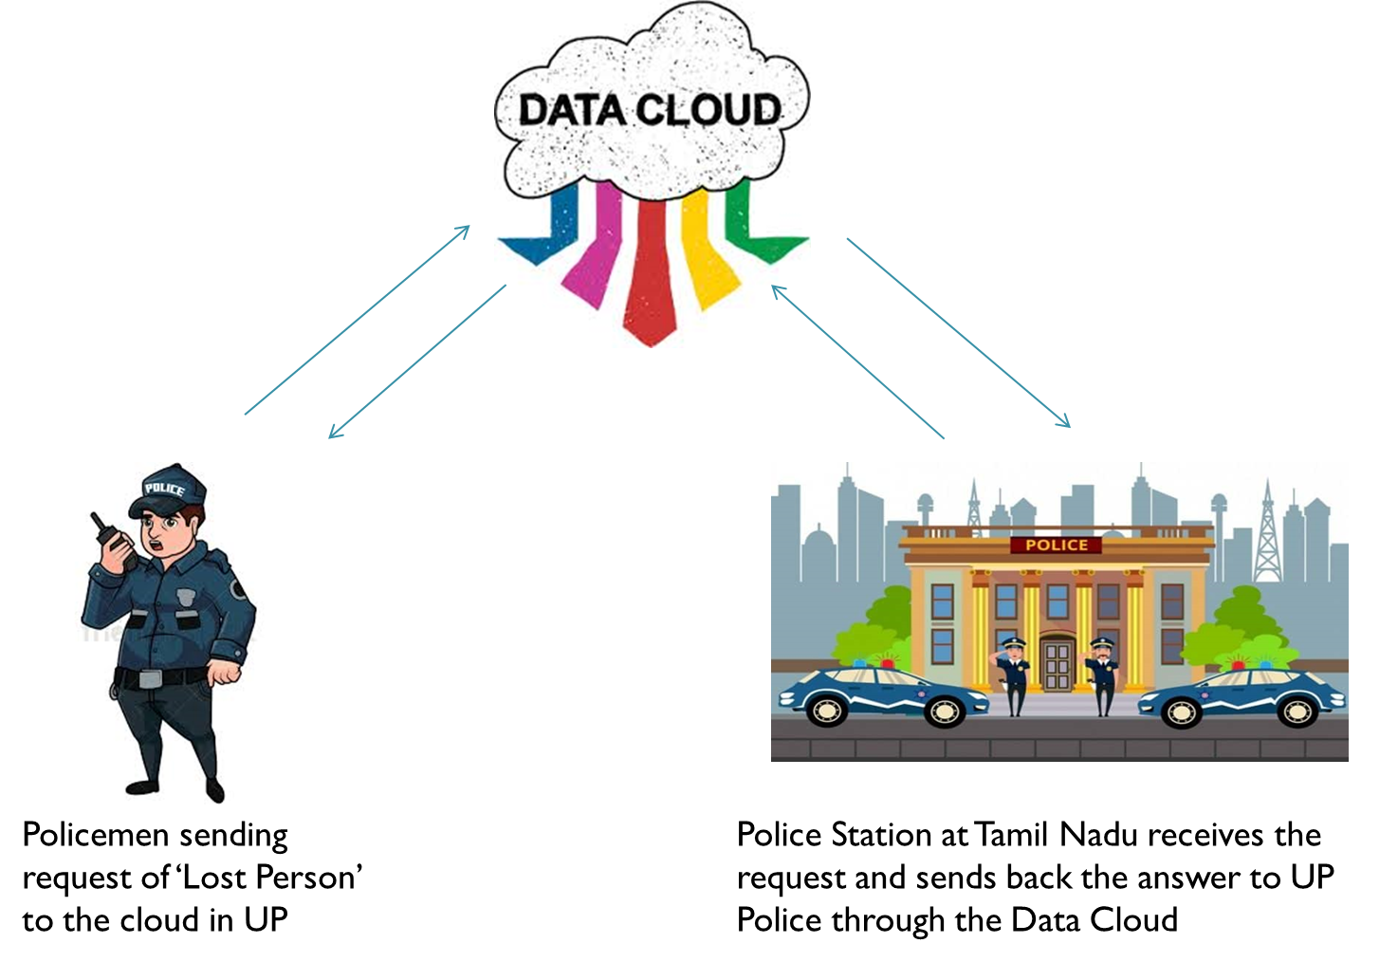

Figure 3: An Example depicting how overall system will work
Figure 3 represents overall functioning which is external request and response feature of the system. This is the communication between two authorities namely, where a person is lost and where a person would be found. These authorities which are spread vast geographically are connected through cloud dedicated for the one purpose ‘Lost and Found Cloud’.
Figure 2 represents the on the spot working of the system, in which Infrared beam combined with IoT sensor, detects the Iris Biometric of the lost person and validates its result with Aadhar database. If verified this sensor gives report to the ‘Lost and Found Cloud’. Further this cloud gives relevant information about recognition and location to the authorities.[17-25]
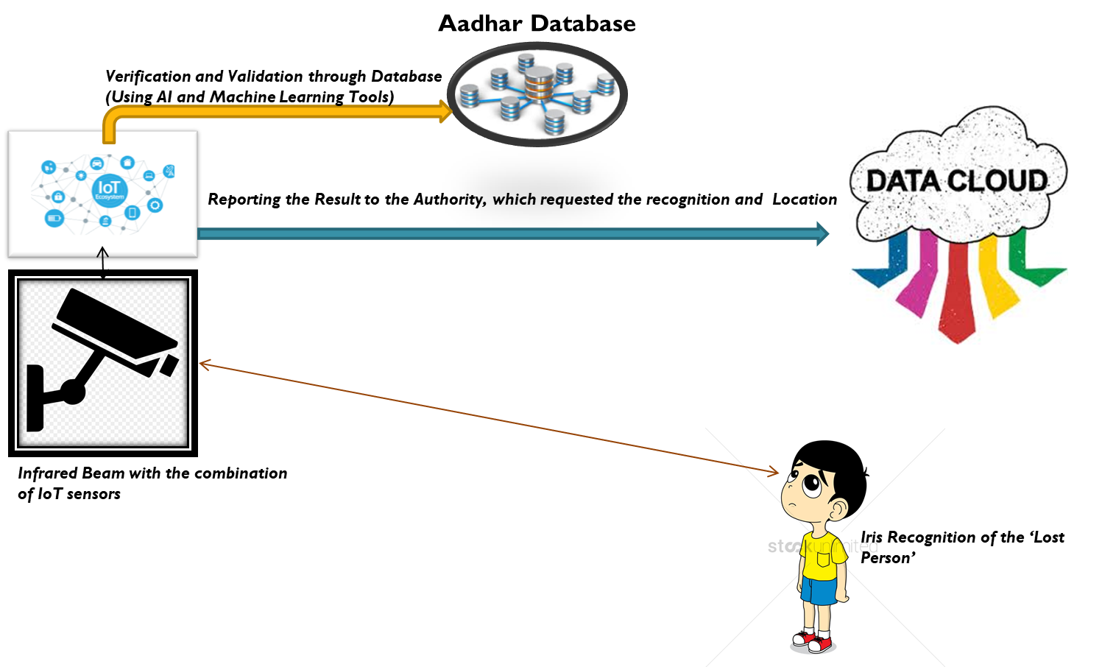

Figure 4; Proposed system of Recognition and Location

Conclusion

We have worked on a system which will lead to efficient finding of lost people and criminals . As we have discussed in figure number 3 how the overall proposed system works. We also have discussed in figure 4, the working of the combination i.e. Artificial intelligence network, internet of things sensor Infrared beem sensor for Iris recognition, Aadhaar database. Overall we have proposed a system in which if a lost person is at any part of the nation who is to be searched, can be easily and efficiently found. In this system we have proposed a framework in which Infrared Beam Sensor (combined with IOT) detects the person, Verifies its data with the Aadhaar Database. If this match is to be found valuable it gives the report to the cloud, so that the required information can be sent to the authorized place. This way the lost person is recognized and located accurately. Further the proposed model of 'lost and found' will be proven true experimental processes and on ground verifications.

REFERENCES
- J. Zhang, H. Huang, X. Wang, Resource provision algorithms in cloud computing: A survey, J. Netw. Comput. Appl. 64 (2016) 23􀀪42. doi:10.1016/j.jnca.2015.12.018.
- Vince Thomas, Nitesh Chawla, Kevin Bowyer, Patrick Flynn,Learning to predict gender from iris images, in: Biometrics: Theory,Applications, and Systems, Sept 2007.
- Peeranat Thoonsaengngam, Kittipol Horapong, Somying Thainimit,Vutipong Areekul, Efficient iris recognition using adaptivequotient thresholding, in: Springer LNCS 3832: InternationalConference on Biometrics, January 2006, pp. 472–478.
- Jason Thornton, Marios Savvides, B.V.K. Vijaya Kumar, Robustiris recognition using advanced correlation techniques, in: SecondInternational Conference on Image Analysis and Recognition,Springer Lecture Notes in Computer Science 3656, 2005, pp. 1098–1105.
- Jason Thornton, Marios Savvides, B.V.K. Vijaya Kumar, Enhancediris matching using estimation of in-plane nonlinear deformations,in: SPIE 6202: Biometric Technology for Human Identification III,2006, pp. 62020:E1–E11.
- Jason Thornton, Marios Savvides, B.V.K. Vijaya Kumar, A Baysianapproach to deformed pattern matching of images, IEEE Trans.Pattern Anal. Mach. Intell. 29 (4) (2007) 596–606.
- Jason Thornton, Marios Savvides, B.V.K. Vijaya Kumar, Anevaluation of iris pattern representations, in: Biometrics: Theory,Applications, and Systems, Sept 2007.
- Qi-Chuan Tian, Quan Pan, Yong-Mei Cheng, Quan-Xue Gao, Fastalgorithm and application of hough transform in iris segmentation,in: International Conference on Machine Learning and Cybernetics,volume 7, August 2004, pp. 3977–3980.
- Christel-loic Tisse, Lionel Martin, Lionel Torres, Michel Robert,Person identification technique using human iris recognition, in:Vision Interface, 2002, pp. 294–299.
- Mihran Tuceryan, Moment based texture segmentation, in: PatternRecognition Letters, volume 15, 1994, pp. 659–668.
- T. Matsumoto, H. Matsumoto, K. Yamada, and S. Hoshino, “Impact of Artificial GummyFingers on Fingerprint Systems”, Proc. SPIE, Vol. 4677, pp. 275-289, San Jose, USA, Feb2002.
- L. Hong, A. K. Jain, and S. Pankanti, “Can Multibiometrics Improve Performance?”, Proc.AutoID'99, pp. 59-64, Summit(NJ), USA, Oct 1999.
- L. Hong and A. K. Jain, “Integrating Faces and Fingerprints for Personal Identification”,IEEE Trans. on Pattern Analysis and Machine Intelligence, Vol. 20, No. 12, pp. 1295-1307,Dec 1998.
- L. I. Kuncheva, C. J. Whitaker, C. A. Shipp, and R. P. W. Duin, “Is Independence Good forCombining Classifiers?”, Proc. International Conference on Pattern Recognition (ICPR), Vol.2, pp. 168-171, Barcelona, Spain, 2001.
- Y. A. Zuev and S. Ivanon, “The Voting as a Way to Increase the Decision Reliability.Foundations of Information/Decision Fusion with Applications to Engineering Problems, pp.206-210, Washington D.C., USA, August 1996.
- R. Brunelli and D. Falavigna, “Person Identification Using Multiple Cues”, IEEE Trans. onPattern Analysis and Machine Intelligence, Vol. 12, No. 10, pp. 955-966, Oct 1995.
- E. S. Bigun, J. Bigun, B. Duc, and S. Fischer, “Expert Conciliation for Multimodal PersonAuthentication Systems using Bayesian Statistics”, Proc. International Conference on Audioand Video-Based Biometric Person Authentication (AVBPA), pp. 291-300, Crans-Montana,Switzerland, March 1997.
- R. W. Frischholz and U. Dieckmann, “Bioid: A Multimodal Biometric IdentificationSystem”, IEEE Computer, Vol. 33, No. 2, pp. 64-68, 2000.
- T. K. Ho, J. J. Hull, and S. N. Srihari, “Decision Combination in Multiple ClassifierSystems”, IEEE Trans. on Pattern Analysis and Machine Intelligence, Vol. 16, No. 1, pp. 66-75, January 1994.
- J. Kittler, M. Hatef, R. P. W. Duin, and J. Matas, “On Combining Classifiers”, IEEE Trans.on Pattern Analysis and Machine Intelligence, Vol. 20, No. 3, pp. 226-239, Mar 1998.
- S. Prabhakar and A. K. Jain, “Decision-level Fusion in Fingerprint Verification”, PatternRecognition, Vol. 35, No. 4, pp. 861-874, 2002.
- U. Dieckmann, P. Plankensteiner, and T. Wagner, “Sesam: A Biometric Person Identification System Using Sensor Fusion”, Pattern Recognition Letters, Vol. 18, No. 9, pp.827-833, 1997.
- P. Verlinde and G. Cholet, “Comparing Decision Fusion Paradigms Using k-NN BasedClassifiers, Decision Trees and Logistic Regression in a Multi-Modal Identity Verification Application”, International Conference on Audio and Video-Based Biometric Person Authentication (AVBPA), pp. 188-193, Washington D.C., USA, March 1999.
- S. Ben-Yacoub, Y. Abdeljaoued, and E. Mayoraz, “Fusion of Face and Speech Data forPerson Identity Verification”, Research Paper IDIAP-RR 99-03, IDIAP, CP 592, 1920Martigny, Switzerland, Jan 1999.

