NEURAL NETWORKS FOR KIDNEY STONE DETECTION

Rakesh Kumar¹, Shubham Rawat², Km Manisha², Ankit Kumar³
¹Assistant Professor, Department of Computer Applications
^{2,3}Tula’s Institute, Dehradun
⁴UTU, DEHRADUN

Abstract –Kidney stone disease is a polygenic and complex condition that affects people all over the world, with a growing incidence and prevalence.The goal of this paper is to use two alternative neural network methods with varied architectures and properties to identify kidney stone illness. The goal of this research is to compare the accuracy, time to create the model, and size of the training data set of all three neural networks. For kidney stone disease diagnosis, we will utilise Learning vector quantization (LVQ) and Radial basis function (RBF) networks. A comparison of the two techniques is also performed using MATLAB software. The major goal is to identify the best instrument for medical diagnosis in order to shorten diagnostic time and improve accuracy.
Keywords: Kidney Stone, Neural Network, Learning Vector Quantization (LVQ), Radial Basis Function (RBF).
1. INTRODUCTION
Kidney stones are formed due to the substances present in the calcium, oxalate and uric acid crystallise. The stones are caused due to the overweight, some kind of foods, some medications and not drinking enough of water.People of mixed races, cultures, and geographical places are affected by kidney stones.

Blood tests, urine tests, and scans are all used to diagnose this kidney stone. CT scans, Ultrasound scans, and Doppler scans all have different scanning methods.
In current culture, stone disease is a major source of sickness. A renal stone will affect about 12% of the population at some time in their lives. Kidney stones are more prevalent in males than in women in the United States and other developed countries. By the age of 70, 12% of men and 5% of women will have had renal stones.
Nowadays, there is an area of automation that is also applied in the medical field. Many frequent issues arose as a result of autonomous diagnosis, such as the use of precise and correct results as well as adequate algorithms.The process of medical diagnosis is inherently complex and vague. Among all technologies, the soft computing method known as neural network shows because it detects disease on a partial basis by first learning and then detecting [1].
The radial basis function and learning vector quantization are two neural network techniques utilised in this article to identify a kidney stone. The data is first trained using two methods. Blood results of numerous people who have kidney stones are acquired for various hospitals and laboratories.
The report has five qualities, each with its own range and weight. Table 1 displays the results.

Table1: Blood Report
Attributes | Weight | Limit
Lymphocytes | 30 | 20-50%
Monocytes | 1 | 1-6%
Neutrophil | 2 | 1-4%
S.Creatinine | 61 | 50-70%
Eosinophis | 3 | 4-10%

2. LITERAURE REVIEW
Koushal Kumar Abhishek (2012) used three distinct neural network algorithms with varied design and properties to identify kidney stone illness. The purpose of this research is to look at the accuracy, model creation time, and training data set size of all three neural networks[].
By equating patient mental behaviour, Tijjani and Sani provide an overview of ANN-based techniques for predicting renal issues using Matlab software [3].
Shukla A. et al. (2009) offer a Knowledge Based Approach for Breast Cancer DiagnosisThis study presents a novel method for sculpting a Knowledge-Based System for Breast Cancer Diagnosis, which involves using Ann and applying three neural network algorithms to the disease: BPA, RBF, and LVQ, to find the best model for diagnosis. [4].
Rouhani M et al. (2009) compare multiple ANN architectures on Thyroid Disease, including RBF, GRNN, PNN, LVQ, and SVM. Each architecture's performance is examined, and the optimal approach for each classification job is determined. The best models for diagnosis were chosen using RBF and PNN in this article [5].
Duryeal A.P. et al. (2010)presented an- Optimization of Histotripsy for Kidney Stone Erosion. Histotripsy is a mechanical fractionation method that uses targeted pulsed-ultrasound to guide the activity of a cavitational bubble cloud[6].
Rahman, Tanzila& Uddin, Mohammad (2013) has reduced speckle noise using gabor filter and the image enhancement is done using the histogram equalization. Two segmentation techniques were used, cell segmentation and region based segmentation to extract the kidney regions[8].Hafizah , Wan &Supriyanto, Eko&Yunus, Jasmy (2012) classified kidney ultrasound images into different groups creating a database based on the features extracted.

The RBG.Madhurambal and N.Prabha reported on Urinary Stone Epidemiology, which established urinary stone illness by studying case histories of people of various sexes, occupations, and ages[9].

Prema T.Akkasaligar et al. (2017) have designed a model for Kidney stone detection in Computed Tomography (CT) images [12].

3. Artificial Neural Networks Introduction
A mathematical model of the structure and functioning of biological neural networks is known as an Artificial Neural Network (ANN).Every artificial neural network starts with an artificial neuron, which is a simple mathematical model (function). Multiplication, summation, and activation are three simple rules in this model. The inputs are weighted at the artificial neuron's entry, which implies that each input value is multiplied by its own weight. The sum function in the artificial neuron's centre part adds all weighted inputs and bias. The total of previously weighted inputs and bias passes via an activation function, at the exit of an artificial neuron also known as a transfer function.

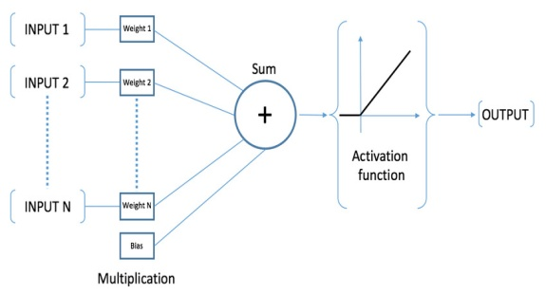

Fig. 1. An artificial neural network's working principle.

4. Training Algorithms for Neural Network Training
4.1 Radial Basis Function:
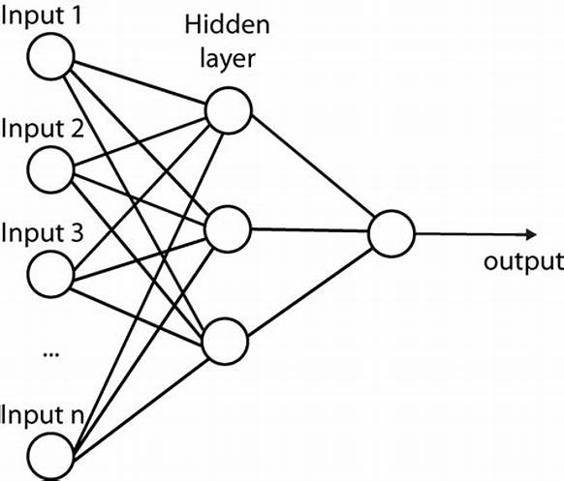

Radial basis function (RBF) networks are a commonly used type of artificial neural network for function approximation problems.For function approximation challenges, radial basis function (RBF) networks are a frequent form of artificial neural network. In comparison to other neural networks, radial basis function networks feature a universal approximation and train quicker. The input layer, the hidden layer, and the output layer make up an RBF network, which is a sort of feed forward neural network.
Other forms of neural networks have slower learning speeds and less universal approximation than radial basis function networks.
RBF network development is related to K-Means clustering and PNN/GRNN networks.PNN/GRNN networks contain one neuron for each point in the training file, but RBF networks have a variable number of neurons, generally significantly fewer than the number of training points. When dealing with small or medium-sized training sets, a PNN/GRNN network is typically more accurate than an RBF network; however PNN/GRNN networks are impracticable when dealing with huge training sets.

Fig.2. Radial Basis Function

4.1.1 Types of Radial Basis Function
1. Input Layer:
The data is sent to the hidden layers from the input layer. As a result, the input layer should have the same number of neurons as the data's dimensionality. As is the case with standard artificial neural networks, no computation is performed in the input layers. The hidden neurons are fully interconnected to the input neurons, and their input is sent forward. The data is sent to the hidden layers from the input layer.
2. Hidden Layer:
The hidden layer transforms the input, which may or may not be linearly separable, into a new space that is more linearly separable. Because patterns that are not linearly separable typically need to be converted into higher-dimensional space to be more linearly separable, the hidden layer has a larger dimensionality than the input layer.
The hidden layers' computations are based on comparisons with prototype vectors, which are vectors from the training set.
The prototype vector and bandwidth of each neuron in the hidden layer are indicated by μ and σ, respectively. The similarity between the input vector and the prototype vector is computed by each neuron. The following is a mathematical representation of the calculation in the hidden layer:
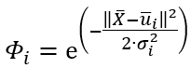

Fig.3
- X bar as the input vector
- μ bar as the iᵗʰ neuron’s prototype vector
- σ as the iᵗʰ neuron’s bandwidth
- phi as the iᵗʰ neuron’s output

3. Output/Summation Layer:
For both classifications and regression tasks, the output layer applies a linear activation function. The output layer computes in the same way as a traditional artificial neural network, which is a linear combination of the input vector and the weight vector. The output layer computation can be expressed mathematically as follows:
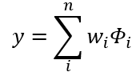

Fig.4
- wᵢ as the weight connection
- phi as the iᵗʰ neuron’s output from the hidden layer
- y as the prediction result

4.1.2 Conclusion of RBF Study:
The RBF network is made up of only one hidden layer that computes the output in its own way. The RBF network is based on the cover theorem; it casts data into a higher-dimensional space using its hidden layer, hence the hidden layer's number of neurons should be bigger than the input layer's number of neurons. The output layer might have a linear activation function or be conceived of as having no activation function at all[7].

4.2Learning Vector Quantization
Learning vector quantization involves data compression or dimensionality reduction. When the input data is labelled, it is possible to employ supervised learning. It is used to solve the problem of pattern classification. The initial phase is feature selection, which is followed by feature categorization based on the class. The first competitive layer and the second linear layer are used in LVQ. The input vectors are classified using a competitive layer, and the classes are transformed into target using a linear layer.

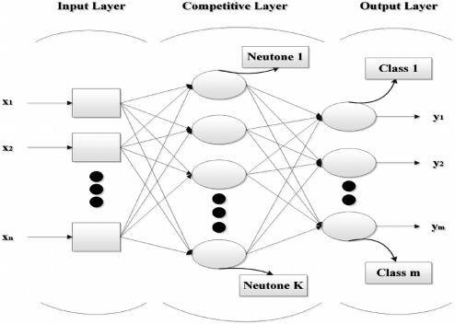
Fig.5. Learning Vector Quantization

5. Dataset Description
The dataset was gathered from hospitals and laboratories. The dataset for this study consists of five occurrences, each with seven attributes: Age, Sex, Lymphocytes, Monocytes, Neutrophil, S.Creatinine, and Eosinophis.

Table2: Data set for kidney stone
Age | Sex | Lymphocytes | Monocytes | Neutrophil | S.Creatinine | Eosinophis
48 | F | YES | NO | YES | NO | YES
40 | M | NO | YES | YES | YES | NO
54s | F | NO | NO | YES | YES | YES
23 | M | NO | YES | NO | NO | YES
57 | F | YES | YES | NO | YES | NO

In the table above, five attributes are used for detection. In five attributes, the YES and NO values are used. If the patient report for the corresponding characteristic falls within the range shown in table 1, the individual suffering from kidney stone will have that attribute YES, otherwise NO. The simulation displays the results of items in the form of successfully classified and wrongly classified instances for simpler evaluation. It also displays the performance curve and time necessary for each exercise.
5.1 Diagnosis using Radial basis Function
mean absolute error = 6.6613e-17
mean squared error = 7.9605e-33
root mean squared error = 8.92216e-17
Percentage Correct Classification: 100.000000%
Percentage Incorrect Classification: 0.000000%

Fig.6. Command window for RBF
Fig.6 demonstrates the outcomes of using the learning vector quantization approach to training neural network. The result demonstrates that the occurrences are classified. The network took 0.0224 seconds to construct. The mean absolute error (MAE) is the average of all test cases' differences between predicted and actual values [4]. 6.6613e-17 is the MAE for the learning vector quantization method. The square root of the mean squared error is the root mean squared error, which yields the error value. The learning vector quantization technique has an RMSE of 8.92216e-17.
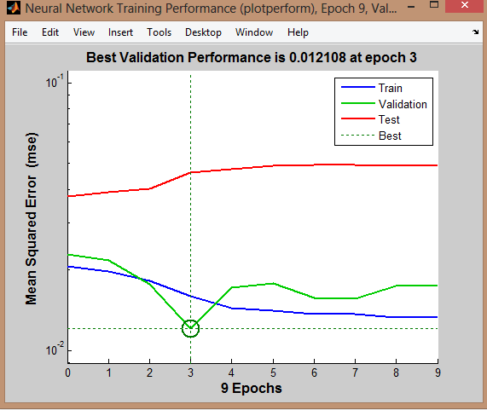
Fig.7. Performance Curve for RBF
Fig.7 depicts the performance curve acquired after successful network testing. The best RBF network training performance was attained at 0.012108.
5.2 Diagnosis using LVQ
mean absolute error = 0.5073
mean square error = 0.2863
root mean square error = 0.5350
Percentage Correct Classification: 100.000000%
Percentage Incorrect Classification: 0.000000%

Fig.8.CommandwindowforLVQ
Fig.8displays the outcomes of using the learning vector quantization technique with training neural network. It classifies the occurrences, as shown by the result. The network takes 0.07 seconds to construct. 0.5073 is the MAE for the learning vector quantization method. Learning vector quantization technique has an RMSE of 0.5350.
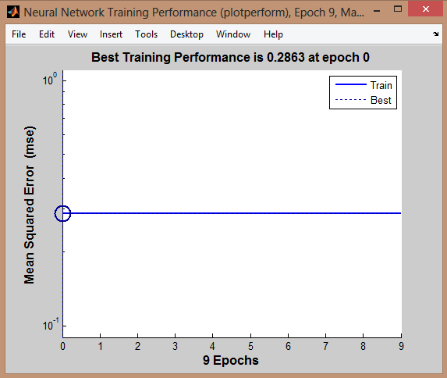

Fig.9.PerformancecurveforRBF
Fig.9 depicts the performance curve achieved after successful network testing. The best LVQ network training performance was found at 0.2863.
6. PREVENTION FOR KIDNEY STONES
- Drink Plenty of Water: Each day, you should consume at least eight 8-ounce glasses of water. Orange juice, lemonade, or limeade are some of the beverage options.
- Eat and drink enough Calcium: This precaution may appear perplexing at first, as doctors will inform you that elevated calcium levels in your urine can lead to a stone. Oxalates in urine might be increased if you don't receive enough calcium. Rhubarb, spinach, beets, bran flakes, potato chips, and french fries all contain them. Oxalates can also lead to kidney stones. Calcium should be obtained through meals and beverages rather than supplements.
- Avoid certain foods and drinks: If you've already had at least one kidney stone, you should limit your daily animal protein intake to a portion the size of a deck of cards. Kidney stones have been related to meals including eggs, spinach, beets, chocolate, and almonds, as well as colas.

6. CONCLUSION
As a result, my project's goal has been accomplished. Radial Basis Function algorithm is the best model for kidney stone disease. The datasets are accurately classified. In addition, building the model takes less time than learning vector quantization. The error rates are also reduced as compared to LVQ.RBF has a performance rate of 0.0121, which is good when compared to LVQ. As an outcome, the radial basis function (RBF) enhances the classification approach for medical purpose greatly.

7. References
[1] http://www.webmd.com/kidneystones/ understanding- kidney-stones-basics.
[2] Koushal Kumar, Abhishek, “Artificial Neural Networksfor Diagnosis of Kidney Stones Disease”, InternationalJournal Information Technology and Computer Science,2012,7,20-25.
[3] Tijjani Adamand U.H Ashimand U.S.Sani,“Designing of Artificial neural network model for the prediction of kidney problem symptoms through patients mental behaviour for preclinical medical diagnosis”, ICBE Feb.2012.
[4] Shukla A. et al , “Diagnosis of Thyroid Disorders usingArtificial Neural Networks”, Department of Information Communication and Technology, ABV-Indian Institute of Information Technology and Management Gwalior, India IEEE International Advance Computing Conference 2009.
[5]RouhaniM.etal,“ThecomparisonofseveralANNArchitectureonthyroiddisease”,IslamiAzadUniversity, GonabadbranchGonabad, 2010.
[6] Duryeal A.P.etal, “Optimization of Histotripsy for Kidney Stone EROSION”, Department of Biomedical Engineering, University of Michigan, Ann Arbor, MI2 Department of Urology, University of Michigan, AnnArbor,MI2010.
[7]Radial Basis Function Neural Network Simplified | by Luthfi Ramadhan | Towards Data Science
[8] P.R. Tamilselvi, "Detection of a Renal calculi using a semi automatic segmentation approach", International Journal of Engineering Science and Innovative Technology (IJESIT), vol. 2, no. 3, May 2013.
[9] R.G.Madhurambal,N.Prabha,S.PonsadiLakshmi,R. Valamathi, “Epidemology of Urinary Stones”,International Conference On Advances In Engineering ,Science And Management ,March 2012.
[10] N. Thein, H. A. Nugroho, T. B. Adji and K. Hamamoto, "An image preprocessing method for kidney stone segmentation in CT scan image.
[11] https://www.webmd.com/kidney-stones/ understanding-kidney-stones-basics
[12] Akkasaligar, P. T., Biradar, S. and Kumbar, V. “Kidney stone detection in computed tomography images”, Proceedings of the International Conference on Smart Technologies For Smart Nation, 2017
[13] G.M.PremingerH.G.TiseliusD.G.AssimosP.AlkenC.BuckM.GalluccietalEAU/AUA Nephrolithiasis Guideline PanelJ Urol178200724182434 [Crossref], [Web of Science ®], [Google Scholar]

