Online Teaching Learning (OTL) Platforms

|  |
| --- |
| **Rakesh Kumar1, Mohit Singh2 , Prabesh Ojha3, Mohit Bhubaneswar Prasad Saklani4** |
|  |
| 1Assistant Professor ,Tulas Institute Dehradun |
| 2, 3, 4 BCA Student, Tulas Institute Dehradun |

**Abstract—**Online Teaching Learning (OTL) Platform is an interactive system where students learn and gain knowledge and skills from their teachers. The development in technology has made teaching and learning possible to transit from face to face to online teaching and learning. The online learning system had been increase due to the increase in corona virus as the only prerequisite needed for online education is being access to the internet and a computer. This paper represents a literature survey on OLT with primary concern of the Design Issue of OLT, Challenges and its Application are considered in this survey paper.

***Keywords****: COVID-19, OTL System, OTL Medium, Analysis;*

# INTRODUCTION

A teaching learning system is an interactive system where students learn and gain knowledge and skills from their teachers. The teacher examines learning needs, defines specific learning objectives, and develops teaching and learning methodologies and the students work toward their objectives while incorporating new knowledge, behaviors, and abilities that broaden their learning opportunities. Teaching and learning face to face inside a classroom is the most common way. But the development in technology has made it possible to transit from face to face teaching and learning to online teaching and learning [1].In Online teaching and learning

teachers and students interact through online medium meaning that there is no physical presence of students and teachers. The online learning system may be used anywhere, with the only prerequisite being access to the internet and a computer.

Online Teaching and Learning system or distance learning involves the use of various resources such as videos, documents which helps students to enhance their knowledge. Although there are multiple examples of computers and technologies being used in education throughout history, online learning is relatively a new concept. Students or learners had already adopted learning from internet sources such as YouTube and other such sites. Many students had also been enrolled to many sites which provide paid online courses like Coursera. The coronavirus outbreak affected many sectors including the academic sectors making it impossible to attend physical classes. Due to this, many educational sectors have adapted the online teaching learning process throughout the world in order to continue the education process [2].

The Online Teaching Learning system has many vital components which includes users, multimedia support evaluation tools, and dashboards. Figure 1 is showing all the major components of OTL. All these components are important and if any of these components are missing then there will be failure in interactive online teaching and learning. Users are the teachers and students and the dashboard is for both the teachers and students. Multimedia support means audio video and text files which will be transmitted between the teachers and students. Evaluation tools help for evaluating student’s grades and overall progress.

Online Teaching Learning provides a viable alternative to traditional classroom teaching. It allows both the teacher and the student to establish their own learning speed, with the flexibility of setting a schedule that fits everyone’s agenda. In the online teaching learning process, students can become more creative, imaginative, and effective explorers. Online Teaching Learning allows students to take classes from any location of their choice instead of being constrained by the location. Furthermore, online lectures can be recorded, saved, and shared.

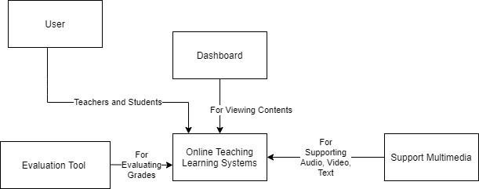

**Figure 1.** Components of the OTL system

This allows students to access the materials whenever it is convenient for them [3]. Here are some of the types of online learning:

* 1. Blended Learning is an approach which combines face- to-face learning activities with online learning components to improve the teaching and learning experiences for both the students and teachers.
  2. Active Learning is an approach that involves students actively engaging with course material through discussions, problem solving, case studies, and other ways.
  3. Personalized Learning is an approach that customizes a student's learning experience to their specific talents, abilities, interests.
  4. Engaged Learning is an approach where students actively participate in their learning and are involved since the beginning in research, projects, and discussions.
  5. Flipped Classroom learning where student’s self-study a topic using downloadable pre-recorded materials and then interact with the instructor in live class sessions.
  6. Asynchronous Learning is an approach which relates to self-paced, time-independent courses with materials that may be accessed at any time, and the teacher student communication occurs through emails, discussion forums, chat rooms, etc.
  7. Synchronous Learning occurs in real time using virtual classrooms or other methods in which teachers and students all log into the platform at the same time and the teacher provides the lecture, demonstration, or other materials and students participate in real time discussions [4].

This paper is divided into 7 chapters. In the second chapter, the design issues of online teaching learning systems are described. In the third chapter, there are challenges of the online teaching and learning system. Chapter 4 is the brief description of some of the popular online teaching learning systems. Chapter 5 contains the comparative analysis of the online teaching learning systems according to their features and services they provide. In chapter 6, there is discussion/way forward and the last chapter is the conclusion of the paper.

# DESIGN ISSUES OF ONLINE TEACHING LEARNING SYSTEM:

The Online Teaching Learning System also has some design issues compared to traditional classroom teaching learning. This section consists of a brief description of design issues in the OTL system.

1. *Security*

Security is one of the major issues of the Online Teaching Learning System. The OTL systems can be hacked which can lead to data breach. The system should assure that the information of the students and teachers is safe. It should be designed in a way that only authorized persons can access the data. There have been some cases where the data’s have been attacked and sold by the hackers. So to prevent unauthorized users, the system should authenticate teacher and student data and limit login attempts. Also, the materials like book files, recorded videos of the lectures and the evaluation of the students should be kept confidential within the system. Security considerations like confidentiality, integrity should be strictly maintained.

1. *Heterogeneity*

Heterogeneous groups include diverse students for example, students who are gifted or the students who have learning disabilities. This can cause a problem in the online teaching learning system as the teacher teaches the same way to all types of students. Gifted students may feel pressured as they have to act as a second teacher and help those students who are struggling. At the speed of a regular classroom, these gifted students may get impatient and bored, which can lead to frustration. For students with disabilities, heterogeneous classrooms can be difficult and they may not be able to engage much in the discussions. Online classes are designed in such a way that all the students can participate equally and be able to ask if they have any questions regarding the lectures. But sometimes the students may not be able to understand the things explained by the teacher or the teacher may not be able to understand the question asked by the students. Since thereis no physical presence of both the teachers and students there may be problems related to communication and understanding [5].

1. *Performance*

Performance is the measurement of the provided task in terms of accuracy, completeness, and speed, and it is one of the most important design issues for any system. Factors like finding the contacts, joining the classroom, etc. Determines the performance of the online teaching learning system.

1. *Scalability*

Scalability is the ability of a system to continue to work properly when its size or volume is modified to fulfill a user's requirements [6]. The rescaling is usually to a bigger size or volume. The key difficulty in the design process is predicting the increase of users of any system, including OTL systems, and the simultaneous data usage over the system. OTL systems should be designed by taking the scalability factor of a system into consideration.

1. *Error handling*

The system's design issue should not capture errors, instead, if an unexpected error happens, the system should be capable of handling it. If there are any errors in an online teaching and learning system, such as video not showing or audio not detected, the system should address them.

1. *Usability*

When creating an OTL system, more focus should be placed on user interfaces that are simple to use, as well as have control over error reversal. On OTL systems, content design should include multimedia such as audio, video, and simulations, as well as control over their sequences and pace. The learning methodology should provide the learner with as much essential information as feasible while minimizing any kinds of distractions. The learning platform should have a consistent look so that the learners can interact as much as possible.

1. *Control*

In terms of event handling, it essentially refers to data arrangement and control flow. The rewards that students receive when they complete a task are dealt with in the execution of events.

# CHALLENGES OF ONLINE TEACHING LEARNING SYSTEM:

Online Teaching Learning Systems has many challenges while implementing it in real life scenarios. Some may find it hard while some may find it easy. This section will explain such challenges of the OTL system.

1. *Accessibility*

Not all the users have reliable access to technology and not every home will always have reliable internet connection and readily available devices for students to use. Low bandwidth and poor internet connections can have an impact on student participation and performance. It might be difficult to do synchronous online learning and teaching with real-time video conferencing. Similarly, the teachers should design the course in a way that can be accessed by each and every student. The perception of students' ability to understand contents, perform tasks, and recall the topics learned should be used to determine the ease of learning.

1. *Knowledge and training skills*

Many students nowadays can handle highly advanced systems very easily but those who may not have much idea about technology may find it difficult to utilize. Before putting the online teaching-learning system into implementation, both teachers and students must have a basic understanding and training skills. If the teacher and students both have knowledge about the system then they can easily navigate through the entire interface smoothly. Students should be able to log in, engage in classes, submit assignments, interact with teachers, and learn how to use the learning platform interfaces.

1. *Performance*

The performance of the users depends on the system. If the students want an improvement in their grades, it would require the system’s fast response time, several servers for different types of content, redundancy, and so on.

1. *User Support*

Users should be given access to tools that will spark their attention over time. These don't include documents, classroom videos, or other materials, but rather user- generated content. Tutorials, articles, and online discussion forums are preferred by many students.

1. *User participation*

Student participation or engagement is one of the major issues for online teaching learning systems. Online listening or observing is a complicated phenomenon that contributes significantly to student's participation in online discussions [7].

1. *Clarity of contents and assessments*

The course's progression should be clearly planned out for students, and the content should be provided in manageable sections throughout the course. In an online course, formative assessments are undervalued. Furthermore, because OTL systems contain a lot of audio and video content, users with poor bandwidth and slow internet face a lot of challenges with clarity.

1. *Adaptability*

It may be hard for some people to switch from classroom learning to online learning. It can demoralize students and teachers who have never experienced online learning before. It may take some time for teachers and students to adapt to online teaching-learning systems [8].

# Online Teaching Learning System:

There are many systems for online teaching and learning. They provide a platform where anyone can share lectures or any other types of learning materials. They can have an audience of their own. Some of the popular OTL platforms are described in this section.

1. *Google Meet*

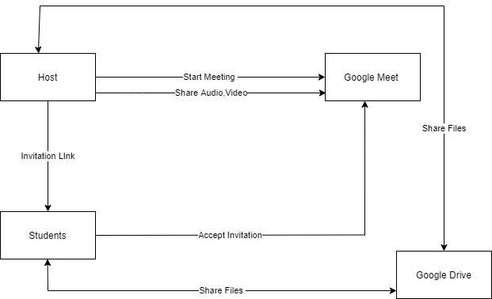Google Meet is a video-communication service developed by Google as the replacement for Google Hangouts. Google meet allows starting a meeting of their own or joining a meeting invited by the host. It is compatible with both desktop and mobile devices. It allows students in an online class to share their screens, presentations, papers, and other resources. Turning the camera off or muting the meeting will be the initial options on the meeting. Students could be added using emails or by forwarding the link of the meeting. Students could also add captions during the meeting. The meeting can also be recorded which will be saved in google drive of the host. Below block diagram of google meet is shown in Figure 2*.*

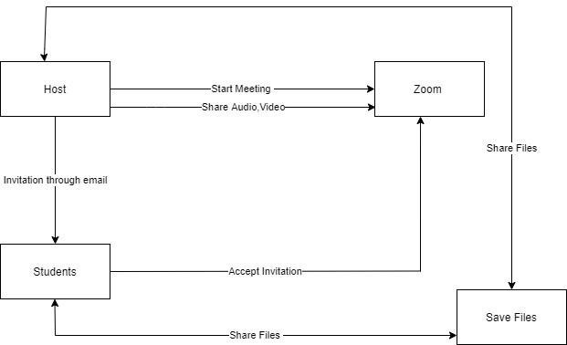

**Figure 2** Block diagram of Google Meet

1. *Zoom*

Zoom is a video conferencing software for meeting and chatting which can be used in both mobile and desktop. A meeting can be attended, hosted or scheduled for later. It can accommodate up to 1,000 people in a meeting.

Scheduling the date and time for the classroom can also be done through calendar integration. It also has a group chat that allows students to ask any questions and the teachers can respond to them. Meetings can be recorded and users can choose from multiple screens to share. Users can choose to end the meeting or leave the meeting. File sharing option is also available in zoom. Figure 3 zoom is given in block diagram.

**Figure 3** Block diagram of Zoom

1. *Moodle*

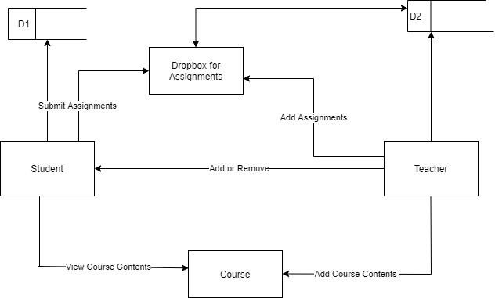Moodle is an open source learning management system (LMS) that provides users with the ability to create their own private websites for online courses [9]. It is currently being used by many academic institutions to deliver collaborative teaching and learning for teachers and students. Users can create their own personalized dashboard, with different features depending on whether they are students or teachers. It offers a variety of features to the user, such as assignments, audio/videos, and so on. Users could upload course materials, create quizzes or tests, receive assignments, and issue grades after the course has been created. It includes a calendar as a tool for keeping track of schedules or upcoming deadlines. Students can track their overall progress and enhance their academic achievement. Figure 4 Moodle is given in block diagram.

**Figure 4** Block diagram of Moodle

1. *Google Classroom*

Google Classroom is a free application especially for schools, colleges as it makes creating, distributing, and grading assignments easier. The teacher creates a classroom and invites the students by adding their emails or by giving them code to join the class. Announcements and attachments could be created easily. Teachers can create assignments or quizzes and set deadlines and grades along with them. On the grades tab, all of the submissions and grades can be viewed. It offers a notification system that keeps students informed about assignments, deadlines. Figure 5 is of Google Classroom given in block diagram.

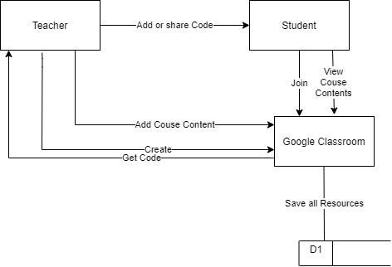

**Figure 5** Block diagram of Google Classroom

*d) Cisco -Webex*

Cisco-Webex is a videoconferencing application for both desktop and mobile devices. It can accommodate up to 3000 people at a time. It is accessible via phone, email, and the internet anytime. Screen sharing can be done and file sharing option is also available. Screen recordings can be done which will be saved in cloud. Figure 6 of Cisco- Webex is given in block diagram.

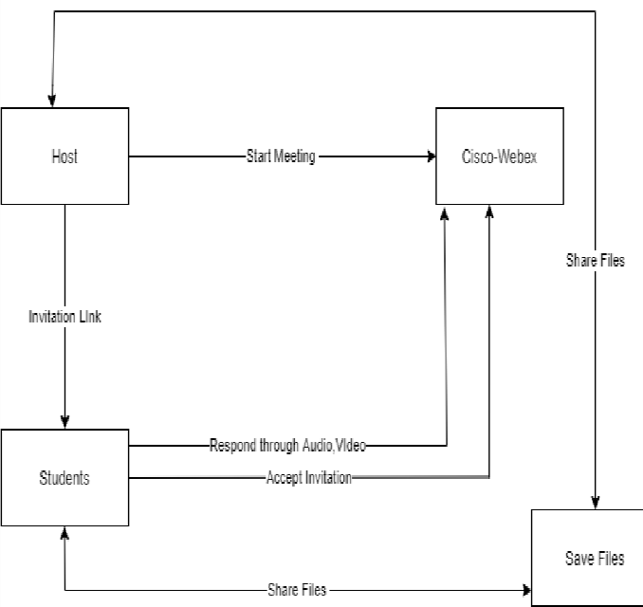

**Figure 6** Block diagram of Cisco-Webex

# COMPARATIVE ANALYSIS OF ONLINE TEACHING LEARNING SYSTEMS:

In this section, comparative analysis of the OTL systems are done based on the 15 parameters (usability, scalability, security, supporting multimedia types, heterogeneity, reliability, availability, privacy, affordability, Qos, design, gamification, learnability, robustness, efficiency) and a comparison table of the OTL system is made based on these parameters. Hierarchical Block diagram of OTL is given in Figure 7.

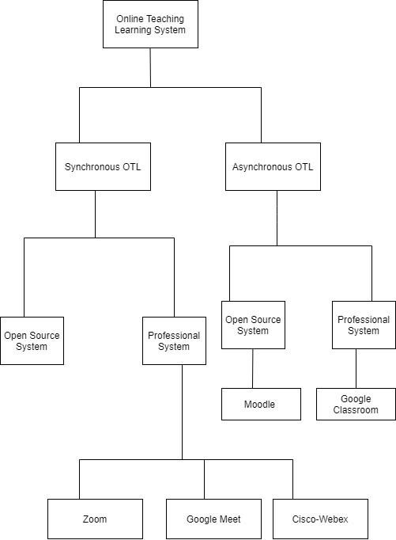

**Figure 7** Hierarchical Block diagram of categories of OLT System

.

1. *Usability*

Usability refers to the ease of users using the software and Web applications to accomplish predetermined goals. It is also a factor that influences things like efficiency, context of usage, user satisfaction, and end-product

efficiency.

1. *Scalability*

Scalability is the ability of a system to manage a growing amount of work by adding resources to the system. The systems were compared to see if increased customer demands in terms of numbers, size of drive occupied by contents, and student enrollments could affect the system's performance.

1. *Security*

The system should have high security. Websites and software must be safe against cybercriminals, which implies that data must not be shared with outsiders without the authorization from the appropriate person.

1. *Supporting multimedia types*

In the online teaching learning system, students are more interested in multimedia sharing video and audio tutorials rather than documents and pdfs. So here we determine whether the OTL system supports these multimedia or not.

1. *Heterogeneity*

It is determined by how successfully the platform is used on both desktop and mobile devices such as Android phones and iPhones.

1. *Reliability*

The OTL systems should be reliable. Reliability of the system refers to the likelihood that a system, its parts, or components will continue to perform essential functions for an extended length of time in a given environment without failing.

1. *Availability*

Availability of a system is a metric that determines the l likelihood that a system will not be down or undergoing maintenance when it is needed. The OTL system can cause hindrance to the classes assigned at a specific time if it is not working or is not available at that particular time.

1. *Privacy*

The system should keep the data of each and every user private. Students' grades, performance, and other personal information should not be exposed. When a person deletes an account or content, all related material must be removed from other profiles as well.

1. *Affordability*

Cost, schedule, and performance should be measured as constraints to meet the goal while the system is being developed. The OTL system built must be inexpensive to use and maintain.

1. *Qos*

It is defined as Quality of Service which is the measurement of overall performance of the system [10]. It is the measuring of all website components' performance, such as video quality and image resolution etc.

1. *Design*

The combination of visual appeal and ease of management creates a pleasant environment in which students are not distracted.

1. *Gamification*

Gamification is a strategy for improving systems and activities in order to generate experiences similar to those found in video games in order to encourage and engage users. It is a crucial tool for engaging and enticing users by incorporating study-focused games such as quizzes, IQ tests, and puzzles into a unique experience.

1. *Learnability*

Learnability refers to how easy it is for users to pick up and understand a software application or product. The easier an application is to understand, the less training and time it will take for someone to use it.

1. *Robustness*

It is defined as how the system responds to unexpected events such as a crash, power outage, and so on. Even in unexpected conditions, the OTL system must act reasonably.

1. *Efficiency*

Efficiency determines the system's performance based on the system's input. The system is extremely efficient if it requires less input and produces more output. It can be determined by many factors such as user feedback, low bandwidth, and usage and so on. It is also important that the system be efficient during quizzes, or notification systems.

These fifteen parameters used for comparing some of the popular Online Teaching Learning systems gives us an idea about their usefulness. From the above table, we can see the different OTL systems have different features. Some are good, average, high, low. On the basis of this table, we can learn more about their features and use the best one for future practice.

# Discussions/Way Forward

In the OTL systems, there are basically two components, the student and the teacher. The needs of both the teacher and student should be kept into consideration while designing the OTL system. The teacher and student both should have their own dashboard. Multiple students should be able to work together both amongst themselves and with their teachers. Students should receive a report on their improvement as well as an analysis of their progress. This helps students in gaining motivation for improvement. Gamification feature could help the students' active learning and transform their behaviors in the direction of learning. Although students may be hesitant to ask questions, using a private message is an excellent practice. Even shy students may engage in more exchanges with teachers. Preparing for sessions by scheduling and marking dates on calendars might be beneficial for both students and teachers. Active blended learning would take the role of passive learning and synchronous classes. There would be more course materials available for additional study. As the number of users grows, there may be some audio and video issues. A timely update to correct these issues would be helpful.

# CONCLUSION

OTL systems have become extremely popular in the present because of the pandemic. Many schools, colleges, and universities have adapted online teaching and learning instead of classroom learning. In this paper, five popular OTL systems were studied along with their design issues, challenges and features. Fifteen parameters(usability, scalability, security, supporting multimedia types, heterogeneity, reliability, availability, privacy, affordability, Qos, design, gamification, learnability, robustness, efficiency) were used to compare the five OTL systems. With the evolution of these systems, more efficient services can be provided to the users. In the future, I would like to research more on this topic and perform surveys from both student and teacher’s view on the effectiveness of the OTL system.

# REFERENCES

1. vikaspedia. “Teaching and Learning.” *vikaspedia*, 2020, https://vikaspedia.in/education/teachers- corner/teaching -and-learning.
2. Science Direct. *Online teaching-learning in higher education during lockdown period of COVID-19 pandemic*. Elsevier Ltd., 2020. *sciencedirect*,

https://[www.sciencedirect.com/science/article/pii/S266](http://www.sciencedirect.com/science/article/pii/S266) 6 374020300121#!

1. Education Media Group. “5 Reasons Why Online Learning is the Future of Education.” *educations*, 2021, https://[www.educations.com/articles-and-advice/5-reaso](http://www.educations.com/articles-and-advice/5-reaso) ns-online-learning-is-future-of-education-17146.
2. EasyLMS. “Synchronous vs. asynchronous learning: what's the difference.” *easy-lms*, 2021,

<https://www.easy-lms.com/knowledge-center/lms-> knowledge-center/synchronous-vs-asynchronous- learning/ite

m10387#:~:text=Synchronous%20learning%20is%20l

e arning%20that,can%20happen%20on%2D%20or%20o f fline.&text=Asynchronous%20learning%20is%20learn i ng%20that,the.

1. verywell family. “Pros and Cons of Heterogeneous Grouping in Classrooms.” *verywellfamily*, 07 June 2020,

[https://www.verywellfamily.com/heterogeneous-](https://www.verywellfamily.com/heterogeneous-grouping-1449185) [grouping-1449185](https://www.verywellfamily.com/heterogeneous-grouping-1449185)

[6] concepta. “The Importance Of Scalability In Software Design.”*conceptatech*,2019, https://[www.conceptatech.com/blog/importance-of-scal](http://www.conceptatech.com/blog/importance-of-scal) ability-in-software-design

* 1. Sage Journals. “Issues and Challenges for Teaching Education: A Literature Review.”

*journals.sagepub*, 2017,

* 1. Edology. “5 problems e-learning students experience, and how to overcome them.” *edology*, 2020,

https://[www.edology.com/blog/study-and-care](http://www.edology.com/blog/study-and-care) ers-advice/problems-with-e-learning/.

* 1. Wikipedia. “Moodle.” *wikipedia*, https://en.wikipedia.org/wiki/Moodle
  2. Wikipedia. “Quality of Service.” *wikipedia*, https://en.wikipedia.org/wiki/Quality_of_servi ce.
  3. Weber, M. J., Farmer, T. A. (2012). Online course offerings: Issues of retention and professional relationship skill development. In Tareilo, J., Bizzell, B. (Eds.), NCPEA handbook of online instruction and programs in education leadership. Retrieved

from <http://cnx.org/content/col11375/latest/> [Google Scholar](http://scholar.google.com/scholar_lookup?hl=en&publication_year=2012&author=M.%2BJ.%2BWeber&author=T.%2BA.%2BFarmer&title=Online%2Bcourse%2Bofferings%3A%2BIssues%2Bof%2Bretention%2Band%2Bprofessional%2Brelationship%2Bskill%2Bdevelopment)

* 1. Stanford-Bowers, D. E. (2008). Persistence in online classes: A study of perceptions among community college stakeholders. MERLOT Journal of Online Learning and Teaching,

4, 37-50. Retrieved

from [http://jolt.merlot.org/vol4no1/stanford-](http://jolt.merlot.org/vol4no1/stanford-bowers0308.pdf) [bowers0308.pdf](http://jolt.merlot.org/vol4no1/stanford-bowers0308.pdf)

|  |  |  |  |  |  |
| --- | --- | --- | --- | --- | --- |
| OTL systems | Google Meet | Zoom | Moodle | Cisco- Webex | Google Classroom |
| Usability | High | Moderate | High | Low | High |
| Scalability | High | High | High | Moderate | Moderate |
| Security | High | Moderate | High | Moderate | High |
| Supporting Multimedia Types | Audio, video, text | Audio, Video | Text | Audio, Video | Text |
| Heterogeneity | Low | Low | High | Moderate | Moderate |
| Reliability | High | High | High | Moderate | High |
| Availability | High | High | High | Moderate | High |
| Privacy | High | High | Moderate | Moderate | High |
| Affordability | Free, Premium | Free, premium | Free | Free, Premium | Free, Premium |
| QoS | High | High | High | Moderate | High |
| Design | Good | Moderate | Moderate | Moderate | Good |
| Gamification | Yes | Yes | Yes | No | Yes |
| Learnability | Good | Good | Good | Good | Good |
| Robustness | Good | Good | Moderate | Good | Good |
| Efficiency | High | High | Moderate | High | High |

**Table 1:** Comparative Analysis of OTL systems