

N

ew equipment/assay verification for clinical

laboratories



Design

validation/verification

plan



We will provide

samples for

verification and test

onsite

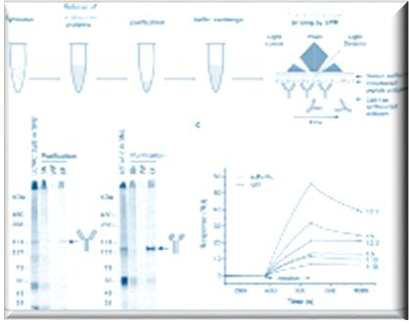

Analyze the data

applying all the

relevant statistics



Write the full

report

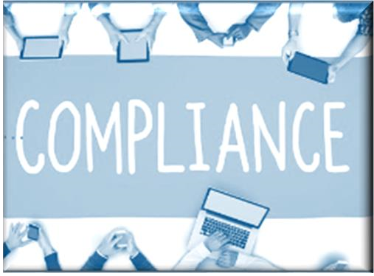

Guarantee

compliance

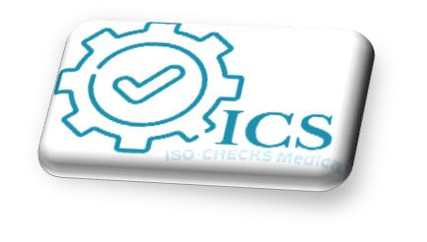

You benefit from

saving time to

concentrate on

you vital day to

day healthcare

duties

Process

overseen

by

a

UKAS

technical assessor/

accreditation expert

1

month start to completion dates