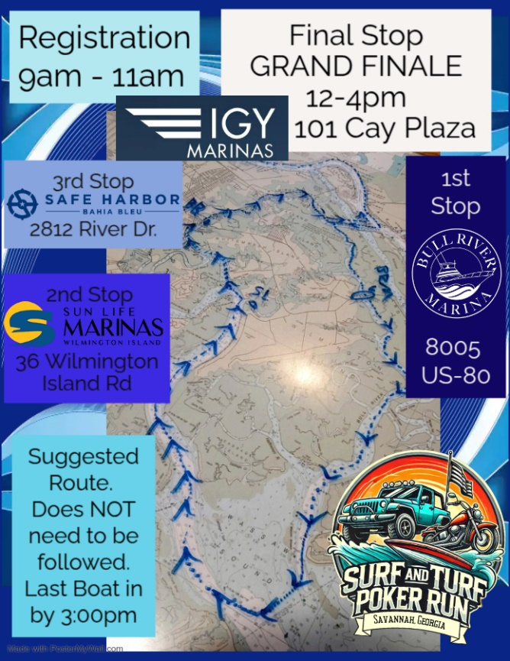
Surf and Turf Poker Run and Grand Finale
Boat Registration at
IGY Marina on Hutchinson Island
101 Cay Plaza
From 9am through 11am

From IGY Savannah Harbor Marina 101 Cay Plaza, Hutchinson Plaza, 912-275-5810
To… Bull River Marina & The Burger Boat 8005 US-80, Savannah, GA 912-897-7300

From…Bull River Marina & The Burger Boat, 8005 US-80, Savannah, GA 31410, 912-897-7300
To… Sun Life Marinas– Wilmington Island (Hogan’s)… 36 Wilmington Island Rd, Savannah, GA 912-897-3474

From…Sun Life Marinas – Wilmington Island (Hogan’s), 36 Wilmington Island Rd, Savannah, GA 31410 912-897-3474
To… Safe Harbor Bahia Bleu 2812 River Drive, Thunderbolt, GA, 912-354-2283

From… Safe Harbor Bahia Bleu, 2812 River Drive, Savannah, GA 31404 912-354-2283
To… IGY Savannah Harbor Marina, 101 Cay Plaza, Savannah, GA 31421

POC: delylah 954-857-6727 or Tom 912-220-9901

Last Poker Scoresheet to be handed in to the judges by 3:00pm. This is a SUGGESTED Route. It can be followed, or you can determine your own route. If you don’t pick a card at one, or several, of the stops, no problem… your hand can be completed at the final stop. Have fun… enjoy the day… And, above all, Stay Safe!

