Name: Grace Harrison

** Be sure to look at the assignment description for instructions of what to include for each section below.

1- What you did in your part:

Brief Description of What Happened in my Part: | My part of the enactment was composed of the introduction of our lesson and half the problems presented in our strings. Jordan performed the other half of the string examples. I started off by using the smartboard where we had broadcasted our power point made to introduce our lesson. It included instructions and expectations such as how students should act during the lesson and what the purpose of a string activity is. Moreover, after the introduction I moved over to the white board, wrote down the first equation/situation and began to ask for students help and explanations.
Pictures of the board  (Add relevant pictures of the board that highlights what is happening on the video time stamp) | 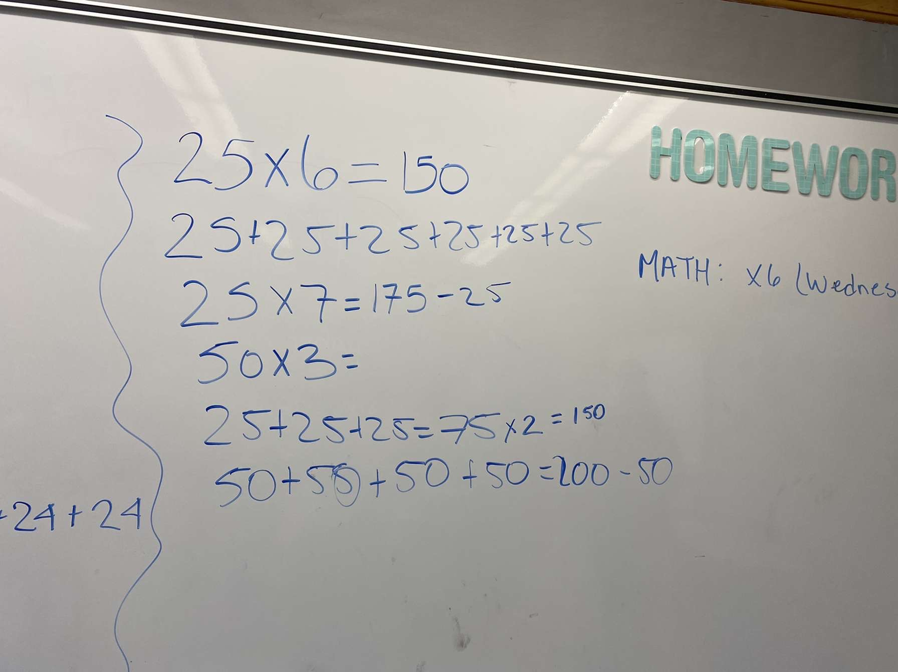  Picture backwards however this was an example of a string along with all the justifications students had given | 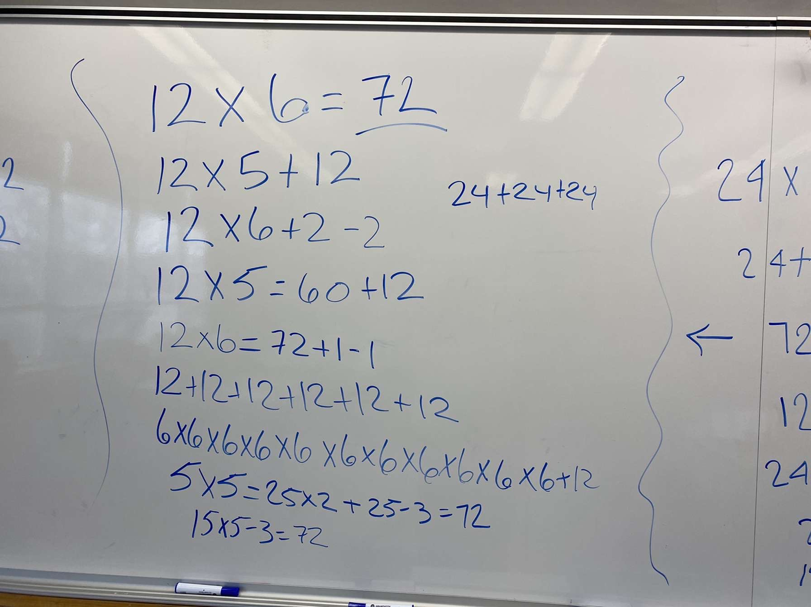  Picture backwards however this was an example of a string along with all the justifications students had given
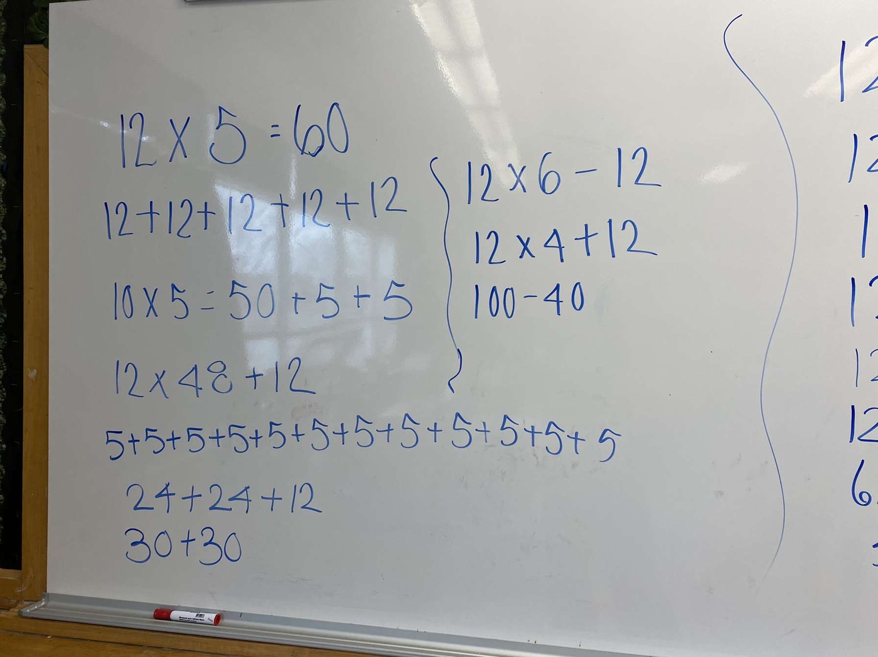
Picture demonstrates the first equation in the string.

Video Time Stamp  (e.g. From X:XX to X:XX in Video X (if more than one video)) | 00:03 to 3:10
Practice of High Quality Teaching:  (Pick one of the 4 practices described in the assignment description) | Setting & Maintaining Expectations
Detailed Description of what happened in that moment  (Be specific – transcribe word-for-word what was said. Include a picture or photo of the board that was discussed at that moment.) | 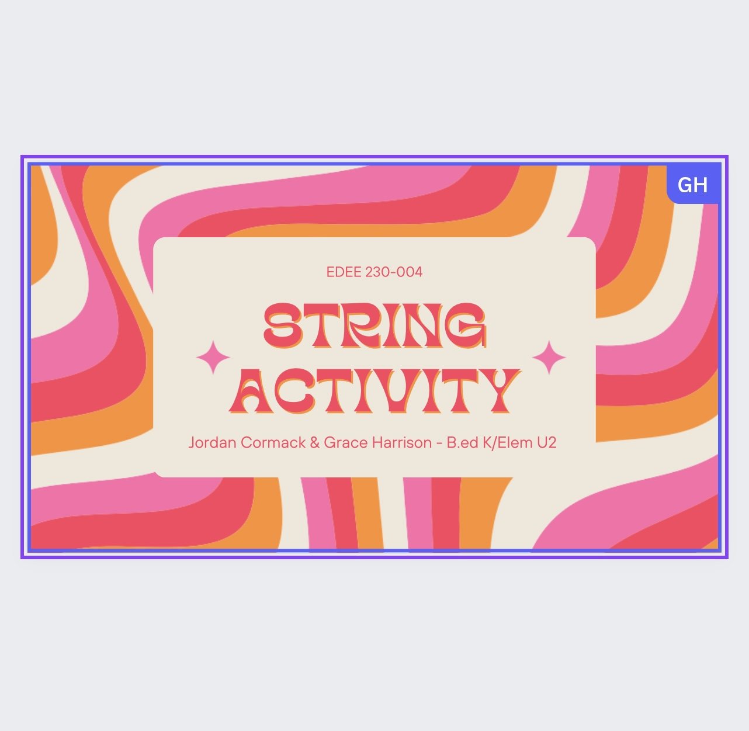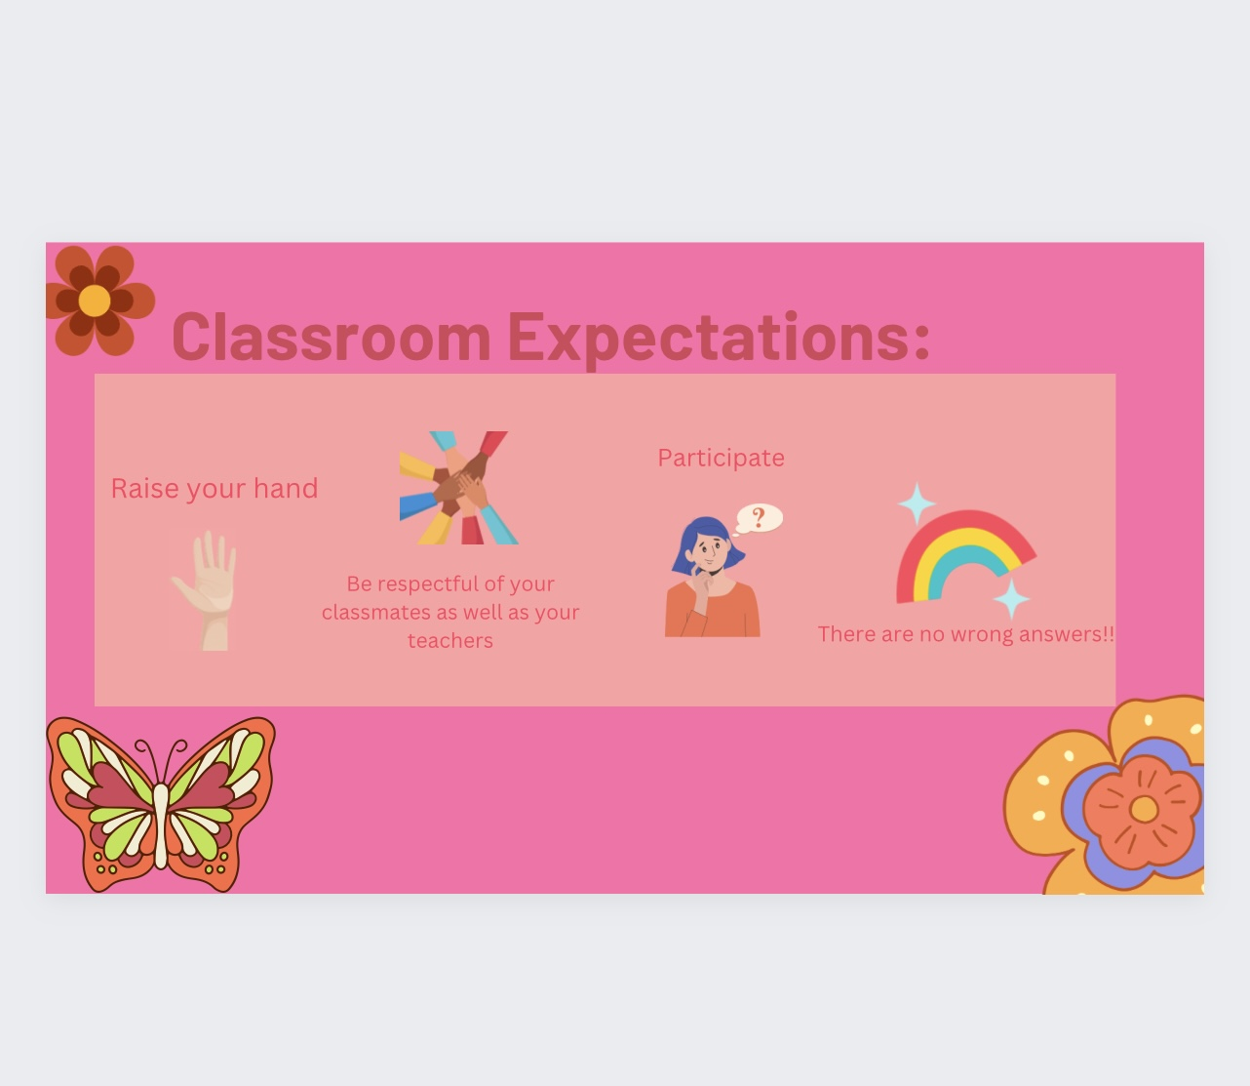  TEACHER: Good morning class; before we get started, we are to go over classroom expectations.  TEACHER: Does anyone know what that could be?  STUDENTS: Give various ideas and examples  TEACHER: It is respectful to raise your hand, we are participating  TEACHER: Is there a wrong way of getting to an answer? There is always to obtain an answer, sometimes we just need to push our answer to discover the answer  The script used in the classroom and followed the slides. It was introductory and its goal is to help students understand what is to be coming in the lesson and to remind them of classroom expectations.  Student thinking involved:  STUDENTS:  - What is string  - Raising your hand, participate, don’t be disrespectful  - Try your best  - Don’t be rude  - We are participating  - There are sometimes wrong answers  - 1 +1 = 11?
Mathematical Instructional Content Goals that you were targeting in that moment  (Focus on an instructional content goal (and not a practice goal). These are listed in the protocol of the lesson.) | In that moment, the introduction served as a steppingstone into introducing the topic to the students. The mathematical goal was to introduce the word “string” to students and develop some understanding before transferring over into equations/situations that will be formed to demonstrate string.  Students will learn how proportional reasoning can be used to solve different equations. Students will learn why the strategy using the relation between equations works.  By setting up a proper introduction to lesson, you heighten the chances of retention and prepare students to actively engage to be able to acquire the reasoning related to the lesson.
Explanation of how the practice was enacted in a way that targeted the instructional goals | The practise was enacted by primarily discussing the idea of the string, introducing the topic to them and shortly after beginning the first example. It targets the goals teaching them proportional reasoning to solve different equations by explaining to them there are multiple ways in being able to provide the answers to the string.  Furthermore, by explaining to students to pay attention to the correlation between the strings and leave the examples on the board, there is a better chance for students to understand that there is a relation between equations and identify how it works.

2- What you will do differently in the future:
Practice of High Quality Teaching:  (You can choose the same practice as in Part 1. Select a practice from the list of practices of high quality teaching in the syllabus. Be sure to select a practice, not a principle.) | Representing Student Thinking
Video Time Stamp  (e.g. From X:XX to X:XX in Video X (if more than one video)) | 3:41 to 9:20
Detailed Description of what happened in that moment  (Be specific – transcribe word-for-word what was said. Include a picture or photo of the board that was discussed at that moment.) | TEACHER: We are going to get started, please be reminded there are multiple ways and methods. 12 X 5, take a couple of seconds to think of how you got the answer  STUDENTS: Answer 60  TEACHER: Does everyone agree with the answer? Hands in the air who thinks the answer is 60. Okay let’s see some methods  STUDENTS:  - 12+12+12+12+12 *addition  - 10 x 5 = 50 + 5 + 5  - 12 x 4 = 48 +12  - 5 + 5 + 5 + 5 + 5 + 5 + 5 + 5 + 5 + 5 + 5 + 5  - 24 + 24 + 12  - 30 + 30  - 12 x 6 – 12  - 12 x 4 + 12  - 100 – 40  The audio kept cutting out on my computer however every time a justification was provided it was pushed to understand completely the students reasoning. Often students could correlate with one another.
Rationale for why you would want to change what happened in that moment  (Be sure your rationale is closely connected to the practice you identified) | There are a few justifications that were clearly drawn off of other justifications and did not reach conclusion in their head. Examples would be 100 – 40 and 30 + 30. My practise is indeed to represent student thinking however in this case there is further thinking to be discovered as they were most likely forming an equation based off of the answer.
Example of what you would do differently  (Be very specific in your descriptions. Write out exactly what you would say instead or provide a picture to show what your representation would look like.) | I would push students thinking somewhat further given the answer and justification they provide me with. The only thing I would do differently would be to figure how they obtained the answer originally and not by knowing the answer and developing from there.  Example:  Student says; 100 – 40 = 60, there is the answer  Teacher says; You are right that 100 – 40 = 60 however how did you know 12 X 5 = 60? What did you initially do to get to the answer 60
Rationale for why you would want to make that particular change  (Keep in mind your mathematical instructional content goals) | I would want to make that particular change in reason that students need to understand how multiplication works and in this case string. If students are creating equations after the answer has already been developed, then they are missing the point of the exercise. Although there is a skill in being able to create equations from an already known answer. Yet this is not the case here, students here are tasked with figuring out and explaining how they obtain a given answer for a given equation. As a teacher if I want to properly represent my students thinking than I need to understand it entirely.

3- Reflection of Learning:
Identification of practice you wanted to work on in your rehearsal reflection | Setting & Maintaining Expectations
Changes in execution of practice from the rehearsal to the enactment (and time stamps)  (Be sure to include one detailed example from your rehearsal and one from your enactment and explain what changed in your execution of the practice. Try to stay brief.). | Description of the Rehearsal [time stamp]:  (we do not have access to rehearsal as the sound does not work)  Although I do understand that the class is an elementary school math course, I do believe that in any course, the most important part of the lesson is often the introduction. The introduction is where you pull in the student’s attention and get ready to engage in the lesson that is about to unfold. In the rehearsal, I do not properly introduce myself and introduce the classroom expectations at a very fast speed. Furthermore, I do not include much class participation. The example I choose to change was the way I read my classroom expectations. In the rehearsal I simply read through them quickly and did not involve the class.  Description of the Enactment [time stamp]: 00:03 to 3:10  In my enactment the change I made was exploring classroom expectations further as long as the whole introduction. I allowed for much more discussion among the class in order for them to feel part of the lesson.  What changed:  The change is simply being in a classroom with elementary school children instead of being with university classmates. I do not love the idea of presentations where the whole class has eyes on you. This has always been the case since I was young. However, the idea of doing it with younger children and being their instructor, takes my stage fear away. The rehearsal did teach me to engage for a slightly longer period of time when going over classroom expectations and engage with students slightly more. Both ideas were implemented during my enactment and made it more complete with great class participation.
Future goals for improving and furthering your practice after the enactment  (Be sure to provide specific examples.) | Future goals:  - Setting classroom expectations at the beginning of the year and continuously referencing it. As well as having them in eyesight for students to remind themselves at any given point.  - A goal; to foster a welcoming and safe classroom environment
Rationale for future goals  (Be sure to provide examples from your enactment to help justify the need to focus on these goals.) | What could be useful to add is perhaps going over a whole string activity on the board by demonstrating the idea of it all. Giving students a visual aspect on top of the description already provided. It could be rewarding for some to see visually what the idea string is in order to participate. In my rehearsal I go over my classroom expectations too quickly, however in my enactment I open up more and go into classroom discussion. However, I do believe a beneficial aspect of my introduction could involve the visual demonstration of an example of a string. By doing so, my goals would align properly. Showing students that there are multiple ways of obtaining an answer and or conclusion.
Other goals for my math teaching | - Providing many examples to demonstrate to students that there are multiple ways of reaching an answer.  - Allowing time for classroom discussion, allows students to see and observe that there are multiple ways at reaching an answer. Often it gives students the courage to participate and step out of their comfort zones.  - My goal for math teaching is to approach mathematical understanding and mathematical problems from different angle and perspective to allow for a more maximal understanding.

