**Learning Plan**

Jordan Cormack & Grace Harrison

Department of Integrated Studies in Education, McGill University

EDFE 256-001: Second Field Experience (K/Elem)

Allie Holloway

May 21st, 2023

**Learning Plan: ELEMENTARY & SECONDARY[1]**

| **Student Teacher** | Jordan Cormack  Grace Harrison | | | **Cooperating Teacher(s)** | | Amanda Ellinor | |
| --- | --- | --- | --- | --- | --- | --- | --- |
| **Date** | Tuesday, May 23rd 2023 | **Duration:** | 60 minutes | | **Room** | | S3/4  Rm 120 |
|  |  |  |  |  |  |  |  |

| **Title of lesson** | Introduction to Internet Safety | **Grade level** | 3/4 |
| --- | --- | --- | --- |
| **Subject** | Ethics, and Religious Culture | **Topic** | Internet Safety |
| **Relevance** | * The children are increasingly more exposed to Social Media and they are at the age where they are curious. It is becoming increasingly more important in our society to teach kids the importance of using the Internet responsibly and safely. It is equally important to educate children on the dangers that are involved with the internet/social media and how to take the right steps in order to be cautious. | | |
| **Materials/Resources Required** | * Smartboard; * Slideshow: Internet Safety provided by CT * Pre-Test (found in Appendix) * Interactive activity provided by CT - <https://zoeandmolly.ca/app/en/> * Video - Being Safe on the Internet (Amaze ORG on Youtube) * Kahoot * Printed exit tickets (found in Appendix) | | |
| **QEP Subject Area Competencies** | **Competency 1: Reflects on Ethical Questions**   * Students will be asked to reflect on questions given to them concerning ethical dilemmas. * Students will be asked to discuss prompt questions, and share their opinions and feelings.   **Competency 3: Engages in Dialogue**   * Develops a point of view * Participates in discussion * Organizes his/her thinking and expresses their thoughts | | |
| **Learning Objectives** | **Ethics and Religious Culture:**   * Students will learn through a differentiated learning method accustomed to fit the needs of everyone. * Students will understand the dangers that surround the internet/social media. * Students will understand how to be safe and cautious while using social media. * Students will be able to apply their knowledge through interactive assessments. * Students will be asked to think ethically. * Students will apply acquired knowledge to real life situations. | | |
| **Essential Question(s)** | * How can we use the Internet Safely? * How does Internet safety affect our daily life? | | |

| **Lesson Timing**  **(1 hour)** | **Introduction (hook):** | **Student will know:** |
| --- | --- | --- |
| (prompt discussion + pre test worksheet)  The lesson will commence by introducing the topic with a prompt discussion. We will ask something like, “with a show of hands, who here has tiktok, snapchat, etc?”  The goal is to evaluate and understand students comprehension and assess where they are at.  Following the discussion, students will be given a worksheet (pre test) to be completed quickly in small groups to get students thinking about the topic. A timer will be put on for students to collaboratively jot their ideas down. In turn this will help contribute to future meaningful discussion. | * The importance of accessing the internet safely. * The possible consequences of Social Media. * The effects the internet/social media can have on young individuals. |
|  | **Development (Learning activities – step by step sequential procedure):**  (power point, video, interactive quiz & kahoot)  Step 1: Move the class on from the pre test by discussing.  Step 2: The power point will be launched. The power point promotes students to be interactive. The goal is to have students be as involved as possible as we want students to take the most away from this important topic.  Step 3: Interactive activity with students  <https://zoeandmolly.ca/app/en/>  Step 4: After our classroom interactive activity, we are going to watch a short video to continue with our topic material.  <https://www.youtube.com/watch?v=HxySrSbSY7o> (Being Safe on the Internet)  Step 5: Following the activity & video, a classroom discussion will take place. We will go over with students what they took away from this lesson. What are some important key points? Verify students understanding, the dangers of social media and understand how one can be safe while using social media)  Step 6: Play Kahoot with the students. (Internet Safety) An interactive game where everyone will play individually. <https://create.kahoot.it/details/93115b30-f07c-4bae-8887-f837a6e3df61>  Step 7: After the Kahoot we are going to shift our lesson into its closure; the exit ticket. Here we will encourage students to think about questions they still have about the internet. | **Students will understand:** |
| * How to safely use the internet. * How dangerous social media and the internet can be. * The importance behind caution and seeking help in moments of uncertainty. |
|  |
|  | **Students will do:** |
| * Activities concerning cyberbullying & online safety. * Students will create and develop questions related to content. * Students will participate and think critically. |
| **Cross Curricular Competencies:** |
| **C1: To Use Information**   * Students will be asked to take the information they learn and answer critical questions through kahoot and an exit ticket. * Students will be expected to use this information from the lesson in order to use the internet safely.   **C9: To communicate appropriately**   * Students will be expected to communicate and participate in classroom discussions. * Students will be asked to communicate through written activities. |
| **Broad Areas of Learning:** |
| **Health and Well-Being:**   * Students will develop an understanding about the dangers around the internet and social media. Students will become aware and learn to be cautious when interacting with technology. By having students develop good habits, in turn it will help them remain safe and we take into account their well being.   **Media Literacy:**   * Through exploration of the lesson/topic, students are exposed to a technological aspect. Students will understand the content by the support and aid of technological tools. |
| **Universal Design for Learning/ Differentiation:** |
| * The lesson is designed in order to be flexible for those who need differentiation. * Multiple different means will be used to execute the lesson in order to maximize a consensus of understanding. * Ipads will be implemented and accessible for any student who needs them when we do the class exit ticket. Flexible seating is available in the classroom; They will have the ability to sit wherever they please during the activity. * We will be doing different activities throughout the lesson that will hopefully give everyone something they are capable of doing. * Reading corner and headphones are available for those who need for working time. |
| **Closure (transition):**  Exit ticket   * Students will fill out an exit ticket by answering some short questions that will be followed up in the next class. * They will be given a sheet of paper that asks: * 3 things you have learned today * 2 things you would like to learn more about * 1 question you still have * Our CT will be able to use this exit ticket to gauge what the students’ are interested in learning, and what they have already learned, etc. * The lesson will set the foundation for the continuation of the unit | **FORMATIVE - Assessment FOR learning:** |
| * Interactive quiz that is ungraded and completed individually. |
| **FORMATIVE - Assessment AS learning:** |
| * Did the students participate actively? * Did the students discuss and ask questions? * Were students able to complete activities and stay on task? * Students will be evaluated formatively by getting involved in classroom discussions. * As well as through the individual interactive activity of Kahoot. |
| **SUMMATIVE - Assessment OF learning:** |
| * Students will be asked to complete multiple activities throughout the lesson in which they will be graded on understanding and participation. * Exit tickets will act as our main guide to evaluate if students have grasped the concept. |
| **Equity, Diversity & Inclusion (EDI) Considerations:** | | |
| **Further considerations:**  Students will work to complete activities to the best of their abilities. Differentiation will be implemented whenever needed in order to accommodate students’ who need it.   * Vocabulary will be modified to students' abilities. * Ideas will be presented through auditory and visual means. * Some activities may be completed on the computer/ipad. * Kahoot will be done individually, however if needed there will be guidance and support given to those who may require it. * The exit ticket will be a good indicator to evaluate their knowledge and comprehension on the subject matter. From there, the teacher will be able to adjust accordingly for future lessons. * The principles of UDL are present in the lesson, highlighting differentiated learning. Engagement is used as the lesson is carried by students' participation. Representation is used by different means of presentation both audio and visual as well as both electronically vs paper. Along with action and expression that is delivered through different formatting of the lesson presentation. | | |

| **Reflection:** |
| --- |
| * Did I effectively grab the students’ attention and get them interested in Internet Safety? * Did I successfully facilitate a meaningful and impactful class discussion on cyberbullying and Internet Safety? * Was the material appropriate for the class? * Were my explanations and demonstrations easy to follow and understand? * Did I remain engaging and enthusiastic about Internet Safety throughout the entire lesson? * Did I deliver the topic matter in an effective way that can be used outside of the classroom? |
| **Professional Competencies:** |
| **Competency 3: Plan teaching and learning situations:**  I will work to develop strong and relevant learning opportunities which aim to enhance the curriculum. I will take into consideration all the important components of this learning situation such as student diversity, organization of materials, and differentiation.  **Competency 8: Support students’ love of learning:**  I will maintain positive relationships with my students through listening to them and their opinions. I will help promote the importance of their self-confidence by teaching an in-depth lesson on Internet Safety. I will aim to engage the students using relevant information while also relating to something they are familiar with, such as: tiktok, snapchat, etc.  **Competency 12: Mobilize digital technologies:**  I will aim to promote the use of technology in a safe manner. I will present resources for the students' that present important information concerning internet safety. There will be technology incorporated within the lesson as well. I will integrate the use of the SmartBoard and Ipads throughout the lesson to mobilize technologies.  **Competency 13: Act in accordance with the ethical principles of the profession:**  I will demonstrate and promote to students how one's values affect their everyday life in society. Students should act in an ethical manner on the internet as much as in person in the classroom. By showing students ethical principles and fostering strong relationships with them, the goal is for them to respect and follow along. |

***[1]*** *Based on a simplified version of Understanding by Design (UBD) and the IB Middle Year Program Planner*

**​​Appendix**

**Pre-Test:**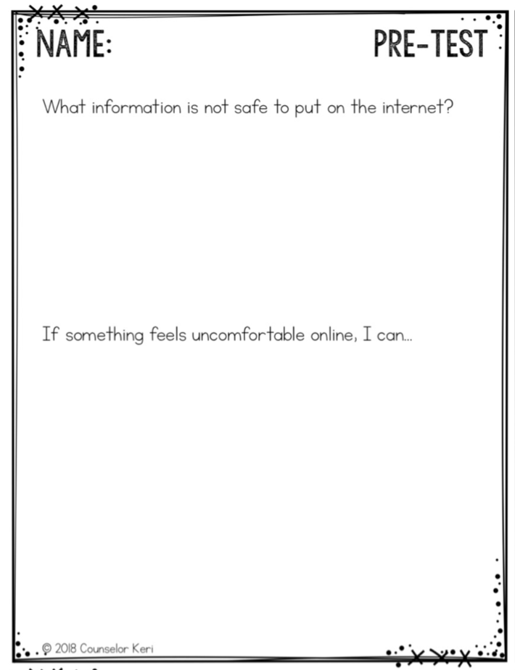

**Exit ticket:**

