Literacy Trunk



Grace Harrison

Department of Education, McGill University

Language arts, EDEE 223-003

Melanie Bennett-Stonebanks

February 20th, 2023

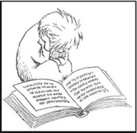

**READ ALOUD WORKSHEET**

|  |  |  |
| --- | --- | --- |
| Reader: Grace Harrison | Date: February 20th, 2023 |  |
| **PRE-READ ALOUD (PREP)**  Book Choice | 1. Title:  * Love you Forever by Robert Munsch  1. Brief synopsis (your own words)  * Love You Forever follows the evolution of a young boy from the moment he was born, all the way through his adulthood. His mother portrays the hardship’s involved within the parental role. Moreover, it demonstrates the unconditional love a parent can provide in the life of their child. As the boy progresses along in life, readers are exposed to a variety of situations where mischief is involved. Whilst the troubles the child gets himself into, his mother’s is always there every night, singing her song while rocking him to sleep. As the boy turns into a man and has a life of his own, he returns the favor as his mothers gets older. Driving across town the son goes to sing and rock his mother to sleep. He then return’s home where he has built a family of his own and continues the tradition with his daughter.  1. Reason for choice:  * I choose this particular book as it holds great meaning to me. When I was a little girl, I lost my father, and this was the book my mom read to me almost every night before I would fall asleep. As I grew older, I never stopped reading it. The meaning behind the book changed as I aged, as I matured, and I was able to reach deeper connections. I remember it being a comforting moment where I felt safe alongside my mom. There is a lullaby that goas along with this book pulling you in even more. Furthermore, I picked this book for many other reasons as well. Another one being that I believe that it can be a good read for children who perhaps only have one parent in their life. It shows them that it is acceptable and demonstrates the power behind love. The book also offers the idea that gender roles and the relationship they have do not always correlate with the norms of society. In the book, nearing the end we are shown a man, who takes on the nurturing role to take care of his mother. Going greater than love and happiness, the book provides a great life lesson on the circle of life. It shows children, that in reality one day, you will have to be the part you parents once were to you. Of course, young children will not pull these deep meanings off the bat, however it can be a mind opening reading on many different levels. Personally, I really enjoy the read. I believe love is so precious and children should be exposed to it and understand its power. The book can be an essential tool, guiding children towards important and essential topics.  1. 4. How, where, when might you include this in a lesson?  * The book could be included in an English based/Language Arts lesson(s). The main idea I have would be to create a book unit with “Love You Forever” which would allow for multiple lessons. The book is enriching is many aspects of learning. Its themes include; death, the circle of life, fulfillment, happiness, family, love, gender roles and much more. The book is an easy read, allowing children to be able to understand it and hopefully connect and pull meaning from it. A “storybox” for the book would be a perfect introductory measure either prior to the initial reading or right after. It enhances the learning experience for the children. The ideal age grades would be grade 1-3. You can work the lesson to accommodate depending on grade level and level of difficulty. | |
| Notes for Book Introduction (Aside from introducing titles, cover illustrations, naming author/illustrator):  **1.What context [background knowledge]** might you provide before reading | 1.Context:  Before reading through the box, a good starting point would be to go through the story box with the students. Student’s will get to touch and see pieces that will help bring meaning to the story through a visual aspect. If the classroom is composed of a carpet or open space, this is where ideally, I would want all the students to sit. I would start a discussion with them about what they think the book is going to be about from having seen the items from the story box.  Additional questions;  Ask students if they read books before going to bed?  Ask them if they know what a lullaby is?  Ask them if sometimes at home, if they give their parents a tough time?  Ask them what they think the definition of love is? | |



**READ ALOUD WORKSHEET**

|  |  |  |
| --- | --- | --- |
| (if any necessary)? |  | |
| **Notes for Book Performance:** -Identify places you will pause, words you will emphasis, moments you think students will need to take time to look at illustrations, opportunities where children can actively engage with text (act out; respond; repeat) | Note #1   * Once students are ready to begin reading, I would like to take a moment, initially to ask them to talk about the book cover. I would go on to ask them what they think is going to happen in the book. As well as ask them what love you forever means to them.   Note #2   * At the end of page four, I will ask students to repeat the following after me;   “I’ll love you forever,  Ill like you for always,  As long as I’m living  My baby you’ll be.”  Note #3   * Emphasize the phrase “This kid is driving me CRAZY”   Note #4   * After completing page 6, I will ask students to analyse the picture of page 7. (They will find a young boy who is playing with toilet paper on the bathroom floor, making a mess) Students will surely be amused with this illustration. I want to give them the opportunity to interact and perhaps share a moment of their own where they caused mischief in their household.   Note #5   * At the end of page 8, I will carefully read over a repeating phrase.   “I’ll love you forever,  Ill like you for always,  As long as I’m living  My baby you’ll be.”   * I want to see if my students remember if I have already said it. Moreover, I want them to understand there is meaning behind it as it is going to come up at multiple occasions during the reading.   Note #6   * At the end of page 12, while looking at the illustrations on page 13. I will ask the class why after all the hardships this young boy has given his mother, why does she go into his room and sing to him (every night)? * Is the young boy who was once a baby, growing older each page we go? * Additionally, asking them; do we see now are repeating phrase is a song?   Note #7   * On page 19, can someone describe to me what’s happening?   Note #8   * My goal here is for students to understand what is going on page 23. The roles are being reverses and it is now the son’s job to drive across town and hold/sing to his mother as she is no longer capable. * I will ask them. What is happening? What does growing old mean? Can anyone play this role (addressing gender roles)?   Note #9   * On pages 24-29, I want students to evaluate what’s transpiring and give their hypothesis while taking into account the circle of life. * I will explain to them in simple terms what the circle of life is and guide them through how it applies here.   Note #10   * Once known as this young boy, who is now a grown man with a child of his own... I will ask students what do you think he is going to sing to his own daughter? * After students give various answers, we will read page 30 and conclude by saying together;   “I’ll love you forever,  Ill like you for always,  As long as I’m living  My baby you’ll be.”  Note #11   * Place emphasis on the singing phrase that is read before bed. |  | |
| **Engendering Response:**  1. What kinds of simple **questions** can you ask to encourage responses and prompt critical thinking while or after you read?  2.  What other ways (**activities**) might you use to encourage their responses? | 1.Questions:   * What is love? * Is the role of your parents and/or guardians important? * What is growing up? * What is the storyline behind the book, what happens to the boy?   2.Activities:   * To prompt writing; write out your definition of love. * Draw a picture of you at home, doing something (anything). * Either write or draw a picture of your bedtime routine. * Act out, a song or lullaby or something that makes you happy. * Do a simple circle of life activity together. |  | |
| POST READ ALOUD:  **Reflection:**  How did your reading go? What could you improve upon? | Overall the reading went well. The passion I have for this book goes above and beyond and is demonstrated when I read it. I find that when yourself (the teacher) is invested in the book, it shows the children that you want them to feel your experience.  One area I could use improvement with is getting the proper rhythm for a phrase that is repetitive throughout the story. I seem to not read it cohesively each time, perhaps as I go to fast or get sidetracked while either observing the class or the illustrations.  It is also very important that I remember to not go through the story too fast as it comes with some deeply rooted meanings and if students are prompted properly and included in the reading, I am confident of the outcome.  The reading is one that typically goes well as the book has some fun illustrations to which students can relate to (especially on the front of mischief and getting into trouble). |  | |

Reading Strategy

(2 activities)

**After having completed the read aloud, students will take part in 2 reading strategy activities**

*Activity 1 Instructions:*

* *Students will receive a copy of the book and go over it again as a team*
* *Students will work in groups of 3-4 students*
* *There is a great amount of words the repeat themselves throughout the pages and students’ tasks will be to identify word passages.*
* *The goal is to promote the alphabet, reading fluency, and word pronunciation.*
* *A worksheet will be provided to each student (an example of a rough drafted worksheet)*

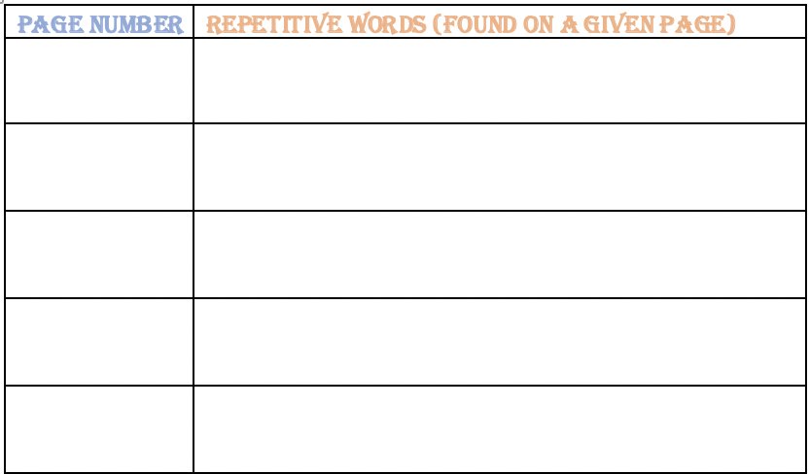

*Activity 2 Instructions:*

* *Students will be asked to sit at their desks while I play on screen (smart board) an audiobook of “Love You Forever”. I will do this as; students should be able to read through or listen to a given text at least 2 times before having to do any work. Moreover, by having them listen to another voice, perhaps those who did not respond well to my reading will have a better experience this way. The goal is to make sure all students have understood the book in order to complete their work properly.*

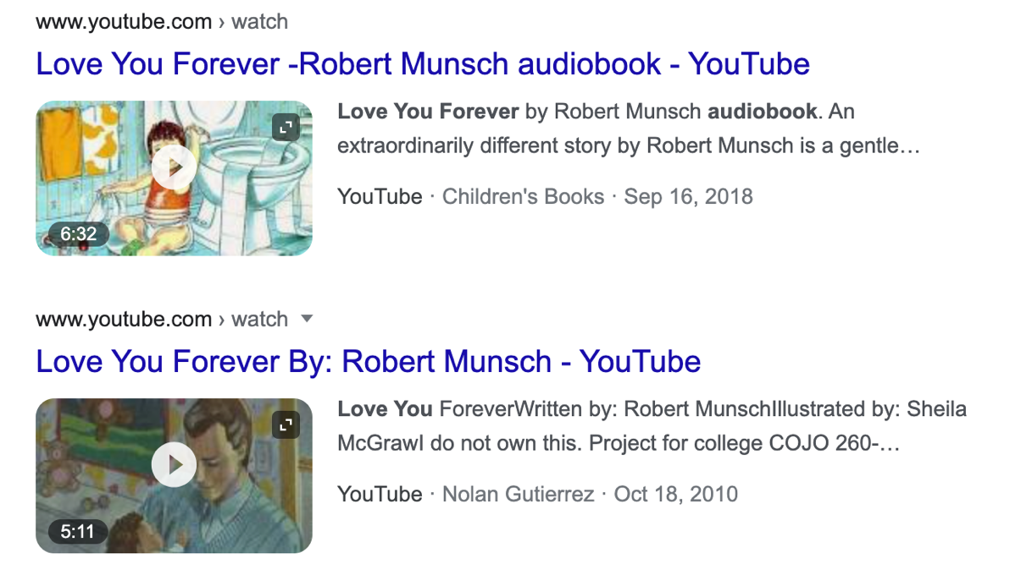

* *Students will work independently on this worksheet. The worksheet is to develop their story skills. What they have learnt about the reading. See below for worksheet \*\**

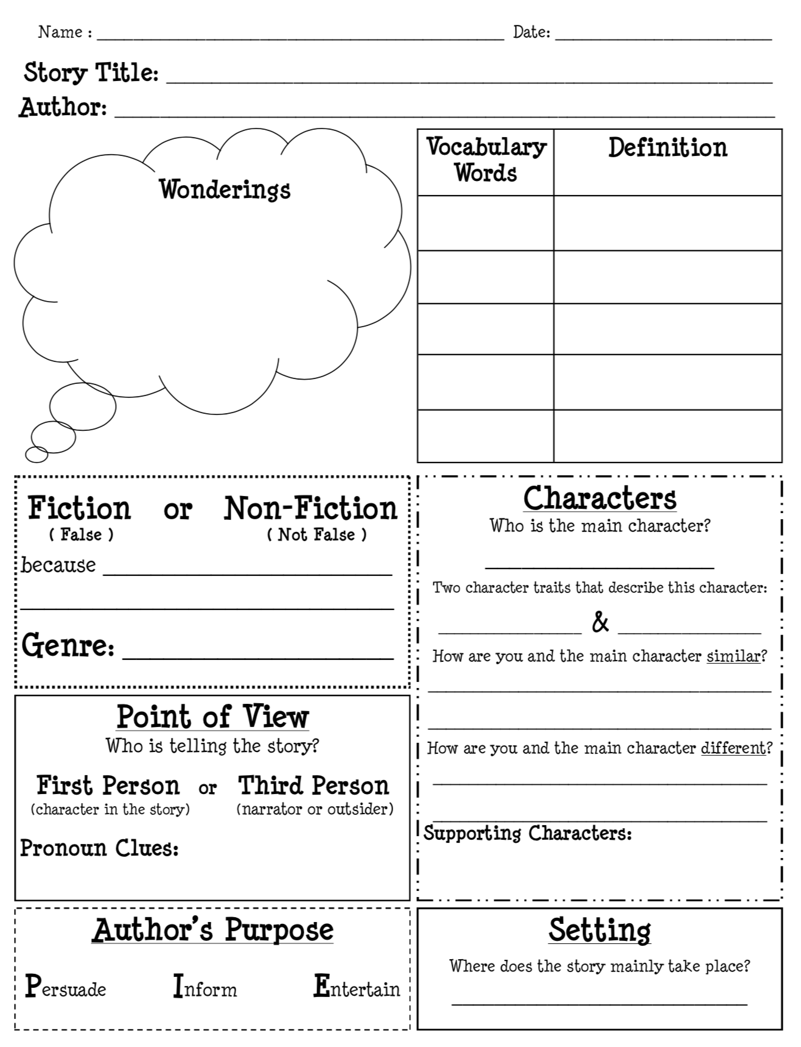

Writing/response Strategy

*Activity Instructions:*

* *Students will have the opportunity to respond and react to the reading “Love You Forever”*
* *Each student will receive a booklet to complete. Students will work individually and after a given amount of time, they will be able to spring some ideas off of their classmates.*
* *Below you will find some ideas of a lesson plan that includes a given booklet related to the book we are discussing;*
* *The booklet would include a writing prompt, summary of the book, connections, important events, plot and much more*

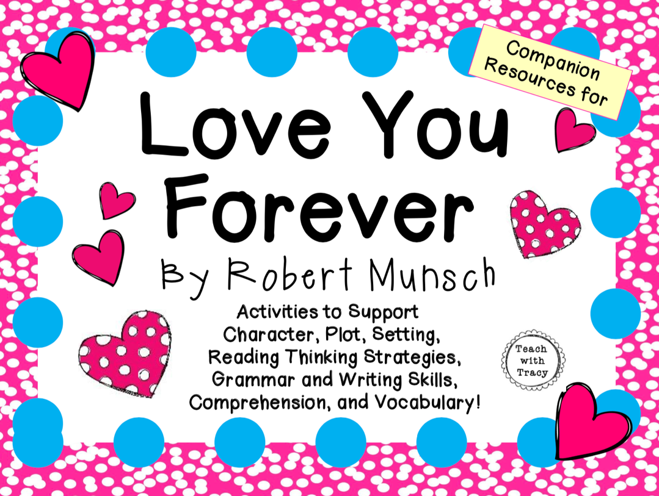

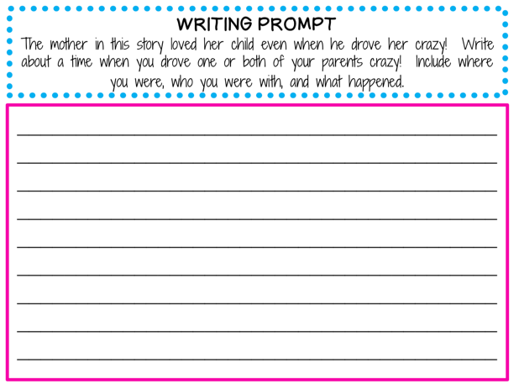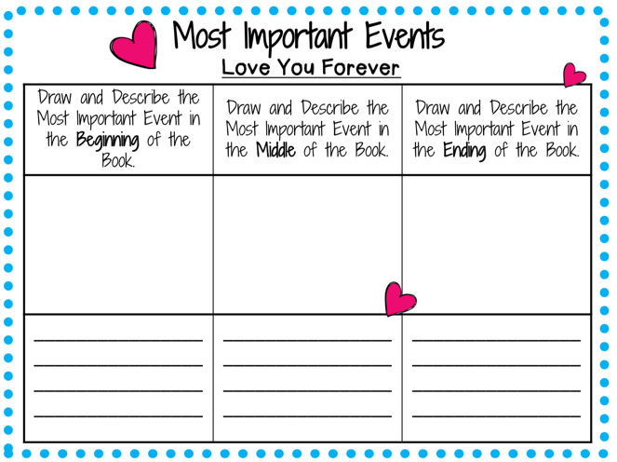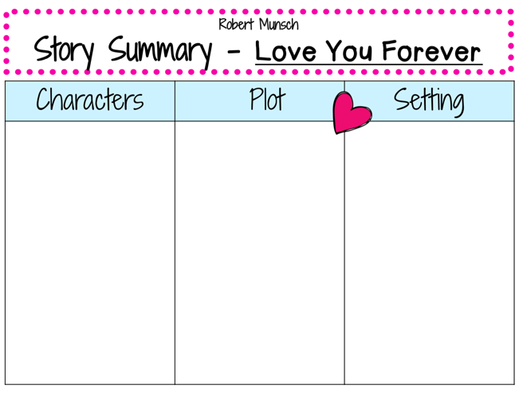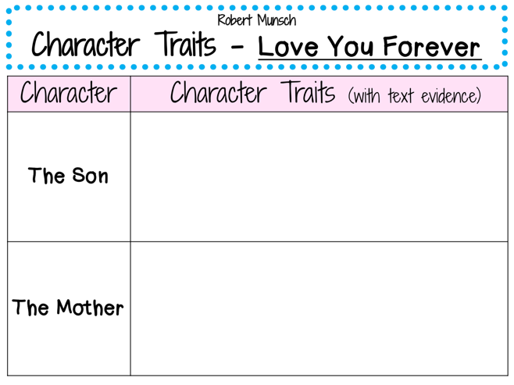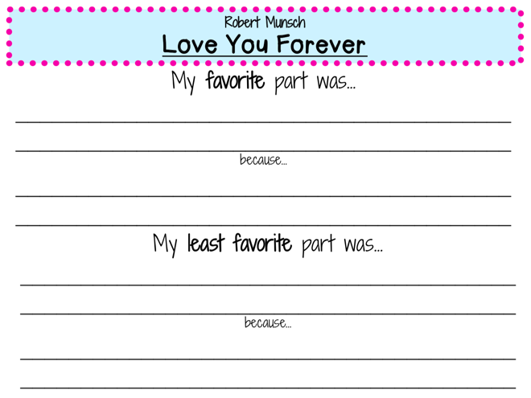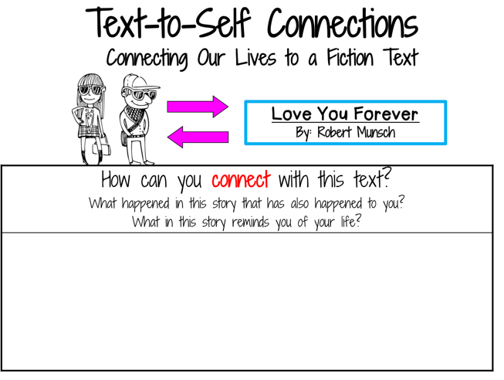

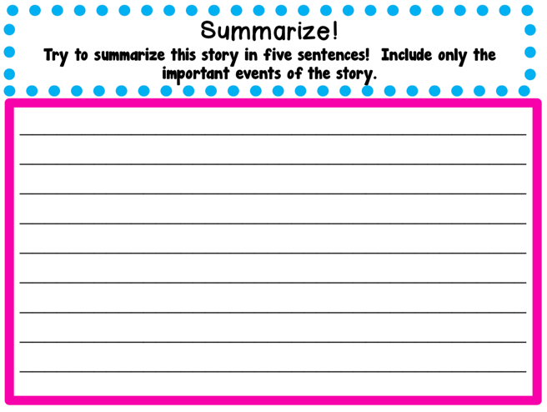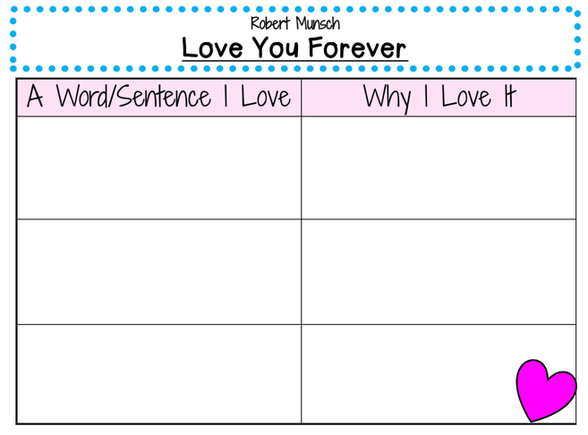

Fine arts approach

*Activity Instructions:*

* *Students will be able to create an art piece on a small canvas about love. They will be asked to write down what they think their definition of love.*
* *Moving on, they will brainstorm how they would like to put their definition into a piece of art.*
* *Materials needed; small canvas (provided by teacher), paint, paintbrushes and their smock/apron*

*\*\*Inspiration ideas below*

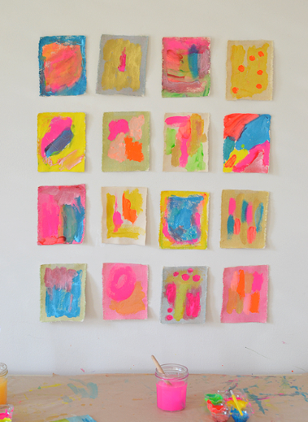

Insta post

Words can’t express how much this book means to me. It instantly just puts a smile on my face. As a future elementary school educator, I feel it is essential to have this book in my library collection. My end goal would be to use this book incorporated into a lesson. I believe its meaning behind it is significant and well worth diving into. The illustrations are different and enriching as they have an olden touch.

I choose my hashtags by reflecting on what was important to me and why I believed the book was a well worth read. I want to promote the book not because I like it, by reason that it can be beneficial for children to understand its multiple meanings. Love being the most potent theme, is one children should feel safe around. Teaching children about love has a long list of benefits that I want to be part of as a future teacher.

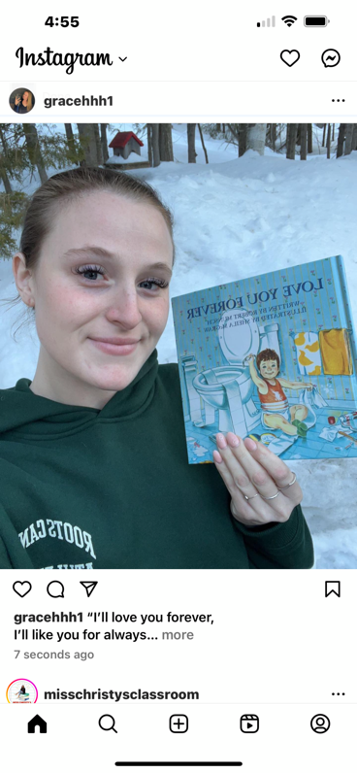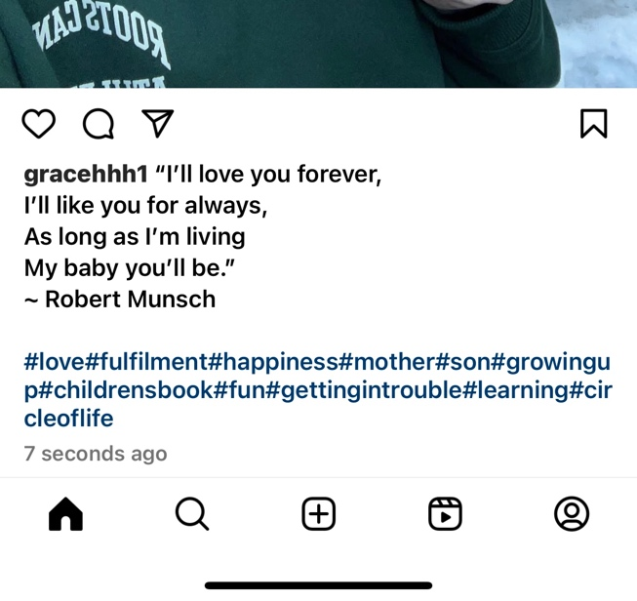

“storybox” unboxing video

I choose to include in my box the following:

* A blanket (bedtime story, used to show comfort)
* A small stuffed animal (reassurance/safety)
* Toilet paper (reference to mischief that takes place in the book)
* Alarm clock (everyday life, start of a new day)
* Toy car (as the boy turns into an adult and has a house of his own)
* Headphones (teenager phase)

LINK:

* <https://vimeo.com/800546137>

References

*Munsch, R. N., & McGraw, S. (2006). Love you forever. Firefly Books.*

*Results for Love you forever book. TPT. (n.d.). Retrieved February 19, 2023, from https://www.teacherspayteachers.com/Browse/Search:love%20you%20forever%20book*

*(lesson plans taken from website for idea base)*