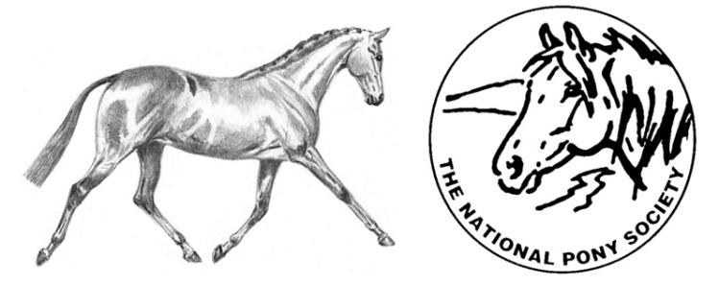
NATIONAL PONY SOCIETY
NPS AREA 4 EDUCATION /TRAINING BURSARY
The aim of the bursary is to offer financial assistance to access specialist training for up to the sum of £200.00 kindly given by Area 4.
- Applicants must be aged between 10 and 18 years old on 1st January 2022 and be a current NPS Area 4 member in their own right or their parent/guardian must be a member.

- Funding may be requested for:
A) A series of lessons with a new instructor, working at a higher level;
B) Cross-discipline tuition (e.g. a WHP rider who wishes to take lessons with an approved eventing instructor);
C) Attendance on a short, intensive course with an approved instructor.

- The instructor will be asked to raise an invoice for their work and funds will be paid direct to the instructor as part or full payment for their time.

- Candidates will be evaluated in December 2021, with funding tranches to be paid throughout 2022.

- The successful candidate will be notified with their bursary at the beginning of January 2022 and will be asked to attend NPS Area 4 AGM in November 2022 to give an update of what they have achieved with the help of the Bursary and to write a short report for the Area to include in their report for the 2023 NPS Review, explaining what they did with the funds and how it has benefitted them.
If you are interested, please complete the attached application form, and return it to Christine Duke no later than the 20th December 2021

NPS AREA 4 BURSARY APPLICATION FORM

Name: ____________________________________________ D.O.B. _____/______/_______
Address: ____________________________________________________________________
___________________________________________________________________________
Telephone: ________________________ Email: ____________________________________
I am a current NPS Area 4 Member My parent/guardian is a current NPS Area 4 Member ……….

Membership No: __________________Year Joined: _____________ NPS Area: ___________
Name of current instructor(s)/trainer(s): __________________________________________
Name of proposed instructor(s)/trainer(s): __________________________________________
- Please outline your ridden or in hand experience so far (max 250 words)

- a) Please outline your involvement with the NPS at both national and area level (e.g. assisting at area shows, member of area or national teams)

Please tick if appropriate
Attend local NPS Area Show
Assist at local NPS Area shows or events
Attend NPS Spring Festival
Attend NPS Summer Championship Show
Assist at the Spring or Summer Championships

b) Please provide further details of your involvement with the NPS (max 250 words):

- Please explain what you would like to use the NPS Area 4 bursary for and how this would develop your current training and experience (max 250 words)
Type of training  (e.g. Dressage lesson) | Objectives and aims once training is completed  (e.g. Qualify for National Dressage Champs) | How will this be achieved  (e.g. 6 lesson with person X)

- Please indicate the anticipated costs for your proposed training plan. If the NPS Area 4 bursary is insufficient to cover the costs, please indicate how the shortfall will be met
Training | Cost of Training | Mileage Cost | Total Cost | Short Fall (if any)
Reference 1
Referee cannot be a relative of the applicant or a member of the Council but must be a current member of the NPS.
Referee 1
Name: ____________________________________NPS Membership No: ________________
Telephone: ________________________ Email: ____________________________________
Reference: ___________________________________________________________________
____________________________________________________________________________
____________________________________________________________________________
____________________________________________________________________________
____________________________________________________________________________
____________________________________________________________________________
____________________________________________________________________________
____________________________________________________________________________
____________________________________________________________________________
____________________________________________________________________________
Signed: __________________________________________Date: ______________________

Referee 2 – Optional. Referee cannot be a relative of the applicant or a member of the Council but can be a non-member of the Society.
Name: ______________________________________________________________________
Telephone: ________________________ Email: ____________________________________
Are you a current member of The National Pony Society? Yes No
Reference: ___________________________________________________________________
____________________________________________________________________________
____________________________________________________________________________
____________________________________________________________________________
____________________________________________________________________________
____________________________________________________________________________
____________________________________________________________________________
____________________________________________________________________________
Signed: __________________________________________Date: ______________________
Applicant declaration (if aged 18 only)
I declare that the information given is accurate to the best of my knowledge and agree to the society’s terms and conditions.
Print Name: __________________________________________________________________
Signed: ____________________________________ Date: _____________________________

Parent/Guardian of the Applicant declaration
I declare that the information given about _____________ (name) is accurate to the best of my knowledge and agree to the society’s terms and conditions.
Print Name: __________________________________________________________________
Signed: ____________________________________ Date: _____________________________

Please return this form:-
Mrs C M Duke
Stable Cottage
Little Hutton
Caldwell
Richmond
N Yorks
DL11 7QL

Should you require any further information please contact Christine on 01833 627008 or email chris.duke008@btinternet.com
Closing date for applications: 20th December 2021

