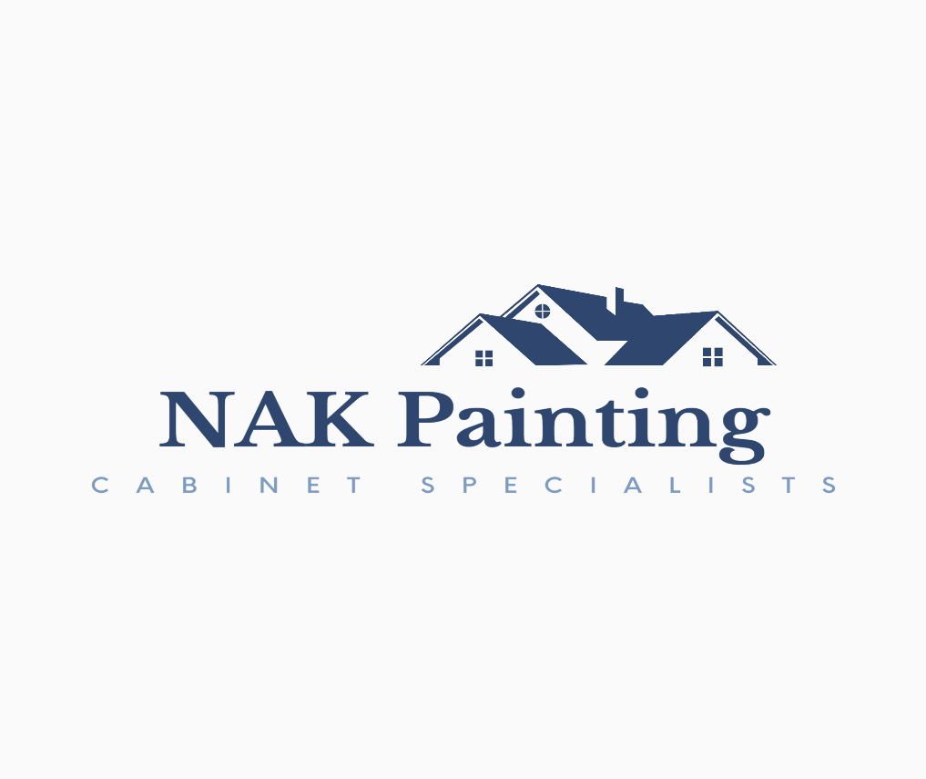

**Milesi Wood Coatings:**

Milesi is one of the largest and most influential manufacturing companies in the world. Their products are manufactured in Parona, Italy and shipped to us in your chosen color. The production plant was constructed to ensure production standards are among the highest in the world. Their environmental standards are topnotch. They are committed to enhancing safety, health and the reduction of environmental impact that all of their production and commercial activities create.

**Milesi Paints:**

The paints that I will be using in your home are the very best. I keep the health and safety of your family in mind and use products that have very little off-gassing. Milesi’s line of 2K paints are super durable, long lasting and family friendly. It does not come pre-catalyzed like the paints you’re accustom to. The hardeners must be added immediately before painting. It has a very short working time as the resin hardeners set up in minutes.

**Other Products:**

The first primer that is used is a water-born bonding primer with very little off-gassing but helps to bond the paints with the surface of your cabinets. The second primer used will be an alcohol-based tannin blocker to insure there is no yellowing over time. Which, unfortunately, has slightly more off-gassing. The smell is a little stronger while wet but quickly disappears as it dries. However, if you are sensitive to smells, we can arrange this part for a time that you’re not home and use industrial fans to pull out the smell. The manufacturer does recommend 24 hours before coating with paint.