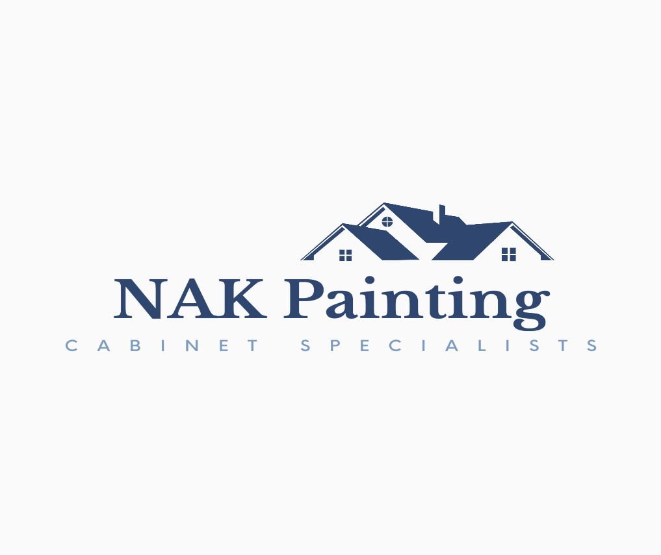

**We LOVE our CUSTOMERS!**

Thank YOU for becoming an advocate of our small business! Since most of our work is via word-of-mouth recommendations, we greatly rely on an army of satisfied customers. **WE APPRECIATE YOU!**

**Thank you for recommending our company to __________________________!**

How our **Customer Loyalty Program** works:

* Every time you refer someone that hires our service, we’ll send you a $50 gift card!
* After the 5th service, you’ll receive a $100 gift card for EVERY new customer you send to us!
* There are NO limits to what you can earn, simply by recommending us!

We want to make sure you receive your gift cards so don’t forget to tell referrals to mention your name!

There are a few ways you can refer us.

* Please follow us on Facebook at NAK Cabinet Painting
* Please follow us on Instagram @NAKCabinetPainting
* We’re also on the Nextdoor app.
* Leave us an honest review on Google and at NAKCabinetPainting.com
* If you’d like to share our business page, I’m happy to send you the link!

We just wanted to let you know how much we appreciate **YOU**!

**Thank YOU for choosing our small business!**

Sincerely, Nicole Kever