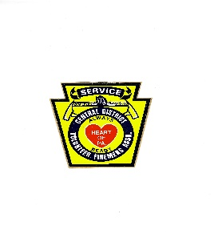
Gerald Corbin Central District Firemen’s Association Training Grant Program

Objective: The Gerald Corbin Central District Firemen’s Association has established a training grant program to support member fire companies and associations within the Association in their training initiatives. The program aims to enhance the skill set of fire service personnel through structured educational opportunities.
Key Features:
- The program will reserve a cap of $3,000.00 annually in the budget for this grant initiative.
- Each grant request will be capped at $500.00 per grant request
- Only fire departments or associations that are members in good standing of Central District are eligible for the grant.
- A single grant will be awarded per county unless no other counties apply, in which case multiple awards in the same county are possible.
- Applicants must submit a detailed application request on the purpose or need along with receipts included on reimbursement of expenses that have been paid for a training imitative.
- The grant packet should include training activities conducted throughout the year. The number of personnel that will benefit from the grant. Photographic documentation of the training should be submitted if possible. A detailed explanation on how the grant will be utilized must be specified.
- Eligible uses for the grant can be used for funding for seminars or workshops. Costs related to Educational Training Agency (ETA) programs. Purchasing training manuals and materials. Support for specialized programs.
- Judging for grant request will be judged by a neutral fire agency with no members that belong to Central District Firemen’s Association. The Educational Committee will oversee the grant program’s implementation and promotion.
- Grant packet for the grant can be obtained by the Secretary of the Central District Firemen’s Association at: Central District Vol. Firemen’s Association P.O. Box 136, Hollidaysburg, Pa. 16648
- Applications timeframe runs from July 1 through June 30 of the following year. Grant award winners will be announced at the Central District Convention Awards meeting.
- The Advisory committee will establish the budget and review this process each year based on a report from the Education Committee.

