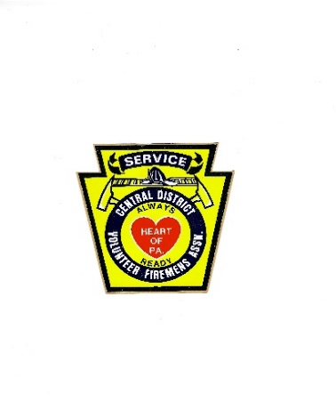
THE GERALD CORBIN TRAINING GRANT
Central District Firemen’s Association
Grant Program Application

1. Organization Information
Name of Organization: ___________________________________________________________________
Address: __________________________________________________________________________________
City, State, Zip Code: ____________________________________________________________________
Phone Number: _________________________________________________________________________
Email Address: __________________________________________________________________________

2. Leadership Contacts
Name of Presiding Officer: _____________________________________________________________
Phone Number: _______________________________________________________________________
Email Address: ________________________________________________________________________
Name of Fire Chief: _____________________________________________________________________
Phone Number: ________________________________________________________________________
Email Address: _________________________________________________________________________

3. Organizational Details
Number of Active Members: ________________________________________________
County: _______________________________________________________________________
Population Served: __________________________________________________________

4. Grant Request Details
Amount of Funding Requested: $_________________________________ (maximum $500.00)
Copy of Receipt of Expenses Required

5. Narrative
Provide a detailed description of how the requested funds will be used and the impact on your organization. Include specifics about the training activities, seminars, programs, or equipment the grant will support. (Additional sheets may be attached if needed.)
_________________________________________________________________________________________________________
_________________________________________________________________________________________________________
_________________________________________________________________________________________________________
_________________________________________________________________________________________________________
_________________________________________________________________________________________________________
_________________________________________________________________________________________________________

6. Justification for Grant
Explain why your organization is seeking this grant and how it will help meet your training goals or enhance your capabilities. Include any relevant background information that supports your application. (Additional sheets may be attached if needed.)
_______________________________________________________________________________________________________
_______________________________________________________________________________________________________
_______________________________________________________________________________________________________
_______________________________________________________________________________________________________
_______________________________________________________________________________________________________

Submission Instructions
• Applications must be submitted by June 30 prior to Convention.
• Submit completed applications to:
Central District Volunteer Firemen’s Association
P.O. Box 136
Hollidaysburg, PA 16648-0136
• Additional sheets may be attached for the Training Grant Narrative.

