2023 TROUT FESTIVAL FISHING DERBY RULES

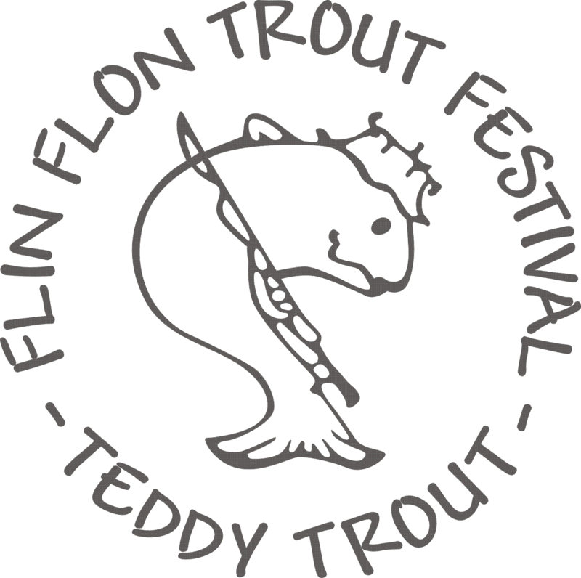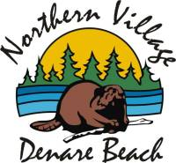

1. FISHING DERBY … SUNRISE MAY 29 – NOON JUNE 29, 2023

2**. ALL FISH IS CATCH, PHOTO AND RELEASE ONLY – WALLEYE, BURBOT, NORTHERN PIKE AND TROUT FOR ENTRY**

3. ONLY A CLEAR PHOTO OF FULL FISH WITH TROUT FESTIVAL MEASURING TAPE WILL QUALIFY

4. PHOTOS TO BE SUBMITTED TO *flinflontroutfestival.com* NO LATER THAN JUNE 29 NOON

5. MANITOBA OR SASKATCHEWAN FISHING LICENSE IS REQUIRED – DEPENDING ON THE LAKE FISH WAS CAUGHT… INDICATE ON SUBMISSION.

6. ALL PARTICIPANTS MUST HAVE PURCHASED A TROUT FESTIVAL DERBY TICKET BEFORE FISHING IN CONTEST. TICKET MUST MATCH TICKET STUB WHEN RECEIVING PRIZES AND HAVE PRESENT AT THAT TIME

7. ONLY ONE FISH WILL BE CONSIDERED FROM EACH PARTICIPANT. BIGGEST ENTRY WILL ELIMNATE ALL OTHER ENTRIES FROM THE SAME PARTICIPANT.

8. IN EVENT OF A TIE THE EARLIEST ENTRY WILL BE PRIORITY

9. ALL ANGLERS MUST COMPLY WITH GOVERNMENT ANGLING REQUIREMENTS AS FOUND IN THE MANITOBA & SAKATCHEWAN FISHING GUIDELINES

10. ALL DISPUTES ARISING IN CONTEST WILL BE DEALT WITH THE TROUT FESTIVAL COMMITTEE & DENARE BEACH RECREATION AND THEIR DECISION WILL BE FINAL

ALL TICKETS QUALIFY FOR ENTRY IN “SPECIAL” AND “SPLASH” PRIZES

GOOD LUCK AND SAFE FISHING

TROUT FESTIVAL COMMITTEE & DENARE BEACH RECREATION

