The Flin Flon Trout Festival is proud to announce our 69th Annual Canada Day Parade.
This year’s parade theme is “THE WATER & THE WILD”; to promote our new brand
We hope you will take the opportunity to participate. Whether big or small. all entries are welcome. Tow a trailer or a boat; use a truck, decorate a golf cart or a quad; march as a group; whatever you wish to do to celebrate, you are welcome to enter.
For some helpful ideas visit the Trout Festival Website at
flinflontroutfestival.com

The parade will begin promptly at 11:00 am. Parade check in will start at 10:00 a.m. on Green Street next to the Zoo/Park.

Please complete the Parade Registration form and return by dropping off at CFAR; Northland Ford; Friendship Centre – OR scan & email to one the contacts listed below.

ENTRY DEADLINE IS JUNE 28TH by 4:00 p.m.

If you have any questions, please contact:
SHEENA REED @ 204-687-6157; email; sheenarcoach@outlook.com
OR allison@northlandford.mb.ca

Thank you for supporting the Trout Festival.

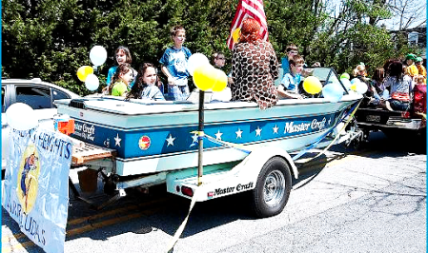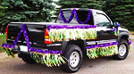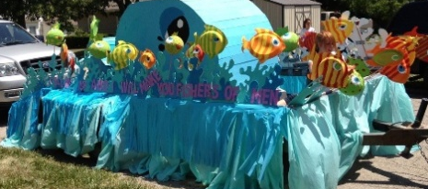

For more information call Sheena Reed @ 204-687-6157 or 204-271-2142
FLIN FLON TROUT FESTIVAL PARADE
JULY 1, 2019
For judging all floats are to be the Marshalling Area by 10 a.m.
Marshalling Area: Floats – Centential Crescent and Prince Charles Place
VIP’s – Green Street in front of Zoo
Classic Cars – Green Street in front of Acklands
Marchers, Bicycles – Bellevue Avenue at Rotary Park

Rules & Regulations
- The theme is “THE WATER & THE WILD”
- Sponsored by Northland Ford
- Floats and vehicles should be at Marshalling Area by 10:00 a.m. for judging.

- Parade Route: Start @ CFAR, travel down Green Street to Northland Ford, turn right onto #10 Hwy., go up Third Avenue hills and around to Main Street, down Main to 4th Ave. (old C0-OP) where the parade will disperse.

- Prizes – 2 Catagories – Commercial & Non-commercial - 1st=$100/2nd=$75/3rd=$50

- Judging of floats will be done prior to start of the parade.

- Every entry must fill out and sign the registration form by June 29th. Forms may be dropped off at Northland Ford, CFAR, or Flin Flon Aboriginal Friendship Centre.

- The Parade travels at approximately 3-4 km per hour down the center of the road. Cars & Floats should remain about 3-5 feet apart. Please try not to stop or delay the parade.

- DO NOT THROW ANYTHING FROM YOUR FLOAT! It is prohibited as it could cause injury should someone were to dive for the treat and get hit by a vehicle. You may have walkers HANDING OUT treats; but please do not throw them.

