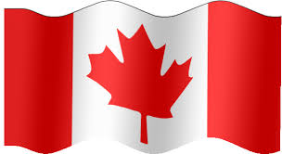
THE WATER & THE WILD
Parade Entry Ideas
For those who are new to the parade world here are some ideas to get your
creative brains started. The trick is to be creative and have fun!
Be sure to review the rules and regulations for this parade before you begin.
Do not fret if your float is not perfect because it is really supposed to be
about family and fun.

Pick your vehicle:
Will your float be in the bed of a pickup or will a pickup pull a flatbed trailer? Will you use a unique vehicle i.e. an antique car, boat, camper, bus, quad, golf cart? Or will you have a large group marching.
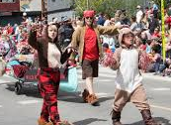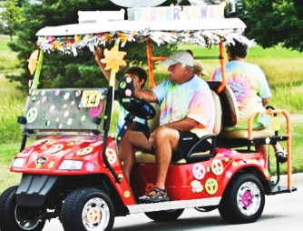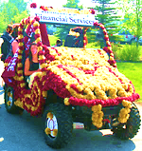
Theme Scenes
Pick a theme that compliments the parade theme (THE WATER & THE WILD). Keep it simple! Theme scenes can be built with props commonly found at your home or through local stores. Be creative and set the stage for the scene you want to build.
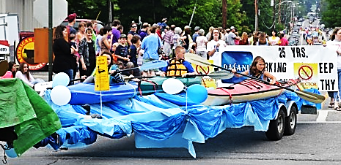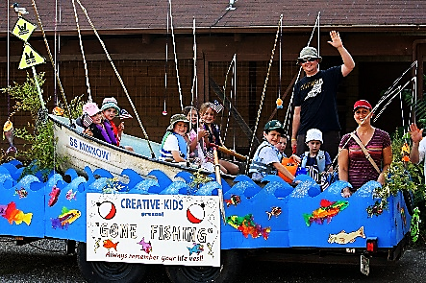

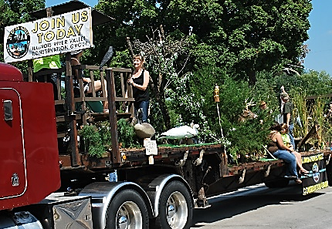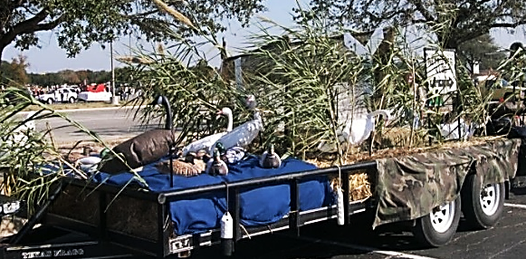

Building Materials Necessary supplies for floats typically include:
• Artificial grass or rug to cover the trailer bed
• Fabric or vinyl fringe to cover the sides of the trailer
• Paint to use for signs or to paint any cut outs or props
• Tape - magnetic tape works best on trailers
Additional supplies that you may choose to consider; especially if cost isn't
an issue, include:
• Balloons
• Crepe paper streamers
• Festooning
• Foamboard Letters
• Streamers
If you make 3-D shapes with chicken wire, you will need some type of
material to stuff into the wire. Tissue paper is a popular choice.

Skirt your float. Tack chicken wire, fabric, cardboard or foil fringe around
the base of the trailer; allow it to hang near the ground. If you use chicken
wire, plug the holes with tissue paper, crepe paper or brightly coloured napkins.

Glam up your float with lights, ballons and sounds.
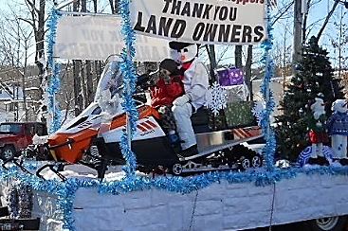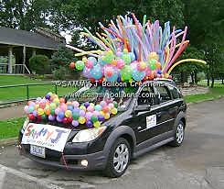

Don’t forget the sign!
It is always good to have a sign either incorporated into your entry or have some
individuals carry a sign in front of your entry or on the float, so people know who you are and you can communicate your theme.
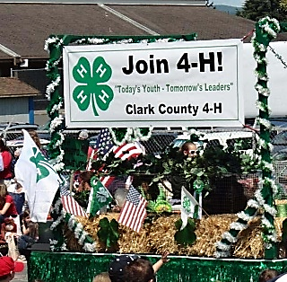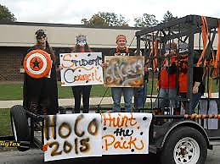

Easy Ideas to Implement:

On Foot: Have members dress alike with bright colors or costumes. Have something for them to do, waive a flag, hand something out to spectators, sing, and play musical instruments. Consider placing small children in a decorated wagon.
Carry signs that spell out your message or theme.
Develop a dance routine of sorts where they march in rows and make turns or spin
items all at the same time. View it as a performance and practice if you can!
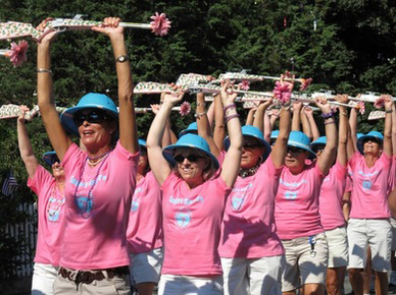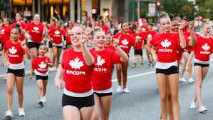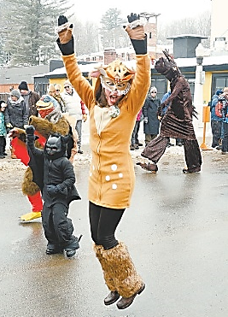

Vehicles: Decorate the vehicle and use a vehicle with an open area for people
to sit in – convertible car, bed of a truck, etc. Decorate with fringe, signs,
balloons, etc.
Play music from the vehicle to add excitement.
Have individuals walk with the vehicle and hand out giveaways like balloons, candy, etc.
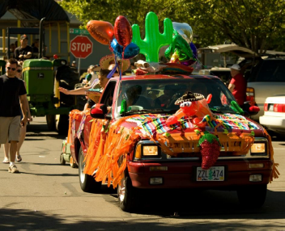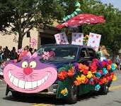

Tow Something: Large flat bed or small trailers (i.e. double wide snowmobile trailer)
can be easily decorated to come to life in a parade.
Small utility trailers and boats (or a party boat) can be just as fun as larger flat beds.
Decorated with signs, colourful streamers & fringe will help them make a splash.
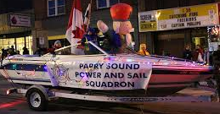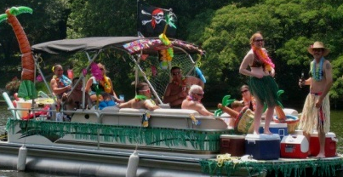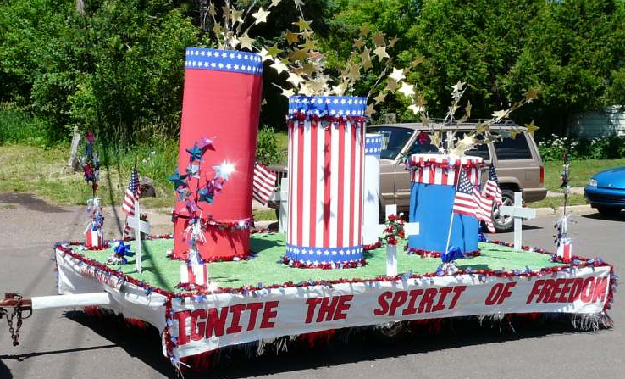

Incorporate large visuals: Cold air or helium balloons can make a big splash. You can also use large puppets, flags, posters

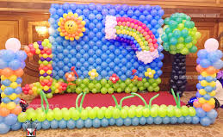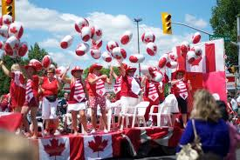

Wear costumes: Incorporating individuals in costume that fit your theme will make a big impression especially on young spectators – it’s almost like going to a play. Tip: kids love dressing up and it can get them involved, especially little girls!

Have Music: Music can compliment the theme or just and to the fun.

Use Animals: Animals of all kinds from dogs and horses to sheep, goats and donkeys are frequently a favourite with kids! Just be sure to remember you are responsible
for the clean up behind them, don’t leave a mess for marching groups that may be behind you.
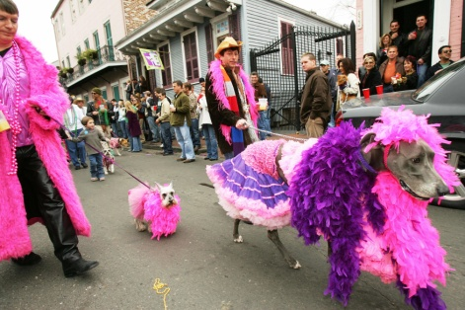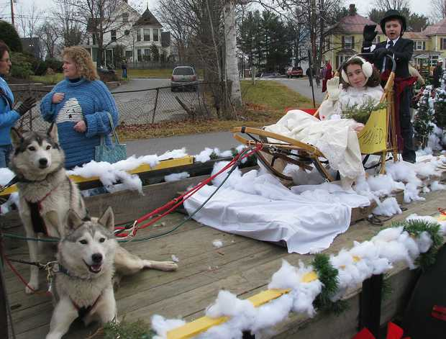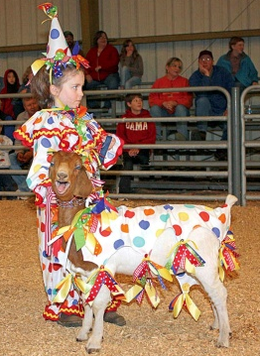

Check the internet – for pictures, images and ideas. Sites like Pintrest have many helpful hints and suggestions. Or Youtube for things like how to build a balloon arch.

Remember to keep safe. Secure any individuals, who may be standing on a float, do not allow people to get on and off a float while it is moving, etc. Be sure to read all
the rules and regulations and share them with all participants in the parade entry.

