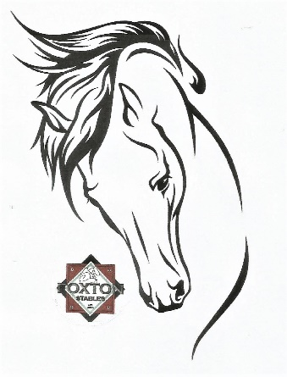
Foundation Charity Horse Show
CLAY COUNTY FAIRGROUNDS
6650 N STATE ROAD 59
BRAZIL, IN 47834
HUNTER/JUMPER HORSE SHOW
Saturday, May 16 and September 19, 2020
T.I.P., IHJA, and MiHJA approved
Stall Fee: $15.00 for the day, $50.00 for the Weekend-Friday-Sunday ($10 refund/stall if you clean.)
Shavings: $7.00/bag
Haul in Fee: $16.00/horse each day
Camping Fee: $25.00/night with electric
Class Fees: Office Fee $10.00 per horse
Non-member Fee $5.00
Single Classes: $12.00/class
Hunter Division (2 over fences & 1 under saddle): $30.00/division
Warm-ups and Lead-line: $10.00/class
IHJA Medals: $15.00/class

We will again be offering Thoroughbred Incentive Program (T.I.P.) classes at this year’s show. These classes are sponsored by The Jockey Club and are designed for thoroughbred horses only while showing at open horse shows and competitions.
T.I.P classes will be indicated as such on the Hunter Jumper Show Bill.
Eligibility- Only Thoroughbreds that have been registered with The Jockey Club or a foreign Thoroughbred stud book recognized by the Jockey Club are eligible to participate in T.I.P. classes and awards. Riders and owners should obtain a T.I.P. number for all horse/rider combinations. T.I.P. number applications are done online at www.tjctip.com. T.I.P. numbers must be provided to the horse show office. The Jockey Club T.I.P. Young Jumper award will be awarded to the Thoroughbred with the most points over the season that is in its first or second year of showing. Out of State Horses must have health certificate within 30 days. Secured ASTM/SEI approved helmets must be worn at all times when mounted on a horse. Proper shoes with heels, no sneakers, required. Braiding is not required.
Judging will be influenced by the use of inappropriate tack in the show ring. Specifications can be found in the rule book on the Indiana Hunter Jumper Association website and the Midwest Hunter Jumper association website. Classes may be moved or combined according to the management. Judges decisions are final!!!
Your participation will support the efforts of the Indiana Equine Foundation, committee programs & educational scholarships/clinics. For further information contact: Darla Bridges at redpegasusranch@hotmail.com.
WARNING: Under Indiana Law, an Equine professional is not liable for an injury to, or death of, a participant in equine activities resulting from the inherent risks of equine activities.

Our show bill looks overwhelming, but it is recognized by several organizations for year end points. There will be class descriptions available in the office along with charts that indicate the heights for each division. We are happy to answer any questions you may have and guide you in the direction of classes that are suitable to you and your horse/pony/rider. Please don’t be afraid to ask questions.

