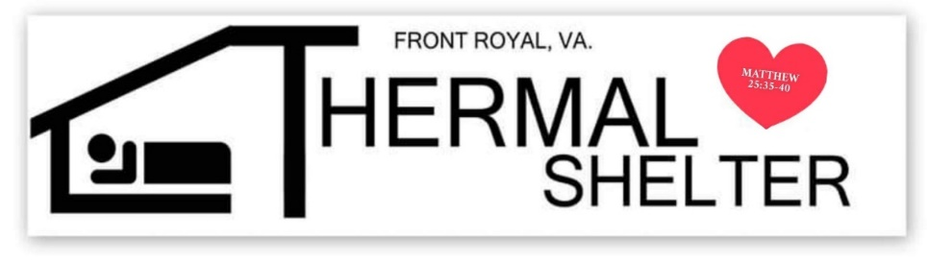

Thermal Shelter of Front Royal

Opens Sunday, November 1, 2020.
We will be open every night until
Wednesday, March 31, 2021.

Non-denominational, low barrier, overnight shelter for homeless adult (over 18) Men and Women

A warm, safe place to sleep with dinner, light breakfast and bag lunch provided.
Hours are 7pm until 7am – 7 days a week.

Location: Health and Human Services Complex –
465 W. 15th St. Front Royal, VA 22630
West side of complex – old cafeteria

If transportation is needed a van will pick up at
Front Royal United Methodist Church Parking Lot.
Time: 6:30 pm every evening.
Address: 1 West Main St.
Front Royal.

Thermal Shelter – 540.692.4714 (7pm-7am)
Facebook Page – Thermal Shelter of Front Royal
www.thermalshelteroffrontroyal.com
Michelle Smeltzer – 540-892-6108
Please leave a message if no answer.

