WOVEN WIPES  Baby Wipes, Mechanic Wipes, Sanitary Wipes, Rags, Medical Wipes, Make Up Wipes, Hand Wipes  Despite their packaging claims, wipes are the absolute worse things you can flush down your toilet, they are the single most destructive and costly product to a wastewater treatment or septic system.  They are not “safe” to flush…anything is flushable, golf balls are flushable but we don’t recommend they be flushed either. It is all a marketing gimmick.  Wipes clog up pumps, valves and equipment. They are not biodegradable and tend to gather grease and twirl together into strands or balls and cause a lot of damage.  Here are wipes wrapped around pipes in the Wastewater Plant. Wipes cost the district $35,000 a year in direct and indirect costs.  4 | OTHER INORGANCIS  Medicine, Bandages, Dental Floss, Feminine Products, Soil, Paint, Birth Control items, Diapers, Gas/Oil, Q-tips or Needles, etc…  Inorganic can cause immediate damage to pumps and contaminate the discharge effluent in both wastewater and septic systems. This can create large fines and cleanup costs and create hazards to employees. Medicines, Petroleum, Pesticides & Fertilizers can contaminate the harbor and kill off the bacteria we need to clean the wastewater. Please do not flush or pour any items down the drain other than human bathroom waste. Toilets and sinks are not trash cans.  SUMP PUMPS & DRAINS  It is a violation for any sump pump, cellar drain, roof drain, perimeter drain or other plumbing that allows non-sanitary wastewater to enter the sewer collection system. The extra volume of “clean” water costs a lot of unnecessary money to treat, overwhelms the Plant by volume causing solids to be washed overboard and can bring contaminants into the Plant from burst heating tanks, flooded basements and contaminated soils. If contamination of the Harbor or Plant occurs from such a connection, it is the property owner’s responsibility to pay for all the cost of fines and cleanup.  5 | SWH WATER & SEWER DISTRICT  Maintain  YOUR DRAIN  DO NOT SEND THESE ITEMS DOWN YOUR SEWER DRAIN  FATS, OIL or GREASE  (F.O.G.)  WOVEN WIPES  (Baby, Sanitary, Hand or Cleaning)  OTHER INORGANICS  (Medical waste, sanitary Items, Household items, makeup items, etc..)  ORGANICS  (Food Scraps, Plant Material or Paper)  SUMP PUMPS & DRAINS  (Cellar Pumps, Roof & Foundation Drains)  Southwest Harbor Water & Sewer District  26 Village Green Way  P.O. Box 1100 SWH, ME 04679  207-244-3948  For detailed info please visit our website;  www.swhdistrict.org
FATS, OIL & GREASE  Similar to your Doctor telling you to stop eating fried and fatty foods because it is bad for your heart and clogs your arteries…the same thing is true about your septic system or your wastewater treatment system. These are referenced under the acronym “F.O.G.”  Items that make up F.O.G. include;  Meat/Fish Fats and Drippings  Salad Dressing / Vinaigrettes  Sauces, Marinades, Pesto, BBQ Sauce  Dairy Products  Vegetable Oils / Cooking Oils & Lard  Margarine and Butter  Condiments: Mayo, Ketchup, Mustard, etc...  Food Grade or Petroleum Lubricants.  Soups, Stews and Chowders  F.O.G. coats and coagulates in the drain pipes and builds up along the inside walls causing clogs that can back up your sewerage into your home. The collection mains in the street act the same way causing neighborhoods to have sewerage back up.  While Commercial establishments have grease traps to capture F.O.G., residential homes do not. Removing F.O.G. items from your wastewater stream will greatly reduce the potential for sewer backup from your own internal plumbing, blockage in the sewer collection system, extend the life of your septic system and greatly decrease the cost the District spends on grease removal, equipment repair and pressure washing collection mains.  1 | These grease blobs where removed from your Wastewater Treatment plant’s intake line after a rain storm. This blocks our intake lines and gets stuck in lift station pumps. The District spent over $21,000.00 in direct F.O.G. removal and $35,000.00 in F.O.G. related repairs last year.  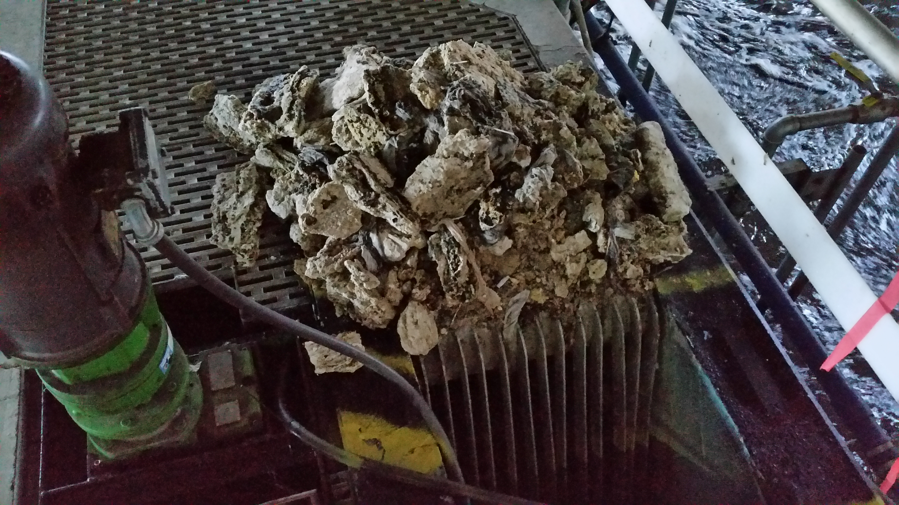  ORGANICS  More than half our budget, ($300,000.00), is spent on removing organics. These costs are directly affected by how much organic matter we have to treat, the less organics the lower the cost, the lower the cost the less your sewer bills go up. The best way to reduce this cost is to reduce organics entering the Plant. It is extremely important not to flush or dump ANY organics down the drain even if you have a garbage disposal. Garbage disposals are the most deceiving appliance, they encourage you to dispose of organics into your sewer drain, which is the opposite of what you should be doing. Overloading of organics can ruin a septic system and cost thousands in wastewater treatment costs.  2 | Dispose of ALL table scraps, food preparation scraps, old leftovers or any meat or vegetable waste into your trash cans or compost pile. Scrape off plates and cookware into the trash as well when done using them. Do not flush any animal wastes, bedding or litter down your toilet, these should be composted or put in the trash.  DRY WIPE PLATE OR COOKWARE BEFORE WASHING www.ceasethegreasetx.com  POUR WARM F.O.G.  INTO A CONTAINER  OR COOL OFF AND  SCRAP INTO THE  TRASH  ALWAYS USE A DRAIN SCREEN TO CATCH SCRAPS. www.schierproducts.com  www.schierproducts.com Never pour ANYTHING down the drain  PLACE FOOD SCRAPS INTO TRASH, NOT IN GARBARGE DISPOSAL OR DOWN THE SINK! www.schierproducts.com  3

