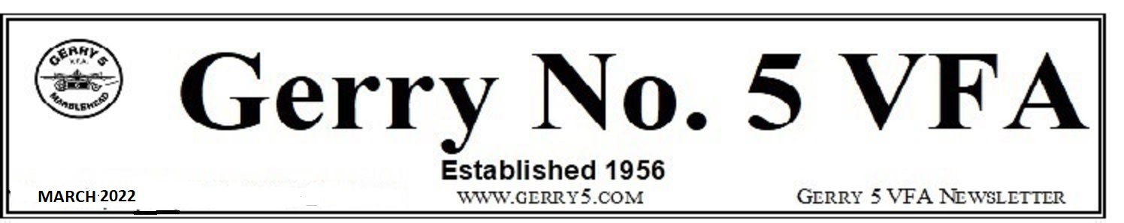
Event by Rockin' 4 Vets, Alive & Kicking Productions and Three Cod Tavern
Friday, April 9th, Doors Open 7:00 p.m. Gerry No. 5 V.F.A., Inc.
Tickets · $37.50 - $79
Tickets available on-line at: home-grown-rock.eventbrite.com or at the Three Cod Tavern in downtown Marblehead.
OPEN TO THE PUBLIC
James Montgomery comes to the Gerry VFA Hall to kick of the 2022 season of Rockin' 4 Vets Home Grown Rock benefit concert series. Boston's legendary blues performer, James Montgomery, will bring his band to The Gerry, in Marblehead, MA, Saturday April 9th as the kick-off for Rockin' 4 Vets 2022 benefit concert series across New England. Montgomery, is known for his solid reputation as a front man for the James Montgomery Band, as well as for the artists he's performed with over the years including Steven Tyler, Brad Whitford and Joey Kramer of Aerosmith; Billy Squier, Skunk Baxter (Doobie Bros, & Steely Dan), The Allman Brothers Band, Huey Lewis and his long stint as front man for the Johnny Winter Band. He will bring that swagger and style to this intimate venue for an evening to be remembered.
Additional music will be provided by Fia James Band and Gus Percy.
VIP tickets are available and include:
- Pre-show photo-op with James
- Wine & Cheese Meet & Greet
- Reserved front row seating
- Autographed event poster
- Free copy of Live JMB CD

Proceeds go to assist Veterans with utilities and other expenses. Get your tickets now!
KEY FOBS are now available. Please see Art if interested.
NO MORE WALK OF SHAME
An ATM is being installed at the Gerry this week for your convenience. A fee may be charged but many banks reimburse for this fee. Save a few steps and get your green here.
REMINDERS – UPCOMING EVENTS
March 13th – SPRING FORWARD – Daylight Savings Time Begins
March 16th, 6:00 p.m. – Board of Directors Meeting - Any member having business before the Board, please contact a Board member or the Manager prior to the meeting. Board Meetings, barring Executive Sessions, are open for member viewing but no participation.
March 17th – St. Patrick’s Day = Erin Go Bragh!
March 20th – First Day of Spring
April 6th, 6:00 p.m.– Board of Directors Meeting
April 6th, 7:00 p.m. – Member Meeting followed by a light snack

