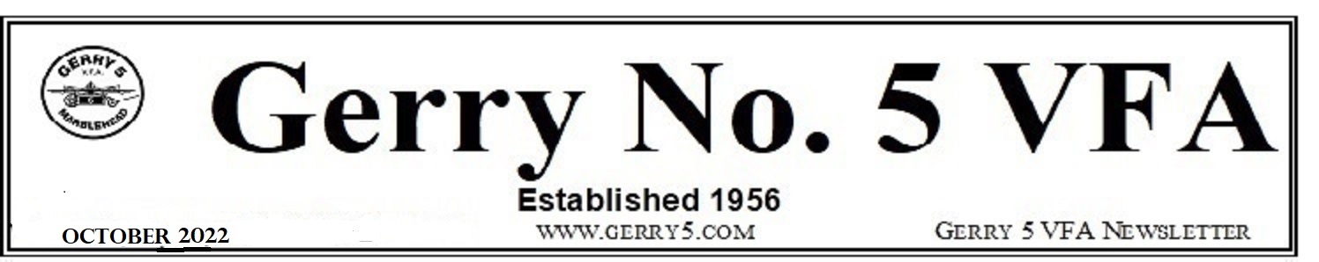
October 27, 2022 Update
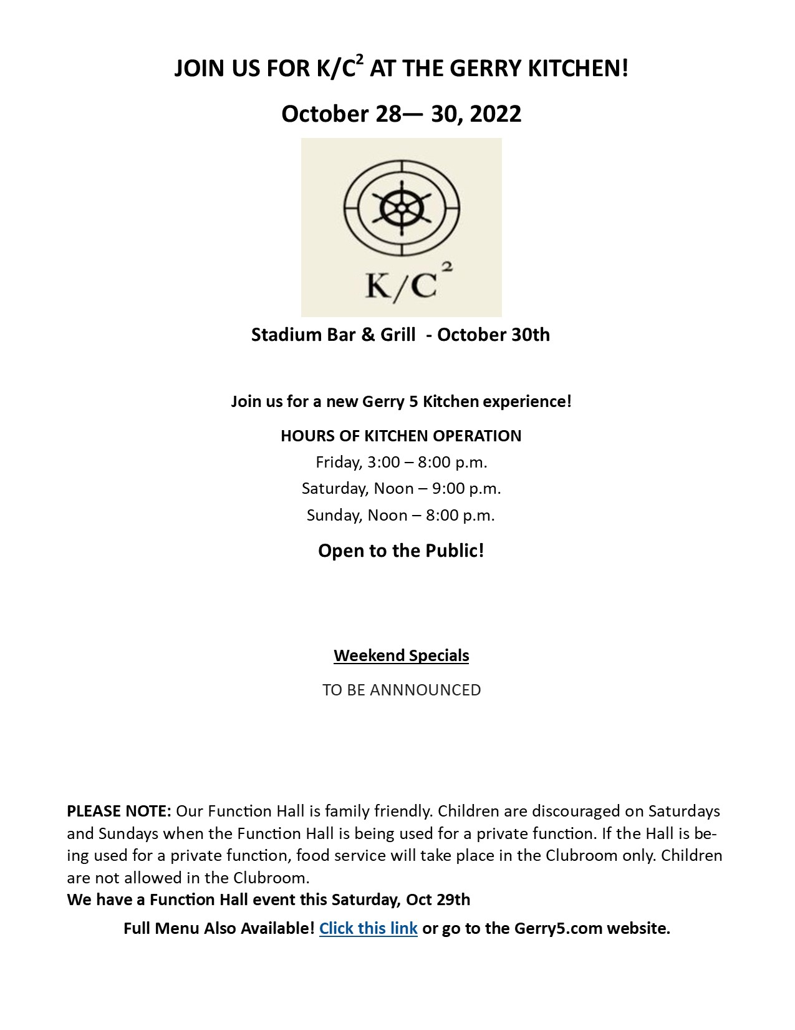

Sunday, October 30th, Kids Halloween Party
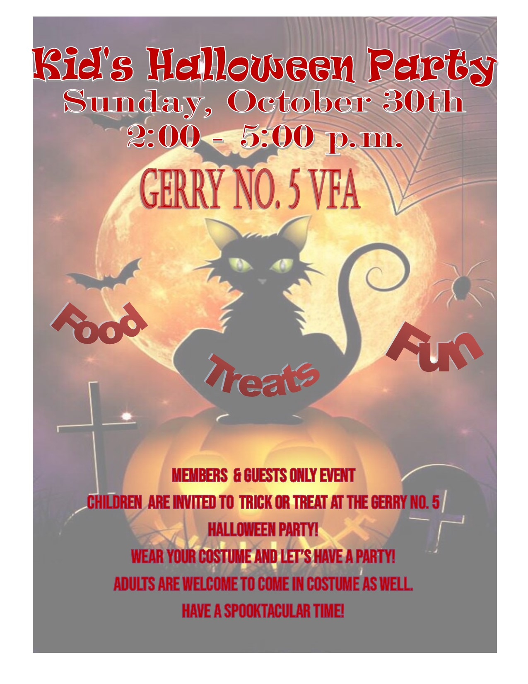
Menu: Hot Dogs, Grilled Cheese, Mac & Cheese

Trivia Bingo on Wednesdays
7:00 – 10:00 p.m.
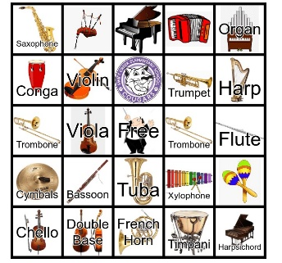
Guess the answer, get Bingo and Win
Join us!
8th ANNUAL CRAFT FAIR - November 19th – Check Out our Preview Site
The 8th Annual Craft Fair will be held on Saturday, November 19th, in the Function Hall, 9:00 a.m. – 2:00 p.m. We are returning after two years of cancellations due to COVID-19. Contact Kathy Tankersley Bernier at gerry5vfa@yahoo.com or ziggyii@comcast.net with questions. We have new vendors as well as some returning favorites. Lots of variety – clothing, home décor, jewelry, artwork, Holiday ornaments, tumblers and much more. We will also hold our usual raffles. Just want to shop? Check out our Preview Page on the web site for a glimpse of what our vendors are offering @ gerry5.com/craft_fair_preview.
SAVE THE DATE – Spread the word!

Tickets will be on sale soon!

Saturday, November 26th, Benefit for the Marblehead Counseling Center/Marblehead Food Pantry
6 pm doors open with the Melody Makers, 8:30 pm The Guy Ford Band
Tickets are $25
Please bring a food donation
proceeds go to Marblehead Counseling Center / Marblehead Food Pantry
more details coming
SAVE THE DATE!

PLEASE NOTE: Our Function Hall is family friendly. Children are discouraged on Saturdays and Sundays when the Function Hall is being used for a private function. If the Hall is being used for a private function, food service will take place in the Clubroom only. Children are not allowed in the Clubroom.
For example, this Saturday, Oct 29th, we have a Function Hall rental.

BUSINESS NEWS
Nominations for Officers and Directors – November 2nd Meeting Want to get involved? Have a voice, represent our membership, and share in the management of the Gerry No. 5? Here’s your opportunity to do so. The positions to be filled help oversee the management of the Club and shape its future. It doesn’t require a lot of time but it does require a true commitment for the betterment of the Gerry. Interested? Put your name in the running by being nominated at the November 2nd^{h} member meeting. The election will be finalized with ballots being due NLT 7 p.m. on December 7th.
New Business at the November 2nd member meeting will include nominations of Officers and TWO Director positions.
Nominations must be made from the floor. The person being nominated must be present to accept the nomination. If the nominee is not present, the member making the nomination must present a written acceptance letter by the nominee to the Chairman of the meeting. No name will be placed on the ballot unless the nomination has been accepted.
Write-in or sticker candidates must present a written notice of intention to the President prior to the start of voting on Election Day in December.
Members are reminded that nominees must possess the skills, knowledge, and abilities to serve in the position for which they are nominated.
We MUST have a quorum to conduct the meeting and make nominations. Please attend.
Proposed By-Law Changes – Discussion November 3rd, Vote December 7th
Four By-Law changes were proposed at the October meeting upon the recommendation of the Board of Directors and the By-Law Committee.
General discussion of the proposed changes and any proposed amendments to these will take place at the November meeting. These changes affect ALL MEMBERS. Please read them carefully and plan to attend the November meeting. The Board needs your feedback. The Board encourages all members to participate in order to make this a collaborative effort and decision. Voting is by secret ballot of those present at the December 7th member meeting.
The proposed revisions are posted in the Clubroom and on the web site under Business Documents on the Library page (www.gerry5.com/library.)

IMPORTANT DATE REMINDERS!
K/C² serving food Friday, Saturday, Sunday
October 28-30
Wednesdays, Music Trivia Bingo, 7:00 – 10:00 p.m.
Sunday, October 30th, Stadium Bar and Grill
Patriots @ Jets (1:00 p.m.)
Sunday, October 30th, Kids Halloween Party, 2:00 – 5:00 p.m.
Monday, October 31st – Happy Halloween!
Wednesday, November 2nd, Board of Directors Meeting, 6:00 p.m.
Members Meeting, 7:00 p.m.
(Nominations, By-Law Discussion)
Sunday, November 6th, 2:00 a.m. – Daylight Savings Ends
Stadium Bar & Grill
Colts @ Patriots (1:00 p.m.)
Wednesday, November 16th, Board of Directors Meeting, 6:00 p.m.
Saturday, November 19th, 8th Annual Craft Fair, 9:00 a.m. – 2: 00 p.m.
SAVE THE DATE(S)*
Thursday, November 24th, Thanksgiving Day, Club opens at 9:45 a.m.
Marblehead vs. Swampscott game will be on TV
Thanksgiving Dinner, 2:00 – 6:00 p.m.
Saturday, November 26th, Benefit for the Marblehead Counseling Center/Marblehead Food Pantry
6 pm doors open with the Melody Makers, 8:30 pm The Guy Ford Band
Sunday, December 11th, Kids Christmas Party, 2:00 – 5:00 p.m.
Saturday, December 24th, Christmas Eve Open House, 2:00 -5:00 p.m.
Sunday, December 25th, Merry Christmas - CLOSED
Saturday, December 31st, Kids New Year’s Eve Party, 5:00 – 8:00 p.m.
*Dates and times are subject to change
Remember there are always things to do at the Gerry. Whether you want to socialize or just relax, we’re here for you. Don’t forget to check out the games in the Clubroom and the Function Hall (when not in use).
Gerry Gear Available!
Existing inventory has been updated. See https://gerry5.com/announcements-opportunity (bottom of page) for details or flyers at the Gerry. Order forms for items not in stock will be available soon. See something you’d like, contact the Secretary or Manager. Stay tuned.

Comments? Questions? Complaints? Please address these to the manager or the Board in writing, via email, or in person.
Thank you for reading!

