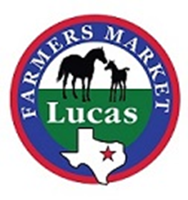
Vendor Profile

Owner and company name:

About: (year founded, why did you start business, etc.)

What products/services does your business offer?

Have you participated in the Lucas Farmers Market before?

If so, describe your experience.

What are you most looking forward to this market?

What is your favorite or most unique product or service you offer?

What is the most rewarding part of participating in the Lucas Farmers Market?

(if possible, please provide a photo of your farm, store, products, your employees)

