**The Royal Adventures of The White House**

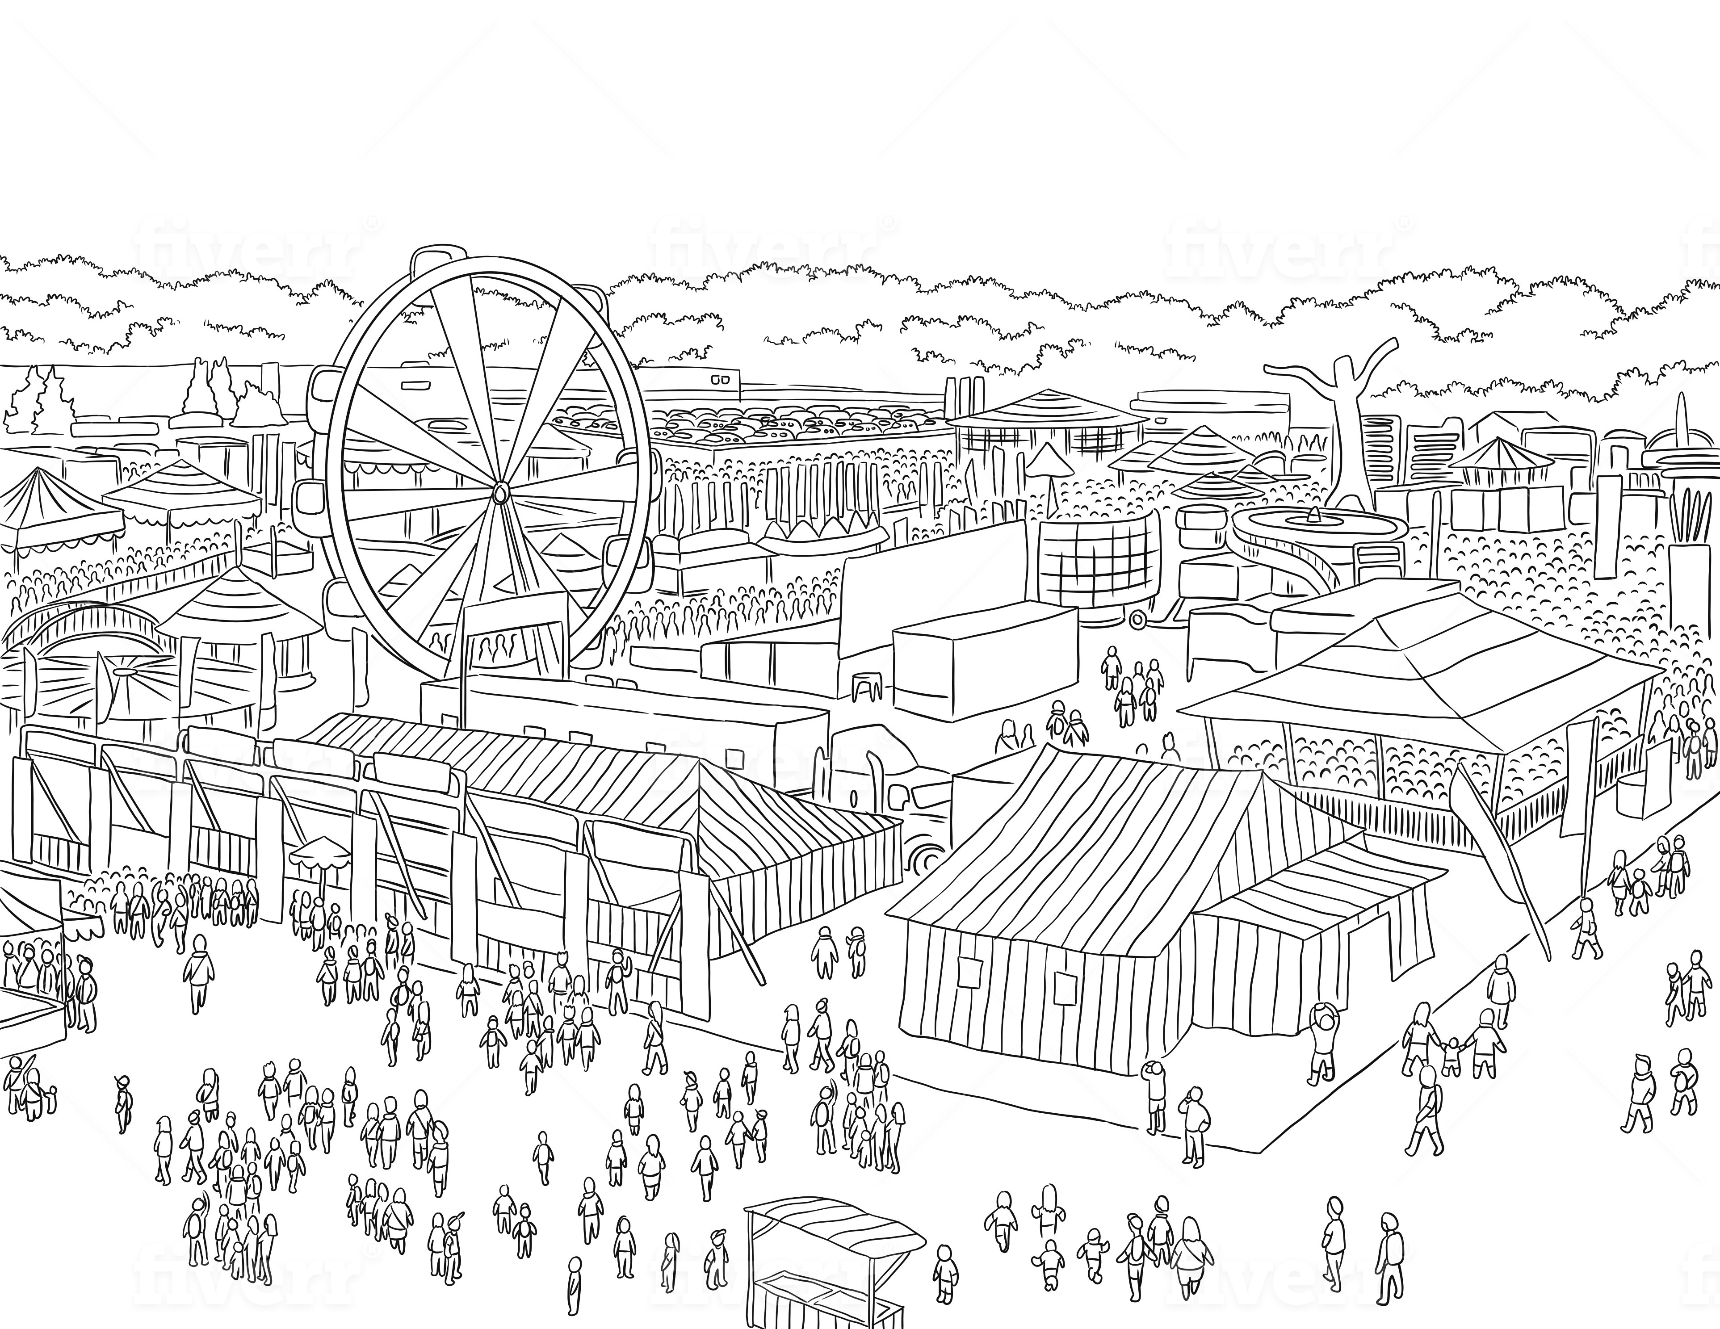

www.joanntaylor.net