THE ROYAL ADVENTURES OF THE WHITE HOUSE

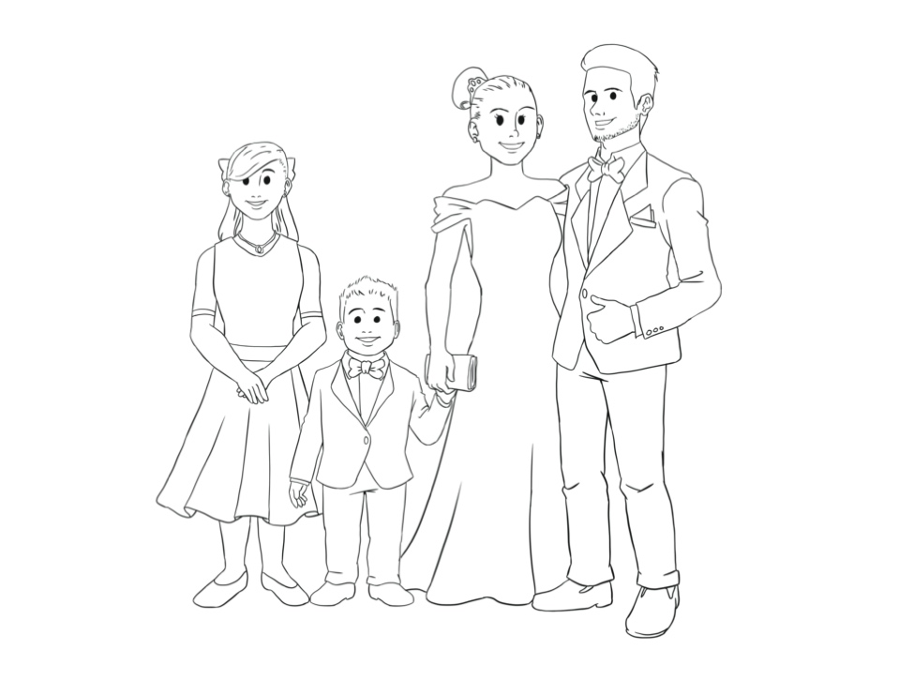

By JoAnn Taylor

Illustrated by Alland Wijaya

Copyright 2020 JoAnn Taylor

WORKBOOK

THE ROYAL ADVENTURES OF THE WHITE HOUSE

Why was Irene, Texas considered a small town?

What is the name of the girl telling the story?

In which state was Hailey and her family born?

List one requirement needed to become President of the United States.

CHAPTER 1 QUIZ

Do you think Hailey wanted her dad to become President? Explain.

THE ROYAL ADVENTURES OF THE WHITE HOUSE



COLORING

THE ROYAL ADVENTURES OF THE WHITE HOUSE

VOCABULARY

ELECTORAL COLLEGE:

ACTIVIST:

PRESIDENT:

VOTER:

CANDIDATE:

DEBATE:

MANDATORY:

Write the meanings of the following words!

THE ROYAL ADVENTURES OF THE WHITE HOUSE

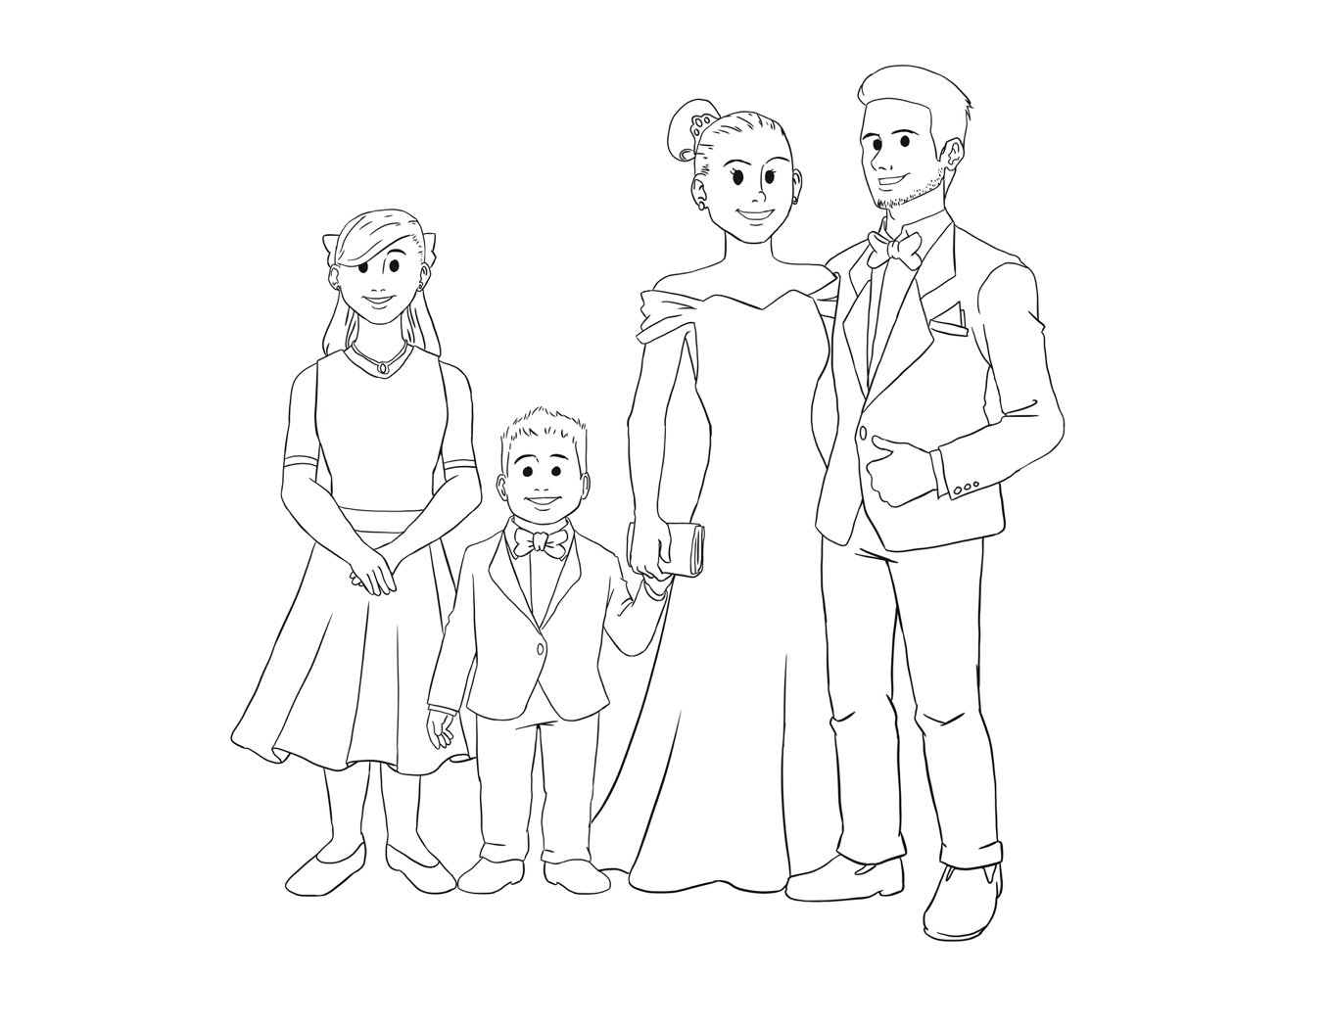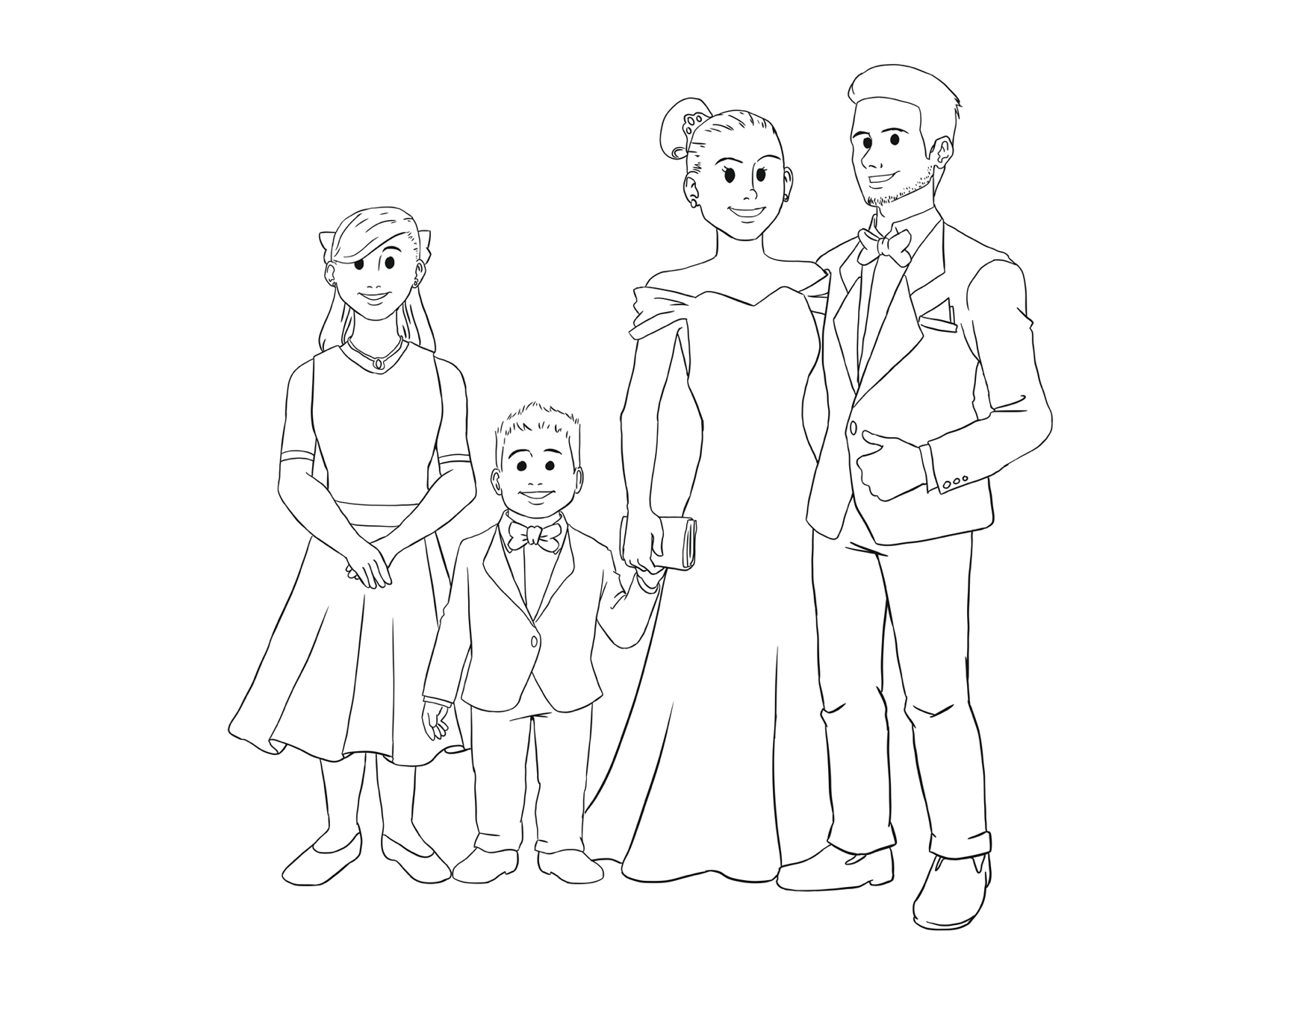

Reunite Hailey and her dad!

SOLVE THE MAZE

THE ROYAL ADVENTURES OF THE WHITE HOUSE

CHAPTER 2 QUIZ

What did Hailey’s dad promise to do for the people after he was elected?

How do you think Hailey’s dad won the party’s nomination?

Have you ever had to defend someone even if it meant you would face consequences? Explain.

What cities in the United States would you love to visit?

Describe the term “swing state”.

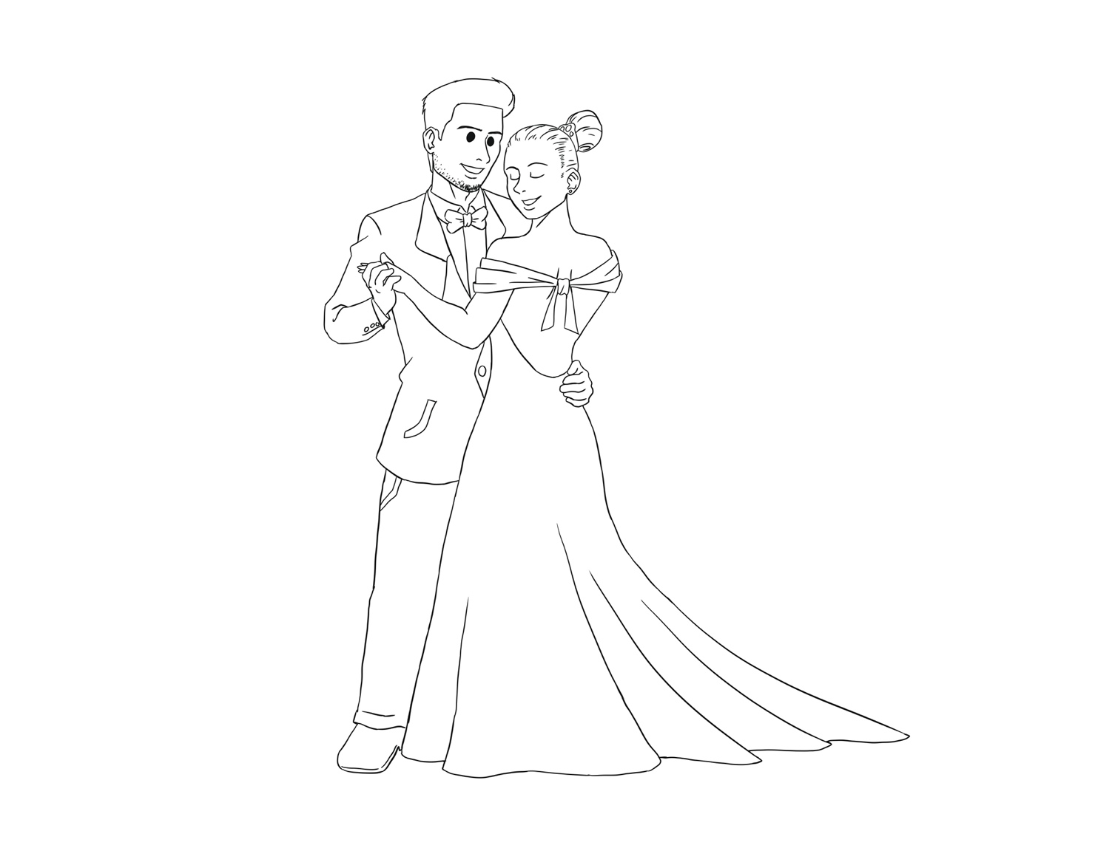

Draw the ballroom around the President and First Lady!

THE ROYAL ADVENTURES OF THE WHITE HOUSE

DRAW & COLOR

THE ROYAL ADVENTURES OF THE WHITE HOUSE



COLORING

THE ROYAL ADVENTURES OF THE WHITE HOUSE

CHAPTER 3 QUIZ

What happened during the debate?

What is the difference between popular vote and electoral vote?

What is the Electoral College?

What did Hailey think about the way the President is elected?

What made the other presidential candidate a strong opponent?

THE ROYAL ADVENTURES OF THE WHITE HOUSE

WORD SEARCH



PRESIDENT

CANDIDATE

SWING

VOTER

WHITE HOUSE

FIRST LADY

ELECTOR

STATES

DEBATE

THE ROYAL ADVENTURES OF THE WHITE HOUSE

WRITING PROMPTS

What is a promise? Do you keep your promises? Explain.

What policies do you think would make the United States better?

How are the Republicans and Democrats similar? Different?

Why should a Presidential candidate visit your city?

Compare and contrast the first and current President.

Imagine you were running for a political office. What would be your message to the people?

Why are the three branches of government important?

Summarize *The Royal Adventures of The White House.* (Explain the beginning, middle and end of the story).

Describe the characters in *The Royal Adventures of the White House.*

Compare and contrast a democracy and a monarchy.

THE ROYAL ADVENTURES OF THE WHITE HOUSE

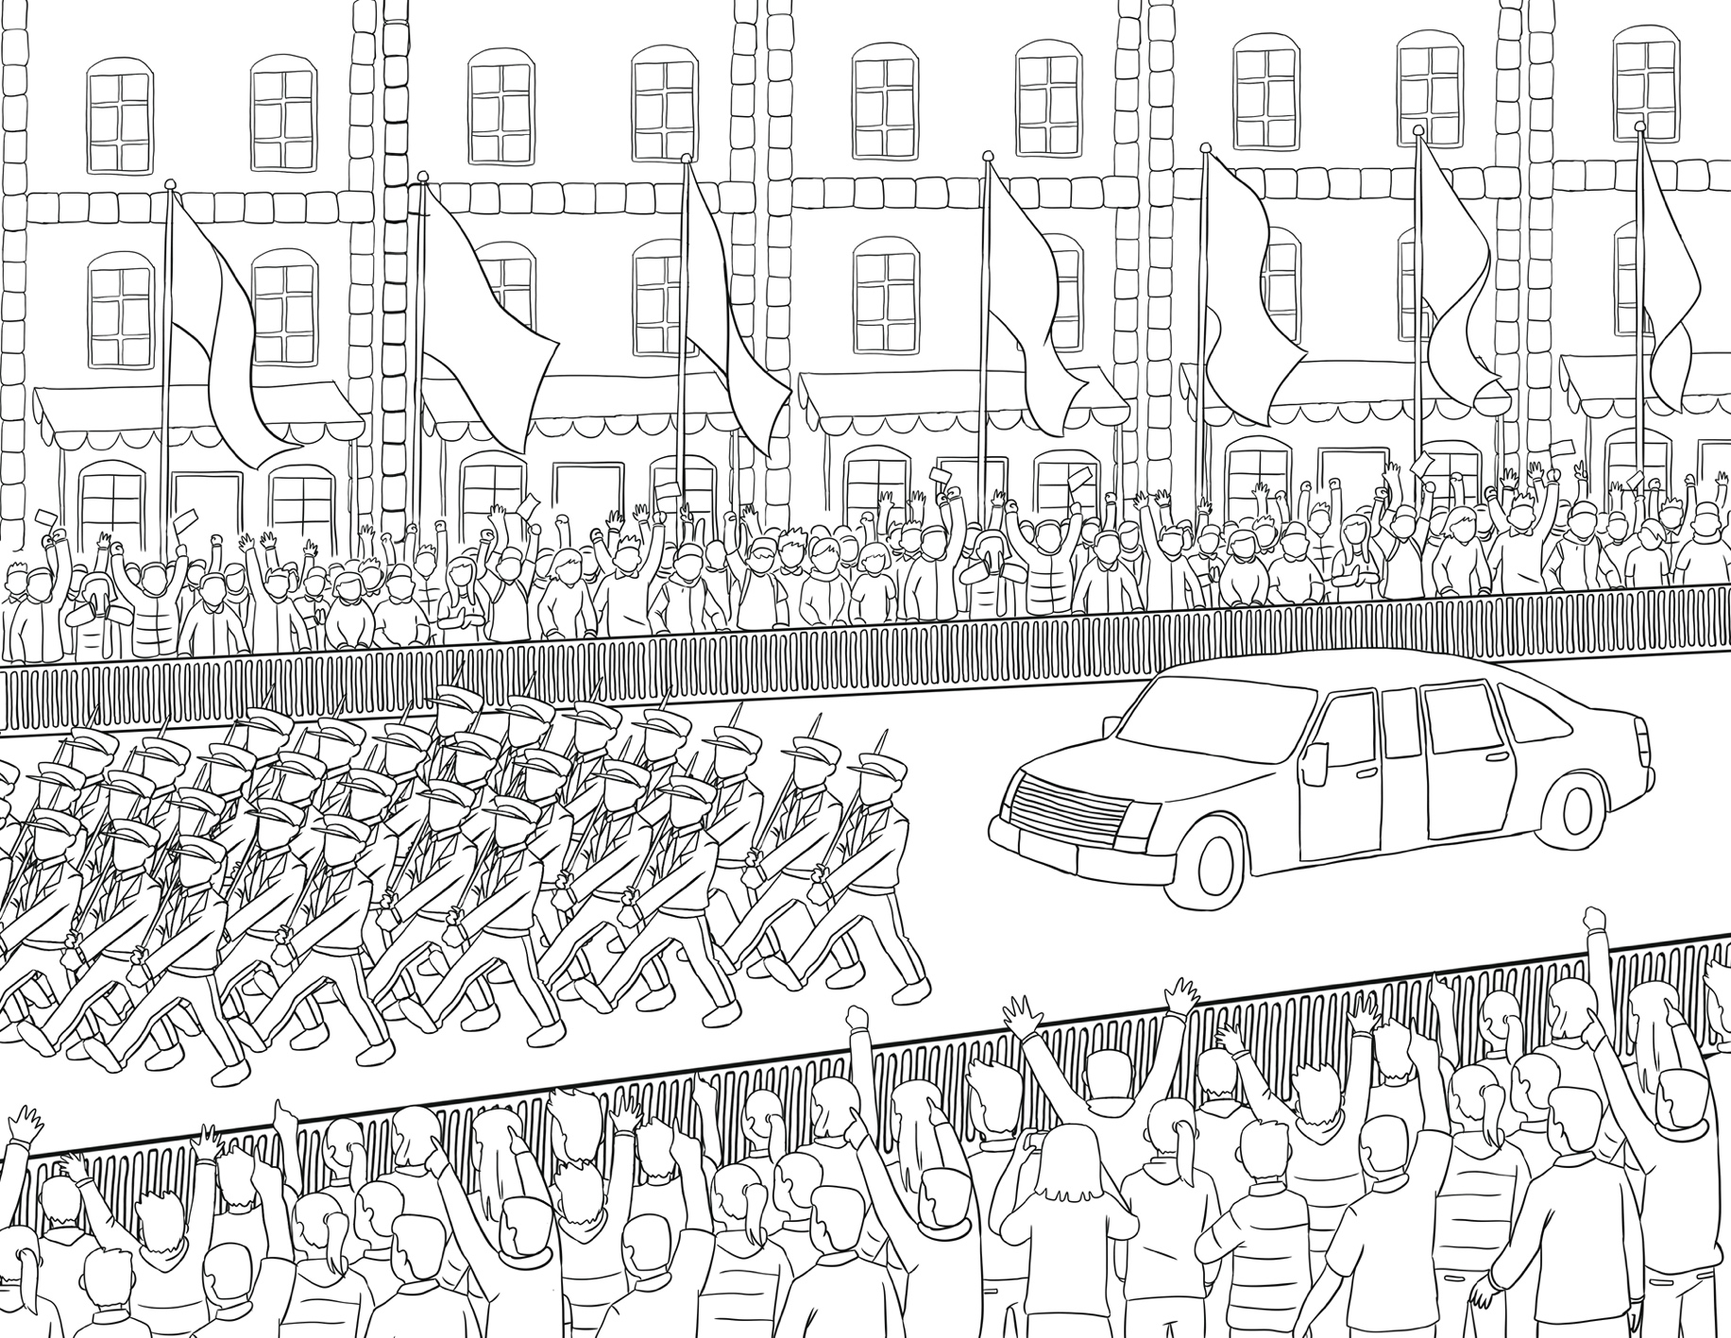

COLORING

THE ROYAL ADVENTURES OF THE WHITE HOUSE

What did the new President promise in his inaugural address?

CHAPTER 4 QUIZ

Who counts the electoral votes?

How did Hailey feel at the Inaugural Ball?

What did Hailey’s family do while they waited for the results?

‘

What would you like to do if you were elected as President?

THE ROYAL ADVENTURES OF THE WHITE HOUSE

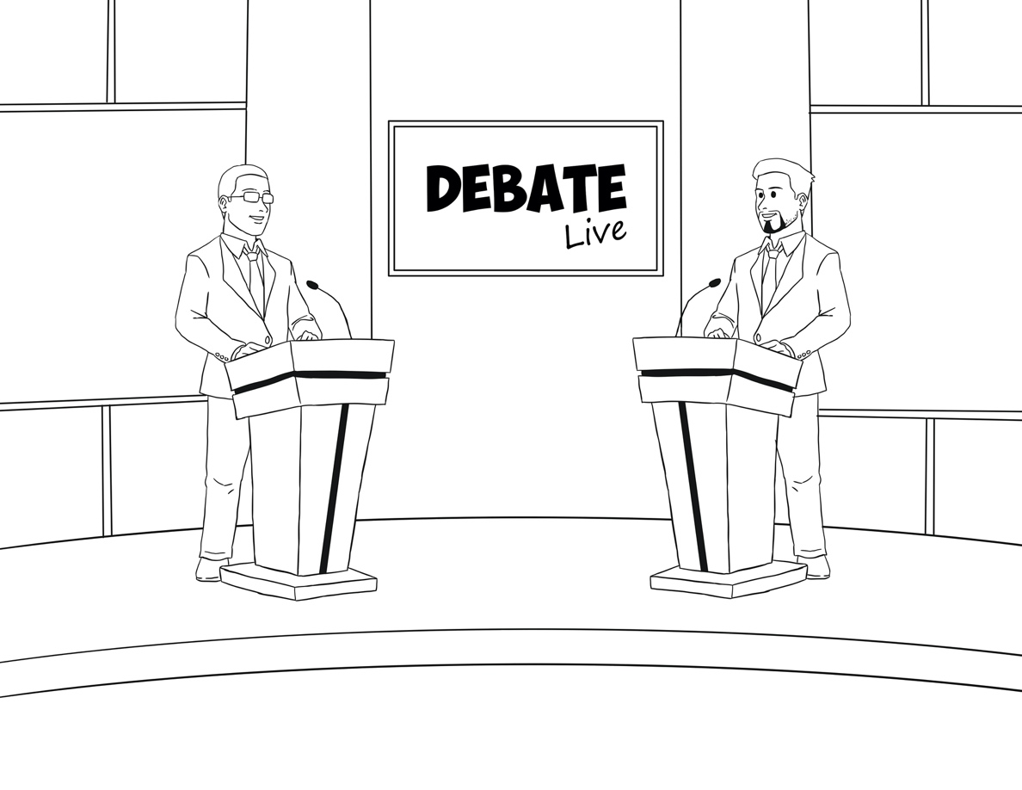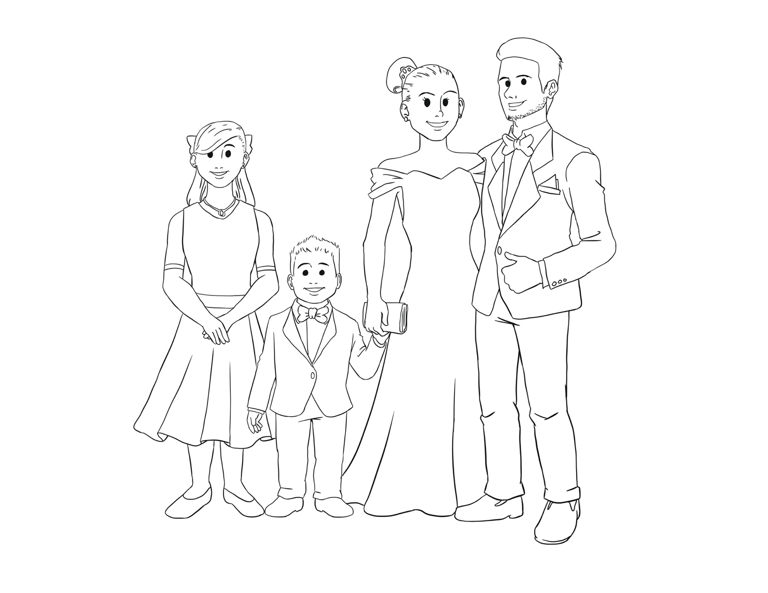

Help the candidate get to the debate!

SOLVE THE MAZE