Keeping our Children Safe Online

November 10, 2021

5:30 PM

Presented by:

District Attorney Tripp Fitzner, Middle Judicial Circuit

Sheriff Joel Cochran, Washington County Sheriff’s Office

How to “block” strangers:
SNAPCHAT

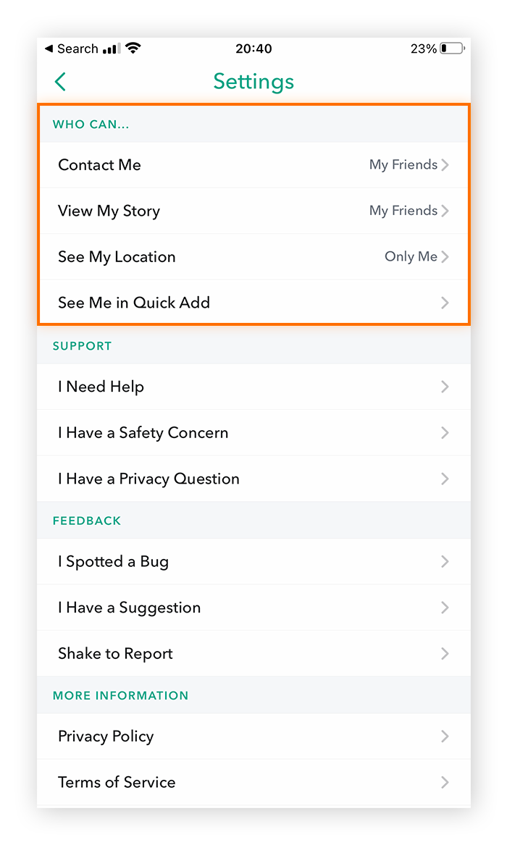

- Open settings (marked with the gear icon)
- Under ‘contact me’ and ‘view my story’ select ‘my friends’ instead of everyone
How to make sure your child isn’t a “recommendation”:

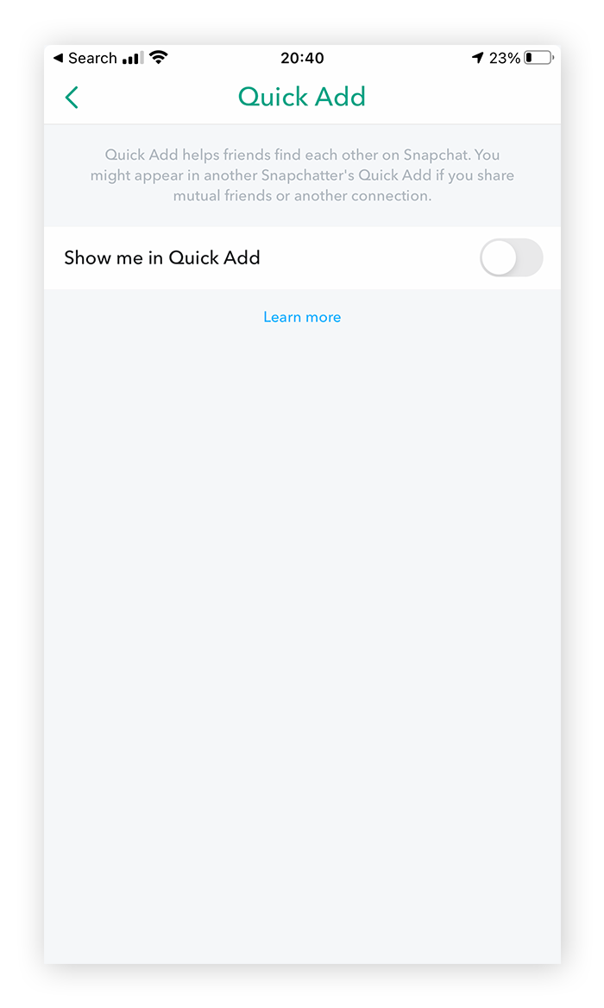

- Open settings (marked with the gear icon)
- Tap ‘see me in quick add’
- Toggle (click) the switch to off
How to hide your child’s location:

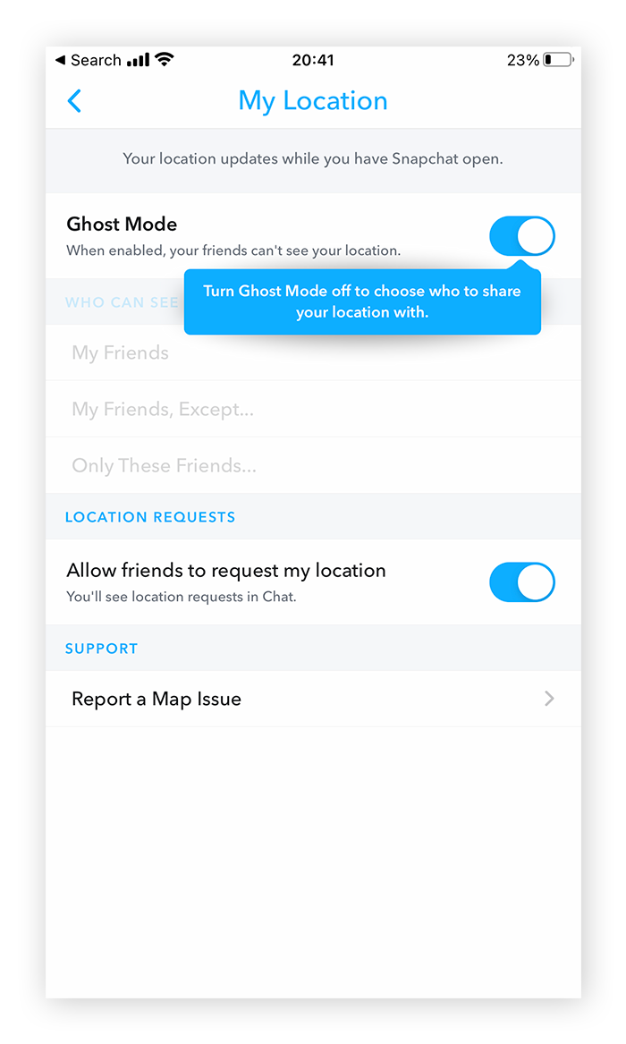

- Open settings (marked with the gear icon)
- Tap ‘see my location’
- Toggle on ‘ghost mode’
How to protect your child’s phone number:

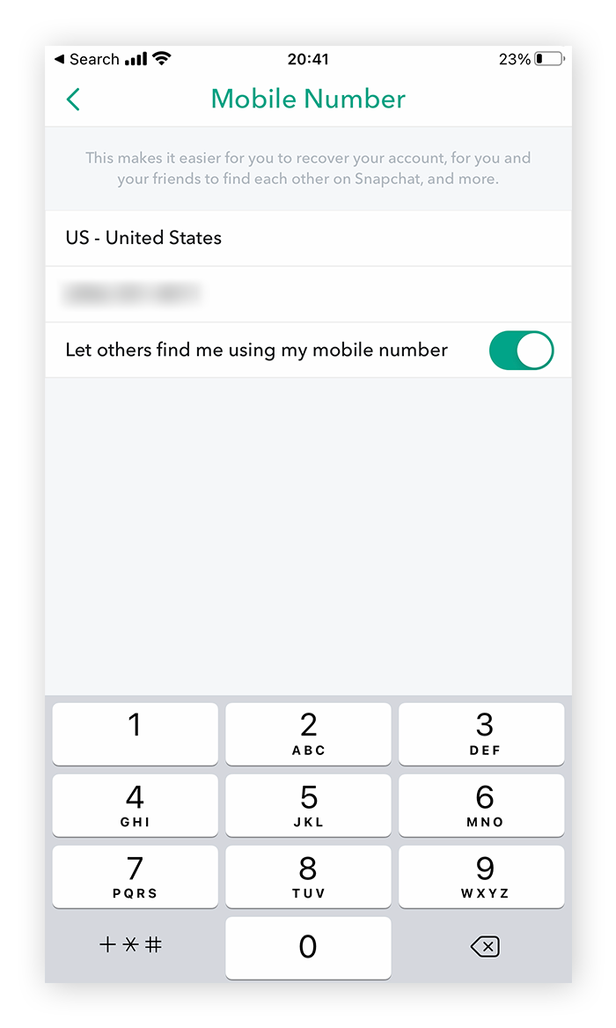

- Open settings (marked with the gear icon)
- Tap ‘mobile number’
- Untoggle the ‘let others find me using my mobile number’ option
INSTAGRAM

How to keep account private

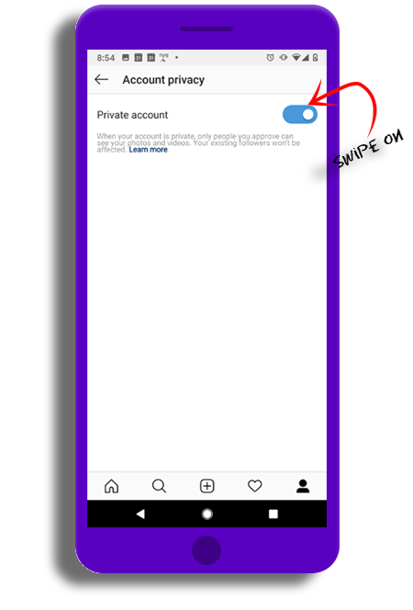

- From your account tap the three horizontal bars
- Tap ‘settings’ then ‘privacy’ and then ‘account privacy’
- Toggle the button blue
How to Unfollow:
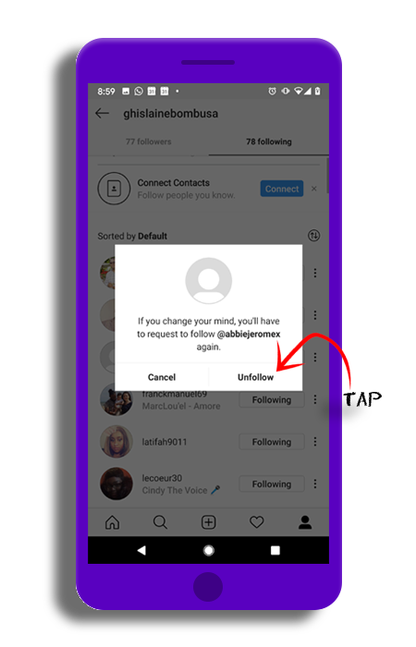

- Go to your profile and tap ‘followers’ at the top of the screen
- Tap ‘remove’ next to the followers you wish to unfollow
- Tap ‘remove’ again
- You can also unfollow an account by going directly to their profile and tapping ‘following’. They will not be notified but they will no longer see your posts.
How to manage comments…part one

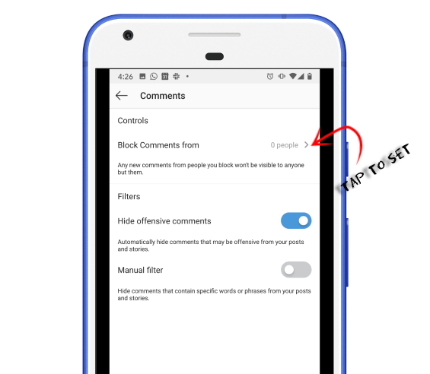

To allow comments before posting:
- Go to your profile and tap the three horizontal lines then tap ‘settings’
- Tap ‘privacy’ and then ‘comments’
- Next to ‘allow comments from’ tap the arrow and choose your option

How to manage comments…part two

To block comments before posting:
- Next to block comments from, tap ‘people’.
- Enter the name of the person you want to block and then tap ‘block’ next to their name.

How to filter comments:

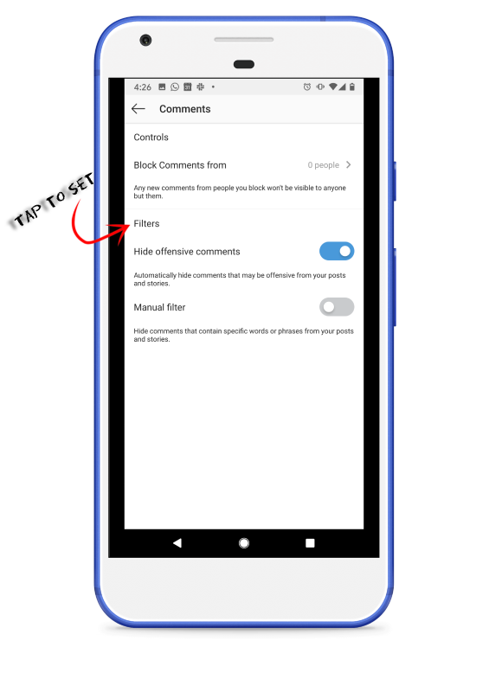

To block comments before posting:
- Go to your profile and tap the three horizontal lines then tap ‘settings’
- Tap ‘privacy’ and then ‘comments’
- Next to block comments from, tap ‘people’. Toggle the ‘hide offensive comments’ to blue
- You can also manually filter specific words or phrases from your posts or stories: next to ‘manual filter’ toggle the feature on. Then enter the word you want to filter.
How to mute someone:

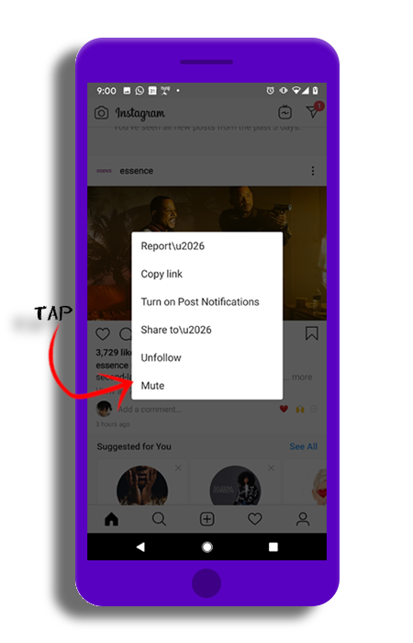

If you don’t want to see someone’s posts in your feed, you can mute them
- Go to their profile by tapping the search icon and the bottom or find them by typing their name into the search
- Tap following below their profile info and tap ‘mute’
- Instragram won’t let them know you muted them
How to use the “close friends” setting—so that only certain people can see your child’s profile:

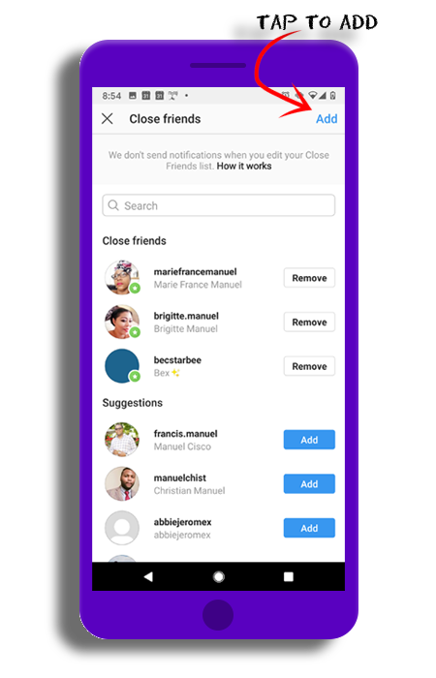

To create a close friends list:
- Go to your profile and tap the three horizontal lines then tap ‘settings’
- Tap ‘close friends’, and then tap “suggestions” at the top
- Tap ‘add’ next to the people you want to add
- You can also tap ‘search’ to search for a friend – tap ‘done’ when you’re finished
How to restrict an account:

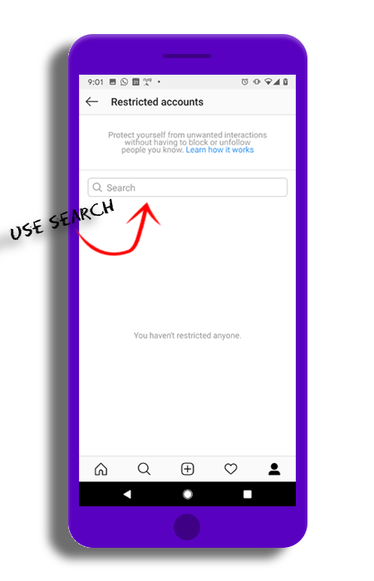

Restrict is a way to protect your account and block specific people
- Go to your profile and tap the three horizontal lines then tap ‘settings’
- Go to the privacy tab in ‘settings’
- Tap ‘restrict accounts’ then search for a user then tap ‘restrict’

FACEBOOK

How to set privacy settings within Facebook:

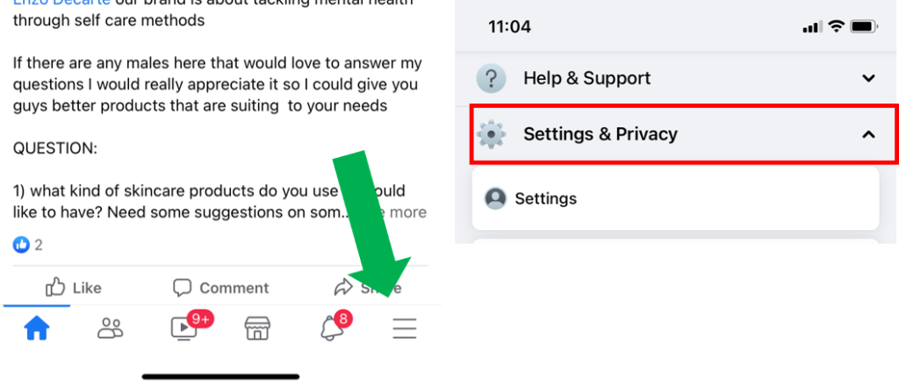

Click on “privacy shortcuts” in order to review certain privacy settings:

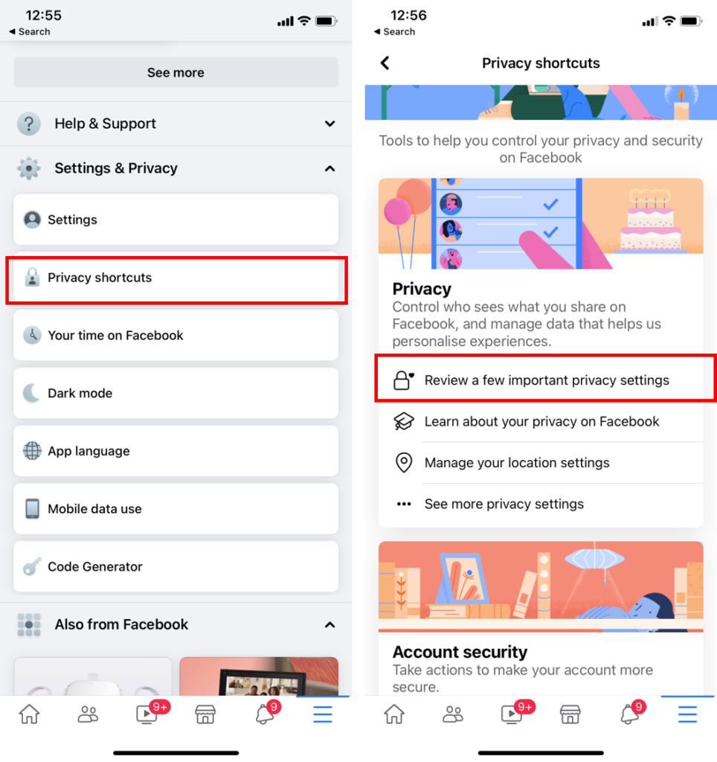
How to perform a “privacy checkup” within the platform:

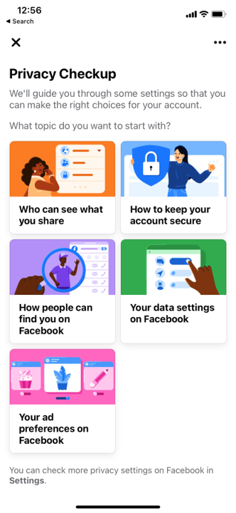

How the same privacy screen/settings look from a desktop:

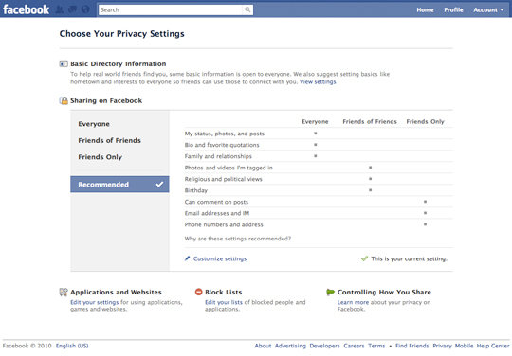

How to block someone on Facebook Part One:

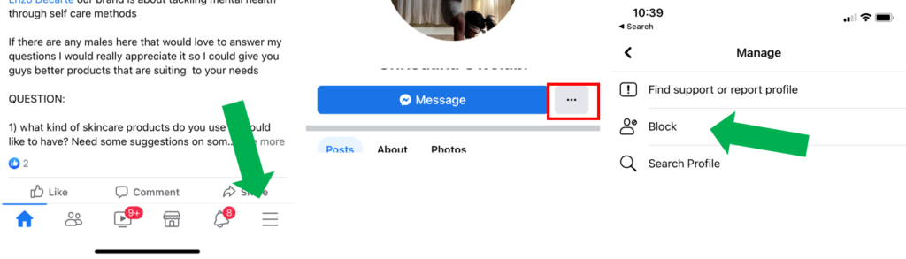

- From your home feed, either search or click on their name
- Tap the three dots next to the message button on their profile
- Tap ‘block;, then ‘block’ again

How to block someone on Facebook part two:

From your home feed, take the three horizontal dots in the bottom right-hand corner, then:

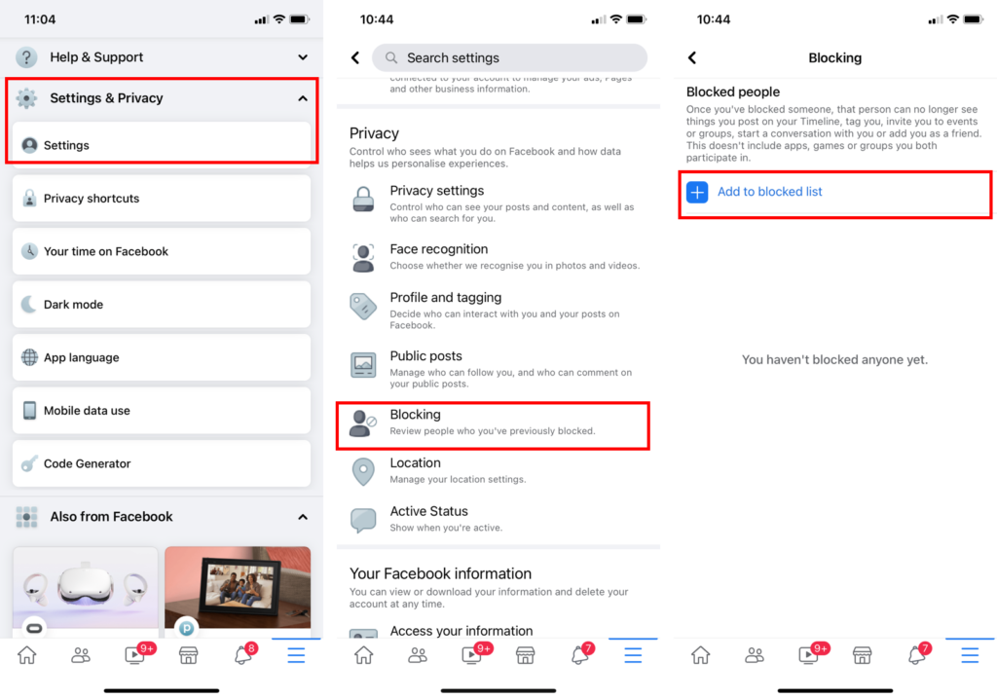

- Scroll down and tap ‘settings & privacy’ then tap ‘settings’
- Scroll down and tap ‘blocking’, then ‘add to blocked list’
- Then search for the name or email and tap ‘block’

How to make your child’s TikTok account private:

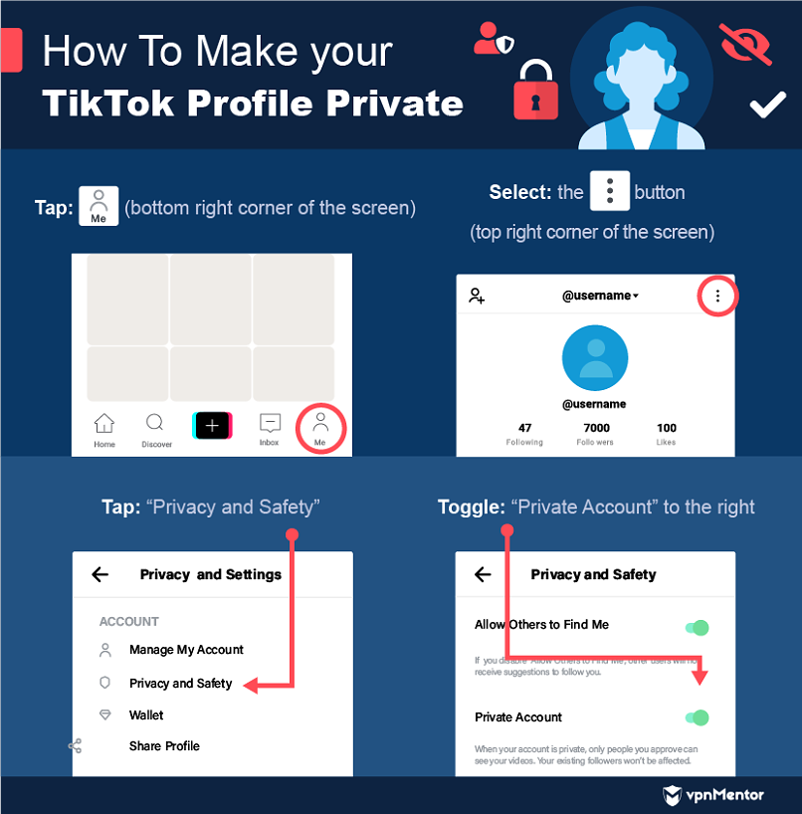

How to activate family pairing on the TikTok app:

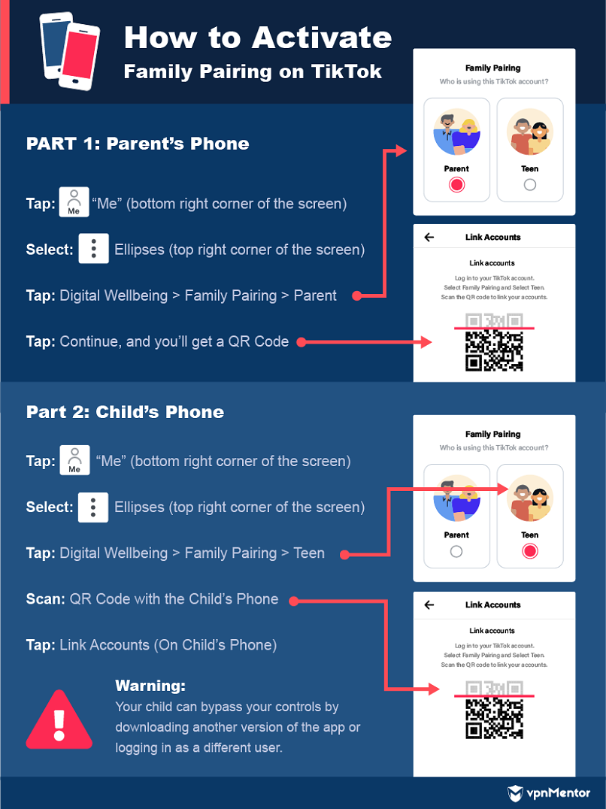

How to protect your child’s well-being on TikTok:

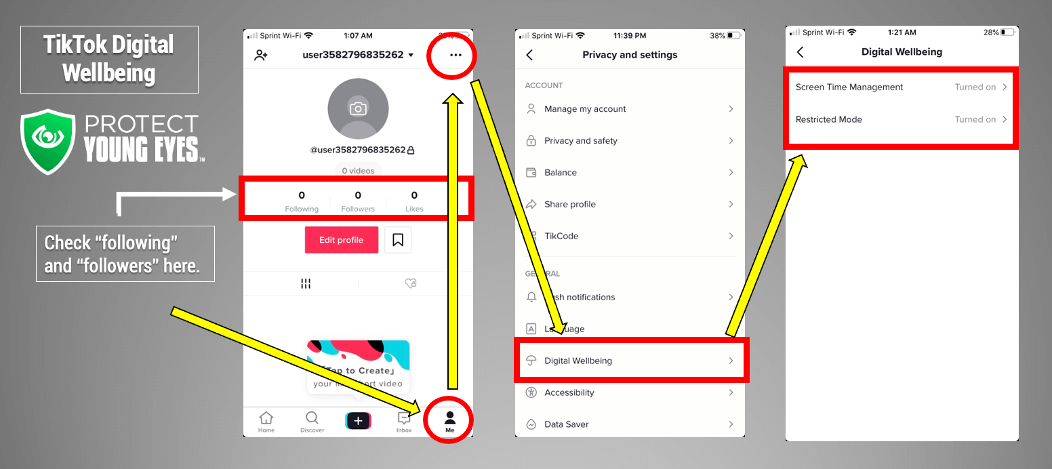

- Open the app in your child’s mobile device
- Click the “Me” visual on the bottom right of the screen
- Click the three dots on the top-right of your child’s profile
- Click “digital wellbeing”
- Turn on/activate “Screen Time Management”
- Turn on/ activate “Restricted Mode”

How to set up an Xbox profile for your child:
Xbox Live

- Press the xbox button to open the guide menu
- Navigate to the ‘settings’ icon
- Select ‘family’ under the account section
- Select ‘add to family’
- Select ‘add new’
- Sign in with your child’s Microsoft account and password
- Then sign in with your Microsoft account and password

