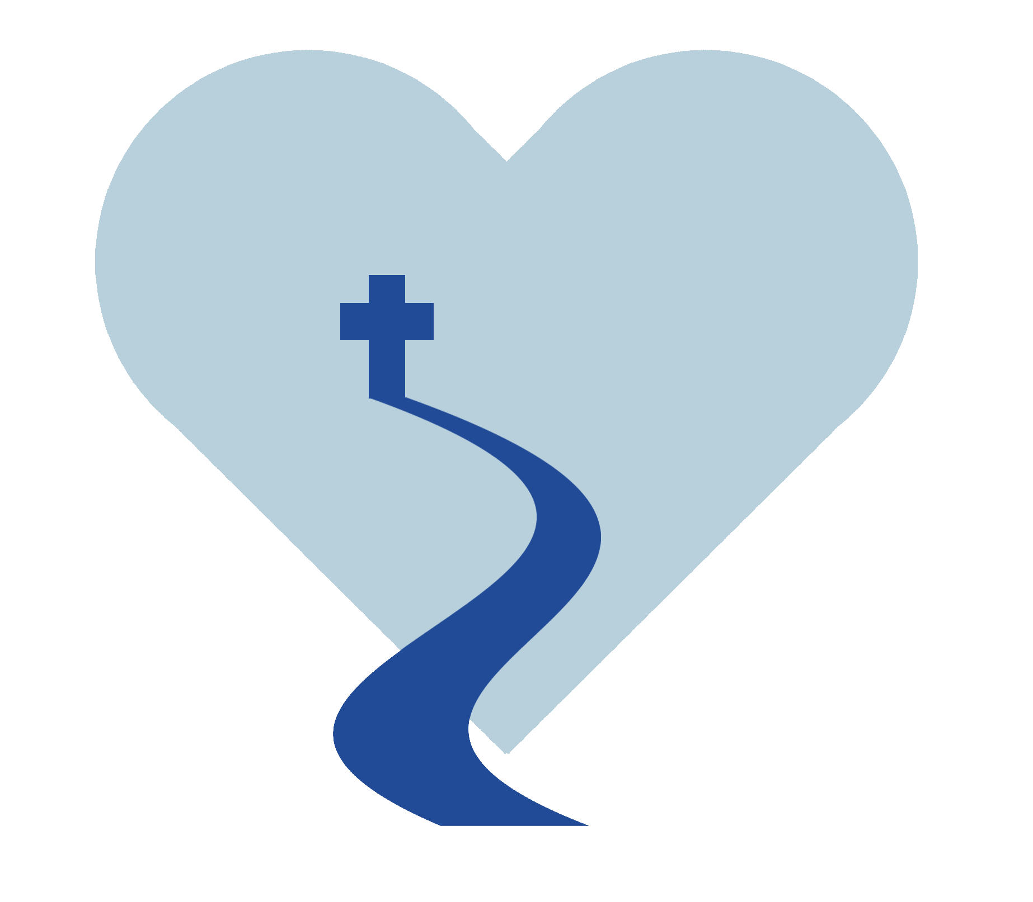**Items for Gift Registry**

Community Baby Shower

Walking with Moms in Need

Stillwater, MN

* Diapers
* Baby Clothes - gender neutral (6 month size clothes)
* sleep sacks
* baby tub
* hoodie towel/washcloth set
* socks/booties
* carseat cover
* pacifier
* teethers, rattles, toys, chewable baby book
* boppy pillow
* nipple cream
* sling carrier
* Blessed Our Lady of Guadalupe Candles (When a mom goes into labor, we will light candles and pray for her.)
* Guardian Angel prayer card, St. Gianna prayer card, etc.
* Prayer Baby Blanket