How to Complete Your Absentee Ballot
Listed below are steps to completing your ballot and mailing it in. More detailed instructions from the County Clerk on how to vote an absentee mail-in ballot are also included with your ballot. Please read them carefully and thoroughly. All steps must be completed or your ballot will be rejected.

- Complete the absentee ballot.

- When you have finished marking the ballot, place the voted ballot in the inner (yellow) envelope. DO NOT DETACH THE FLAP on the inner envelope. If this flap is detached, your ballot will not be counted.
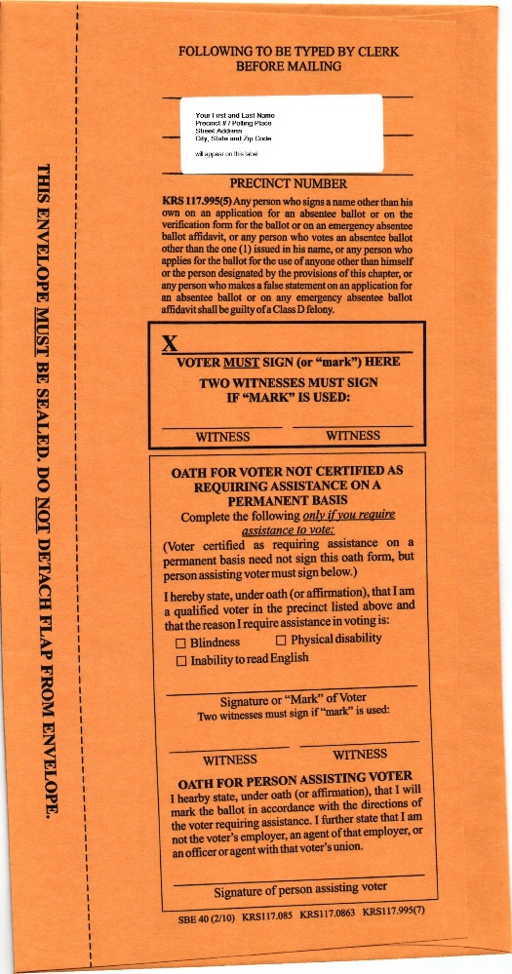

- SIGN and SEAL the inner envelope. Place this envelope in the outer (white) envelope. SIGN and SEAL the outer envelope once the ballot is placed inside.
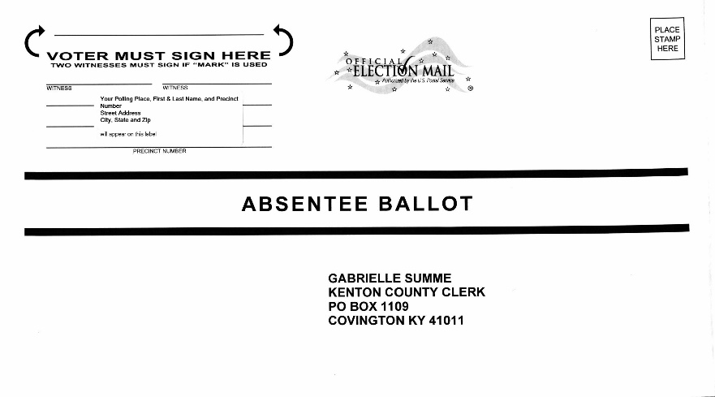

- Affix postage to the outer envelope and mail to the County Clerk.

