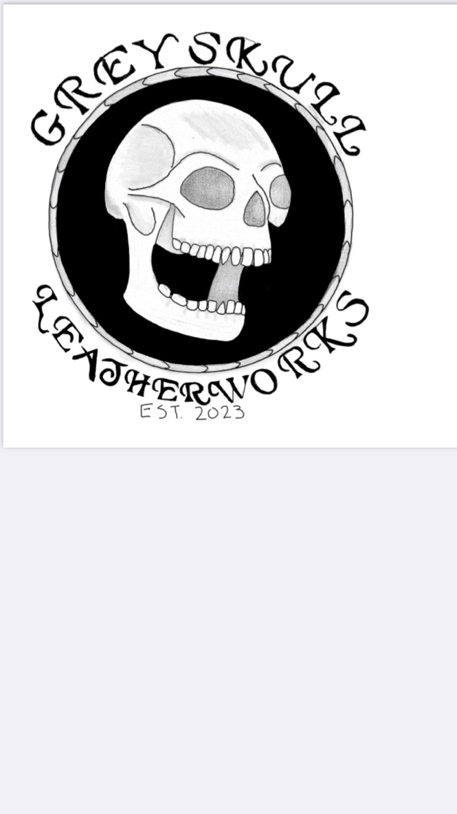**Custom Leather Holsters and Wallets**

www.GreyskullLeatherworks.com

Skeletor@GreyskullLeatherworks.com

(636) 373-5892

Name _______________________________ Phone ___________________________

Email ___________________________________________

Address _________________________________________

_________________________________________

**Custom Holster:**

Make:____________________ Model:____________________ Barrel Length______________

IWB $99_____ OWB $99______ Pancake $109____ Leather Lining +$29_______ Custom______

**Custom Wallet:**

Biker Wallet $199______ XL Bi-Fold $169______ Bi-Fold $149______ Minimalist $99_______

**Leather Color Exterior**(Circle One)

Black, Chocolate, Dark Brown, Light Brown, British Tan, Saddle Tan, Red, Natural.

**Leather Color Interior** (Circle One if applicable)

Black, Chocolate, Dark Brown, Light Brown, British Tan, Saddle Tan, Red, Natural.

**Stitch Color** (Circle One)

Black, Brown, Cream, Red, Blue, Orange, Green, Yellow, Silver, Pink, Purple

**Additional Options**

Custom Tooling $29_________ Leather Stamping $19___________ Initials $9_______________

Notes/Requested Artwork