Class Registration Form  (Tear Off)  Name:  Email:  Phone Number:  Class Selection:  100 Level:  - The Gospel of John-Understanding Jesus  Wednesday 12 Noon  - Church Membership-Discovering the Attitude That Makes a Difference  Wednesday 6pm  Check the circle for each class you are choosing and indicate the time if applicable. Return form to Visitor/Registration Table  Thank you!  You may also register online:  www.pilgrimbcfw.org  (scroll down, click Registration Form)  Classes Begin  Wednesday, February 5, 2020  Regis  You can use this fresh, professional brochure just as it is or easily customize it.  On the next page, we’ve added a few tips (like this one) to help you get started. |  | Pilgrim Bible Institute  Pilgrim Baptist Church  1331 Gay St.  Fort Wayne, IN 46803 |  |  | Pilgrim Bible Institute  Spring 2020  - “Christian Education for Today’s Disciples”  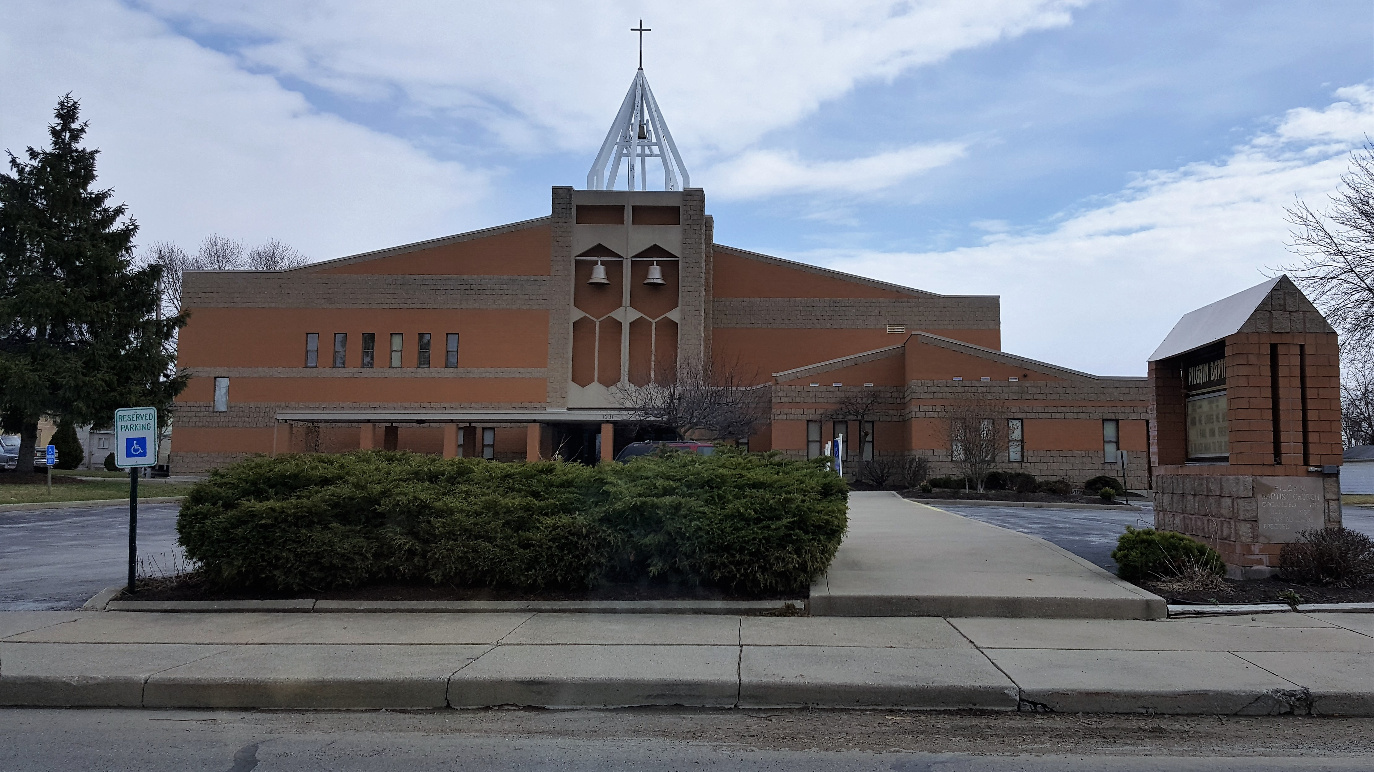  Sister Denise Moore  Director  Sister Wille Mae Griffin  Dean  Rev. Raymond C. Dix Jr.  Senior Pastor  Church Office:  (260) 424-5416  Online Registration  www.pilgrimbcfw.org

Course Descriptions:  The Gospel of John: Understanding Jesus  Synopsis:  During this course, students will learn key elements of the ministry of the Jesus from Scripture. The Gospel of John tells the unique story of Jesus as the Second Person of the Trinity, from the perspective of John, a member of Jesus’ inner circle. This study will reveal key perspectives of the life and personality of Jesus. The students will learn more about our Lord and His purpose for coming to the world.  Instructor:  Pastor Raymond Dix Jr.  Place: Room 149 Main Level  Class Length: 12 weeks, 1-hour sessions w/periodic breaks between weeks  Date/Time: Wednesdays 12 noon  Church Membership: Discovering the Attitude That Makes a Difference  Synopsis:  This course is designed to help students learn how to effectively study and understand what it means to belong to a local church. This is a six (6) week course and will cover the following: | - Functioning Church Membership  - Promoting Unity  - Personal Preferences and Desires  - Praying for Church Leaders  And much more!  Instructor: Pastor Raymond C. Dix Jr.  Place: Room 149 Main Level  Class Length: 6 weeks, 1-hour sessions w/periodic breaks between weeks  Date/Time: Wednesdays 6pm  Attendance Policy:  Each student is required to attend 75% of all registered class time in order to receive a certificate of completion. We encourage all students to communicate with the instructor or Dean if there are unforeseen circumstances.  Note: In person PBI classes are free for all Pilgrim members. Livestreaming is available for $20 per class and Non-members are encouraged to attend with a small fee of $20.00 per class. You may register for streaming online. Nonmembers automatically get streaming w/in class registration. No books are required to be purchased for this term. Please return your registration to Pilgrim Baptist Church, or you may register online.  Online Registration  www.pilgrimbcfw.org  (Scroll down then click Registration Form) | PBI Staff  Sister Denise Moore  Sister Wille Mae Griffin  Sister Roberta Chambers  Deacon Harry Griffin  Superintendent, Freddie Johnson  If you wish to be part of the PBI ministry team, please contact the church office at (260) 424-5416 or any of the above team members for details.  PBI:  “Christian Education for today’s disciples.”  

