PERSONAL HEALTH HISTORY- To be completed by Patient Prior to Office Visit

Please be advised that completing preliminary health and insurance questionnaires does not establish a physician-patient relationship with this practice. Dr. Chadfield will review your health history and conduct an initial evaluation to determine whether you are a suitable candidate and whether the practice will accept you as a patient.

_____________________________________________________________________________________________________
Last Name First Name Middle Initial

Age: ______________________ Date of First Visit: _______________

Who is your Primary Care Physician?

Name: ___________________________________________________ Phone: _______________________________

Address: __________________________________________________________________________________________

Please list who referred you to this clinic?

Name: ___________________________________________________________________________________________

Mark the areas on your body where you feel pain now or regularly
Use the appropriate codes indicated below.

ACHE >>>> NUMBNESS --------- PINS & NEEDLES 000000 BURNING xxxxx STABBING //////
>>>> --------- 000000 xxxxx //////
>>>> --------- 000000 xxxxx //////

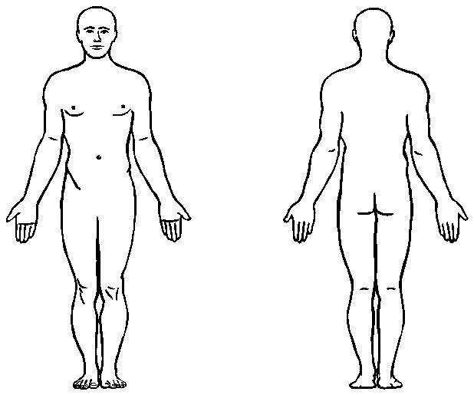

What number is your pain at worst ________ when best ________ today ___________(0 no pain/10 worst pain)

