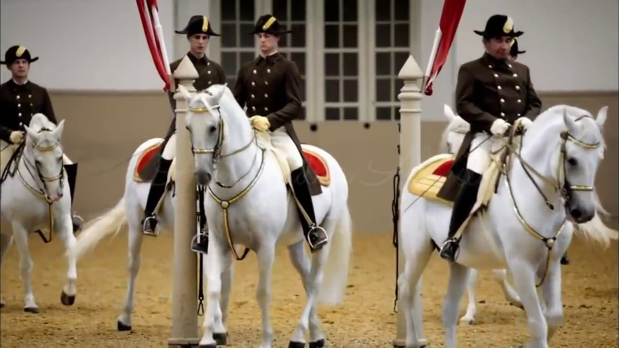

2020/2021 SEASON

February 2021

Issue 4



Dear Members & Dressage Enthusiasts –

IN THIS ISSUE

2021 Officers

*

Dressage Company & Horse Events

*

Local Horse Show Dates

*

January Meeting Minutes

*

Yoga for Dressage Riders

*

Membership Form

It looks like February will be the month where our ride time will be cut short a bit due to the freezing temperatures and snow accumulation which may hinder us to get out to the barn.

Well, this is a good time to do check into some other form of exercise to keep us fit for the saddle like Yoga or Pilates. Maybe the included article will inspire you to try it out.

Also we hope you can all join us for our next zoom meeting where we will be discussing some articles from the latest USDF Connection magazine. If you do not have a copy, please let us know and we will send you the articles by email.

As usual you can always look up more info on our website and Facebook page!!

And finally we want to thank everybody who renewed their membership, and welcome our new members as well.

Isi Brown

The Dressage Company Newsletter Editor

The Dressage Company Newsletter -- Page 1

*DRESSAGE COMPANY*

*NEXT MEETING*

ZOOM MEETING

Monday, February 15th

Please check Facebook/website

and page 3 for more details

*OTHER HORSE EVENTS*

*UPCOMING SHOWS 2021*

MAJESTIC FARM – SERIES 1

~~January Blast - January 9~~

~~February Frolic – February 6~~

March Madness – March 6

April Adventures – April 24

May CT & Dressage – May 15th

June Dressage – June 19th

MORE UPDATES OF POSSIBLE OTHER SHOWS AND USDF/USEF RECOGNIZED SHOWS TO FOLLOW.

GOOD LUCK TO ALL PARTICIPANTS IN ADVANCE. HAVE FUN!

**2021 OFFICERS**

*President – Debbie Boeh*

[debbieboeh@hotmail.com](mailto:debbieboeh@hotmail.com)

*Vice President - Sue McBeth*

Shakespeare1950@embargmail.com

*Treasurer - Carol Hartlaub*

[Chart3977@aol.com](mailto:Chart3977@aol.com)

*Secretary – Sue Segerman*

[segermansue@cinci.rr.com](mailto:segermansue@cinci.rr.com)

Sargent at Arms -Mary Lynn Griswold

[marylynngriswold@gmail.com](mailto:marylynngriswold@gmail.com)

*Membership Chair*

Melanie Stewart

[rmstewart@fuse.net](mailto:rmstewart@fuse.net)

*Trustees*

Leslie Laine

Trish Hammer

Isi Brown

*Webmaster*

Leslie Laine

[ldlaine@fuse.net](mailto:ldlaine@fuse.net)

*Newsletter Editor - Isi Brown*

[isidressage@gmail.com](mailto:isidressage@gmail.com)

*Historian/Social Media Chairs*

Sue Segerman

[segermansue@cinci.rr.com](mailto:segermansue@cinci.rr.com)

**NOTE:**

**The Dressage Company TM is a Group Member Organization of the United States Dressage Federation (USDF). Members are automatically USFS Group Members. We are located in Region 2.**

For showing at recognized shows, make sure you have the correct membership to be qualified for all championships, awards etc.

The Dressage Company Newsletter -- Page 2

**NEXT MEETING – MONDAY, FEBRUARY 15th – ZOOM MEETING**

After a short business meeting, we will be discussing 2 articles from the USDF Connection Magazine, January/February 2021 edition:

***"The Thoracic Sling" on page 18 – This muscle group plays a key role in collection***

***(by Hilary M. Clayton)***

***"The Gift Horse" on page 48 – donated Dressage horses benefit collegiate riders, special-needs riders, and even horseless youth. Thinking of donating?***

***(by Natalie DeFee Mendik)***

Hope you can join us.

January Dressage Company Meeting Minutes 1/19/21

Meeting started at 7:09PM via Zoom - Minutes as published in the last newsletter were approved.

Membership - There are 14 renewals and 1 new (junior) at the present time. Reviewed the letter to go out to past members to encourage renewal membership - to be sent out

Treasure - No new activity except membership to USDF.

- Estimated costs for ribbons for YEA 2020 $500.00 and low amount spent for awards because of donated items

- Bank signatures on checks need to updated for president’s ability to sign

Administration - Need of second person for Facebook access – checking with Sue Segerman

- Sue McBeth – to look into updating bylaws regarding back-up person on all needed positions – ie-bank, Facebook, website

TDC Show - We are still looking for a possible venue for a horse show in 2021. Sue McBeth is looking possible venues – unfortunately Majestic Farm is not renting their facility.

YEA - Questions/concerns re qualifying judges at local shows. A statement reminding all members interested in the YEA to pay close attention to several of the key points (membership in TDC/Entry of horse and Rider/Qualified Dressage judge -as per TDC/USDF “L”graduate or higher of USEF “r” Eventing or higher) To be put in newsletter

Educational - Debbie Boeh invited all to an educational activity – Dr. Havercos will be at her facility Thursday January 21 – Chiropractor – informative- if interested please contact Debbie. Sue Segerman was contacted to put a message out on Facebook – since it was short notice.

Future meetings and clinics

- Suggested topics for future meeting and clinics were discussed; Zoom based educational ideas/discussions for safe interaction -possible topics – vets/dental/riding

- Pertinent book/article review and discussion – Sue McBeth looking into article for February Meeting

Next meeting - February 15th. Zoom Meeting - Looking at first 30 Minutes “business” meeting followed by article/possible educational discussion

The meeting adjourned at 8:15 PM (estimated)

The Dressage Company Newsletter -- Page 3

Submitted by Melanie Stewart

**YOGA FOR DRESSAGE RIDERS**

**(below was copied from the follow link https://dressageridertraining.com/article/beginners-yoga-for-dressage-riders/)**

Yoga is an incredibly under utilized form of training for dressage riders and I would love to see that change. You see yoga has the ability to make you feel centered, balanced and more energized. It improves your posture and evens out any imbalances throughout your body. Just as we want our horses to be balanced, centered and energized it makes sense that as a rider we to should be aiming to feel the same. After all how the horse feels is a replication of how the rider feels.

The great thing about yoga is its ability to get to all those deep muscles that we tend to neglect, while at the same time improving your straightness and opening up your hips. All of which are incredibly important for riding. The combination of length, balance and strength allow you to get more in control of your center of gravity and more balanced in the center of the horse while riding. It is when you are balanced that you are able to give subtle independent aids on the horse. Not only does yoga work on your body it also works on your mind. Its increases body awareness, focus and clarity. Then at the heart of yoga is breath.

Staying connected to your breath and mind while you take your body into challenging and uncomfortable poses. Exactly what a dressage rider needs when heading into an arena or trying out your first flying change! Being in control of your body, your horses body, the balance and impulsion while at the same time being accurate calm and centred. As you can see yoga can have some incredible benefits for dressage riders.

As riders we want our horse to calmly move through the movements with grace and ease, so it just makes sense that we put that sort of training in practice off the horse to. Dressage is about feeling, flow, balance, mindfulness and breath and dressage is very much the same when done well. So try out this short beginners yoga and start to bring some balance into your body today.

Want more yoga for dressage or more specific exercise to help improve your rider fitness and strength? Then checkout our dressage rider program. [Learn more here.](https://dressageridertraining.com/register/)

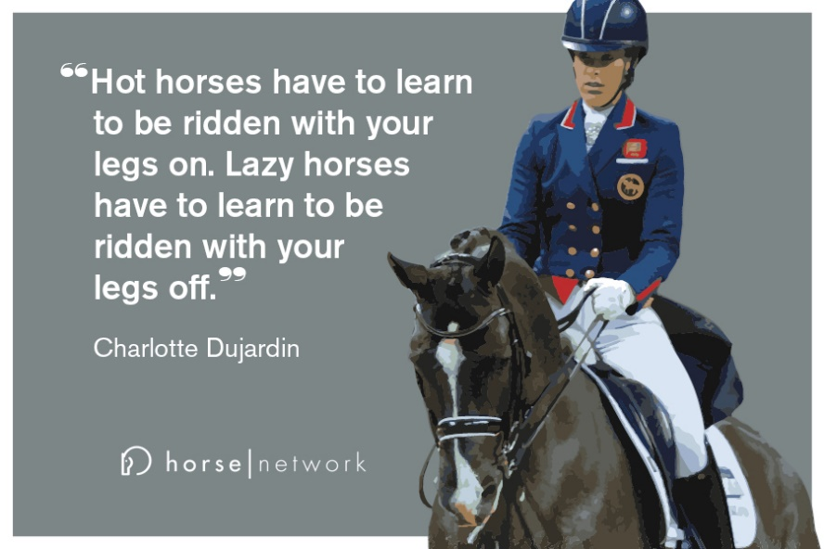

The Dressage Company Newsletter -- Page 4

|  |  |  |  |
| --- | --- | --- | --- |
|  |  |  |  |





If you have anything horse related for sale, please send me details to [isidressage@gmail.com](mailto:isidressage@gmail.com) and a picture, and we put it in our sales corner. Remember for members up to 5 lines are free, beyond that please see rates to the left.

***2021 Membership Form***

***Application/Renewal***

The membership year runs from Nov 1, through Oct. 31.

Dues are $45.00/year for Senior members and $30.00/year for Junior members (a rider who has not reached their 21st birthday before November 1st of the membership year). The dues include an affiliate USDF membership fee.

Are you a USDF member through another organization? { } YES { } NO

If yes, please include you membership number: __________________

{ } New Member { } Renewal { } Change of Address

NAME

ADDRESS

CITY, ST, ZIP

PHONE

EMAIL                                                                         DOB

**SIGNATURE**

Make check payable to The Dressage Company and mail this completed form to:

Mail to: Melanie Stewart

8736 Apple Blossom Lane

West Chester, OH 45069

Email questions or inquiries to: rmstewart@fuse.net

d

The Dressage Company Newsletter -- Page 5

The Dressage Company Newsletter -- Page 5