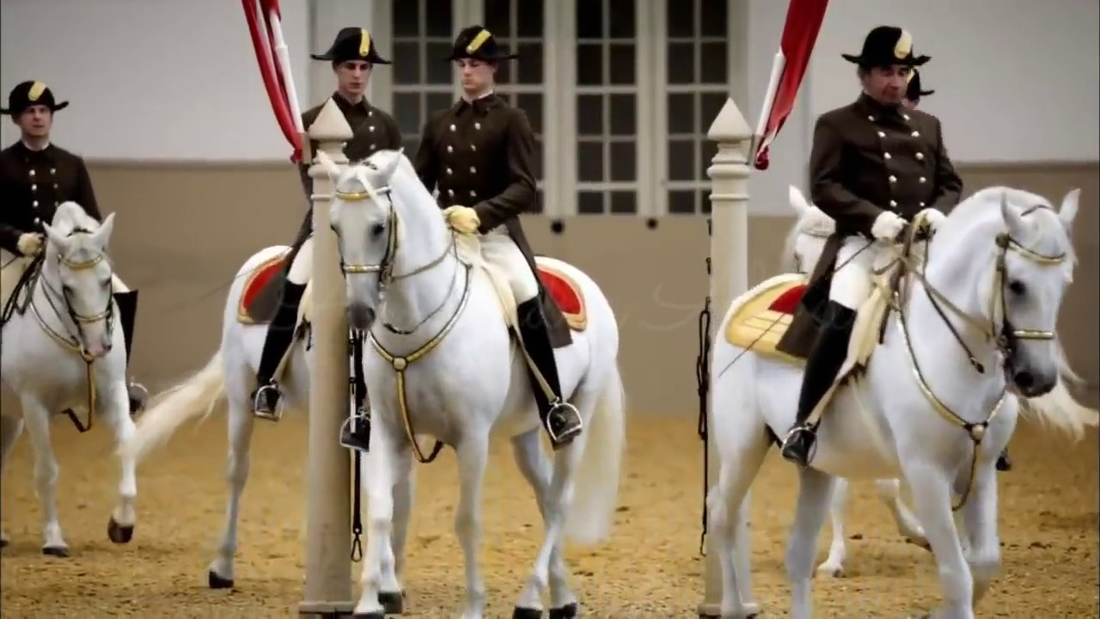

2020/2021 SEASON

January 2021

Issue 3



Dear Members & Dressage Enthusiasts –

IN THIS ISSUE

2021 Officers

*

Dressage Company & Horse Events

*

December Meeting

*

TDC 2020 Champions

*

Local Horse Show Dates

*

Winter Exercises for Horse & Rider

*

Membership Form

Happy NEW YEAR 2021!!

Hopefully all of you had a wonderful holiday season, and started the new year of with some quality horse time!

We are all hopeful that this new year will bring back some of our favorite horse events like the Dressage Finals, Landrover Kentucky, Equine Affair, Congress and for sure some interesting clinics and last but not least horse shows.

We will try to keep you updated as soon as possible about the events we have planned for this year, and for most updated information please check our Facebook site and our website as follows:

[www.thedressageco.com](http://www.thedressageco.com)

So again all the best to all of you, and we can’t wait to see you at our next meeting either via Zoom or hopefully soon in person!!

Isi Brown

The Dressage Company Newsletter Editor

The Dressage Company Newsletter -- Page 1

*DRESSAGE COMPANY*

*NEXT MEETING*

ZOOM MEETING

Monday, January 18th

Please check Facebook/website

for more details

*OTHER HORSE EVENTS*

*UPCOMING SHOWS 2021*

MAJESTIC FARM – SERIES 1

~~January Blast - January 9~~

February Frolic – February 6

March Madness – March 6

April Adventures – April 24

May CT & Dressage – May 15th

June Dressage – June 19th

MORE UPDATES OF POSSIBLE OTHER SHOWS AND USDF/USEF RECOGNIZED SHOWS TO FOLLOW.

GOOD LUCK TO ALL PARTICIPANTS IN ADVANCE. HAVE FUN!

**2020 OFFICERS**

*President – Debbie Boeh*

[debbieboeh@hotmail.com](mailto:debbieboeh@hotmail.com)

*Vice President - Sue McBeth*

Shakespeare1950@embargmail.com

*Treasurer - Carol Hartlaub*

[Chart3977@aol.com](mailto:Chart3977@aol.com)

*Secretary – Sue Segerman*

[segermansue@cinci.rr.com](mailto:segermansue@cinci.rr.com)

Sargent at Arms -Mary Lynn Griswold

[marylynngriswold@gmail.com](mailto:marylynngriswold@gmail.com)

*Membership Chair*

Melanie Stewart

[rmstewart@fuse.net](mailto:rmstewart@fuse.net)

*Trustees*

Leslie Laine

Trish Hammer

Isi Brown

*Webmaster*

Leslie Laine

[ldlaine@fuse.net](mailto:ldlaine@fuse.net)

*Newsletter Editor - Isi Brown*

[isidressage@gmail.com](mailto:isidressage@gmail.com)

*Historian/Social Media Chairs*

Sue Segerman

[segermansue@cinci.rr.com](mailto:segermansue@cinci.rr.com)

**NOTE:**

**The Dressage Company TM is a Group Member Organization of the United States Dressage Federation (USDF). Members are automatically USFS Group Members. We are located in Region 2.**

For showing at recognized shows, make sure you have the correct membership to be qualified for all championships, awards etc.

The Dressage Company Newsletter -- Page 2

**The Dressage Company – December Meeting**

**2020 Awards Pick Up**



Congrats to our Champions !!

The Dressage Company Newsletter -- Page 3

|  |  |  |  |
| --- | --- | --- | --- |
| **Level/Division** | **RIDER/HORSE COMBINATION** | **AVERAGE** | **PLACEMENT** |
| First Level AA | Leslie Laine/Felpz | 67.619 | Champion |
|  |  |  |  |
| Second Level AA | Leslie Laine/Felpz | 65.691 | Champion |
|  |  |  |  |
| Third Level AA | Sue Segerman/Moonshine OAM | 58.633 | Champion |
|  |  |  |  |
| Third Level Open | Debbie Boeh/Lindor Gold | 70.125 | Champion |
|  |  |  |  |
| Fourth Level Open | Debbie Boeh/Lindor Gold | 68.675 | Champion |
|  |  |  |  |
|  | **HIGH PERCENTAGE WINNERS** |  |  |
|  |  |  |  |
| First Level | Leslie Laine/Felpz | 69.857 |  |
| Second Level | Leslie Laine/Felpz | 66.463 |  |
| Third Level | Debbie Boeh/Lindor Gold | 72.625 |  |
| Fourth Level | Debbie Boeh/Lindor Gold | 70 |  |

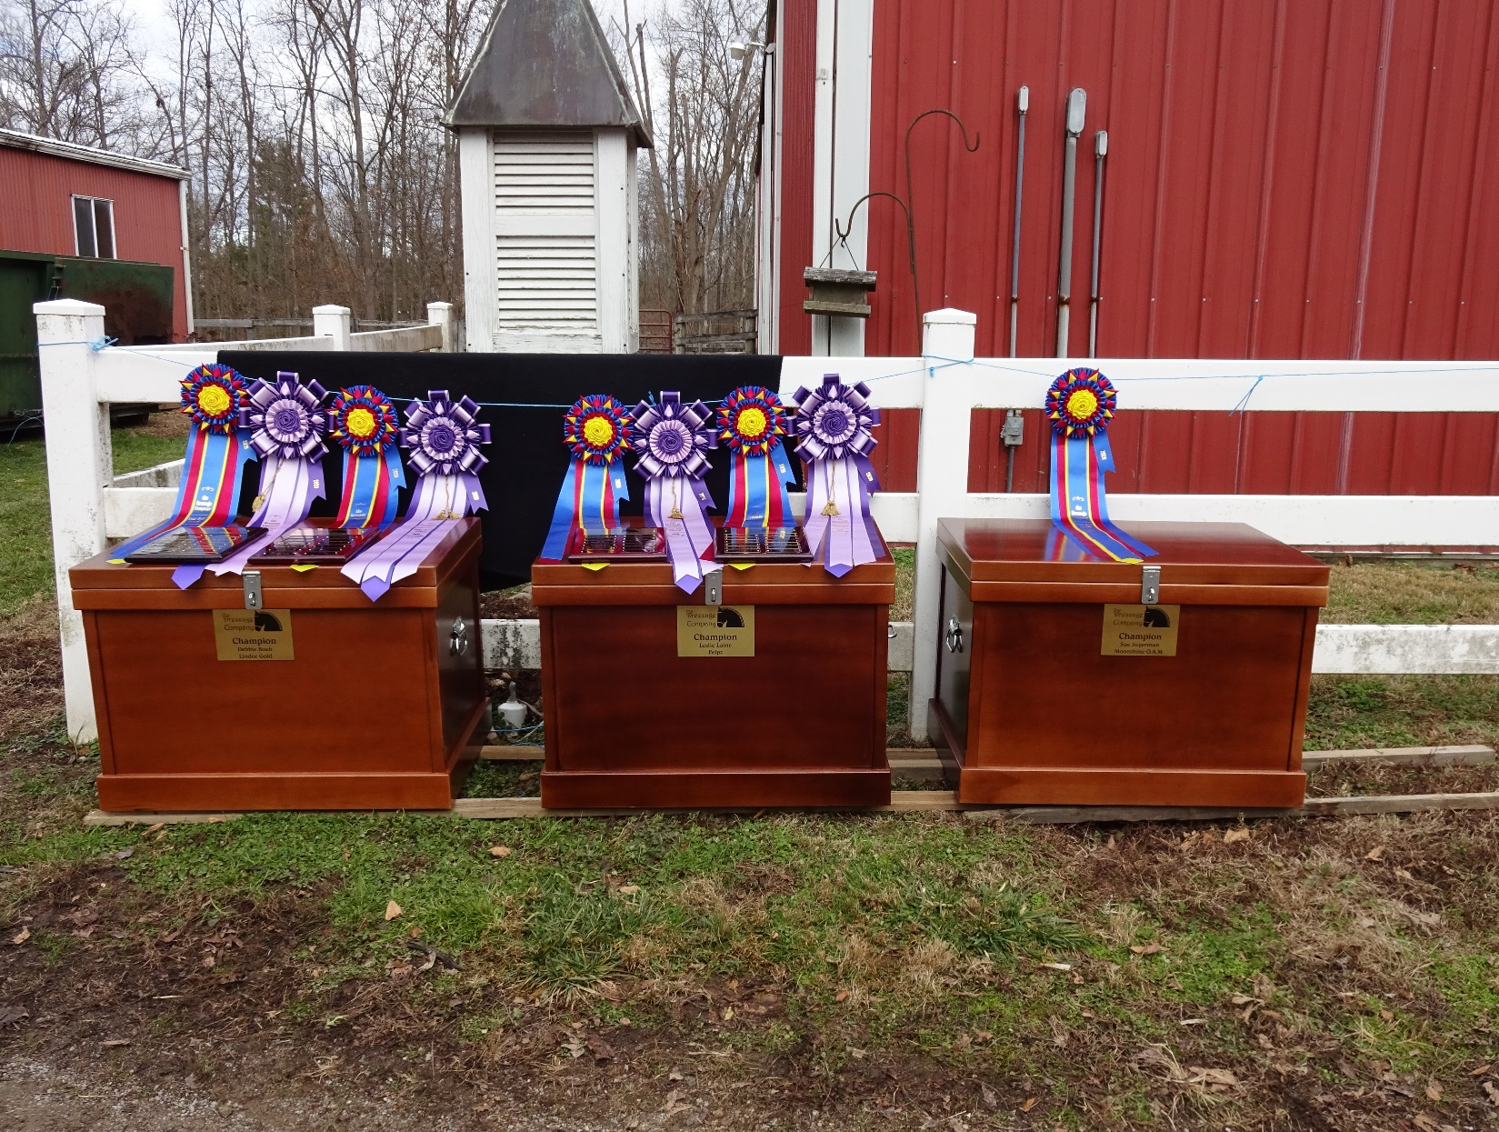

**A Winter Warm-Up Exercise for Dressage Horses**

Try this helpful exercise that benefits both horses with too much energy and those who get tight through the back.

[DRESSAGE TODAY](https://dressagetoday.com/author/dressagetoday) -UPDATED:JUL 25, 2019 - ORIGINAL:JAN 7, 2012

Here is a nice warm-up exercise that is helpful for your horse with too much energy in the cold, but also inspiring for a horse that gets tight through his back in the cold weather.

Once you have walked long enough (sometimes power hand-walking can help the rider to warm up) and trotted enough to put your horse on the aids, try **rising trot-canter transitions on a 20-meter circle.**

Your goal is to first ride one circle in trot one in canter, then half circle in trot and half circle in canter, then a quarter circle in trot and quarter circle in canter.

Try to be really accurate from point to point and ride the transition on the spot. Your horse will get more balanced in anticipation of each downward or upward transition. Your fresh horse will be able to let out some steam but has to keep thinking of your downward transition not to get out of hand, and your lazy horse has to think forward to the next upward transition. The rider's body will warm-up following the new rhythm of each gait and also with the challenge not to be left behind the movement.

The Dressage Company Newsletter – Page 4

***2021 Membership Form***

***Application/Renewal***

The membership year runs from Nov 1, through Oct. 31.

Dues are $45.00/year for Senior members and $30.00/year for Junior members (a rider who has not reached their 21st birthday before November 1st of the membership year). The dues include an affiliate USDF membership fee.

Are you a USDF member through another organization? { } YES { } NO

If yes, please include you membership number: __________________

{ } New Member { } Renewal { } Change of Address

NAME

ADDRESS

CITY, ST, ZIP

PHONE

EMAIL                                                                         DOB

**SIGNATURE**

Make check payable to The Dressage Company and mail this completed form to:

Mail to: Melanie Stewart

8736 Apple Blossom Lane

West Chester, OH 45069

Email questions or inquiries to: rmstewart@fuse.net

d

The Dressage Company Newsletter -- Page 5



If you have anything horse related for sale, please send me details to [isidressage@gmail.com](mailto:isidressage@gmail.com) and a picture, and we put it in our sales corner. Remember for members up to 5 lines are free, beyond that please see rates to the left.

