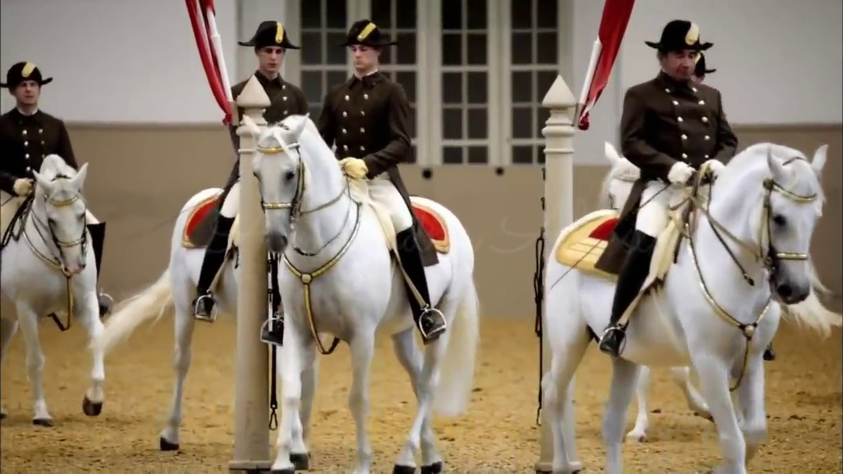

2020/2021 SEASON

March 2021

Issue



Dear Members & Dressage Enthusiasts –

IN THIS ISSUE

2021 Officers

*

Dressage Company & Horse Events

*

Local Horse Show Dates

*

February Meeting Minutes

*

Saddle Up for USDF Education

*

Membership Form

It’s hard to believe but it has been a year now since all our lives got side tracked by the Coronavirus.

Last March we had planned for a fun meeting at the Mad Potter which unfortunately never happened, and from then on pretty much most of our meetings were virtual. Hopefully with the daily infections going down, and more and more people being vaccinated, we can start planning more events again.

Also we hope you can all join us for our next virtual meeting where we will be discussing some upcoming events.

As usual you can always look up more info on our website and Facebook page!!

Isi Brown

The Dressage Company Newsletter Editor

The Dressage Company Newsletter -- Page 1

*DRESSAGE COMPANY*

*NEXT MEETING*

VIRTUAL MEETING

Monday, March 15th

Please check Facebook/website

for more details

*OTHER HORSE EVENTS*

*UPCOMING SHOWS 2021*

MAJESTIC FARM – SERIES 1

~~January Blast - January 9~~

~~February Frolic – February 6~~

~~March Madness – March 6~~

April Adventures – April 24

May CT & Dressage – May 15th

June Dressage – June 19th

MORE UPDATES OF POSSIBLE OTHER SHOWS AND USDF/USEF RECOGNIZED SHOWS TO FOLLOW.

GOOD LUCK TO ALL PARTICIPANTS IN ADVANCE. HAVE FUN!

**2021 OFFICERS**

*President – Debbie Boeh*

[debbieboeh@hotmail.com](mailto:debbieboeh@hotmail.com)

*Vice President - Sue McBeth*

Shakespeare1950@embargmail.com

*Treasurer - Carol Hartlaub*

[Chart3977@aol.com](mailto:Chart3977@aol.com)

*Secretary – Sue Segerman*

[segermansue@cinci.rr.com](mailto:segermansue@cinci.rr.com)

Sargent at Arms -Mary Lynn Griswold

[marylynngriswold@gmail.com](mailto:marylynngriswold@gmail.com)

*Membership Chair*

Melanie Stewart

[rmstewart@fuse.net](mailto:rmstewart@fuse.net)

*Trustees*

Leslie Laine

Trish Hammer

Isi Brown

*Webmaster*

Leslie Laine

[ldlaine@fuse.net](mailto:ldlaine@fuse.net)

*Newsletter Editor - Isi Brown*

[isidressage@gmail.com](mailto:isidressage@gmail.com)

*Historian/Social Media Chairs*

Sue Segerman

[segermansue@cinci.rr.com](mailto:segermansue@cinci.rr.com)

**NOTE:**

**The Dressage Company TM is a Group Member Organization of the United States Dressage Federation (USDF). Members are automatically USFS Group Members. We are located in Region 2.**

For showing at recognized shows, make sure you have the correct membership to be qualified for all championships, awards etc.

The Dressage Company Newsletter -- Page 2

**NEXT MEETING – MONDAY, MARCH 15th – VIRTUAL MEETING**

***Further details will be advised on the website and Facebook.***

Hope you can join us.

February Dressage Company Meeting Minutes 2/15/21

Minutes from last meeting approved.

No treasurer report

Membership-16 paid members. People need to be reminded that it takes a little time to process their membership with USDF.  
  
Old Business-Debbie Boeh is trying to meet with Barb from Majestic to discuss using judges that would allow our members to qualify for year end awards. Several of the schooling shows are not being judged by L or r judges.

Educational events are still in planning stages

Isi Brown added as additional editor to Facebook page  
  
No New Business  
  
Business meeting ended at 7:42pm, followed by discussion of articles in USDF Connection magazine

Submitted by Sue Segeman

USDF Education –**GMO Newsletters**

**Saddle Up for USDF Education**

By Jayne Ayers for the Region 2 Education Committee

Have you ever wished you could find a clear explanation of a confusing dressage term or see a video of a correct rein back or know more about equine nutrition?

All members of this club are also Group Members of the United States Dressage Federation, or USDF. Whether you are new to the sport or an experienced professional, USDF offers many opportunities for you to expand your knowledge of dressage. You can learn more about training theory, improve your eye, learn what the judge is looking for, get training tips, explore freestyle design, and much more.

There are in-person clinics and seminars, online programs, and a huge library of videos, articles, and podcasts. A program to recognize your educational efforts is called USDF University, which offers credit for each thing you do. USDF university also approves and promotes programs designed by other organizations, with topics pertaining to things like veterinary issues, horse management, tack choices, and rider fitness. Links to all these are on the USDF website.

The biggest challenge might be to get comfortable with navigating the website. When you go exploring, some things can be accessed by anyone. If you want full access, you need to login. For the educational offerings on the site, the general search engine might not be your best next step. Instead, **go to the Education tab. If you click on “Education Library” under “USDF University”** or you get a new search engine, targeted to educational resources.

For instance, if you type in “Turn on the Haunches” you will get more than a dozen articles, podcasts, and videos on the subject. A few are full manuals, available for a charge from the USDF Store. The rest are free for you to enjoy right away. And you even get USDF education credits for those you view or listen to, automatically entered to your account! It’s a quick, easy way to get targeted information on whatever aspects of dressage are new or challenging for you.

There are 26 Short Courses under another tab, with topics from flying changes to foal basics and scribe training, all under 20 minutes to complete, with education credit available if you choose to take a quiz or survey. Over a dozen longer Online Courses are also available, with more extensive topics like Lungeing, the Aids of the Rider, Materiale Classes, and Sports Psychology.

For in depth learning, USDF has quite of number of online webinars and in-person programs which need to be organized by a GMO or Region, and require advance sign up. Some are an hour long, some several full days. A few are national in scope, like the annual **Trainer’s Conference** and the **Sport Horse** **Prospect Development Forum**. Others are put on by Group Member Organizations (GMO), clubs like yours. The in-person ones may be held locally, but often are open to those willing to travel from other areas. If it is an online program, like the one on freestyle, it is often open to USDF members outside the sponsoring club. Checking in regularly with the USDF Website or with your Regional Newsletter or Facebook page is a great way to keep up with what is scheduled.

One example is the **L Education Program**, which is required of those wanting to become judges, but is even more popular with riders, trainers, and anyone else interested in knowing what the judge is looking for and how judging is done. It includes classroom sessions with hundreds of video examples, as well as live horse demonstrations. Any GMO can put one on. If three full weekends seems like too much to tackle, an online program, consisting of three one-hour sessions, called **Taste of the L Program**, is also available. That and the new remote access **Musical Freestyle Program** can be found under the **Education** tab, then clicking on **Continuing Education in Dressage Judging**.

Whether you are completely new to dressage or an experienced instructor, the educational opportunities available from USDF might be just the thing to help you on your way to success.





If you have anything horse related for sale, please send me details to [isidressage@gmail.com](mailto:isidressage@gmail.com) and a picture, and we put it in our sales corner. Remember for members up to 5 lines are free, beyond that please see rates to the left.

The Dressage Company Newsletter -- Page 4

|  |  |  |  |
| --- | --- | --- | --- |
|  |  |  |  |

***2021 Membership Form***

***Application/Renewal***

The membership year runs from Nov 1, through Oct. 31.

Dues are $45.00/year for Senior members and $30.00/year for Junior members (a rider who has not reached their 21st birthday before November 1st of the membership year). The dues include an affiliate USDF membership fee.

Are you a USDF member through another organization? { } YES { } NO

If yes, please include you membership number: __________________

{ } New Member { } Renewal { } Change of Address

NAME

ADDRESS

CITY, ST, ZIP

PHONE

EMAIL                                                                         DOB

**SIGNATURE**

Make check payable to The Dressage Company and mail this completed form to:

Mail to: Melanie Stewart

8736 Apple Blossom Lane

West Chester, OH 45069

Email questions or inquiries to: rmstewart@fuse.net

d

The Dressage Company Newsletter -- Page 5

The Dressage Company Newsletter -- Page 5

The Dressage Company Newsletter -- Page 5