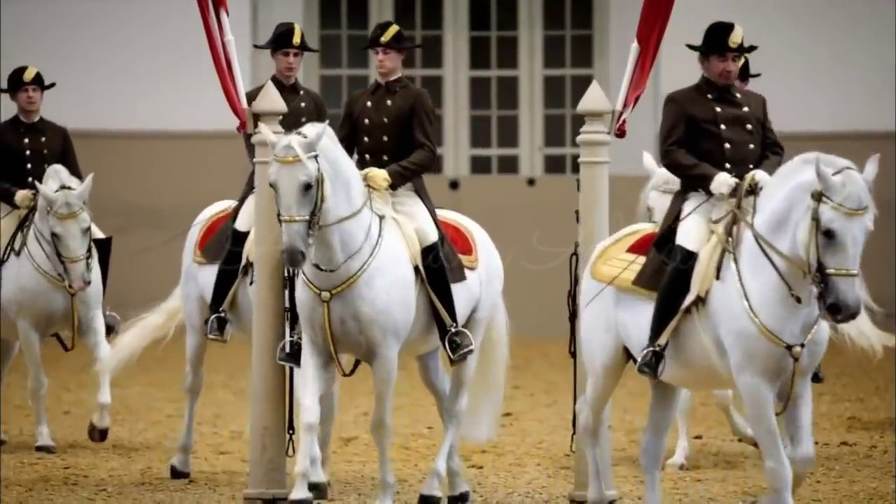

2020/2021 SEASON

May 2021

Issue 7



Dear Members & Dressage Enthusiasts –

IN THIS ISSUE

2021 Officers

*

Dressage Company & Horse Events

*

Local Horse Show Dates

*

March/April Meeting Minutes

*

Income Report

*

Dressage Quotes

*

Membership Form

We are so excited that finally we are going to have an in-person activity. This was something we had planned a year ago – a get-together to get to know each other better and have some fun, and a year later, here we are.

So hopefully a lot of you can join us on May 17 for some painting, wine & snacks and just enjoy each other’s company. It has been too long.

We are in the works for more in person activities for the following month as well, and as usual as soon as we have more details, we will keep you advised. One idea was a demonstration/talk on large animal rescue as well as barn safety.

As usual you can always look up more info on our website and Facebook page!!

Isi Brown

The Dressage Company Newsletter Editor

The Dressage Company Newsletter -- Page 1

*DRESSAGE COMPANY*

*NEXT MEETING*

Monday, May 17

PINOT’S PALLETE (see page 3)

*OTHER HORSE EVENTS*

*UPCOMING SHOWS 2021*

MAJESTIC FARM – SERIES 1

~~January Blast - January 9~~

~~February Frolic – February 6~~

~~March Madness – March 6~~

~~April Adventures – April 24~~

May CT & Dressage – May 15th

June Dressage – June 19th

OLD STONE DRESSAGE SHOW – May 30th

USDF SHOWS

HARMONY IN THE PARK SPRING I – MAY 14-15

HARMONY IN THE PARK SPRING II – MAY 16

OH DRESSAGE S. SPRING WARMUP – MAY 16

KDA SPRING WARM UP – MAY 28- 29

KDA 34th ANNUAl DRESSAGE SHOW – MAY 30

MORE UPDATES OF POSSIBLE OTHER SHOWS AND USDF/USEF RECOGNIZED SHOWS TO FOLLOW.

GOOD LUCK TO ALL!!

**2021 OFFICERS**

*President – Debbie Boeh*

[debbieboeh@hotmail.com](mailto:debbieboeh@hotmail.com)

*Vice President - Sue McBeth*

Shakespeare1950@embargmail.com

*Treasurer - Carol Hartlaub*

[Chart3977@aol.com](mailto:Chart3977@aol.com)

*Secretary – Sue Segerman*

[segermansue@cinci.rr.com](mailto:segermansue@cinci.rr.com)

Sargent at Arms -Mary Lynn Griswold

[marylynngriswold@gmail.com](mailto:marylynngriswold@gmail.com)

*Membership Chair*

Melanie Stewart

[rmstewart@fuse.net](mailto:rmstewart@fuse.net)

*Trustees*

Leslie Laine

Trish Hammer

Isi Brown

*Webmaster*

Leslie Laine

[ldlaine@fuse.net](mailto:ldlaine@fuse.net)

*Newsletter Editor - Isi Brown*

[isidressage@gmail.com](mailto:isidressage@gmail.com)

*Historian/Social Media Chairs*

Sue Segerman

[segermansue@cinci.rr.com](mailto:segermansue@cinci.rr.com)

**NOTE:**

**The Dressage Company TM is a Group Member Organization of the United States Dressage Federation (USDF). Members are automatically USFS Group Members. We are located in Region 2.**

For showing at recognized shows, make sure you have the correct membership to be qualified for all championships, awards etc.

The Dressage Company Newsletter -- Page 2

**NEXT MEETING – MONDAY, MAY 17th**

Please join in for a fun Sip & Paint event on May 17th at:

PINOT’S PALETTE

7334 Tylers Corner, Suite 800

West Chester, OH 45069

 & 

Arrive between 6:30 and 7pm with painting from 7 to 9pm

Non TDC members $39 per person, TDC members receive a $20 dollar discount



[This Photo](http://easylifemealandpartyplanning.blogspot.com/2013/11/three-easy-appetizers-for-parties.html) by Unknown Author is licensed under [CC BY-NC](https://creativecommons.org/licenses/by-nc/3.0/)

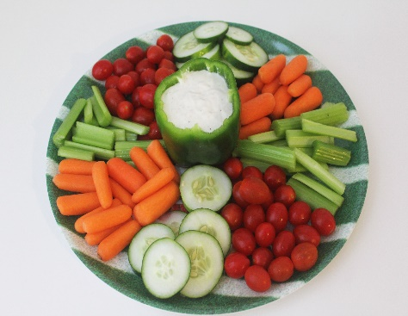

[This Photo](http://www.lovelychicas.com/easy-healthy-super-bowl-appetizer-veggie-tray/) by Unknown Author is licensed under [CC BY-NC-ND](https://creativecommons.org/licenses/by-nc-nd/3.0/)

Light appetizers and snacks will be provided

Beverages, both non-alcoholic and alcholic, may be purchased on site

RSVP to Sue McBeth by Friday, May 14th

Email: [shakespeare1950@embarqmail.com](mailto:shakespeare1950@embarqmail.com)

Text of call: 513 – 484 – 5168

The Dressage Company Newsletter -- Page 3

*MEETING MINUTES - MARCH & APRIL 2021*

**APRIL MINUTES**

The Dressage Company Membership Meeting (via Google Meet) - April 19,2021

The meeting was called to order at 7:08 p.m.

Minutes as published in the last newsletter were approved.

Membership Report: we have 17 paid members.

Treasurer’s Report: We have $5543.28 in checking (including $451.91 disbursement from the disbanding of the Queen City Dressage Circuit) and $5241.83 in the money market for a total of $10, 785.11. The Treasurer’s report was approved as presented.

Our Dressage Company show plans continue to be on hold as we have no venue. Carol Hartlaub will check into the availability of the soon-to-be completed indoor arena at Miami University.

Upcoming meetings: Sue McBeth will explore the availability of the Reilly Township Rescue Squad for a repeat of the program they provided to The Dressage Company in the past on dealing with equine emergencies. She will also explore getting an instructor to allow members to experience Feldenkrais exercises to enhance riders’ pelvic floor control.

Education at this meeting: Attendees discussed the Feldenkrais exercise article published in the March/April 2021 USDF Connection and viewed/discussed a USDF educational video “Bits 101” featuring Beth Haist presenting for the 2020 USDF convention.

The meeting adjourned at 8:30 p.m.

**MARCH MINUTES**

The Dressage Company Meeting Minutes-via Google Meet - March 15, 2021

Meeting called to order at 7:05PM

1. Minutes as published in last newsletter were approved.
2. Membership report-we have 17 paid members, including one new member.
3. Treasurer’s report-Carol is sending to President and Newsletter editor for inclusion in newsletter-current bank balance is $10,273.20
4. The Year End Awards Points for on the website needs to be updated for a year without a show, as it does not currently look like the club will host a 2021 show. Sue McBeth and Leslie Laine will prepare a new form. It was discussed and agreed on that this year participants will need to attend 4 meetings as volunteer points, with virtual meetings counting.
5. Due to not all judges at Majestic Farms shows being L or r rated, members will be reminded in the newsletter to be sure to sign up for shows with appropriate judges if they want their scores to count for our year end awards. It was noted that the DLSC show on 9/18/21 will have an L judge, and Old Stone will be hosting shows this year, but judges are not yet posted. Debbie Boeh will reach out to Old Stone to see if they will use L or r judges.
6. The QCDC link will be removed from our website as it has disbanded.
7. Our YES banquet plans are currently on hold until we see what the Covid 19 situation brings.
8. Our next meeting’s educational portion will cover Part 2 of The Thoracic Sling.

The business meeting adjourned at 7:45PM, and was followed by educational discussion of several articles relating to EHV-1.

The Dressage Company Newsletter -- Page 4

*DRESSAGE QUOTES*



*GOOD RIDE quote* is a photograph by Dressage Design which was uploaded on October 19th, 2017.





If you have anything horse related for sale, please send me details to [isidressage@gmail.com](mailto:isidressage@gmail.com) and a picture, and we put it in our sales corner. Remember for members up to 5 lines are free, beyond that please see rates to the left.

The Dressage Company Newsletter -- Page 5

***2021 Membership Form***

***Application/Renewal***

The membership year runs from Nov 1, through Oct. 31.

Dues are $45.00/year for Senior members and $30.00/year for Junior members (a rider who has not reached their 21st birthday before November 1st of the membership year). The dues include an affiliate USDF membership fee.

Are you a USDF member through another organization? { } YES { } NO

If yes, please include you membership number: __________________

{ } New Member { } Renewal { } Change of Address

NAME

ADDRESS

CITY, ST, ZIP

PHONE

EMAIL                                                                         DOB

**SIGNATURE**

Make check payable to The Dressage Company and mail this completed form to:

Mail to: Melanie Stewart

8736 Apple Blossom Lane

West Chester, OH 45069

Email questions or inquiries to: rmstewart@fuse.net

d

The Dressage Company Newsletter -- Page 6