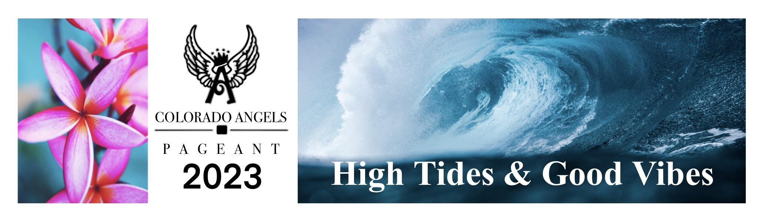
Colorado Angels Pageant Corporate Sponsorship Form

Circle Level of Support: | ANGEL $3,000 | CROWN $2,000 | TIARA $1,000 | SASH $500
Company Recognized During Event | 
Vendor Space
Listed as Sponsor Facebook ⎫
Listed as Sponsor on Website | Logo | Logo | Name
Name Ad Space in Program | Full Sheet | ½ sheet | ¼ sheet | Business card
Company Recognition on T-Shirts | Logo | Logo | Name

Name: ________________________________________________________
Address: _______________________________________________________
Phone: ________________________________________________________
Email: ________________________________________________________
Name of business as you would like it to appear:
_______________________________________________________________
Please make checks payable to:
Colorado Angels Pageant
1151 Eagle Drive # 219
Loveland, CO 80537

