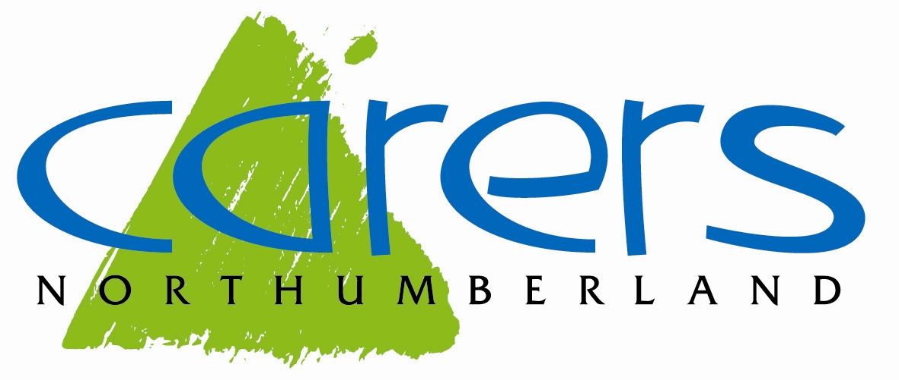
Carers Northumberland – Improving the lives of carers in Northumberland

Carers Northumberland was formed in April 2008 with the aim of improving the lives of unpaid carers who provide regular, unpaid, emotional, physical, and practical help to support a family member, partner or friend who has a disability, physical or mental illness, is frail or has drug or alcohol related problems.

Carers Northumberland’s core service supports adult carers of adults regardless of the condition of the person they care for, hence the sentiment ‘behind every condition there is a carer’.

Carers come in all shapes and sizes, it could be a wife caring for her husband; a husband caring for his wife; parents caring for an adult child with physical and/or mental illness; adult children caring for one or both parents, grandparents or other older relative; adult sibling caring for one another following the death of their parents and as we see more and more, older couples mutually caring for each other with often complex physical and mental conditions. A carer can be someone who looks in on an elderly neighbour once a day, or someone who is carrying out intensive 24 hour a day support. Caring can be short-term, where the person being cared for is recovering from an illness or injury, sporadic, where the effects of a condition can change the level of caring and support required such as long-term mental illness, or long-term – this could be caring for someone with a life-limiting condition or a condition which becomes progressively worse over time.

Northumberland is England’s most northerly county, stretching from the Scottish Border in the north, Newcastle upon Tyne in the east, Cumbria in the west and County Durham in the south. Northumberland is a county of stunning contrasts, from ancient castles to high-tech industry, from pristine beaches to wild countryside. Northumberland is the largest unitary authority by geographic coverage with the greatest area of Green Belt of any Local Planning Authority. Covering an area of 5,013 square kilometres and a population of 320,600 (2021 Census), Northumberland is the least densely populated of the North East’s 12 local authority areas and the sixth most sparsely populated in England.
Just over 31,000 residents identified themselves as carers through the 2021 Census (9.7% of the county’s overall population), though under-reporting is endemic, carers do not always identify themselves as such, and this figure is likely to be higher. Of those carers who identified themselves as such, 9,957 stated they are caring for someone for more than 50 hours per week, and the majority of these are aged over 70. This is an increase of 13% from the 2011 Census. Carers themselves are often in poor health. Many of those providing this valuable support do not see themselves as carers. They think of themselves as family members, or friends, and caring is just one of the things they do. As a result, they often don’t realise that they also have needs and that help, and support is available for them.

Carers Northumberland is an independent charity that works with unpaid carers to offer a wide range of support and information, including links to other services, both statutory and voluntary. At 31 August 2025 there were 8997 unpaid carers registered with Carers Northumberland which included 918 parent carers and 700 young carers. Carers Northumberland provide the following services:

Information Service – The Information Line (01670 320025) offers a single point of contact for enquiries, advice and support linked to caring responsibilities. Our team of Carer Information and Advice Workers are available to answer questions, provide information on local services, complete benefit checks, help apply for grants, help with form filling for benefits such as Attendance Allowance and Carers Allowance, Blue Badge applications, support with financial matters and carer rights. They work closely with specialist agencies across Northumberland, and beyond, to ensure they can find the most appropriate information and advice for carers. The Information Service produces a regular newsletter which can be sent via email or post which keeps carers up to date with local, regional and national issues, useful information and downloads and details of activities and groups around the county. Our website www.carersnorthumberland.org.uk has lots of useful information and downloads.

Peer Support Groups and Events – Carers Northumberland offers a range of opportunities for carers to meet other carers, online, locally and countywide, helping carers to build networks of support and friendship. This includes regular peer support groups which run on a monthly basis across the county (these are currently in Hexham, Ponteland, Berwick, Alnwick, Blyth, Cramlington, Prudhoe and Morpeth), these groups are facilitated either by one of our volunteers or a member of staff and offer an opportunity for carers to meet and chat over a cuppa. In addition to the regular groups, Carers Northumberland offer other opportunities for carers to meet up including regular meals and walks in various locations across the county. One-off events also take place throughout the year, usually to coincide with Carers Week (June) and Carers Rights Day (November), these days consist of information stands, craft activities and therapies. There are also opportunities to attend trips and activities, such as museums, theatre etc. where funding is available.

Carer Training and Workshops – Carers Northumberland offer a range of training courses and workshops throughout the year at different locations around the county, and online, on a rolling programme. These session are designed to explore different aspects of caring and have been shaped by carers themselves. Sessions can be between one and two hours long and are open to any carers registered with Carers Northumberland. Workshops cover a range of topics including, guilt, stress, carers rights, benefits, and planning for the future. We also offer wellbeing sessions which may include complimentary therapies, gentle exercise and mindful crafts.

Telephone Support – Our Carers Information and Advice Workers are also available to chat on an ad hoc or regular basis even if carers don’t have a specific query or issue.

Emergency Care Planning – Carers Northumberland can support carers to make an Emergency Care Plan to document important information about the person they care for. By planning in advance for emergencies carers can have peace of mind that the person they care for is looked after if they are unable to do so, this is especially important for family members or friends who may be called in to help at short notice and means that all the important information is easily accessible in one document.

Carer Support Fund – Research has shown that regular access to short breaks can help carers continue to provide care for longer, offering time to themselves and the opportunity to re-charge their batteries. The Carer Support Fund is available to carers who have been registered with Carers Northumberland for two months or longer and who care for someone who is 18 years or older. The fund offers small grants to take short breaks from their caring responsibilities.

Advance Planning Service – Carers Northumberland are able to support carers and the people they look after to complete Lasting Power of Attorney (LPA), Advance Decisions (living wills) and Advance Statements. Our trained advisors are able to support carers to understand all aspects of making and registering an LPA, help with all form filling, explain the fees and the processes involved in making advance plans for the future.

Social Media and Digital – Carers Northumberland have an active Facebook page where regular updates are posted, and information is shared: www.facebook.com/CarersNland/. There is also a private Facebook group where carers can ask questions, meet other carers, share experiences and keep each other up to date: www.facebook.com/groups/CarersNorthumberland/. Carers Northumberland have a comprehensive website where carers can register online, book onto events and groups, and ask questions: www.carersnorthumberland.org.uk

Young Carers – Carers Northumberland also support young carers (young people aged under 18 years who help to care for a family member with additional needs, physical disability, mental health condition, learning difficulties, and/or substance misuse or addictions. This service aims to ensure that children and young people have the support they need to learn, develop and thrive, and to enjoy positive childhoods enabling them to achieve their full potential. The Young Carer Service supports young carers on a one-to-one basis, as well as with group activities, events and trips and a fund to enable a break. The service also offers a tailored package of support to schools to enable them to support young carers during their time in education.

Working for Carers – The Working for Carers Project is funding by the North East Combined Authority in partnership with Newcastle Carers and North Tyneside Carers’ Centre. The project aims to address the barriers that carers face when wanting to return to work, education, training, or volunteering and also supports carers who are in work to make informed decisions about staying in work while managing a caring role. The project works with carers on a one-to-one basis at the carers own pace and aims to support them to find suitable employment, training and education opportunities.

The Trustees seek to maintain a supportive culture in the organisation, with a relationship between Trustees and staff that reflects equality and mutual respect where the roles and responsibilities of all are clearly defined and understood. Carers Northumberland’s vision is “To improve the lives of unpaid carers in Northumberland.”

The charity’s vision is underpinned by clear organisational values:

Responsive
Reacting in a timely manner to all methods of conduct

Trusted
Trusted by Carers to provide accurate, efficient, tailored advice and services. Trusted by partners to action referrals quickly, provide support and act with integrity. Trusted to show up, do what we say we will do, and value carers.

Caring
We show kindness, empathy, and compassion for others, with a service that is caring and approachable.

More information can be found on our website: www.carersnorthumberland.org.uk

