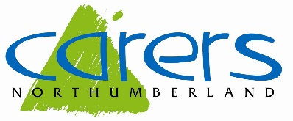

Carer Ambassador

Context

Carers Northumberland is a registered charity committed to improving the lives of carers in Northumberland through provision of high quality support and information services.

Getting the word out is a really important part of what we do, many carers don’t even know that they are carers and that they have rights. By helping us to share information and promote carer awareness you will make a real difference.

What’s involved?

- Share our posts on social media
- Identify carers in your local community and signpost them to our services
- Hand out information (leaflets / posters etc) locally and encourage local businesses to do the same.
- Raise awareness

What are we looking for?

- Busy people who can’t commit to a regular volunteering role, but still want to help
- People who are active in their local community
- Good written and verbal communication skills, including listening and observational skills
- Have some knowledge of carers and their rights, or are willing to learn

Hours

As much or a little as you like.

Location

We are looking for people across all corners of Northumberland

Training

We will provide information on how to identify carers, what rights carers have and information about the services Carers Northumberland offers.

An understanding of the ethos and objectives of the charity in improving the lives of carers in Northumberland will be provided.

