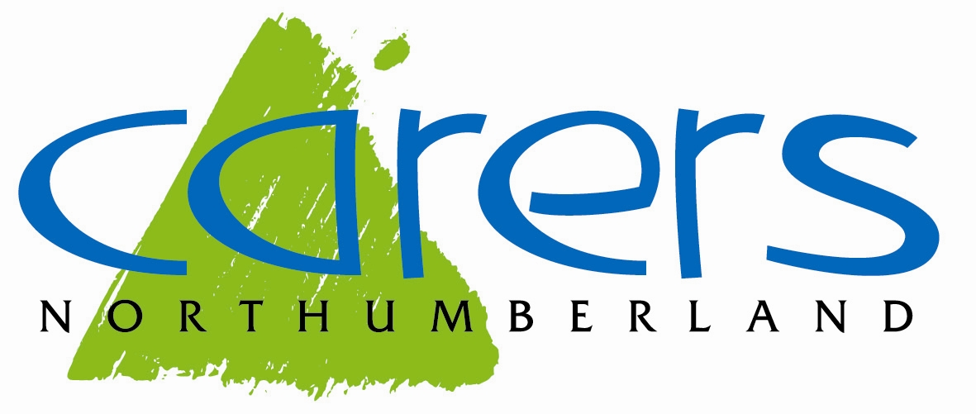
Carers Northumberland – Improving the lives of carers in Northumberland
Carers Northumberland was formed in April 2008 with the aim of improving the lives of unpaid carers who provide regular, unpaid, emotional, physical, and practical help to support a family member, partner or friend who has a disability, physical or mental illness, is frail or has drug or alcohol related problems.
Carers Northumberland’s core service supports adult carers of adults regardless of the condition of the person they care for, hence the sentiment ‘behind every condition there is a carer’.
Carers come in all shapes and sizes, it could be a wife caring for her husband; a husband caring for his wife; parents caring for an adult child with physical and/or mental illness; adult children caring for one or both parents, grandparents or other older relative; adult sibling caring for one another following the death of their parents and as we see more and more, older couples mutually caring for each other with often complex physical and mental conditions. A carer can be someone who looks in on an elderly neighbour once a day, or someone who is carrying out intensive 24 hour a day support. Caring can be short-term, where the person being cared for is recovering from an illness or injury, sporadic, where the effects of a condition can change the level of caring and support required such as long-term mental illness, or long-term – this could be caring for someone with a life-limiting condition or a condition which becomes progressively worse over time.
Northumberland is the sixth largest county in England, with one of the lowest populations, 320,600 residents. Just over 31,000 residents identified themselves as carers through the 2021 census, though under-reporting is endemic, carers do not always identify themselves as such, and this figure is likely to be higher. In 95% of the county, population density is extremely low, concentrated in widely spaced small communities. The urban Southeast is more densely populated but with high deprivation, it’s population in worse health than the rest of the county (11th worst of 320 UK areas). The demographics of the county indicate a higher proportion of people with life-limiting and chronic conditions and a higher proportion of older people than the national average, with these numbers set to grow, and the number of carers are set to grow with it. Of those carers who identified themselves as such, around 9,957 stated they are caring for someone for more than 50 hours per week, and the majority of these are aged over 70, this is an increase of 13% from the 2011 to the 2021 census. Carers themselves are often in poor health. Many of those providing this valuable support do not see themselves as carers. They think of themselves as family members, or friends, and caring is just one of the things they do. As a result, they often don’t realise that they also have needs and that help, and support is available for them.
Carers Northumberland is an independent charity that works with carers of all ages to offer a wide range of support and information, including links to other services, both statutory and voluntary. Carers Northumberland provide the following services:
- A comprehensive centralised information and advice service which includes a dedicated carer information telephone service, providing advice and guidance on benefits, finance, advance planning, signposting, and also regular newsletters.
- Individual support, either face-to-face or by telephone for specific and ongoing issues relating to the caring role.
- Regular Peer Support Groups in locations throughout the county.
- Information sessions in locations across the county.
- Wellbeing Workshops
- Activities, events, and trips
- Training and skills development for carers, volunteers, and professionals
- Access to short breaks
- Promoting and raising awareness of carers’ rights
- Support to access employment, volunteering, and training
- Specific support for young carers (aged 18 or under)
The Trustees seek to maintain a supportive culture in the organisation, with a relationship between Trustees and staff that reflects equality and mutual respect where the roles and responsibilities of all are clearly defined and understood. Carers Northumberland’s mission is to be a ‘well-known, respected, and sustainable organisation providing accessible, first class, carer focused support in local communities across Northumberland.
The charity’s ethos is underpinned by clear organisation values:
EMPOWER
Empowering carers to realise their own strengths and abilities and help them find a voice
Empowering staff and volunteers to do the best job possible
COMPASSION
Understanding and being responsive to the needs of others
COMMUNITY
Recognising and utilising community assets and approaches for the benefit of everyone
Working in partnership where appropriate
Work within the community of carers in Northumberland
INTEGRITY
Being honest and consistent with strong moral and ethical principles
QUALITY
Making sure that the delivery of services is to a high professional standard
EQUALITY/FAIRNESS
Ensuring everyone is treated fairly and in accordance with their own needs
CHALLENGING
Allowing, listening, and responding positively to challenge
Challenging others in respect of carers rights, carer inclusion and carer promotion
PASSIONATE
Being focused and having the desire and enthusiasm to support carers

More information can be found on our website: www.carersnorthumberland.org.uk

