 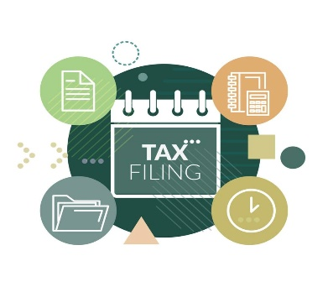

***Lisa White***

***Podabela Tax Services LLC***

***767 Broadway, Suite 1099***

***New York, NY 10003***

***Business Website: Podabelallc.com***

***Business Email:*** [***Podabelatax@gmail.com***](mailto:Podabelatax@gmail.com)

***Business Telephone: (646) 799-2680***

***Business Fax: (646) 974-8547***

***Price List***

**These Fees Include Filing of Your State & Local Taxes, Needed Schedules & Forms**

***Consultation*** *------------------------------------------------------------------------------------------------------------------ Free*

***E-file Federal Forms 1040, Schedules, and Forms***

* *Individual -------------------------------------------------------------------------------------- Price Starts at- $147*
* *Independent Contractor ------------------------------------------------------------------- Price Starts at- $167*
* *Sole Proprietor ---------- Price Starts at- $187, S-Corporation, C-Corporation- Price Starts at- $357*

***Late Filing e-File Federal Forms 1040, Schedules, and Forms***

* *Individual -------------------------------------------------------------------------------------- Price Starts at- $157*
* *Independent Contractor ------------------------------------------------------------------- Price Starts at- $177*
* *Sole Proprietor ---------- Price Starts at- $197, S-Corporation, C-Corporation- Price Starts at- $377*

***Page 1 of 2***

***Page 2 of 2***

***Price List***

***Lisa White***

***Podabela Tax Services LLC***

***767 Broadway, Suite 1099***

***New York, NY 10003***

***Business Website: Podabelallc.com***

***Business Email:*** [***Podabelatax@gmail.com***](mailto:Podabelatax@gmail.com)

***Business Telephone: (646) 799-2680***

***Business Fax: (646) 974-8547***

***Tax Return Amendment Federal Forms 1040, Schedules, and Forms for an Individual or Business***

* *Individual ------------------------------------------------------------------------------------ Price Starts at- $307*
* *Independent Contractor ---------------------------------------------------------------- Price Starts at- $327*
* *Sole Proprietor-------- Price Starts at- $347, S-Corporation, C-Corporation- Price Starts at- $457*

***Quarterly Tax Filing*** *------------------------------------------------------------------------------- Price Starts at- $147*

***Refund Transfer*** *(This fee is deducted from your refund) --------------------------------------------------- $100*

***Tax Return Extension*** *------------------------------------------------------------------------------------------------ $37*

***LLC Business Formation*** *(New York State-Includes filing Articles of Organization, Name search and availability, Filing fee and EIN business tax number ------------------------------------------------------- $297*

*(Additional fee if adding required publication of LLC)*

***A Convenience fee will be added if you choose to pay by debit or credit card***

***We accept Zelle to (646) 799-2680, PayPal, and all major credit and debit cards***