**KEYS TO DIVINE PROVISION**

1. **INTRODUCTION**

In the beginning the ALMIGHTY GOD made provisions for man by providing him all that he needs for the daily life and sustenance. Hence mas was not created until all that he need was in place.

* The ALMIGHTY GOD is the author and owner of all things (visible and invisible)
* HIS NAME IS JEHOVAH JIREH – OUR PROVIDER

Gen 1v1: In the beginning GOD created the Heavens and earth

* **Man was never created to be the provider for himself**
* **Trying to do GOD’s job leads to stress**

**Ps 24 v1: The earth is the LORD’s and the fullness**

1. The enemy does not own or control the resources of the earth

* Temptation of LORD JESUS (To give the Kingdom of the earth)

1. Wealth, money, riches is a part of the provision in the KINGDOM OF GOD
2. You don’t need to go anywhere else to have access to money

* **Corporate world is still part of what ALMIGHTY GOD controls**

**2. ASSURANCES IN THE WORD OF GOD**

Our experience of driving along with a food in the boot of the car while hungry and looking for food because it has not been “revealed” to us

* Deut 28 v 1-13
* James 1 v17: Every good and prefect gift come from GOD
* 2 Peter 1v3: HIS DIVINE power has given us all that we need for life
* We are complete in HIM
* Ps 37v27: I have not seen the righteous forsaken

**BIBLE NARRATIVE**: 1 Kings 17v1-16: Provision for Prophet Elijah

V1: Elijah knew the GOD before WHOM he stands

V2: It takes the WORD OF GOD to point us to the source of our provision

V3-4: It could be from unlikely sources (beside a brook) and unlikely means (ravens)

V5: It requires obedience and faith in GOD

V6: Elijah was fed twice and drank water

V7-8: Before tough times comes the ALMIGHTY GOD had already planned the next step

**Question: Where is Zarephat?**

V10: The source of provision is from a widow?

V10-11: Here giving was tested – Prophet Elijah asked her to give first

V12-13: We see the apprehension by the widow

V13: “Fear not” was the response from the Man of GOD

V14: Once again a WORD FROM GOD brought the solution

V15-16: We see DIVINE PROVISION in operation

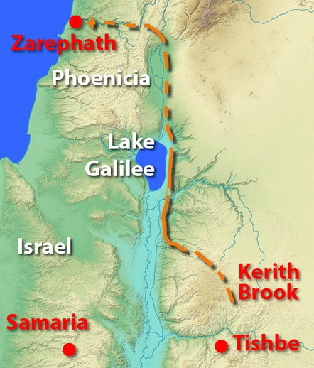

**In summary the following are the steps to DIVINE provision**

(i) Know your GOD as the PROVIDER

(ii) You must hear a WORD OF GOD as to the direction to your supply

(iii) Expect GOD’s help from unlikely sources

(iv)Obey the LORD’s voice as HE knows better

(v) Be ready to move when HE ask you to

(vi) Avoid waste

(vii) Live a simple life (Elijah only ate bread and water twice a day)

(viii) Trust the ALMIGHTY GOD at all time as HE has gone ahead to provide a way out of every difficult situation

(ix) Do not fear to take steps guided by the HOLY SPIRIT

(x) Be a giver as the ALMIGHTY GOD is a GIVER as HE supports givers

**3. LIVE A LIFE OF CONTENTMENT (REMOVES STRESS)**

The reality is that some people can never have enough

* Spouses should not put the other person under pressure to be like the Joneses

1 Timothy 6 v6-11 (AMP version)

V6: Godliness with contentment is great gain

V7: We brought nothing into this world and we will carry nothing out

V8: Having food and clothing we will be content

V9: Those trying to get rich by any means possible will fall into temptations

V10: For the love of money is the root of all evil

* Do not live beyond your means
* There is no free money (The borrower is a slave to the lender)
* Story of GOD asking someone to get out of debt (Revelation TV)

**4. TRYING TOO HARD TO MAKE IT AT ALL COST**

Some Christian believe in hustling rather that working hard and depending on the LORD to be the DIRECTOR of their success.

Definition of Hustling

* Rough push
* To sell something to or obtain something from (someone) by energetic and especially underhanded activity

Urban Dictionary

**Hustling** is **making money** out of everything no matter what it is something that mostly happens in **ghettos** where people don't have much so they need to hustle

GOSPEL TRUTHS

(a) If GOD has selected you to become a billionaire, you will be but be faithful

Case1: Joseph was given a DIVINE dream by ALMIGHTY GOD - it is unstoppable

(b) Conversely if the LORD GOD has not selected you to be a billionaire nothing you can do can force it to happen.

Case 2: Moses trying so hard to deliver Israel by his own might –led to frustration

+ The solution here it to be like Jabez and ask the LORD GOD for help

(c) Everything will happen in GOD’s time and in HIS own way

* When we walk with GOD the way is much straighter but our own ways will lead us going in circles

**5. A LIFE OF DEPENDENCY ON THE ALMIGHTY GOD**

**Matt 6v25-27: ADVICE FROM LORD JESUS**

V24: You cannot serve GOD and mammon at the same time

V25: Don’t worry about what to eat, drink or clothes

V27**:** Who by worrying can add anything to their life?

Every parent’s job is to provide for theirs children

* ALMIGHTY GOD’s mercies are new every morning (Lamentations 3v22 -23)
* If you being bad knows how to give good gifts

Ex 16 v1-5: ALMIGHTY GOD feed 2 million Israelites with manna from **HEAVEN**

**V1-2: Israelites murmured just like we do today**

**V3: They desired to go back to Egypt i.e. the old ways just like we do today**

* + This lead to bondage

V4: THE ALMIGHTY GOD (JEHOVAH JIREH) stepped in to rain manna

V5: They observed Sabbath even in gathering the manna!

**6. BE A GIVER – THE ALMIGHTY GOD PROVIDES ALWAYS FOR GIVERS**

**Giving is a state of the heart**

* + **It is not about not having enough (Luke 21 v1-4: Widow’s mite)**

(a) Philippians 4 v17-19: ALMIGHTY GOD provides constantly for givers

V17-18: Paul was commending the small but faithful Church for their generosity

V19: People will always jump to “My GOD shall supply all your needs”

(b) 1 King 17v10-13: Even the widow first gave to Prophet Elisha

(c) Prov 11v24-26: There is he that scattered and yet increases

(d) Solomon was a giver

2 Chronicles 1v6-7

V6: Solomon offered a thousand burnt offering

V7: The LORD came to him by night

2 Chronicles 7 v5: And King Solomon offered a sacrifice of twenty-two thousand head of cattle and a hundred and twenty thousand sheep and goats. So the king and all the people dedicated the temple of God.

* Cattle: 22000
* Sheep and goat: 120,000

**(e)The wealthiest people on earth today are givers**

<http://uk.businessinsider.com/most-generous-people-in-the-world-2015-10/#20-dietmar-hopp-1>