The Epiphany Star

EST. 1846 April 2018 The Light Shines in Darkness.

Episcopal Church of the Epiphany - 225 West Main Street – Laurens, SC 29360 - epiphany@backroads.net
www.epiphanyoflaurens.org Church – 864-984-7000

The mission of Church of the Epiphany is to celebrate the light of Christ, proclaim the Gospel, deepen our faith, nurture and encourage all people.

FROM FATHER PAUL ABERNATHY

My Dear Sisters and Brothers,

Two words. One liturgical. The other administrative…

Easter Day is the greatest festival of Christendom. Without the proclamation, indeed, the reality that we claim by faith that “Christ is risen!”, there is no Christianity. And with Easter Day, we enter the Great Fifty Days between Easter Day and the Day of Pentecost (this year, falling on May 20). I look forward to the coming Sundays in which we, at length, reading and reflecting on the appointed Bible passages and inspired (I pray!) by the associated sermons, can deepen our communal and individual contemplation and comprehension of the meaning of Jesus’ resurrection for our lives.

We are updating our Epiphany Church Parish Directory, which, with great thanks to the good work of Ann Cox, we last revised in June 2016. This time ‘round, happily receiving the proverbial baton from Ann, I plan to complete the updated Parish Directory by the end of April (if not sooner). To that end, I ask that you please email me (abernathy.paul@yahoo.com) your:
- Name
- Address
- Telephone Number
- Email Address

Thank you.

Always, yours,
Paul

-2-

April Backpack Update

We are almost through the school year. Our next date to pack backpacks will be April 22 after the Sunday service. As I mentioned previously the need for food for students over the weekends is great. We (representatives from Atonement Lutheran, First Presbyterian, First Methodist and Church of the Epiphany) have been discussing possible ways to meet the needs of more students (50 for next year) at Ford Elementary. One suggestion we have agreed to implement for next year is to solicit donations to “Adopt a Backpack” for a year for $200.00. With prudent purchases, we believe we can fill 50 backpacks for 37 weekends with $10,000. Our goal is to have 50 backpacks adopted within our 4 churches. Using the above figures, we would have $5.40 per meal which is cutting it pretty close as we will be filling the backpacks with 2 breakfasts, 2 lunches, 2 suppers and 2 snacks. We will apply for a grant, and we will pool our resources to obtain more purchasing power. We have also received approval to store our food purchases in the District 55 office, but we will need to provide shelving. Some non-profits doing weekend food for students contract with Harvest Hope, but their charge is $7.50 per meal and there is never any fresh fruit. We are hoping to enlist the cooperation of our local grocery store managers to obtain food the most cost-effective way. Any ideas from any of you to make this plan better or ways to obtain grant funds will be greatly appreciated. Please email Connie Daniels at cdaniels1234@hotmail.com and put “Backpacks” in the subject line in case your email goes into the spam folder. Thanks to each and every one of you who have supported the backpack ministry this year.

UNITED THANK OFFERING

Our 2018 United Thank Offering Spring Ingathering is set for Sunday, May 6. There are mite boxes and envelopes in the parish hall. This is a note from our Diocesan Ingathering representative, Phyllis Web:

I wanted to update you on our two UTO grants from 2016/2017. I was at Gravatt, 2016 recipient, in early February and had the opportunity to see a second project. The completed labyrinth is located down by the lake. It is beautiful and in a rectangular shape which I had never seen before. All three areas – the tree house, the labyrinth, and the outdoor educational space in the woods have gotten much use by guests/campers since their completion. Jasmine Road, our 2017 recipient, has made great strides. The house is nearing completion. There are three women who have been screened and they are hoping to move them in by May 1st. The money from the UTO Grant was used to establish a website – https://www.jasmineroad.org. They have hired a program manager & purchased computer for their use. This is in addition to using the money towards personnel, office needs & supplies. We have been a vital part of enabling this program to get on its feet and being able to serve these women as they recover to a new life.

My deepest thanks for all the blessings that were gathered in 2017 allowing Upper South Carolina that sent $28,021.14 to be included in the 2018 granting process.

Linda Barksdale

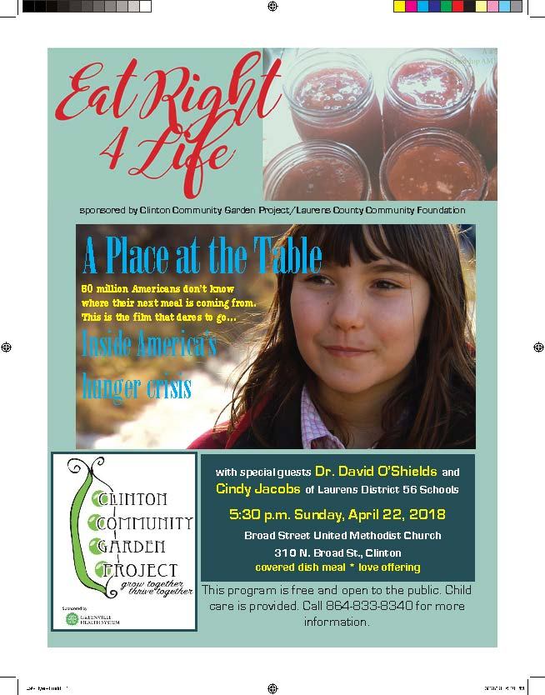

-4-

APRIL USHER AND NURSERY SCHEDULE

April 1: John Womack Harriet Barksdale
April 8: Reid Cox Linda Barksdale
April 15: John Womack Base Smith
April 22: Reid Cox Sarah Daniels
April 29: John Womack Harriet Barksdale

APRIL BIRTHDAYS AND ANNIVERSARIES

April 3: Josiah Daniel Foggie Paul and Pontheolla Abernathy
April 8: Cassie Taylor Power
April 18: Brad Holmes
April 24: Linda Barksdale
April 25: John Calvin Hughes
April 28: Bill and Marilyn Ladd
April 28: MJ and Jason Berryman

VISIT MISS LUCY’S GARDEN BLOG AT
WWW.GARDENEPHIPHANY.WORDPRESS.COM

SEND ANNOUNCEMENTS FOR FUTURE EDITIONS OF THE EPIPHANY STAR TO BILL COOPER, MTHAPPY@PRTCNET.COM OR CALL 864-969-2707. PLEASE LET ME KNOW OF ADDITIONAL BIRTHDAYS OR ANNIVERARIES THAT NEED TO BE INCLUDED.

